ORIGINAL RESEARCH
Eggert et al - Supplementary data

The fingerprint-like pattern of nocturnal brain activity demonstrated in young individuals is also present in senior adulthood
Torsten Eggert1, Hans Dorn1, Heidi Danker-Hopfe1

1 Charité – Universitätsmedizin Berlin, Competence Centre of Sleep Medicine, Berlin, Germany

Supplementary Tables
Supplementary Table 1: Inclusion criteria
Inclusion Criteria
- Study 1: Females; Studies 2 and 3: Males | TI
- Studies 1 and 2: Age ≥ 60 and ≤ 80 years; Study 3: Age ≥ 18 and ≤ 30 years | TI
- Physically and mentally healthy | TI
- Right-handedness [Handedness should be controlled due to possible differences in EEG amplitudes between dominant and non-dominant hemispheres (e.g., Stöhr et al. 1991)] | TI
- Alpha rhythm in the resting state waking EEG with eyes closed [the alpha type is the most common EEG basic rhythm, but other norm variants also exist (e.g., Kubicki and Höller, 1980); however, when basic rhythms are mixed, intervention effects on the EEG are harder to find] | ME
- Ability to consent | TI
- No history of sleep disorders | ME
- No acute subjective (i.e., one month prior to study participation, subjectively perceived total sleep time of at least 6 hours per night, sleep onset latency less than 30 minutes and less than 45 minutes awake after sleep onset) and/or objective sleep complaints (i.e., periodic limb movement arousal index (PLMAI) < 20/h and apnea-hypopnea index (AHI) < 15/h) | ME
- Normal sleep-wake rhythm | ME
- No history of substance consumption or abuse | ME
- Non-smoker | TI
- No CNS active drugs at all (study 3) or CNS active drugs only in a stable medical condition (studies 1 and 2); the latter refers, e.g., to alpha- and beta-blocker, histamine antagonists, glucocorticoids, levothyroxine; no regular use of both prescription and over-the-counter analgesics, hypnotics, sedatives | ME

Notes: Studies 1, 2 and 3 refer to the studies in elderly women, elderly men, and young men, respectively.
Abbreviations: TI, telephone interview; ME, medical examination.
Supplementary Table 2: Exclusion criteria
Exclusion Criteria
- History of a serious neurological or internistic disease | ME
- Acute or history of a mental disease | ME
- Acute physical illness | ME
- Impairment of concentration or alertness, impairment of memory or retention, of speech or motor activity | ME
- Surgery or medical intervention at the central nervous system in the past six months | ME
- Tattoos and piercings in the head and/or neck region to avoid any undesirable local heating | TI
- Abnormalities in the electrocardiogram | ME
- Subjectively increased daytime sleepiness (Epworth Sleepiness Scale; ESS Score > 10) | QA
- Subjectively perceived bad sleep quality (Pittsburgh Sleep Quality Index; PSQI score > 5 for the sample of study 3 and PSQI score > 6 for the samples of studies 1 and 2; the decision to accept higher scores in the elderly samples was based on a study by Buysse et al. (1991), who could show that PSQI scores greater than 5 are frequently observed in healthy older subjects) | QA
- Extreme chronotypes (Morningness–Eveningness Questionnaire; MEQ score < 31 or > 69; exception: MEQ scores > 69 were accepted in studies 1 and 2 if not reflected by exceedingly early bedtimes in the sleep diary) | QA
- Score > 36 in the Self Rating Anxiety Scale (SAS) | QA
- Score > 40 in the Self Rating Depression Scale (SDS) | QA
- Regular shiftwork | TI
- Electronic implants to exclude any possible electromagnetic interference | TI
- Allergies which are of relevance for the fixation of electrodes | TI
- Consumption of > 2 glasses of wine/day or > 3 glasses of beer/day | ME
- Consumption of > 5 cups of caffeinated beverages/day | ME
- Severe impairment of vision and/or hearing (need for hearing aids or spectacles > ± 3 diopters), which could lead to poorer behavioral performances and/or aberrant auditory evoked potentials, e.g., in the case of hearing difficulties; however, this exclusion criterion was only relevant for the experiments performed during daytime | TI
- Study 3: sleep efficiency index < 80% in the adaptation/screening night; Studies 1 and 2: sleep efficiency index < 70% in the adaptation/screening night | SN
- PLMAI ≥ 20/h in the adaptation/screening night | SN
- AHI ≥ 15/h in the adaptation/screening night | SN
- Sleep onset latency > 30 min in the adaptation/screening night (sleep latencies up to < 50 min were tolerated in studies 1 and 2 in exceptional cases) | SN

Notes: Studies 1, 2 and 3 refer to the studies in elderly women, elderly men, and young men, respectively.
Abbreviations: TI, telephone interview; QA, questionnaire; ME, medical examination; SN, screening night.

Supplementary Figures
Supplementary Figure 1: Individual means of the three sleep EEG power spectra for the sample of elderly women. The figure shows all-night power spectral densities recorded at electrode position C3 during NREM sleep averaged within participants.

Supplementary Figure 2: Individual means of the three sleep EEG power spectra for the sample of young men. The figure shows all-night power spectral densities recorded at electrode position C3 during NREM sleep averaged within participants.

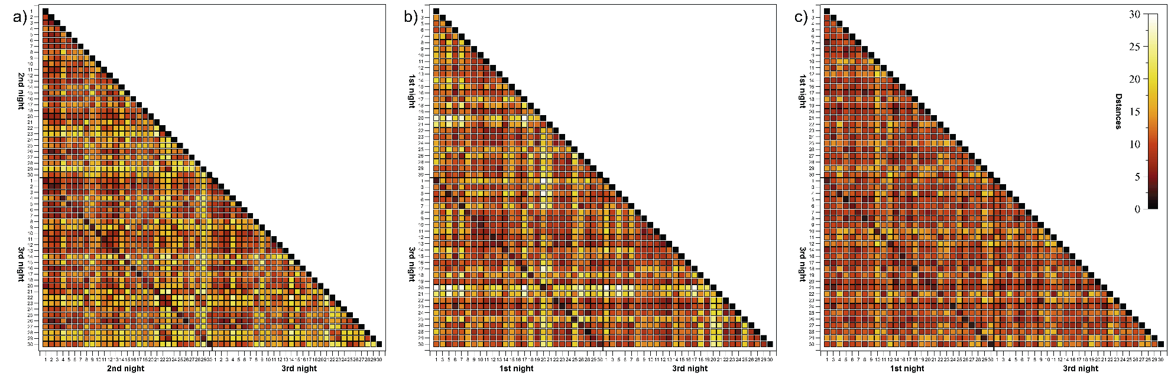
Supplementary Figure 3: Triangular heatmaps visualizing Manhattan distances derived from the comparisons between 1st and 3rd sham nights of elderly women (a), elderly men (b) and young men (c). Proximity measures were performed on NREM sleep EEG signals recorded at C3. The smaller the distances the darker the shading. The black-framed squares mark the area of all within- and between-individual 1st and 3rd sham night comparisons. Tick labels indicate the participant number.
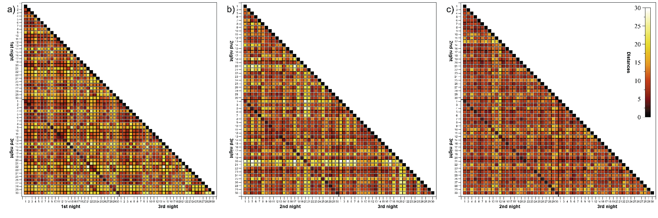
Supplementary Figure 4: Triangular heatmaps visualizing Manhattan distances derived from the comparisons between 2nd and 3rd sham nights of elderly women (a), elderly men (b) and young men (c). Proximity measures were performed on NREM sleep EEG signals recorded at C3. The smaller the distances the darker the shading. The black-framed squares mark the area of all within- and between-individual 2nd and 3rd sham night comparisons. Tick labels indicate the participant number.

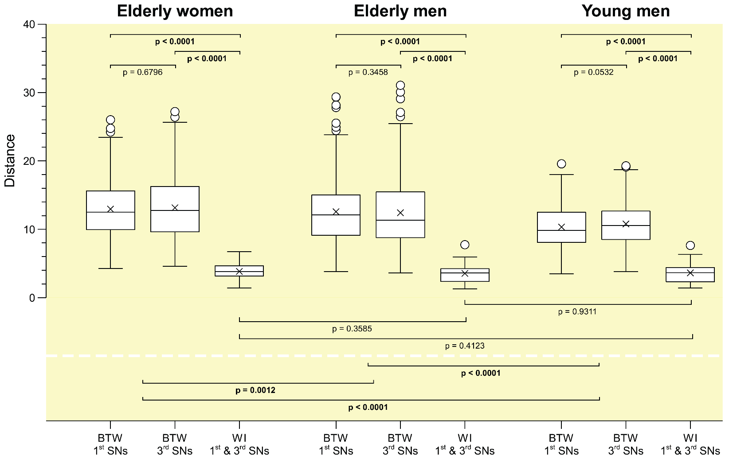
Supplementary Figure 5: Comparisons of inter- and intraindividual Manhattan distances computed between the 1st and 3rd sham nights for all three samples. For each sample, first and second boxplots represent the distribution of between-subject distances for the 1st and 3rd sham nights (elderly women: n=406; elderly and young men: n=351), respectively, whereas the third boxplot shows the distribution of within-subject distances between 1st and 3rd sham nights (elderly women: n=29; elderly and young men: n=27). Proximity measures were performed for NREM sleep EEG signals recorded at C3.
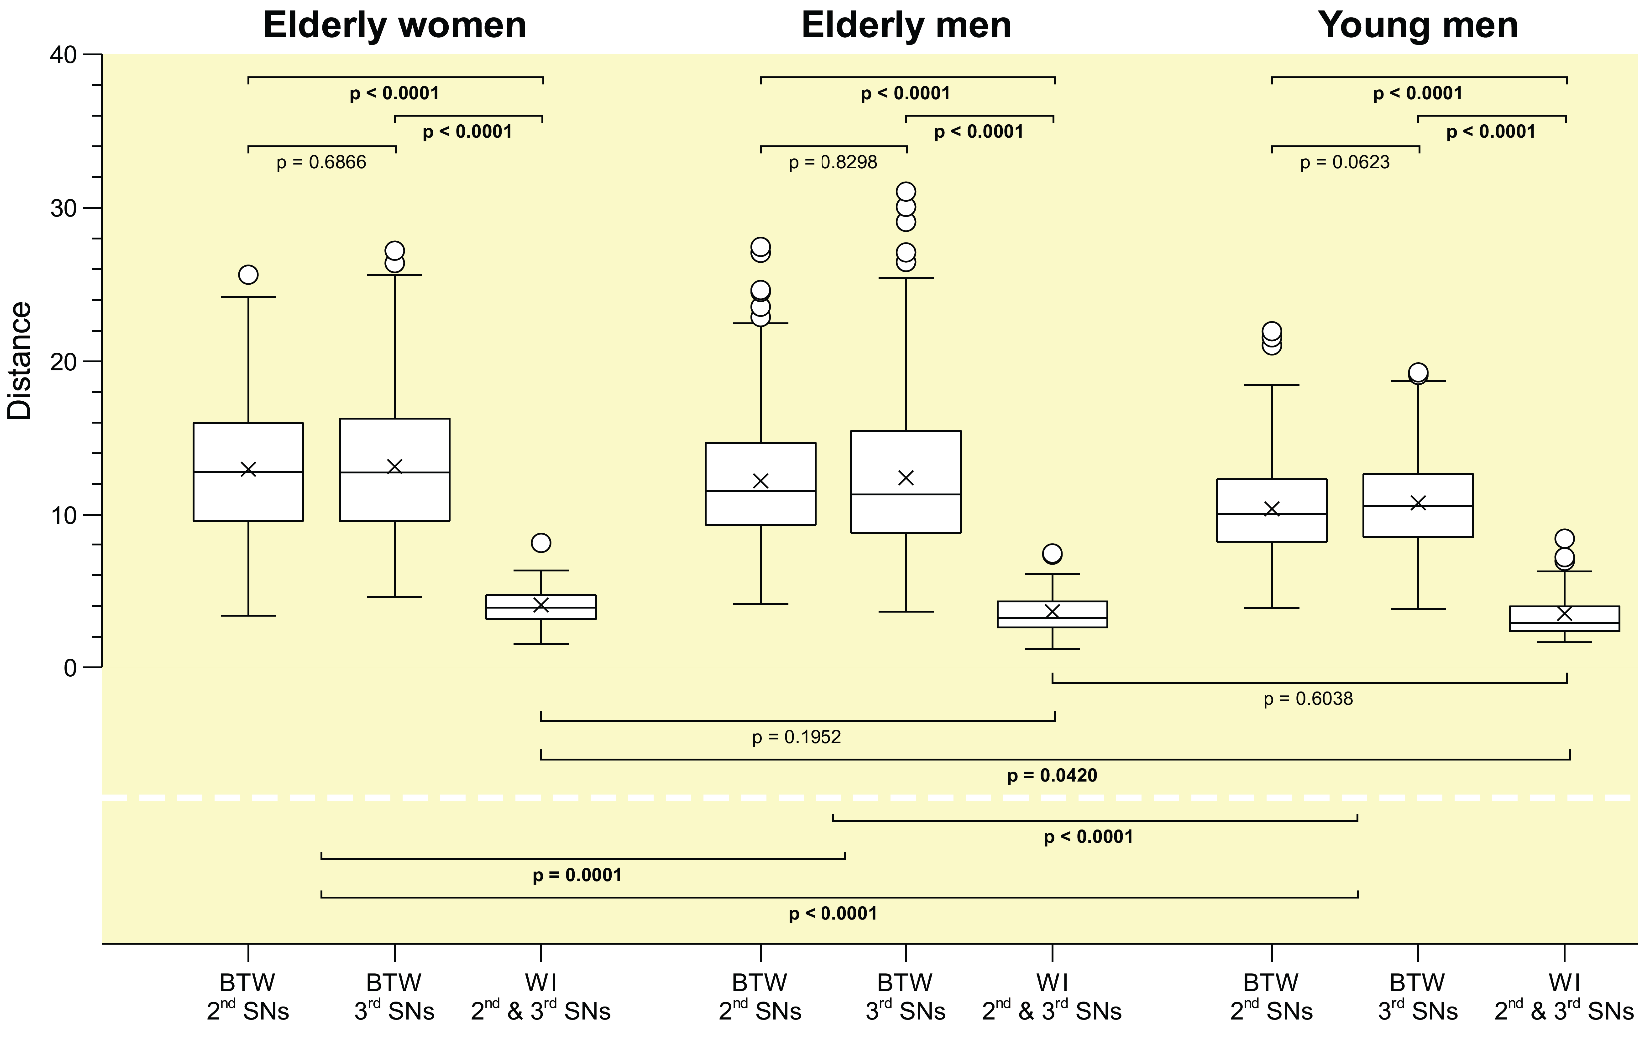
Supplementary Figure 6: Comparisons of inter- and intraindividual Manhattan distances computed between the 2nd and 3rd sham nights for all three samples. For each sample, first and second boxplots represent the distribution of between-subject distances for the 2nd and 3rd sham nights (elderly women: n=406; elderly and young men: n=351), respectively, whereas the third boxplot shows the distribution of within-subject distances between 2nd and 3rd sham nights (elderly women: n=29; elderly and young men: n=27). Proximity measures were performed for NREM sleep EEG signals recorded at C3.

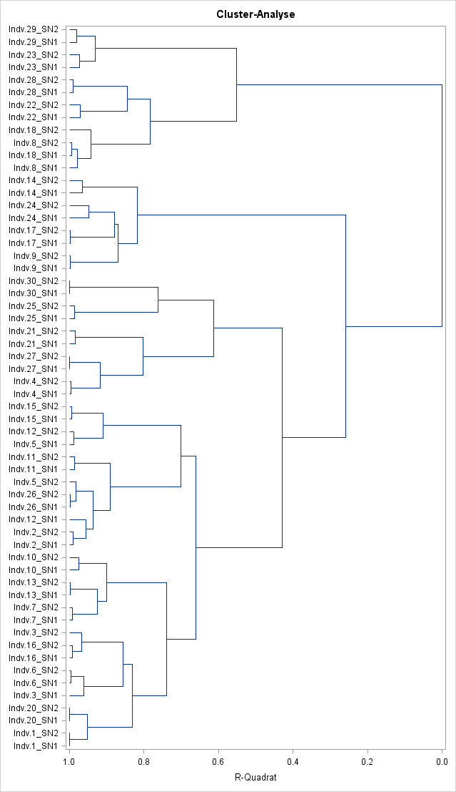

Supplementary Figure 7: Dendrogram displaying the clustering of elderly women based on the similarity of sleep EEG power spectra obtained from 1st and 2nd sham nights. Ward’s method was used for agglomerative clustering. One participant had to be excluded from hierarchical cluster analysis.
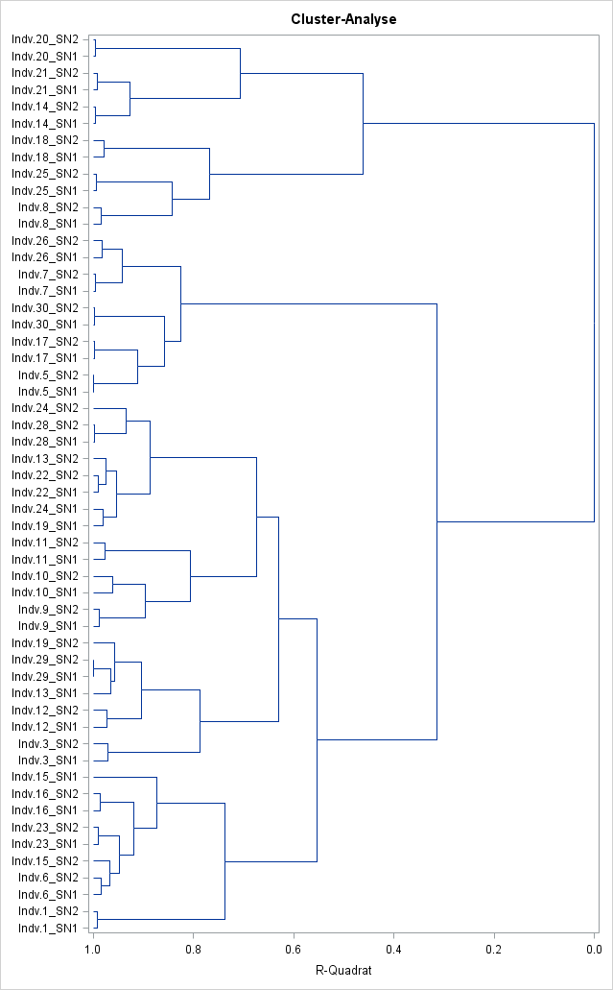

Supplementary Figure 8: Dendrogram displaying the clustering of elderly men based on the similarity of sleep EEG power spectra obtained from 1st and 2nd sham nights. Ward’s method was used for agglomerative clustering. Three participants had to be excluded from hierarchical cluster analysis.

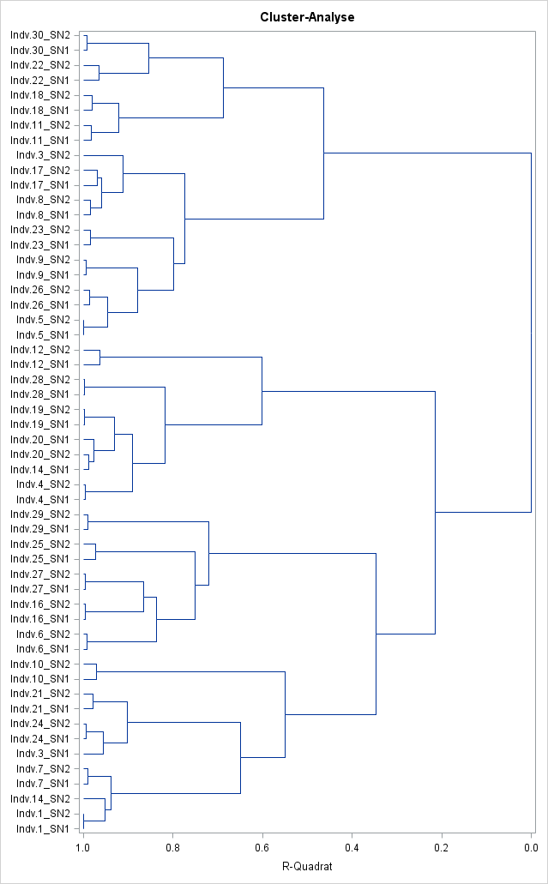

Supplementary Figure 9: Dendrogram displaying the clustering of young men based on the similarity of sleep EEG power spectra obtained from 1st and 2nd sham nights. Ward’s method was used for agglomerative clustering. Three participants had to be excluded from hierarchical cluster analysis.

References
1. Stöhr M, Riffel B, Pfadenhauer K. (1991). Neurophysiologische Untersuchungsmethoden in der Intensivmedizin. Neurophysiological assessment methods in intensive-care medicine Berlin, Heidelberg, Germany: Springer. [in German]
2. Kubicki ST, Höller L. (1980). Systematische Einteilung der EEG-Grundrhythmen und -Normvarianten. EEG-Labor 2:32–53. [in German]
2. Buysse DJ, Reynolds CF, Monk TH, Hoch CC, Yeager AL, Kupfer DJ (1991). Quantification of subjective sleep quality in healthy elderly men and women using the Pittsburg Sleep Quality Index (PSQI). Sleep 14(4):331-338.

