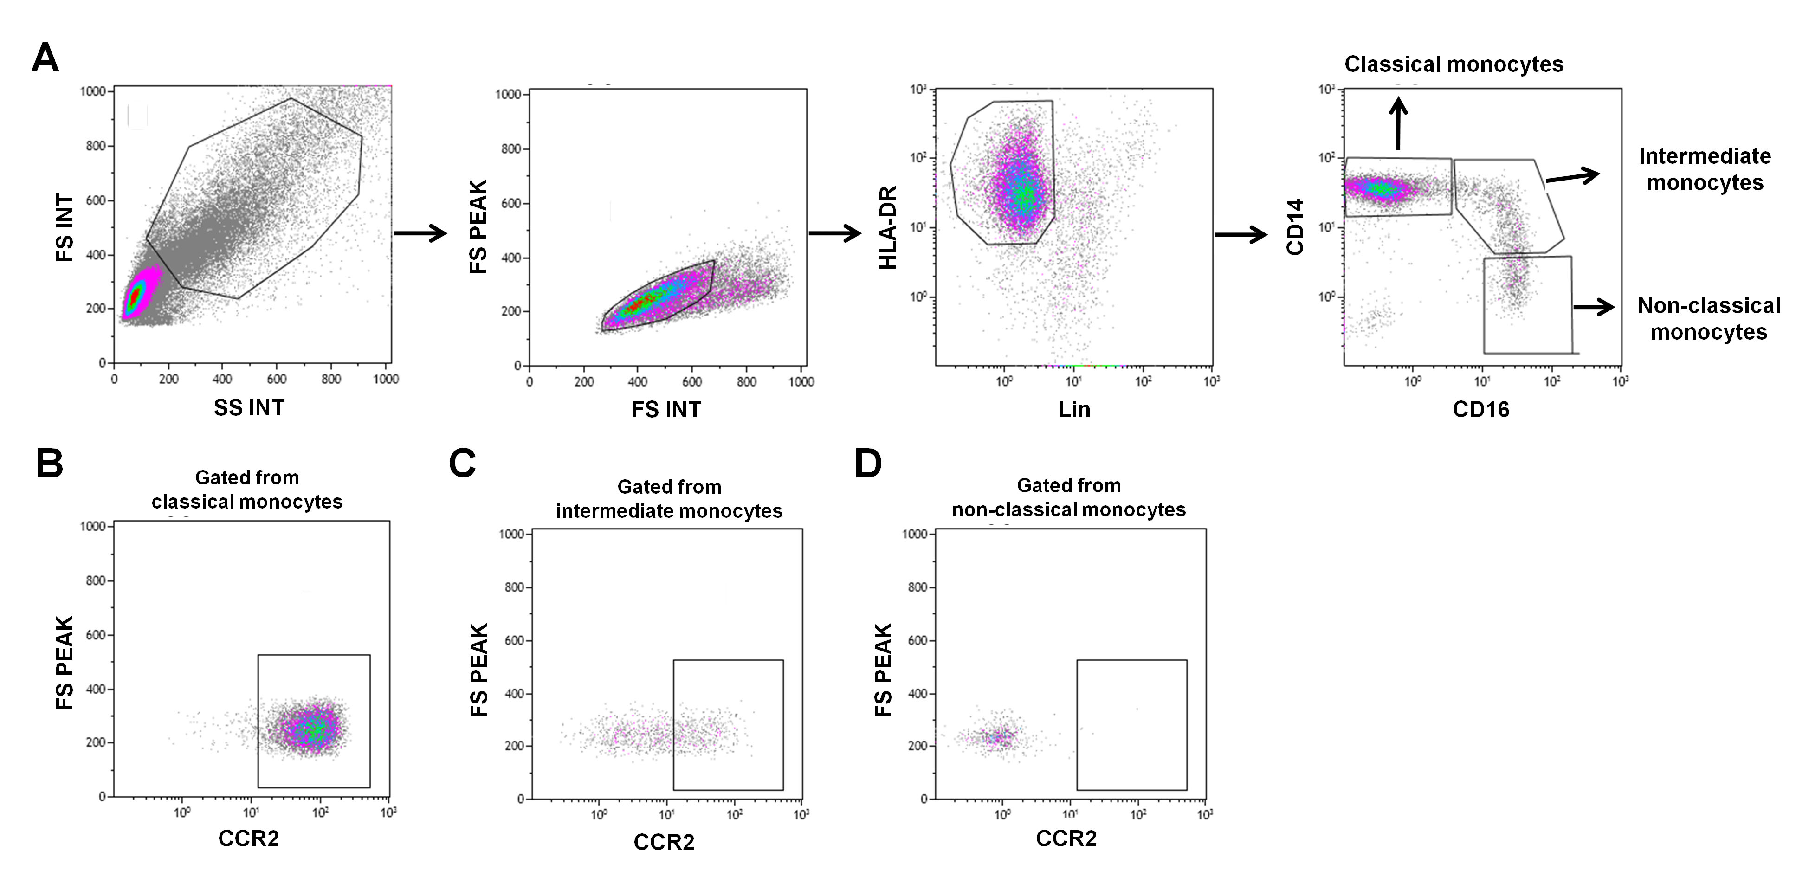
Figure S1 (A) Gating strategy to identify circulating monocyte subsets. Total Lin⁻HLA-DR⁺ cells were gated by the forward/side scatter showing Lin/HLA-DR expression patterns. Classical monocytes (CD14⁺⁺CD16⁻), intermediate monocytes (CD14⁺⁺CD16⁺) and non-classical monocytes (CD14⁺CD16⁺⁺) were gated from Lin⁻HLA-DR⁺ cells based on CD14 and CD16. Expression of CCR2 on the surface of classical (B), intermediate (C) and non-classical (D) monocytes.
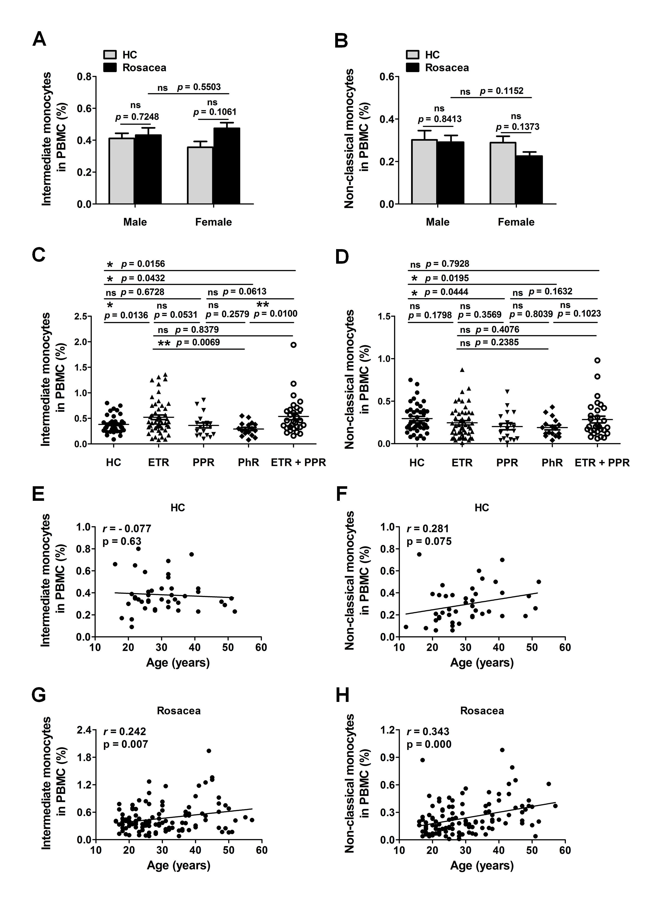
Figure S2 Frequency of intermediate and non-classical monocytes in rosacea patients and HC grouped by gender (A and B) and different subtypes (C and D), respectively. Each plot represented one sample. Significance between two groups was indicated by p value (* p < 0.05, ** p < 0.01, *** p < 0.001, ^{ns} p > 0.05). Correlation between frequency of intermediate and non-classical monocytes and age in HC (E and F) and rosacea patients (G and H). Correlation analysis were conducted using Pearson’s rank correlation coefficient. ( r: Pearson’s correlation coefficient; p: p-value).
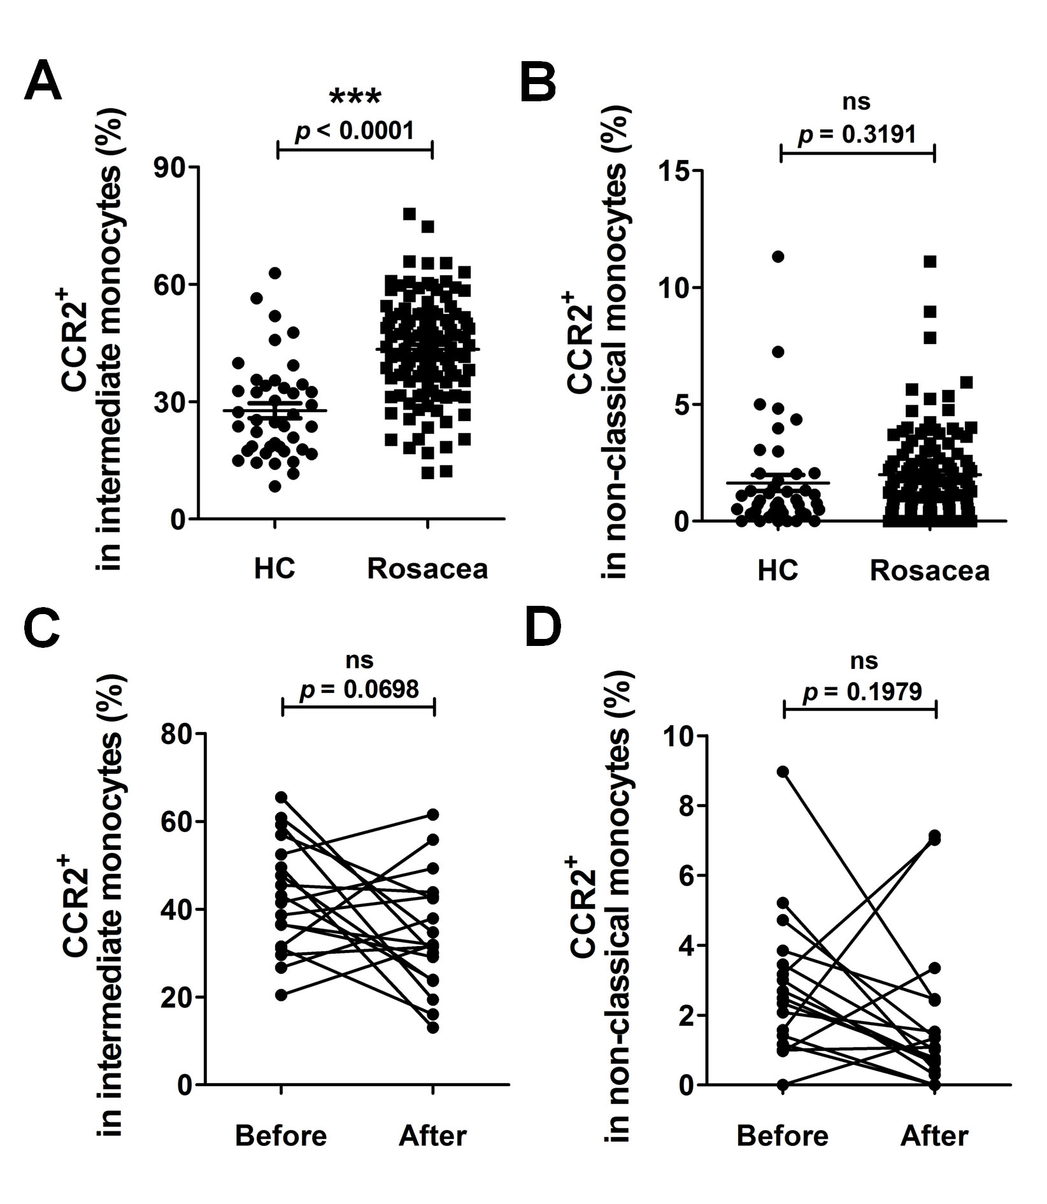
Figure S3 The percentages of CCR2⁺ among intermediate (A) and non-classical (B) monocytes of patients with rosacea and healthy controls (HC). Each plot represented individual subject. Comparisons of CCR2⁺ among intermediate (C) and non-classical (D) monocytes before and after treatment in patients with rosacea. Each plot represented an individual subject before (left) and after (right) treatment. Significance between two groups was indicated by p value (*** p < 0.001, ^{ns} p > 0.05).

