Supplement

Supplementary figure legends | p. 2
Supplementary Figure S1. Comparisons of overall survival between patients initially treated with TARE and TACE | p. 2
Supplementary Figure S2. Comparisons of progression-free survival between patients initially treated with TARE and TACE | p. 4
Supplementary Figure S3. Comparisons of intrahepatic progression-free survival between patients initially treated with TARE and TACE | p. 6
Supplementary Table S1. Follow-up imaging modalities in both groups | p. 8
Supplementary Table S2. Adjuvant or following treatments after TARE or TACE | p. 9
Supplementary Table S3. Adverse events (toxicity) | p. 10

Supplementary figure legends
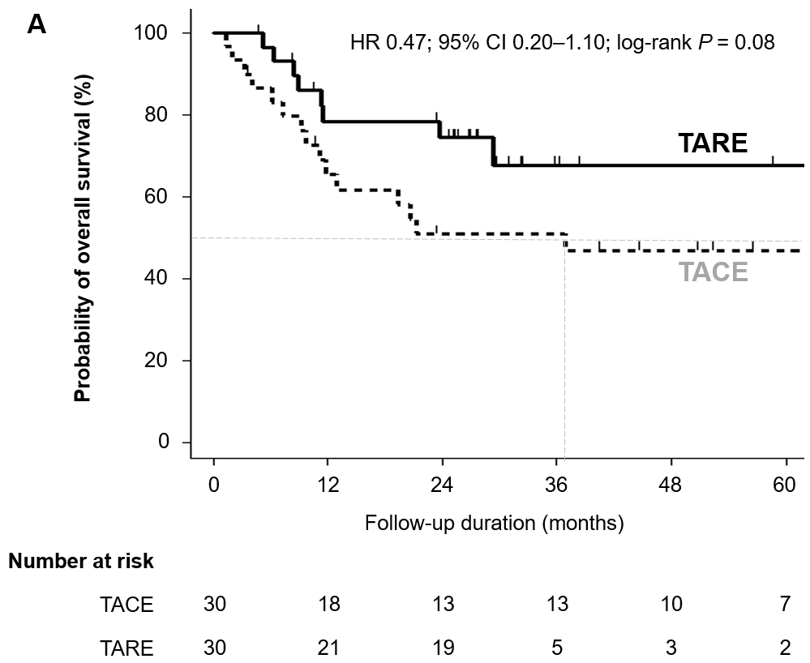
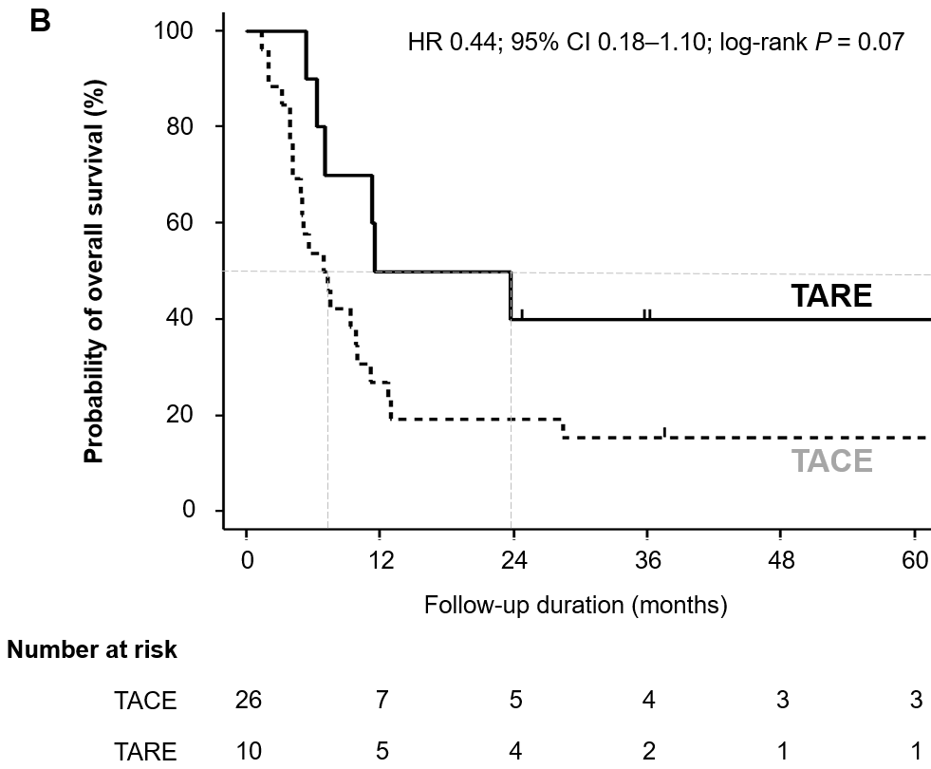
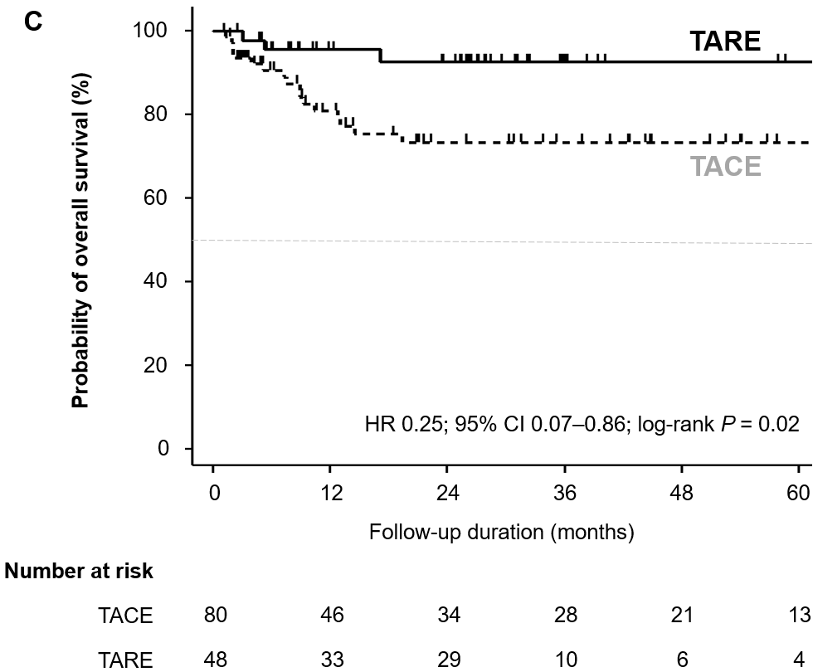
Supplementary Figure S1. Comparisons of OS between patients initially treated with TARE and TACE in (A) patients with single HCC (n=60), (B) patients diagnosed with HCC with Vp3 or Vp4 PVTT (n=36), and (C) patients who did not be treated systemic treatment during follow-up.
Abbreviations: BCLC, Barcelona Clinic Liver Cancer; OS, overall survival; PVTT, portal vein tumor thrombosis; TACE, conventional trans-arterial chemoembolization; TARE, trans-arterial radioembolization.

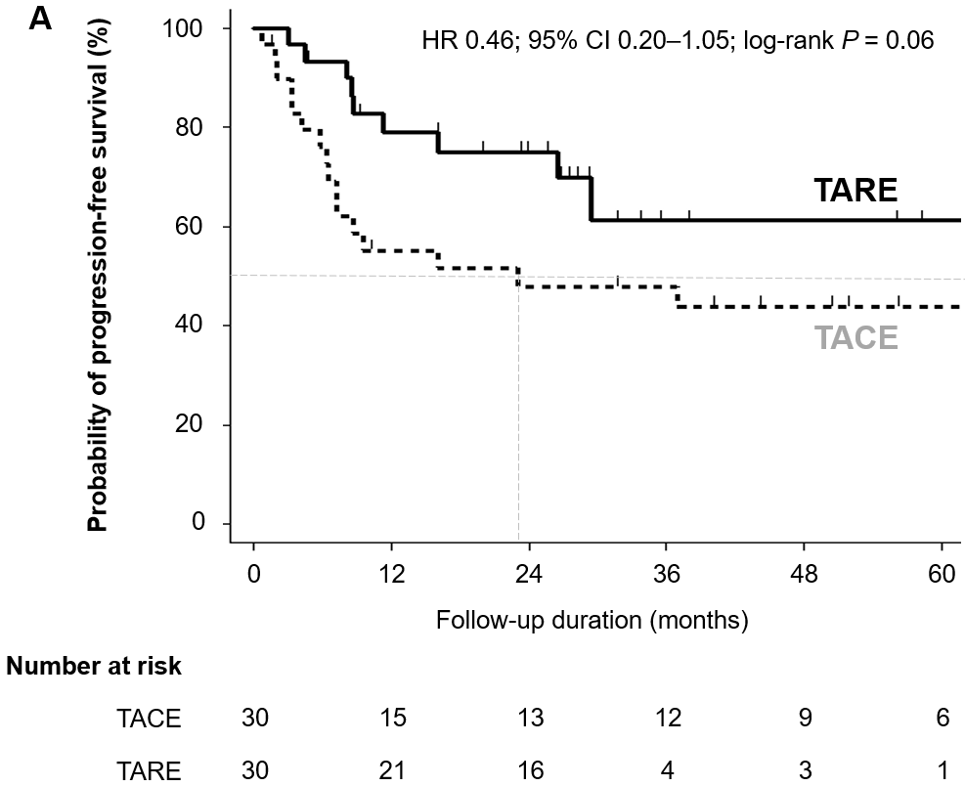
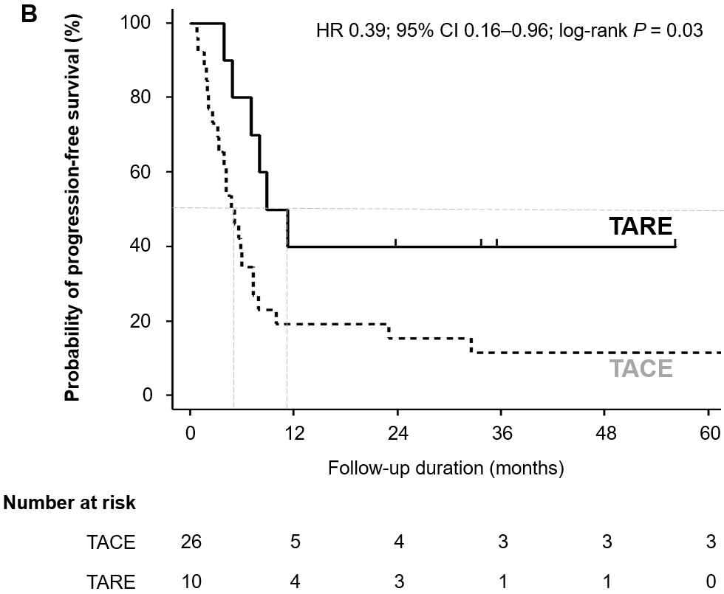
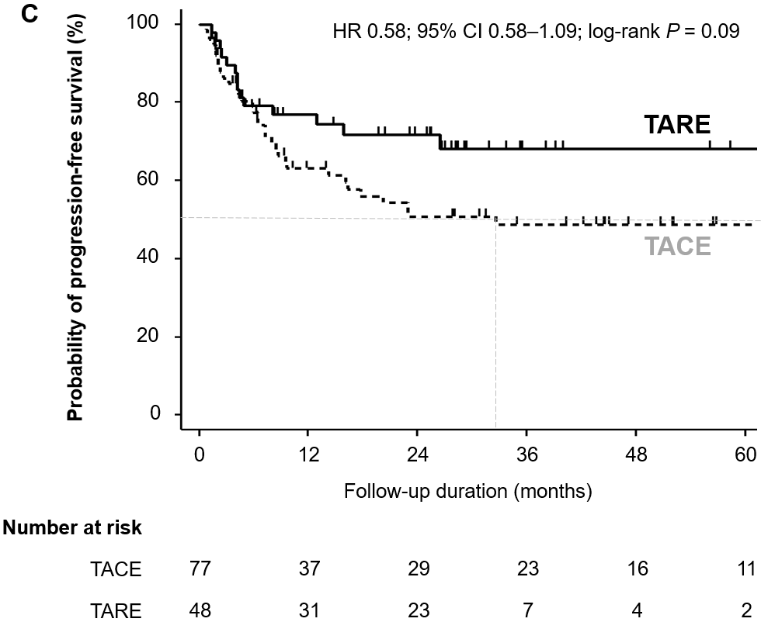
Supplementary Figure S2. Comparisons of PFS between patients initially treated with TARE and TACE in (A) patients with single HCC (n=60), (B) patients diagnosed with HCC with Vp3 or Vp4 PVTT (n=36), and (C) patients who did not be treated systemic treatment during follow-up.
Abbreviation: BCLC, Barcelona Clinic Liver Cancer; PFS, progression-free survival; PVTT, portal vein tumor thrombosis; TACE, conventional trans-arterial chemoembolization; TARE, trans-arterial radioembolization.

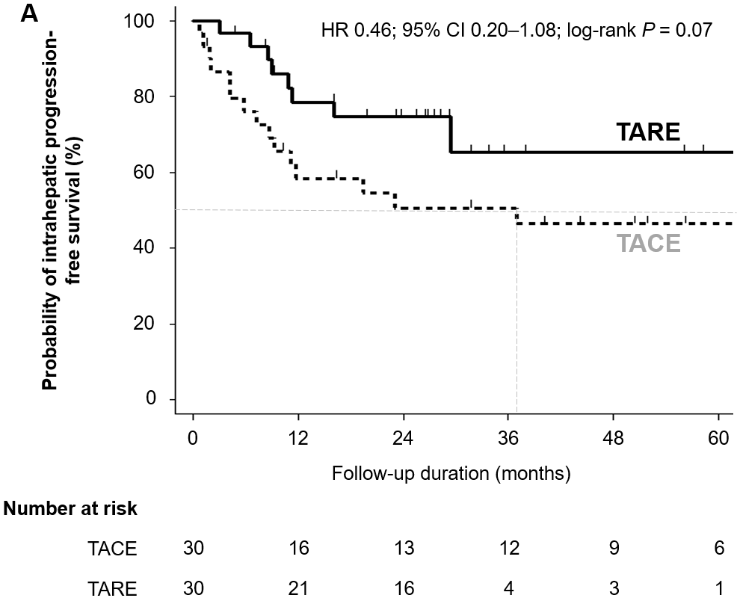
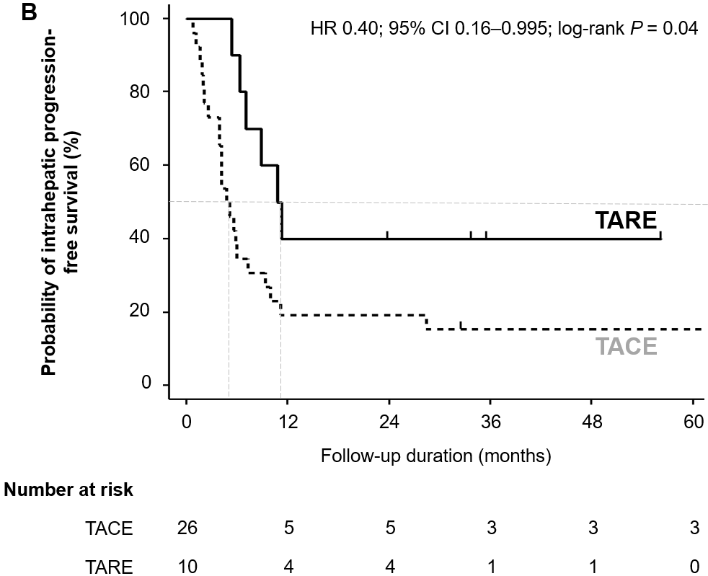
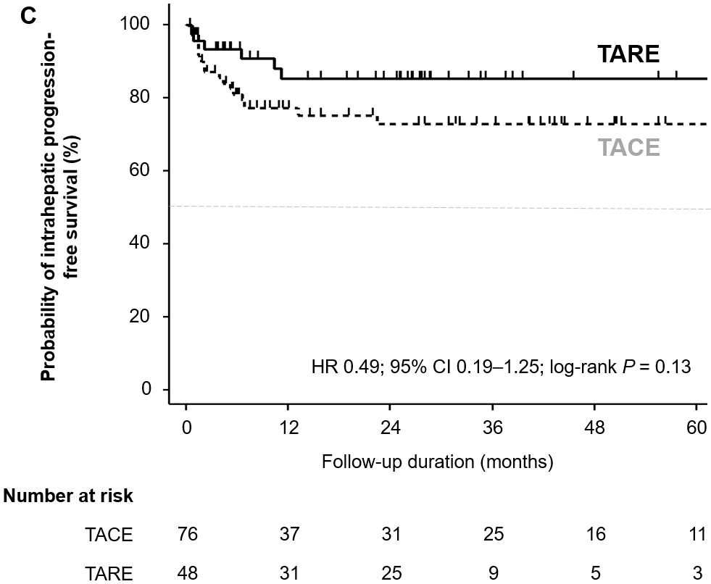
Supplementary Figure S3. Comparisons of intrahepatic PFS between patients initially treated with TARE and TACE in (A) patients with single HCC (n=60), (B) patients diagnosed with HCC with Vp3 or Vp4 PVTT (n=36), and (C) patients who did not be treated systemic treatment during follow-up.
Abbreviation: BCLC, Barcelona Clinic Liver Cancer; PFS, progression-free survival; PVTT, portal vein tumor thrombosis; TACE, conventional trans-arterial chemoembolization; TARE, trans-arterial radioembolization.

Supplementary tables
Supplementary Table S1. Follow-up imaging modalities in both groups.
 | TARE (n = 54) | TACE (n = 84)* | P value
CT | 50 (92.6%) | 73 (91.2%) | 0.79
MRI | 3 (5.6%) | 6 (7.5%)
Both | 1 (1.8%) | 1 (1.2%)
*Four patients followed up without contrast imaging due to worse clinical courses after the treatment.

Supplementary Table S2. Adjuvant or following treatments after TARE or TACE
 | TARE (n = 54) | TACE (n = 84) | P value
Adjuvant or following treatment, n (%)* | 39 (72.2%) | 71 (84.5%) | 0.08
None | 15 (27.8%) | 13 (15.5%)
TARE | 2 (3.7%) | 0 (0.0%)
TACE | 28 (51.9%) | 56 (66.7%)
RFA | 3 (5.6%) | 5 (6.0%)
Resection or LT | 5 (9.3%) | 10 (11.9%)
EBRT | 1 (1.8%) | 0 (0.0%)
* Treatments were performed for remnant or recurred tumors.
Abbreviations: EBRT, external beam radiation therapy; LT, liver transplantation; RFA, radiofrequency ablation; TACE, conventional trans-arterial chemoembolization; TARE, trans-arterial radioembolization.

Supplementary Table S3. Adverse events (toxicity)
 | TARE (n = 54) | TACE (n = 84) | P value
Clinical toxicity (grade 1 or 2), n (%) |  |  | < 0.001
Fatigue | 0 (0.0%) | 4 (4.8%)
Abdominal pain | 9 (16.7%) | 45 (53.6%)
Fever/Chill | 4 (7.4%) | 51 (60.7%)
Nausea/Vomiting | 3 (5.6%) | 19 (22.6%)
Anorexia | 0 (0.0%) | 15 (17.9%)
Diarrhea | 0 (0.0%) | 1 (1.2%)
Clinical toxicity (grade 3 or 4), n (%) |  |  | 0.24
Gastrointestinal hemorrhage | 0 (0.0%) | 2 (2.4%)
Pleural effusion or dyspnea | 0 (0.0%) | 0 (0.0%)
Unbearable pain or fever | 1 (1.8%) | 0 (0.0%)
Ascites exacerbation | 0 (0.0%) | 3 (3.6%)
Hepatic failure | 0 (0.0%) | 2 (2.4%)
Atrial fibrillation | 0 (0.0%) | 0 (0.0%)
Hepatic encephalopathy | 0 (0.0%) | 0 (0.0%)
Sepsis  Infection/Bacteremia | 0 (0.0%)  0 (0.0%) | 2 (2.4%)  3 (3.6%)
Laboratory toxicity (grade 3 or 4), n (%)* |  |  | 0.08
Elevated transaminase | 0 (0.0%) | 3 (4.2%)
Hyperbilirubinemia | 0 (0.0%) | 6 (8.4%)
Serum creatinine elevation | 0 (0.0%) | 0 (0.0%)
MELD score > 10* | 4 (7.8%) | 17 (23.9%) | 0.02
* Data during 3–6 months after TARE or TACE was used (16 missings).

