Supplementary Table 1 The Color Changing Rules of Tianfu Health Code
No. | Health code color | Given to |  | Turned into Green When
1 | Red | People with positive result of COVID-19 nucleic acid test |  | 28 days after discharging from hospital
2 | Red | Confirmed cases |  | 28 days after discharging from hospital
3 | Red | Asymptomatic cases |  | 28 days after discharging from hospital
4 | Red | Suspected cases |  | Ruled out suspicion
5 | Red | Close contacts |  | After 21 days’ quarantine with negative nucleic acid test results
6 | Red | Secondary close contacts |  | After 7 days’ quarantine with negative nucleic acid test results
7 | Red | Overseas residents | Travel to Sichuan Province | After 21 days’ quarantine with negative nucleic acid test results
8 | Red | Overseas residents | Transit to Sichuan Province | After 14 days’ quarantine with negative nucleic acid test results
9 | Red | Take the same flight/bus/train carriage |  | After 21 days’ quarantine with negative nucleic acid test results
10 | Red | Have been to high-/middle- risk domestic areas within 14 days |  | After 14 days’ quarantine with negative nucleic acid test results
11 | Yellow | Have been to the surrounding areas of high-/middle- risk areas outside of Sichuan Province within 14 days |  | Negative results in nucleic acid test, or after 14 days’ quarantine with negative nucleic acid test results
12 | Yellow | Potential close contacts of confirmed cases |  | Negative results in nucleic acid test, or after 14 days’ quarantine with negative nucleic acid test results
13 | Yellow | With COVID-19 Symptoms |  | Redeclaration of health conditions, or after 14 days’ quarantine with negative nucleic acid test results
14 | Green | Not included in abovementioned rules |  | --
Supplementary Table 2. Demographics, pregnancy related and epidemiological information, and attitude toward COVID-19 epidemic of pregnant women in quarantine during the summer outbreak of COVID-19 in Chengdu(N=71)
 | N(%)
Maternal age, years
<35 | 63(88.73%)
≥35 | 8(11.27%)
Educational background
Junior middle school and below | 10(14.08%)
Senior middle school | 20(28.17%)
University and above | 41(57.75%)
Employed or not
No | 51(71.83%)
Yes | 20(28.17%)
Monthly family income, CNY
< 5,000 | 3(4.23%)
5,000-9,999 | 13(18.31%)
10,000-49,999 | 51(71.83%)
50,000 or more | 4(5.63%)
BMI before pregnancy
<18.4 | 5(7.04%)
18.5-23.9 | 62(87.32%)
24.0-27.9 | 3(4.23%)
≥28.0 | 1(1.14%)
Gestational Trimester
First | 16(22.54%)
Second | 45(63.38%)
Third | 10(14.08%)
Ways of conception
Spontaneous pregnancy | 69(97.18%)
Assisted reproductive technology | 2(2.82%)
Parity
Nullipara | 26(36.62%)
Multipara | 45(63.38%)
Fetal number
One (singleton) | 69(97.18%)
Two or more (multiple) | 2(2.82%)
Gestational Complications¹
No | 59(83.10%)
Yes | 12(16.90%)
Infected Symptoms of COVID-19²
No | 65(91.54%)
Yes | 6(8.45%)
Health Code Color
Red | 12(16.90%)
Yellow | 51(71.83%)
Green | 8(11.27%)
Epidemiological History
From overseas | 4(5.63%)
Been to domestic middle- or high-risk areas within 14 days | 8(11.27%)
From blocked communities | 59(83.10%)
Close contact of confirmed cases | 0
Worry about being infected with COVID-19
Quite worried | 2(2.81%)
Moderately worried | 11(15.49%)
Not worried | 58(81.69%)
Optimism about the Summer Outbreak of COVID-19
Quite optimistic | 55(77.46%)
Moderately optimistic | 13(18.31%)
Not optimistic | 3(4.23%)
Satisfactory about the Healthcare Service
Quite satisfactory | 54 (76.06%)
Moderately satisfactory | 15 (21.13%)
Not satisfactory | 2(2.82%)
Note: Data are n (%). CNY, Chinese yuan.
¹Gestational complications include threatened miscarriage, preterm labor, fetal complication, placenta abnormality, hypertensive disorder, gestational diabetes mellitus, intrahepatic cholestasis, thyroid diseases (hypothyroidism).
²Infected symptoms of COVID-19 include fever or chills, cough, shortness of breath or difficulty breathing, fatigue, muscle or body aches, headache, new loss of taste or smell sore throat, congestion or runny nose, nausea or vomiting, diarrhea.
Supplementary Table3. Demographics and epidemiological information of children below 6-year-old in quarantine during the summer outbreak of COVID-19 in Chengdu(N=575)
 | N(%)
Age, years
≤1 | 93(16.17%)
1-6 | 482(83.82%)
Gender
Males | 290(50.43%)
Females | 285(49.57%)
Monthly Family Income, CNY
< 5,000 | 12(2.09%)
5,000-9,999 | 141(24.52%)
10,000-49,999 | 416(72.35%)
50,000 or more | 6(1.04%)
Infected Symptoms of COVID-19¹
No | 529(92.00%)
Yes | 46(8.00%)
Health Code Color
Red | 344(59.83%)
Yellow | 206(35.83%)
Green | 25(4.35%)
Epidemiological History
From overseas | 6(1.04%)
Been to domestic middle- or high-risk areas within 14 days | 137(23.82%)
From blocked communities | 216(37.57%)
Close contact of confirmed cases | 216(37.57%)
Note: Data are n (%). CNY, Chinese yuan.
¹Infected symptoms of COVID-19 include fever or chills, cough, shortness of breath or difficulty breathing, fatigue, muscle or body aches, headache, new loss of taste or smell sore throat, congestion or runny nose, nausea or vomiting, diarrhea.

Supplementary Table 4 The time needed to obtain the epidemiological history of patients by different methods
 | Health QR code(N=50) | Face-to-face inquiry(N=50) | P
Time(second) | 3.52±0.98 | 78.91±23.18 | ＜0.001
Note: Data are presented in the form of (mean ± SD).

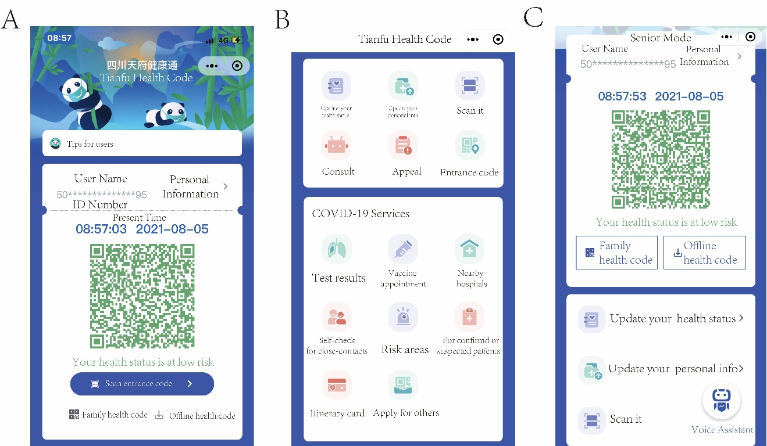
Supplementary Figure 1 Screenshots of health QR code mini program “Tianfu Health Code”
A. the main screen of Tianfu Health Pass with the green health QR code containing personal and epidemiological information.
B. the COVID-19 correlated services Tianfu Health Code provides.
C. the senior mode of Tianfu Health Code with voice assistant and larger font and icons.
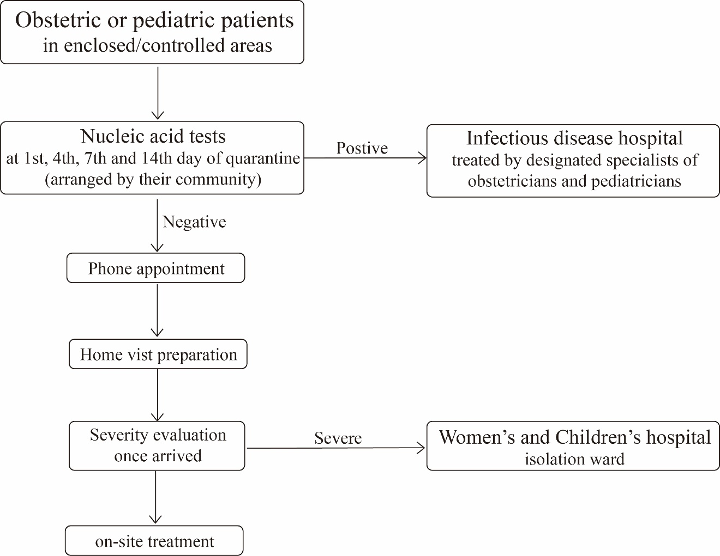
Supplementary Figure 2 The flowchart of providing healthcare for obstetric or pediatric patients in lockdown and restricted areas.

