Supplementary
Table S1. Summary of Tests Used for Each Domain of Cognition by the Trials Included in the Systematic Review (List by the priority of selection)
ISBD suggested domains | Measurements | Number of trials
Speed of processing | Trail Making Test A  Symbol coding  Category fluency: animal naming  Detection task  Token motor test  Reaction time  Serial dotting test  Finger tapping test  Go/no-go, go reaction time | 10  9  2  2  2  1  1  1  1
Attention/vigilance | Continuous Performance Test-Identical Pairs  Visual Attention Identification  RBANS-coding  Rapid Visual Processing | 4  2  1  1
Working memory | Backward digit span  Spatial span  Letter-number span  Spatial working memory  Flanker test  One back task | 12  5  4  2  1  1
(Complex) Verbal learning | RAVLT-delay recall  California Verbal Learning Test  List learning  Hopkins Verbal Learning Test  Process dissociation task | 7  4  3  2  1
Visual learning | Rey–Osterrieth complex figure test  Continuous paired associate learning  Brief Visuospatial Memory Test - Revised  One Card Learning  Visual backward masking task  Continuous Visual Memory Test | 3  2  2  2  2  2
Reasoning and problem solving | NAB®: Mazes  Iowa gambling test | 1  1
Social cognition | MSCEIT: Managing Emotions  Penn emotional acuity test | 1  1
Executive function | Trail Making Test B  Verbal fluency test  Stroop test  Wisconsin Card Sorting Test  Groton Maze learning test  Tower of London  N-back working memory task  Set shifting test | 11  10  7  5  2  2  1  1
Bold text indicates the most common test used in each domain.
Abbreviations: RBANS, Repeatable Battery for the Assessment of Neuropsychological Status; RAVLT, Rey Auditory Verbal Learning Test; NAB, Neuropsychological Assessment Battery; MSCEIT, Mayer–Salovey–Caruso Emotional Intelligence Test.

Table S2. Summary of the 21 Randomized Controlled Trials Included in the Systematic Review
Study | Mood status | Diagnosis/ Age/ mean age | Intervention treatment/ Dose | Context of Treatment As Usual (TAU) | Assessment time | Selected outcomes | Sample size  (Completed: Treatment/ control) | Number of risk of bias ª  (low/ high/ unclear)
Lu et al. 2021 | euthymic | BD-II/20-65/ 37 | 12 weeks memantine (5 mg/day) | 100% MS + 60% AD | 12 weeks | CPT; Wechsler Memory Scale | 325 (87/88) | 6/ 0/ 1
Yang et al. 2019 | euthymic | BD-I&II/ 18-55/ 28 | 10 days active or sham rTMS | 94% SGA + 100% MS | 2 weeks | TMT- A; CPT-IP; Spatial Span; HVLT; BVMT; NAB®: Mazes; MSCEIT | 52 (25/ 27) | 3/ 1/ 3
Bersani, et al. 2017 | euthymic | BD-I&II/ 18–65/ 49 | 3 weeks prefrontocerebellar tDCS (active or sham) | 86% SGA + 24% AD + 100% MS | 3 weeks | TMT-A; ROCF; TMT-B | 42 (21/ 21) | 6/ 0/ 1
Yatham et al. 2017 | euthymic | BD-I/ 19-65/ 38 | 6 weeks lurasidone adjunctive | 65% SGA + 53% AD + 80% MS | 6 weeks | TMT-A; CPT-IP; spatial span; BVMT; CVLT; TMT-B | 34 (15/ 15) | 3/ 2/ 2
Daglas, et al. 2016 | euthymic | BD-I/ 15-25/ 21 | quetiapine or lithium monotherapy as maintenance treatment 12‐month follow‐up | - | 12 months | TMT-A; IDN; digit span; RAVLT; TMT-B; verbal fluency | 34 (17/ 17) | 3/ 1/ 3
Miskowiak et al. 2014 | euthymic | BD/ 18-65/ 41 | 8 weekly EPO (40,000 IU) | 23% SGA + 47% AD + 93% MS | 14 weeks | TMT-A; RVP; letter number sequence; RAVLT; TMT-B; verbal fluency | 44 (23/ 20) | 7/ 0/ 0
Rakofsky et al. 2014 | euthymic | BD-I&II / 18-65/ NR | quetiapine XR for 6 weeks | 100% MS | 6 weeks | Symbol coding; CPT-IT; digit span; list learning; verbal fluency | 23 (5/ 9) | 1/ 0/ 6
Chengappa et al. 2013 | euthymic | BD-I&II/ 18-65/ 46 | 8 weeks adjunctive herb Withania somnifera (WSE) or placebo | 60% SGA + 62% AD + 62% MS | 8 weeks | strategic target detection test; finger tapping tests; auditory digit span; word list memory test; Penn emotional acuity test | 53 (24/ 29) | 6/ 0/ 1
Dean et al. 2012 | euthymic | BD/ NR/ 45 | Adjuvant 2000 mg/day of NAC or placebo6 for 6 months | 39% SGA + 63% AD + 83% MS | 6 months | TMT-A; digit span; word learning; TMT-B; verbal fluency | 75 (5/ 12) | 7/ 0/ 0
McIntyre et al. 2012 | euthymic | BD-I&II/ NR/ 40 | adjunctive intranasal insulin 40 IU or placebo for 8 weeks | 31% SGA + 46% AD + 62% MS | 8 weeks | TMT– A; Visual Backward Masking Test; CVLT; TMT– B; Category Fluency | 62 (34/ 28) | 5/ 0/ 2
Ghaemi et al. 2009 | euthymic | BD/18-60/ 46 | 8-24 mg/d galantamine augmentation for 3 months | NR | 3 months | TMT-A; CVLT; TMT-B; category fluency | 30 (6/ 10) | 4/ 1/ 2
Kocsis et al. 1993 | euthymic | BD/ >18/ 54 | Li vs. placebo cross over for 2 weeks | - | 2 weeks | Finger tapping; word recall; word association | 46 (46) | 3/ 1/ 3
Shaw et al. 1987 | euthymic | BD/ >18/ 51 | Li vs. placebo cross over for 2 weeks | - | 2 weeks | Finger tapping; word recall | 22 (22) | 2/ 1/ 4
Mansu et al. 2021 | depressive | BD-I&II/ 18-65/ 47 | weeks 0 (baseline), 2, 6 for intravenous infliximab (5 mg/kg) | 70% SGA + 66% AD + 73% MS | 12 weeks | Digit Symbol Substitution Test | 33 (15/18) | 5/ 1/ 1
Kauer-Sant'Anna et al. 2019 | depressive | BD-I&II/ >18/ 43 | 24 weeks Tianeptine (37.5 mg/day) | 20% SGA + 100% MS | 24 weeks | CVLT; Letter-number sequencing; Digit span | 69 (24/23) | 6/ 0/ 1
Myczkowski et al. 2018 | resistant bipolar depression | BD-I&II/ 18-65/ 41 | 20 sessions of high active or sham rTMS | 33% SGA + 100% MS | 8 weeks | TMT A; digit span; RAVLT; ROCF; Iowa gambling task; TMT-B; verbal fluency | 43 (20/ 23) | 7/ 0/ 0
Toniolo et al. 2017 | depressive | BD-I&II/ 18-59/ 44 | 6‐week adjunctive creatine monohydrate 6 g/ d | 50% SGA + 44% AD + 100% MS | 6weeks | Digit Span; ROCF; Verbal Fluency | 18 (9/9) | 6/ 0/ 1
Hu et al. 2016 | depressive | BD-II/ NR/ 26 | (i) left high‐frequency, (ii) right low‐frequency (iii) sham stimulation, and underwent four‐week rTMS with quetiapine concomitantly. | 100% SGA (quetiapine) | 4 weeks | TMT-A; TMT-B | 38 (11/ 11/ 12) | 3/ 0/ 4
Young et al. 2004 | depressive | BD/ 18-65/ 49 | corticosteroid receptor antagonist mifepristone vs placebo cross over for one week | 55% SGA + 65% AD + 85% MS | 3 weeks | digit symbol; digit span; RAVLT; fluency test | 20 (19) | 2/ 0/ 5
Perlis et al. 2006 | manic | BD-I/ NR/ 38 | olanzapine vs. risperidone for 3 weeks | - | 3 weeks | Cognitive Test for Delirium | 329 (129/ 121) | 4/ 0/ 3
Shi et al. 2004 | manic | BD-I/ 18-70/ 39 | Olanzaplne vs placebo for 3 weeks | - | 3 weeks | PANSS-cognitive score | 254 (124/ 120) | 5/ 1/ 1
ª Assessed with the Cochrane risk-of-bias tool for randomized controlled trials.
Abbreviations: BD-I, bipolar disorder, type I; BD-II, bipolar disorder, type II; NR, no report; SGA, second-generation antipsychotics; AD, anti-depressants; MS, mood stabilizers; TMT- A/B, Trail Making Test A/B; CPT-IP, Continuous Performance Test-Identical Pairs; HVLT, Hopkins Verbal Learning Test; BVMT, Brief Visuospatial Memory Test; NAB, Neuropsychological Assessment Battery; MSCEIT, Mayer–Salovey–Caruso Emotional Intelligence Test; ROCF, Rey–Osterrieth complex figure test; CVLT, California Verbal Learning Test; IDN, Detection task; RAVLT, Rey Auditory Verbal Learning Test; RVP, Rapid Visual Processing; PANSS, Positive and Negative Syndrome Scale.
Figure S1. Outcomes of Network Meta-Analysis for Adjunctive Interventions across Domains in Patients with Euthymic Bipolar Disorder: network and forest plot
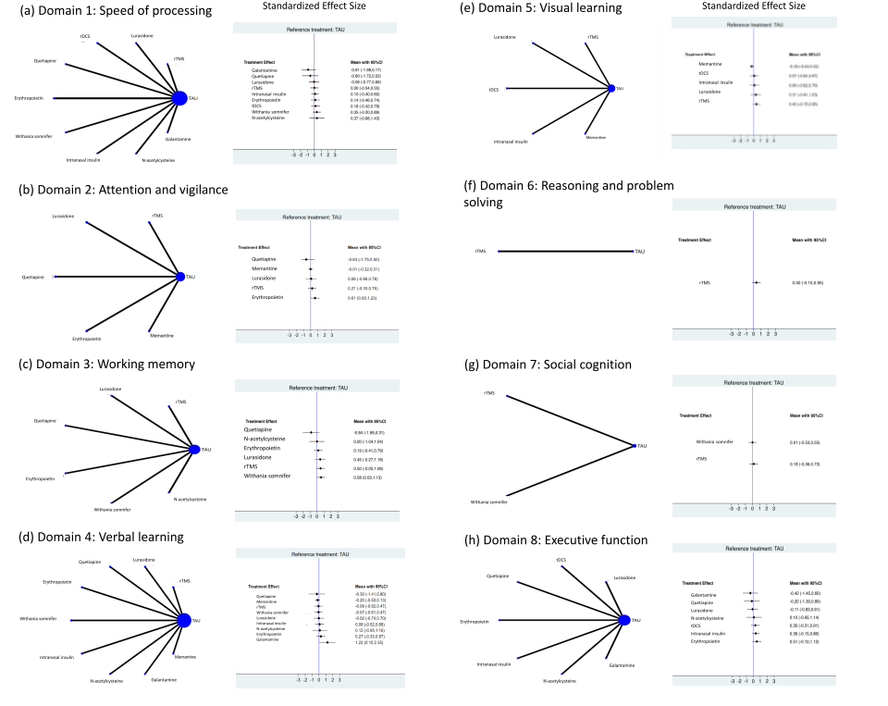

(a) Outcome of speed of processing. (b) Outcome of attention and vigilance. (c) Outcome of working memory. (d) Outcome of verbal learning. (e) Outcome of visual learning. (f) Outcome of reasoning and problem solving. (g) Outcome of social cognition. (h) Outcome of executive function.
The size (area) of the nodes is proportional to the number of patients in each intervention. Line widths are proportional to the number of patients in trials including direct comparisons between the nodes. The right parts of the forest plots indicate the standardized mean differences for each study in direct comparisons with treatment as usual.
Abbreviations: TAU, treatment as usual; rTMS, repetitive transcranial magnetic stimulation; tDCS, transcranial direct current stimulation.

Figure S2. Outcomes of Network Meta-Analysis for Adjunctive Interventions across Domains in Patients with Euthymic Bipolar Disorder: Surface Under the Cumulative Ranking Area (SUCRA)
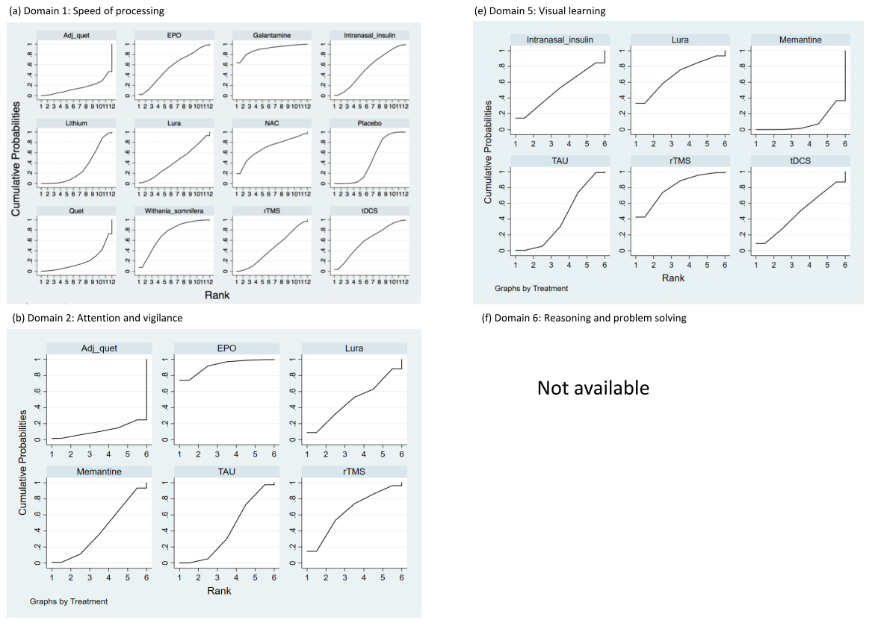
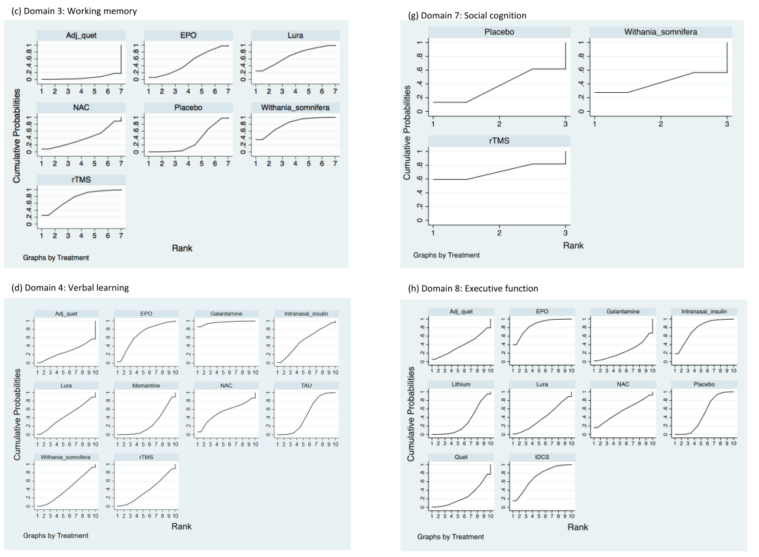
(a) Outcome of speed of processing. (b) Outcome of attention and vigilance. (c) Outcome of working memory. (d) Outcome of verbal learning. (e) Outcome of visual learning. (f) Outcome of reasoning and problem solving. (g) Outcome of social cognition. (h) Outcome of executive function.

Figure S3. Outcomes of Network Meta-Analysis for Adjunctive Interventions across the Domains in Patients with Bipolar Disorder under Depressive Episode
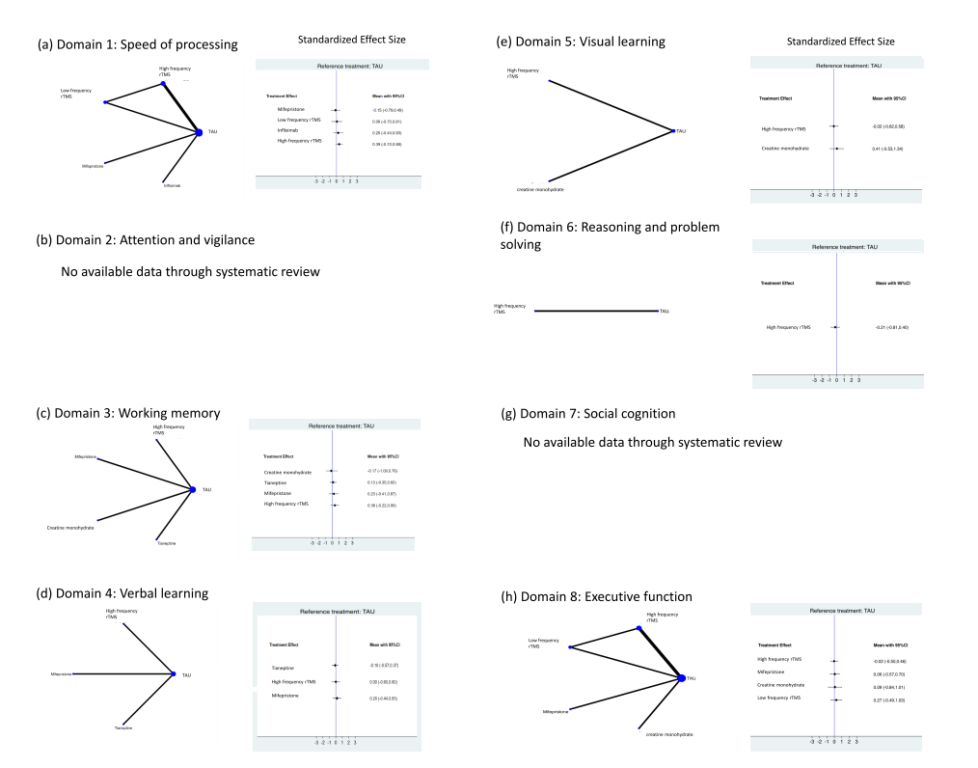
(a) Outcome of speed of processing. (b) Outcome of attention and vigilance. (c) Outcome of working memory. (d) Outcome of verbal learning. (e) Outcome of visual learning. (f) Outcome of reasoning and problem solving. (g) Outcome of social cognition. (h) Outcome of executive function.

The size (area) of the nodes is proportional to the number of patients in each intervention. Line widths are proportional to the number of patients in trials including direct comparisons between the nodes. The right parts of the forest plots indicate the standardized mean differences for each study in direct comparisons with treatment as usual.
Abbreviations: TAU, treatment as usual; rTMS, repetitive transcranial magnetic stimulation.

