SEM/EDX analysis

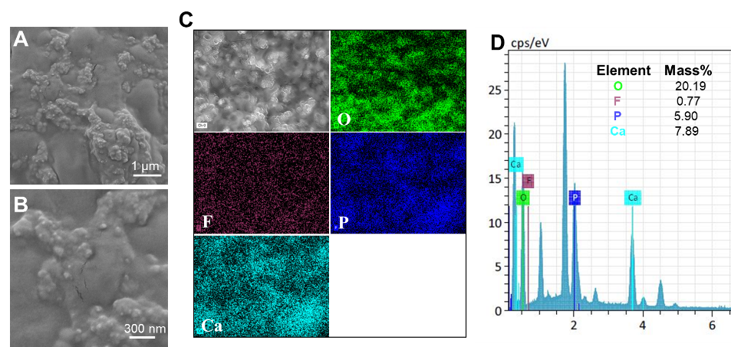
Figure S1 A, B) SEM images of GC Tooth Mousse Plus. B: is a magnified picture of a region from A.
C) EDX mapping and (D) EDX spectra of GC Tooth Mousse Plus.

pH buffering capacity of GC Tooth Mousse Plus®
The 500 mg of GC Tooth Mousse Plus was individually immersed in 20 ml of artificial saliva at pH 4.5 (AS4.5) and at pH 7 (AS7). The pH value of immersion solution was monitored by a FiveEasy Plus pH meter (Mettler Toledo) at 0, 2, 4, 8, 12 and 24 h.
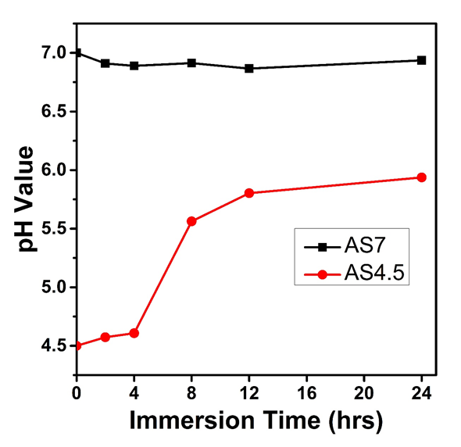
Figure S2 pH buffering capacity of the GC Tooth Mousse Plus upon immersion in AS4.5 and AS7. Abbreviation: AS4.5, artificial saliva at pH 4.5; AS7, artificial saliva at pH 7.0.

F ion release measurement

The 500 mg of GC Tooth Mousse Plus was immersed in 20 ml of NaCl solution (133 mmol/L) buﬀered with 50 mmol/L HEPES (pH=7.0, 37 ºC).³⁵ The concentration of F ions released from the Tooth Mousse was measured at 0, 2, 4, 8, 12 and 24 h. The rest of the analysis proceeds as before.
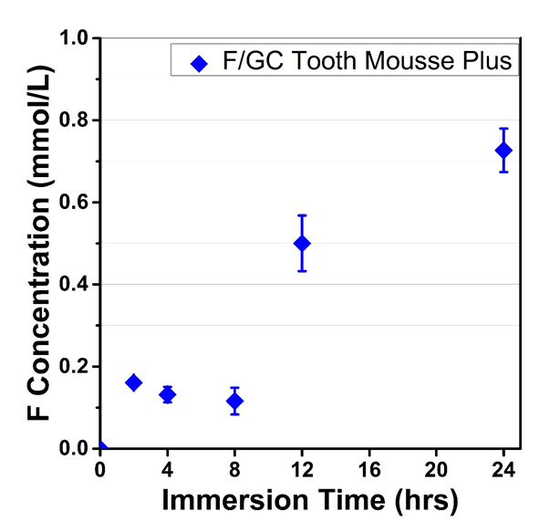
Figure S3 F ion release potential of GC Tooth Mousse Plus when immersed in buffered sodium
chloride solution (133 mmol/L, pH 7.0).

