Supplementary Material:
E7 targeting nanotherapy for HPV related cervical lesions using CRISPR/Cas9 and poly (beta-amino ester)
Nanotherapy for cervical lesions
Supplementary Figures:
SFigure 1. Characterization of NPs. (A) ¹H NMR spectra of PBAE546 (B-C) TME imaging of PBAE546/GFP NPs (weight ratio 60:1). (B) Scale bar, 1 μm. (C) Scale bar, 400 nm.

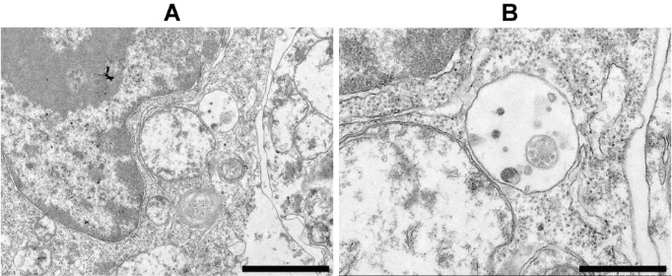
SFigure 2. Transmission electron microscopy (TEM) imaging of 293 cells transfected with PBAE546/GFP NPs. NPs were in cytoplasmic vesicles, indicating endocytosis. (A) Scale bar, 2 μm. (B) Scale bar, 200 nm.

SFigure 3. Comparison of the uptake of NPs with different weight ratios, time points after treatment and doses of RFP in the cervixes of C57BL/6 female mice. Representative fluorescence images of the uterine cervixes of C57BL/6 mice treated (A) with different weight ratios (PBAE546/RFP, 10 μg RFP once a day for 3 days), (B) at different time points after treatment (PBAE546/RFP, weight ratio 60:1, 10 μg RFP once a day for 3 days), and (C) with different doses of RFP (PBAE546/RFP, weight ratio 60:1, once a day for 3 days).

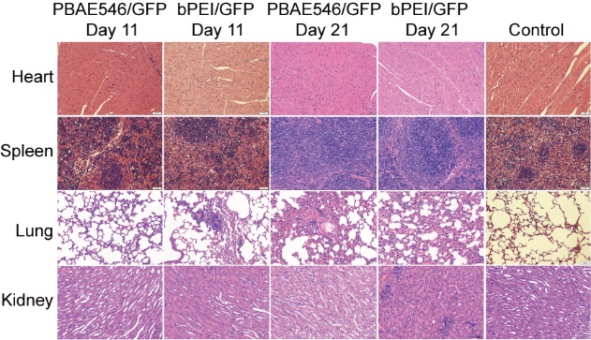
SFigure 4. Toxicity of NPs in the organs of mice that were vaginally treated with NPs. Representative H&E staining images of the hearts, spleens, lungs and kidneys of mice whose vaginas were implanted with NPs via pipetting. The NPs consisted of 546/pcDNA3.1 (weight ratio 60:1) or bPEI/pcDNA3.1 (weight ratio 3:1). NPs carrying 10 µg of the plasmid were pipetted into the vaginas of the mice once per day for 20 days, and the organs were harvested on the 11th and 21st days after the initial administration. Scale bars, 50 µm.

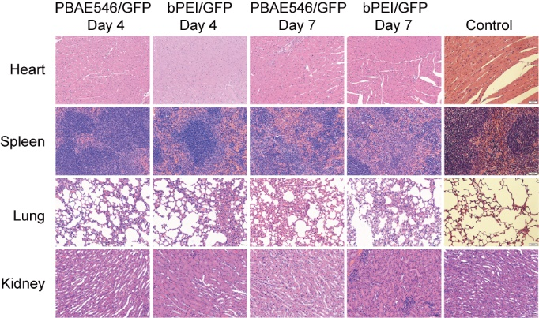
SFigure 5. Toxicity of NPs in the organs of mice whose thigh muscles were injected with NPs. Representative H&E staining images of the hearts, spleens, lungs and kidneys of mice whose thigh muscles were injected with NPs. The NPs consisted of 546/pcDNA3.1 (weight ratio 60:1) or bPEI/pcDNA3.1 (weight ratio 3:1). NPs carrying 100 µg of the plasmid were injected into the thigh muscles of the once per day for 3 days, and the organs were harvested on the 4th and 7th days after the initial administration. Scale bars, 50 µm.

SFigure 6. HPV16 E7-targeting ability of NPs in HeLa (HPV16-negative, HPV18 positive) cells in vitro and in vivo. (A) The viability of HeLa cells was determined at 0, 24, 48 and 72 hours after HPV16 E7-targeting NP treatment by the CCK-8 assay (546/CRISPR gRNA1-3, weight ratio 60:1). (B) HeLa cells were injected subcutaneously into the right hind limb of BALB/c-nu mice. HPV16 E7-targeting NPs (546/CRISPR plasmid, weight ratio 60:1，60 μg plasmid every 4 days) were injected intratumorally when the xenografts reached approximately 35 mm³. The subcutaneously formed tumors were photographed, and (C) the estimated sizes were measured after treatment with NPs. The data represent the mean ± SD (n =3). One-way ANOVA was used for statistical analysis, N.S.: no significant difference.

Supplementary Table 1. sgRNA sequences.
Name | gRNA sequence (5’-3’) | PAM sequence (5’-3’)
HPV16E7 sgRNA1 | TTCCTAGTGTGCCCATTAAC | AGG
HPV16E7 sgRNA2 | ATATTGTAATGGGCTCTGTC | CGG
HPV16E7 sgRNA3 | TACTTTGGAAGACCTGTTAA | TGG

