Supplemental Figure 1: Log plot evaluating the relationship between neutrophil to lymphocyte ratio (NLR) (A), platelet to lymphocyte ratio (PLR) (B), aspartate aminotransferase to lymphocyte ratio (ALRI) (C) and systemic-inflammation index (SII) (D) and alpha fetoprotein (AFP).
Supplemental Figure 1a
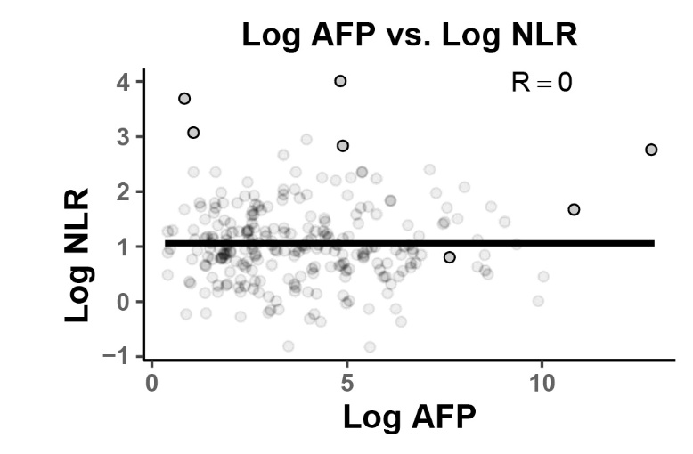

Supplemental Figure 1b
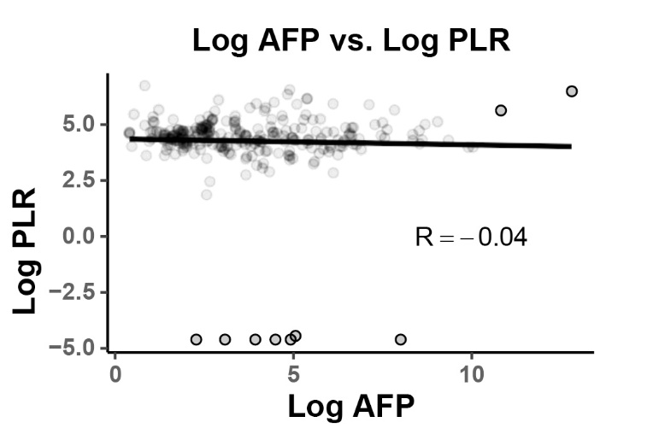
Supplemental Figure 1c
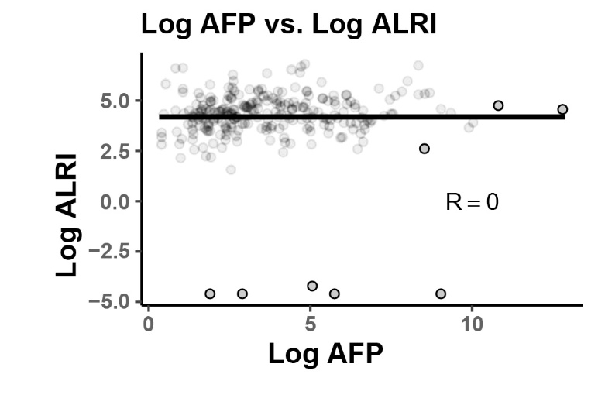

Supplemental Figure 1d
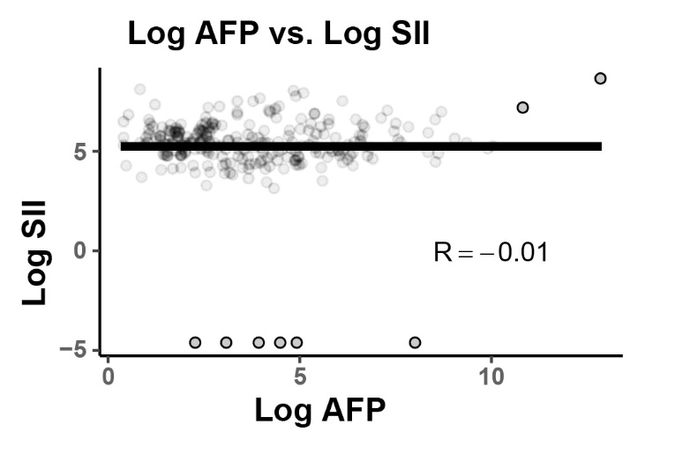

Supplemental Figure 2: Log plot evaluating the relationship between neutrophil to lymphocyte ratio (NLR) (A), platelet to lymphocyte ratio (PLR) (B), aspartate aminotransferase to lymphocyte ratio (ALRI) (C) and systemic-inflammation index (SII) (D) and tumor size.
Supplemental Figure 2a
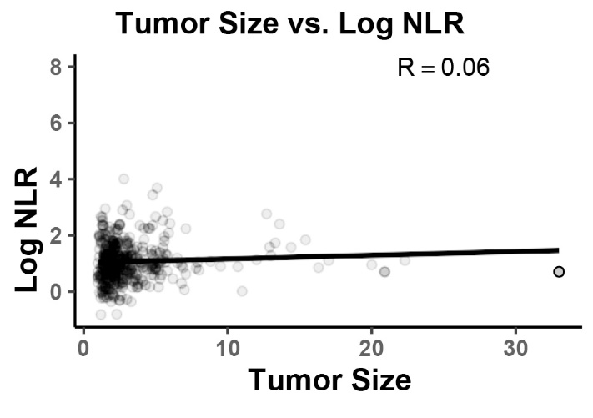
Supplemental Figure 2b
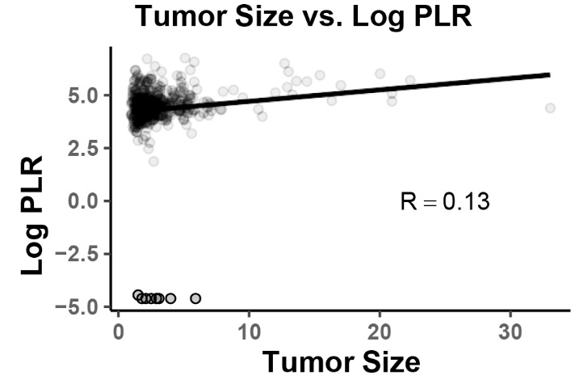

Supplemental Figure 2c
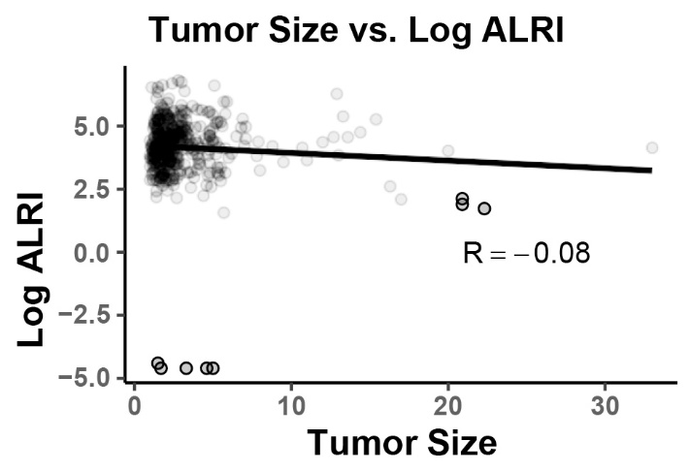
Supplemental Figure 2d
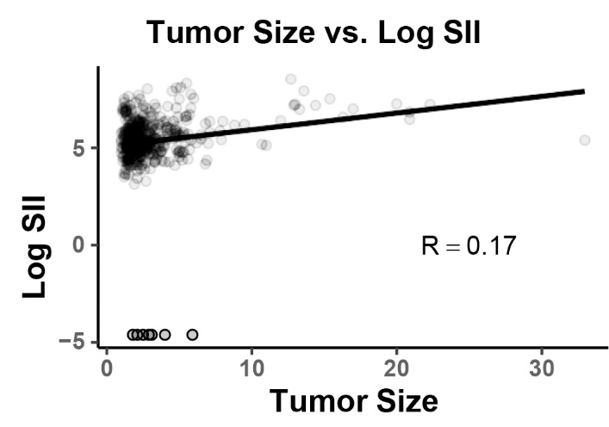

Supplemental Figure 3: Box and whisker diagram evaluating the relationship between neutrophil to lymphocyte ratio (NLR) (A), platelet to lymphocyte ratio (PLR) (B), aspartate aminotransferase to lymphocyte ratio (ALRI) (C) and systemic-inflammation index (SII) (D) and cause of cirrhosis.
Supplemental Figure 3a
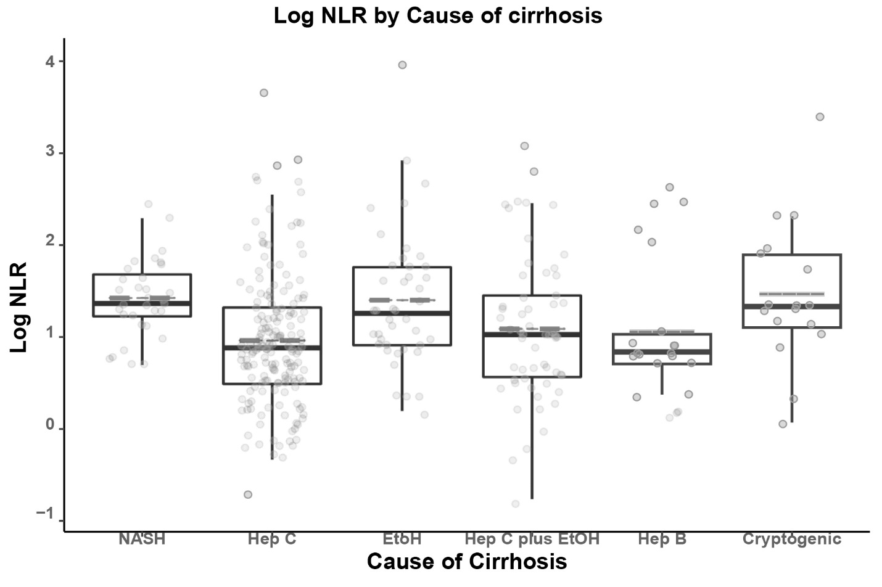

Supplemental Figure 3b
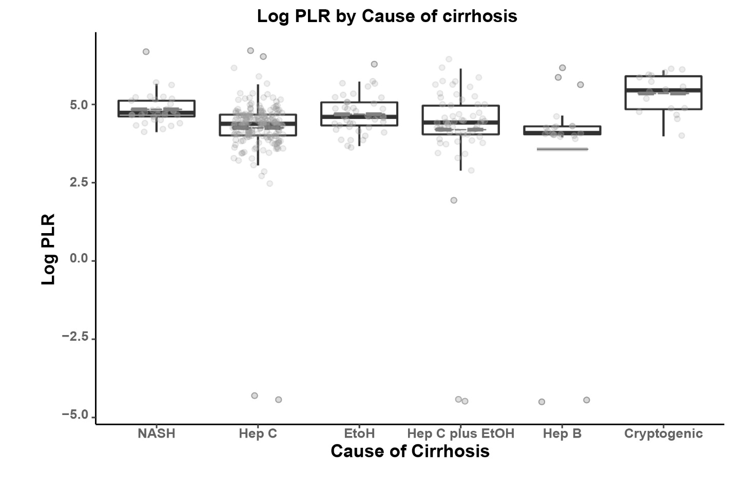

Supplemental Figure 3c
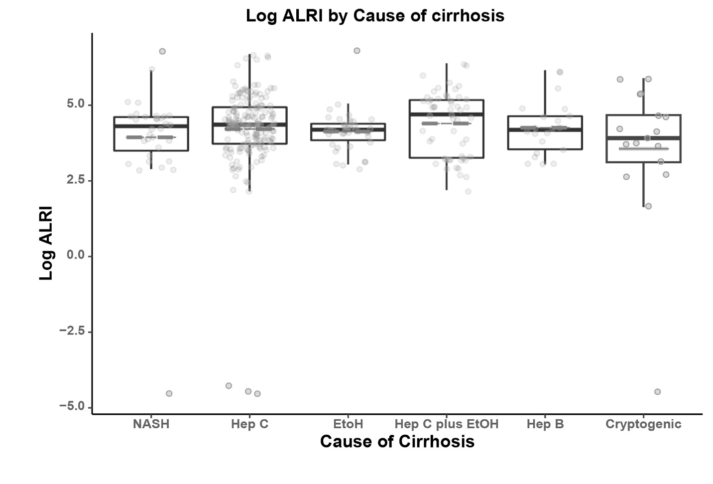

Supplemental Figure 3d
