Appendix

Appendix Table1 List of 35 variables for frailty index

Number | Items | No Frailty | Frailty risk
General information
1 | Weight | Normal | Decline
2 | Diet | Normal | Loss of appetite
3 | Sleep | Normal | Abnormal
4 | Stool | Normal | Diarrhea / constipation / fecal incontinence, etc
5 | Urinate | Normal | Frequent urination / incontinence / poor urination
6 | Spirit | Normal | Poor
Symptom
7 | Cough | No | Yes
8 | Expectoration | No | Yes
9 | Hemoptysis / bloody sputum | No | Yes
10 | Chest tightness | No | Yes
11 | Shortness of breath / dyspnea | No | Yes
12 | Chest pain | No | Yes
13 | Headache | No | Yes
14 | Pain in other parts | No | Yes
15 | Dizzy | No | Yes
16 | Weakness | No | Yes
17 | Fever | No | Yes
Sign
18 | Edema of both lower limbs | No | Yes
Past medical history
19 | Hypertension | No | Yes
20 | Coronary heart disease | No | Yes
21 | Other heart diseases | No | Yes
22 | Chronic obstructive pulmonary disease | No | Yes
23 | Asthma | No | Yes
24 | Other lung diseases | No | Yes
25 | Gastrointestinal diseases | No | Yes
26 | Liver diseases | No | Yes
27 | Other digestive system diseases | No | Yes
28 | Diabetes | No | Yes
29 | Thyroid disease | No | Yes
30 | Other endocrine diseases | No | Yes
31 | Kidney disease | No | Yes
32 | Urinary tract diseases | No | Yes
33 | Nervous system diseases | No | Yes
34 | Immune system diseases | No | Yes
35 | Bone and joint diseases | No | Yes

Appendix Table 2 Effects of per 0.1 and per 1 SD eFI on all outcomes
Outcome | Frailty index  (Per 0.1 increasement)  Full-adjusted model | Frailty index  (Per 1 SD increasement)†  Full-adjusted model
All cause motility  (HR; 95%CI) | 1.18(1.06, 1.32) | 1.13(1.04, 1.22)
Infection  (OR; 95%CI) | 1.55(1.14, 2.10) | 1.37(1.10, 1.71)
Bone suppression  (OR; 95%CI) | 1.25(0.96, 1.63) | 1.17(0.97, 1.42)
Discontinuation  (OR; 95%CI) | 1.02(0.51, 2.04) | 1.02(0.62, 1.67)
Impaired liver function (OR; 95%CI) | 1.10(0.76, 1.61) | 1.07(0.82, 1.41)
Gastrointestinal event (OR; 95%CI) | 1.13(0.73, 1.74) | 1.09(0.80, 1.49)
Length of hospitalization (Days)  (Median difference; 95%CI) | 0.88(-1.28, 3.04) | 0.63(-0.85, 2.77)
Footnote: eFI= electronic frailty index †The standard deviation of frailty index is 0.0719.
Appendix Figure 1. Aadjusted OS normogram based on eFI
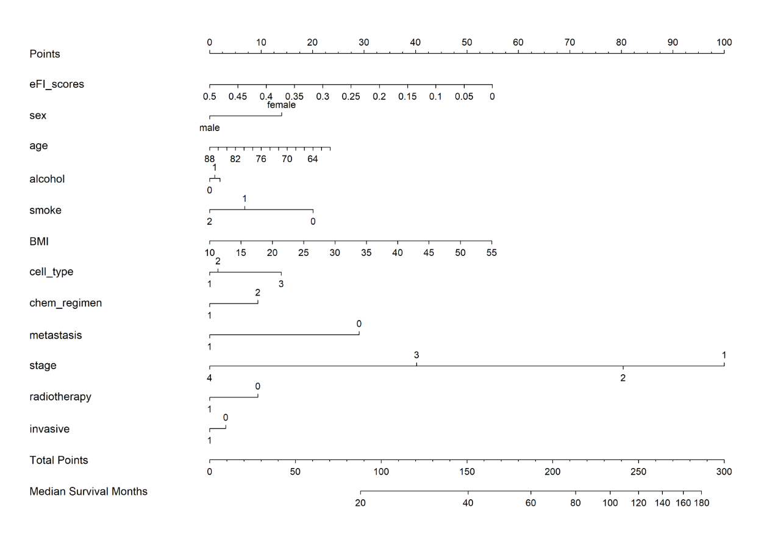
Footnote: OS=overall survival, eFI= electronic frailty index, alcohol (always=1, never=2, sometimes=3), Smoke (1=non-smoker, 2=former smoker, 3=current smoker=), cell-type (squamous=1, carcinoma=2, small cell carcinoma=3), chem-regimen (1=single, 2=combination), metastasis, radiotherapy, invasive examination(0=no,1=yes). clinical stage (1= I,2= II, 3= III, 4= IV).

