Figure S1. Genomic landscape of TCGA EC cohort. The type of alterations was indicated by color. Each column represented one patient.

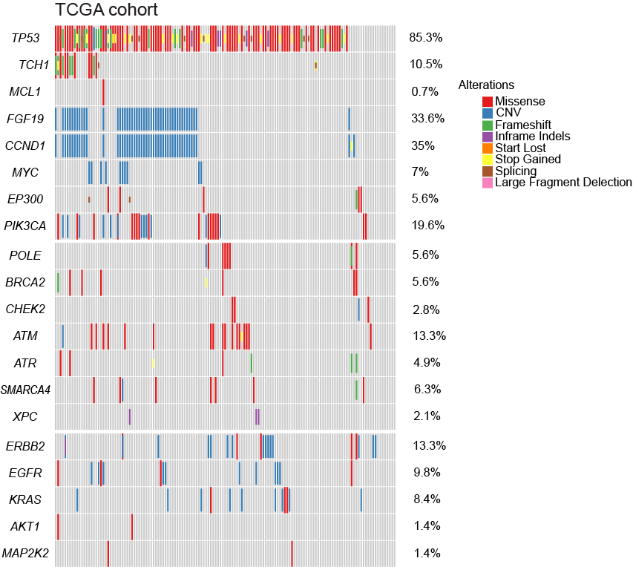

Figure S2. Overall survival of patients according to TNM staging of AEC cohort.
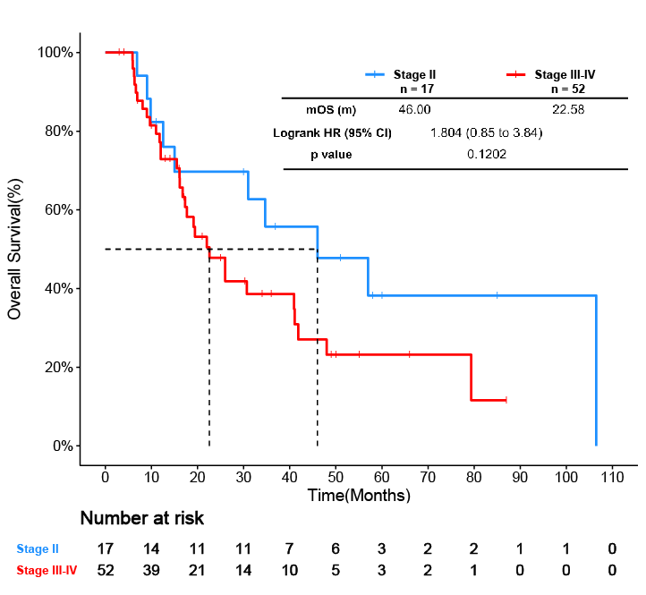

Figure S3. Overall survival of patients according to altered TP53 gene of AEC cohort.

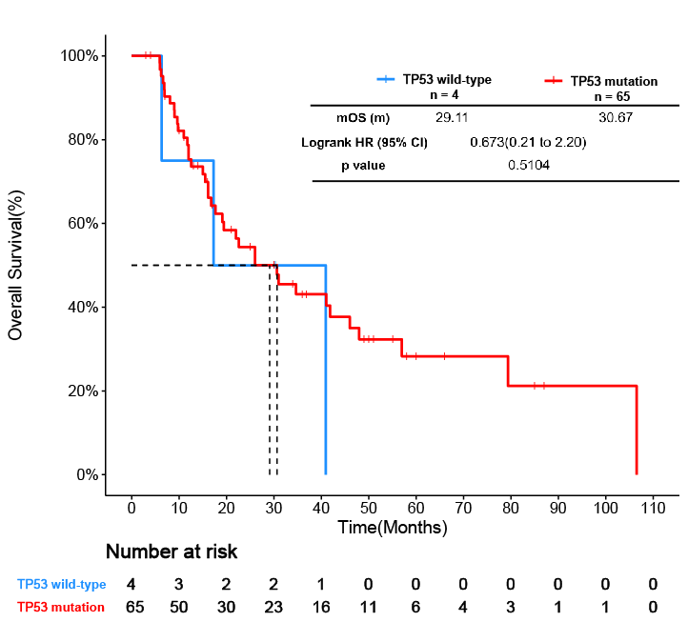

Figure S4. Overall survival of patients according to DNA damage gene status of AEC cohort.
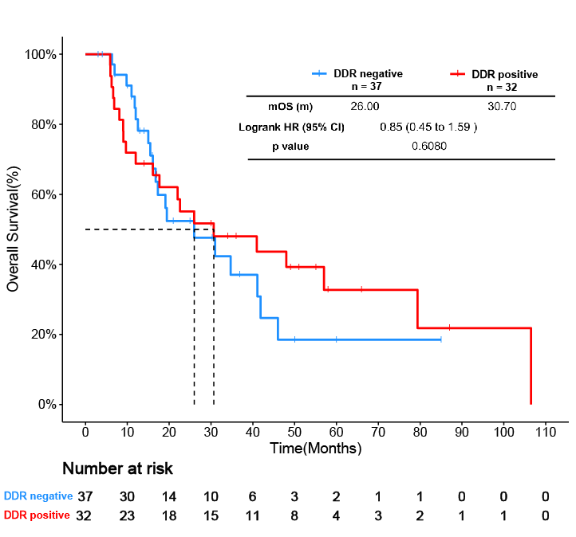

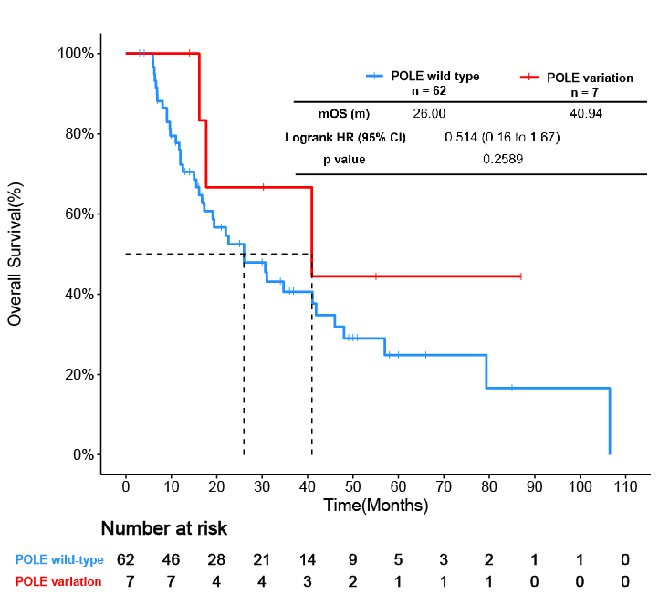
Figure S5. The optimal cutoff point for multivariate cox proportional hazard regression model. The risk of death within one year of patients with different risk scores was shown at the top. X-tile was employed to determine optimal cutoff. The optimal cutoff was set at 18 using maximum χ² and significant p value.

Cutoff | Patient No. | Frequency | χ² | p
>0 | 36 | 52.17% | 17.81 | 0.0008
>7 | 21 | 30.43% | 25.66 | <0.0001
>15 | 20 | 28.99% | 27.15 | <0.0001
>17 | 19 | 27.54% | 26.97 | <0.0001
>18 | 15 | 21.74% | 28.88 | <0.0001
>20 | 13 | 18.84% | 21.41 | <0.0001
>22 | 11 | 15.94% | 20.21 | 0.0005
>23 | 8 | 11.59% | 17.77 | 0.0008
>24 | 5 | 7.25% | 18.08 | 0.0008

Figure S6. Validation of cox proportional hazard regression model with an independent ESCC cohort.
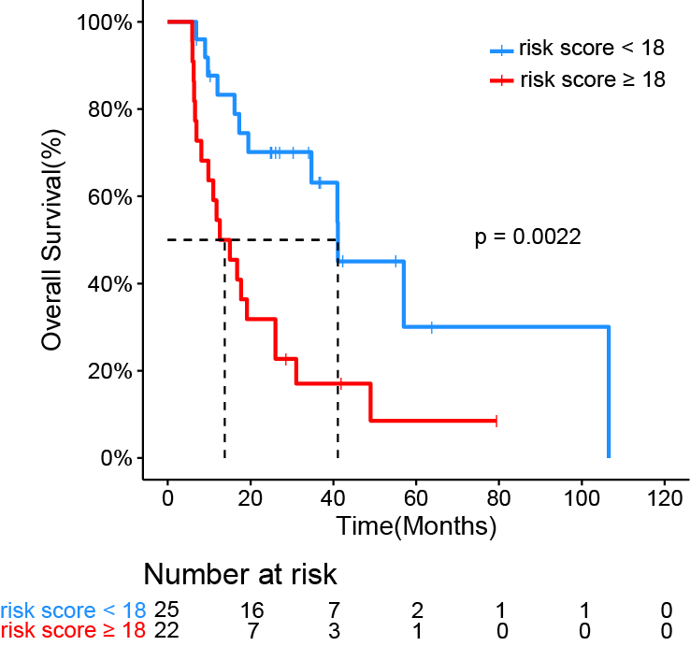

Table S1. Demographic Characteristic of Patients in TCGA cohort. ADC: adenocarcinoma; SCC: squamous cell carcinoma.
 | TCGA database
Characteristic | No. Patients(%)
Total | 143(100%)
Race
Asian | 46(32.17%)
Caucasian | 77(53.84%)
Others | 20(13.99%)
Age(yrs)
≥ 65 yrs | 54(37.76%)
< 65 yrs | 89(62.24%)
Median(range) | 61(36-90)
Gender
Male | 125(87.41%)
Female | 18(12.59%)
Histology
ADC | 57(39.86%)
SCC | 86(60.13%)
TNM Stage
Stage II | 78(54.55%)
Stage III | 56(39.16%)
Stage IV | 9(6.29%)
Smoking
Positive | 59(41.26%)
Negative | 84(58.74%)
Alcohol
Positive | 63(44.06%)
Negative | 80(55.94%)

Table S2. The frequencies of five gene alterations in AEC and TCGA cohorts.
Gene | AEC  No. Patients(%) | TCGA  No. Patients(%)
MYC CNV(vs. Wild-type) | 22(31.88%) | 10(6.99%)
YAP1 CNV (vs. Wild-type) | 5(7.25%) | 2(1.40%)
RB1 alteration (vs. Wild-type) | 7(10.14%) | 11(7.69%)
BRIP1 mutation (vs. Wild-type) | 4(5.80%) | 4(2.80%)
BAP1 mutation (vs. Wild-type) | 4(5.80%) | 6(4.20%)
KDR mutation (vs. Wild-type) | 4(5.80%) | 5(3.50%)
WRN mutation (vs. Wild-type) | 4(5.80%) | 5(3.50%)

