Supplementary Figure 1
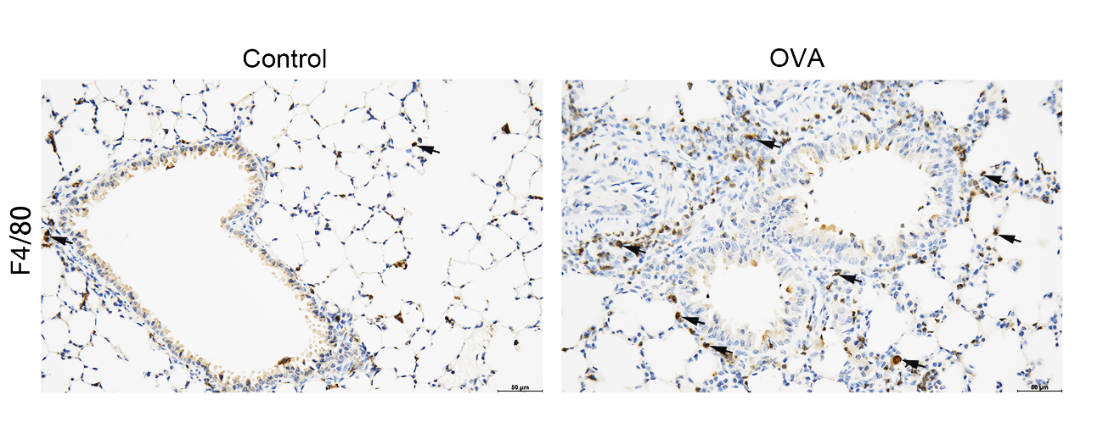
Figure S1 The changes of macrophages in the lung between control and OVA-challenged mice.
Representative lung sections showing the immunohistological staining of F4/80 in mice from control and OVA group, the scale bar is 50 μm. Black arrows indicated immunoreactive staining.

