S1
The concentrations of GLPs and VC selected in the manuscript.

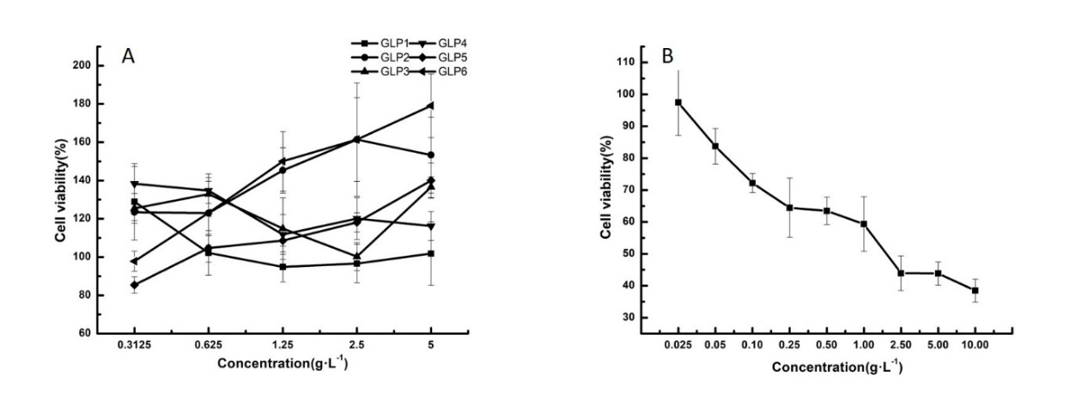
Fig. 1A represented the cell viabilities of HSFs treated by GLPs.
Fig. 1B represented the cell viabilities of HSFs treated by VC, the positive control discussed in the manuscript.

GLPs ranging from 0.31 to 5.00 g·L⁻¹ showed excellent growth promoting activity, for the cell viabilities were all above 80%. Considering the simplicity and uniformity, the intermediate concentration of 1.25 g·L⁻¹ was selected for further study.
Based on Fig.1B, as the VC concentration increased, cell viability decreased. The IC80 concentration of VC calculated by SPSS was 86 mg·L⁻¹. The experimental verification was made subsequently, and the cell viability at the concentration of 86 mg·L⁻¹ was 56.75%±3.2%.

More information on GLP1 I and GLP1 II in the manuscript
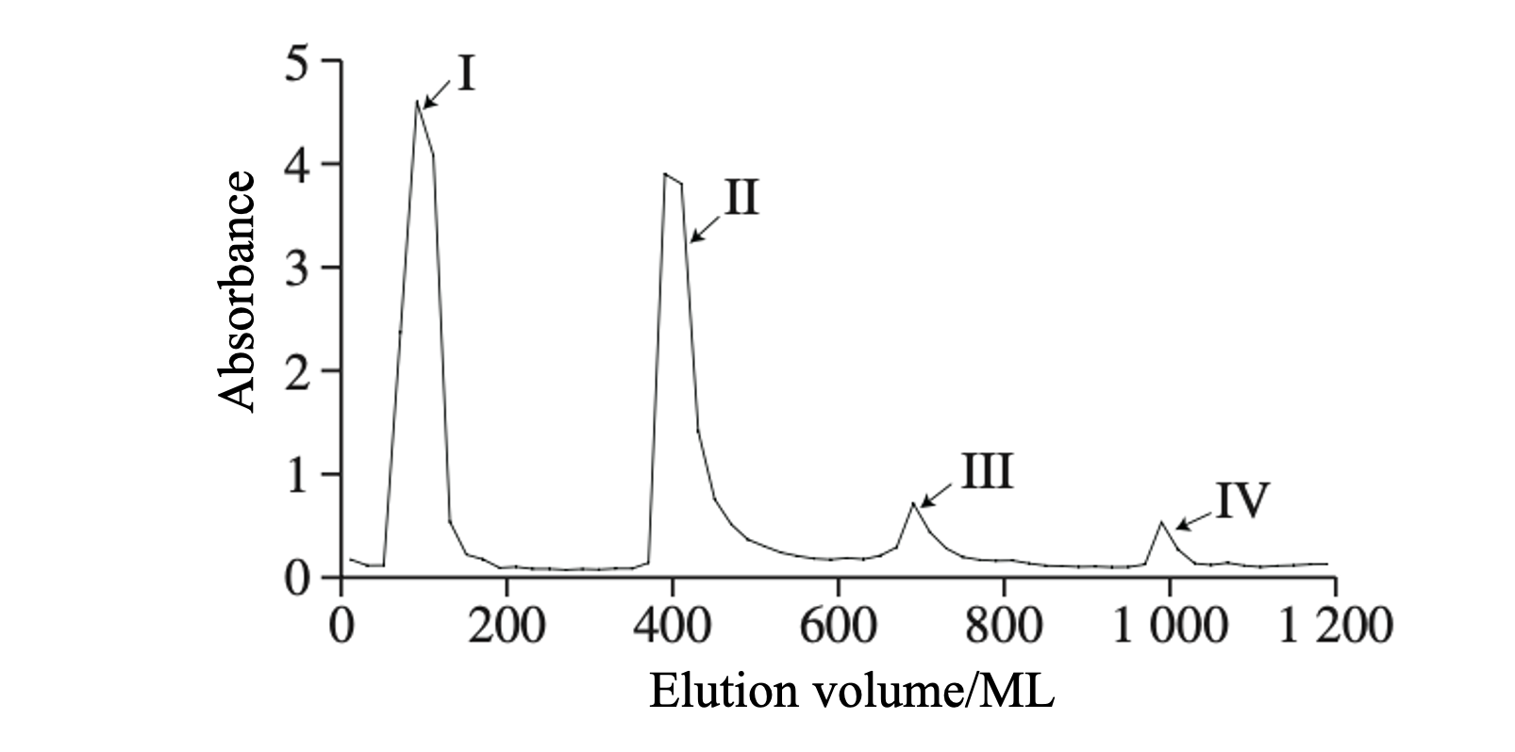
Fig.2 Elution curve of GLPs by DEAE-52 column chromatography
Fig. 2 shows the preliminary separation and purification of GLP1 after deproteinization with DEAE-52 ion exchange resin, and the elution curve is obtained. As can be seen from the figure, a total of 4 elution peaks (I-IV) appeared at 90, 390, 690 and 990 mL, respectively, and each component was collected and combined. Considering the low absorbance of GLP1 III and GLP1 IV, only the first component GLP1 I and the second component GLP1 II were selected for subsequent experiments.
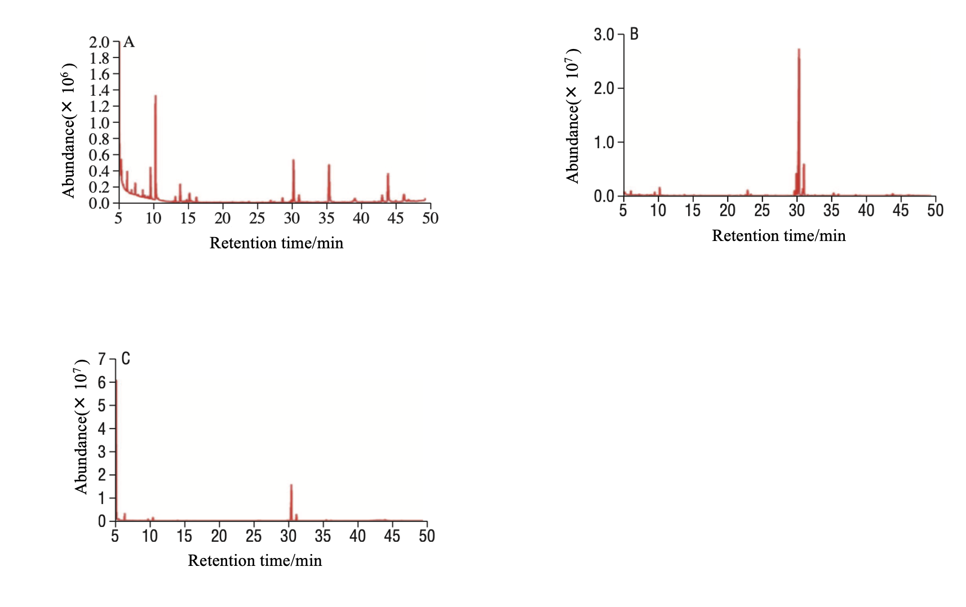
Fig.3 GC spectrum of GLP1 (A), GLP1 I (B), and GLP1 II (C)
Fig.3 shows GC chromatograms of GLP1(A), GLP1I(B) and GLP1II(C). After comparison with the relative molecular weight and standard curve of the standard product (Table 1), monosaccharide composition and molar ratio of GLP and its components are shown in Table 2.

Tab.1 Monosaccharide molecular masses and standard curves
Simple sugars | Relative molecular mass | Standard curve | R²
xylose | 150.13 | y=19292585x | 0.982
Arab sugar | 150.13 | y=1004021x | 0.976
Nuclear sugar | 150.13 | y=9041235x | 0.992
Rhamnose | 164.16 | y=1296253x | 0.995
Fucose | 164.16 | y=7412367x | 0.984
Fructose | 180.16 | y=8881378x | 0.958
Mannose | 180.16 | y=7135721x | 0.981
Galactose | 180.16 | y=9100016x | 0.968
Glucose | 180.16 | y=9817328x | 0.981
Glucuronic acid | 194.14 | y=7085215x | 0.967

Tab.2 Monosaccharide composition and molar ratio in GLP samples
Sample | Mannose | Galactose | Glucose | Rhamnose | Fucose
GLP1 | 1.00 | 2.00 | 31.13 | - | -
GLP1I | 3.78 | 16.75 | 101.43 | 2.04 | 1.00
GLP1II | 2.30 | 1.00 | 133.67 | - | -
Note: -- the monosaccharide was not detected

