Table S1: Clinical information of patients with IFN-a 2b treatment

Number | Gender | Age (years) | Treatment before IFN-a 2b | Time from diagnosis to IFN-a 2b (months) | Duration of IFN-a 2b (months) | Adverse Event | Effect Evaluation | Treatment after IFN-a 2b | Follow-up of Tumor Status after the cease of IFN-a 2b | Time of Progression Free Survival（months） | Current Patient Status | Time of Overall Survival（months）
1 | Female | 36 | Transarterial Embolization | 6 | 18 | Fever Grade 1 / Fatigue Grade1 | Complete Response | Observation | Stable | 76 | Alive | 76
2 | Male | 22 | Chemotherapy | 33 | 20 | None | Complete Response | Observation | Stable | 71 | Alive | 71
3 | Male | 22 | None | 3 | 31 | Fever Grade 1 | Partial Response | Observation | Stable | 57 | Alive | 57
4 | Male | 24 | None | 3 | 24 | None | Partial Response | Observation | Stable | 64 | Alive | 64
5 | Male | 21 | Surgery | 51 | 8 | Fever Grade 1 | Partial Response | Observation | Stable | 28 | Alive | 28
6 | Male | 36 | None | 42 | 15 | Fever Grade 1 | Partial Response | Observation | Progression, 36 months after the cease of IFN-a 2b | 51 | Alive | 64
7 | Female | 56 | Radiofrequency Ablation | 4 | 16 | None | Partial Response | Treatment Continued | / | 16 | Alive | 16
8 | Male | 43 | Radiofrequency Ablation | 21 | 30 | None | Partial Response | Observation | Stable | 73 | Alive | 73
9 | Female | 32 | Radiofrequency Ablation | 8 | 39 | Fever Grade 1 | Partial Response | Treatment Continued | / | 39 | Alive | 39
10 | Female | 35 | None | 9 | 26 | Fever Grade 1 / Fatigue Grade1 | Partial Response | Observation | Stable | 32 | Alive | 32
11 | Male | 33 | Surgery | 42 | 15 | None | Partial Response | Treatment Continued | / | 15 | Alive | 15
12 | Male | 31 | None | 5 | 30 | Thrombopenia Grade 1 / Leukopenia Grade 1 | Partial Response | Observation | Stable | 38 | Alive | 38
13 | Male | 31 | None | 3 | 48 | Fever Grade 1 | Partial Response | Observation | Stable | 52 | Alive | 52
14 | Female | 54 | Radiofrequency Ablation | 3 | 33 | None | Partial Response | Observation | Stable | 39 | Alive | 39
15 | Female | 41 | Transarterial Embolization | 14 | 48 | Fever Grade 1 / Fatigue Grade1 | Partial Response | Observation | Stable | 66 | Alive | 66
16 | Female | 30 | None | 8 | 6 | Hypothyroidism Grade 2 | Partial Response | Treatment Continued | / | 6 | Alive | 6
17 | Female | 42 | None | 16 | 36 | Fatigue Grade 1 / Anemia Grade 1 | Partial Response | Observation | Stable | 41 | Alive | 41
18 | Male | 53 | None | 57 | 15 | None | Partial Response | Treatment Continued | / | 15 | Alive | 15
19 | Male | 32 | None | 3 | 19 | Fever Grade 1 / Decreased appetite Grade 1 | Partial Response | Observation | Stable | 40 | Alive | 40
20 | Female | 34 | Chemotherapy | 11 | 24 | Fever Grade 1 | Partial Response | Observation | Stable | 74 | Alive | 74
21 | Male | 26 | None | 9 | 19 | Fever Grade 1 / Fatigue Grade1 | Partial Response | Observation | Stable | 33 | Alive | 33
22 | Male | 22 | None | 3 | 26 | None | Partial Response | Treatment Continued | / | 26 | Alive | 26
23 | Female | 37 | None | 3 | 28 | Alopecia Grade1 | Stable disease | Treatment Continued | / | 28 | Alive | 28
24 | Female | 27 | None | 8 | 16 | Fever Grade 1 / Fatigue Grade1 | Stable disease | Observation | Stable | 52 | Alive | 52
25 | Female | 40 | None | 3 | 33 | Fever Grade 1 | Stable disease | Treatment Continued | / | 33 | Alive | 33
26 | Male | 22 | Chemotherapy | 25 | 14 | Leukopenia Grade 2 / Thrombopenia Grade 2 | Stable disease | Treatment Continued | / | 14 | Alive | 14
27 | Female | 41 | Radiofrequency Ablation | 54 | 8 | None | Stable disease | Treatment Continued | / | 8 | Alive | 8
28 | Female | 41 | None | 4 | 8 | None | Stable disease | Treatment Continued | / | 8 | Alive | 8
29 | Male | 30 | None | 13 | 13 | Fatigue Grade1 | Stable disease | Observation | Progression, 12 months after the cease of IFN-a 2b | 25 | Alive | 32
30 | Female | 30 | None | 45 | 15 | Alopecia Grade1 / Rash Grade1 | Stable disease | Treatment Continued | / | 15 | Alive | 15
31 | Female | 50 | None | 3 | 13 | Fever Grade 1 | Stable disease | Treatment Continued | / | 13 | Alive | 13
32 | Male | 43 | None | 24 | 27 | Fever Grade 1 | Stable disease | Observation | Stable | 35 | Alive | 35
33 | Male | 52 | None | 6 | 24 | Fever Grade 1 / Fatigue Grade1 | Stable disease | Observation | Progression, 10 months after the cease of IFN-a 2b | 33 | Alive | 42
34 | Female | 42 | Radiofrequency Ablation | 24 | 24 | Fever Grade 1 | Stable disease | Observation | Progression, 12 months after the cease of IFN-a 2b | 36 | Alive | 60
35 | Male | 32 | None | 15 | 9 | Fever Grade 1 | Progressed disease | Observation | Progression | 6 | Alive | 45
36 | Female | 18 | None | 2 | 6 | Fever Grade 1 | Progressed disease | Treatmment of Apatinib | Stable | 6 | Alive | 10
37 | Male | 44 | None | 10 | 10 | Fever Grade 1 / Fatigue Grade1 | Progressed disease | Observation | Progression | 6 | Alive | 36
38 | Male | 30 | Transarterial Embolization | 12 | 6 | Fever Grade 1 | Progressed disease | Observation | Progression | 6 | Dead | 14
39 | Male | 48 | Surgery | 16 | 16 | None | Progressed disease | Observation | Progression | 5 | Alive | 16
40 | Female | 59 | Radiofrequency Ablation | 15 | 8 | None | Progressed disease | Treatmment of Apatinib | Progression | 6 | Alive | 17
41 | Female | 46 | None | 5 | 20 | None | Progressed disease | Treatmment of Apatinib | Not available | 4 | Alive | 20
42 | Male | 65 | Radiofrequency Ablation | 4 | 3 | Rash Grade 1 / Hypothyroidism Grade 2 | Progressed disease | Treatmment of Apatinib | Progression | 3 | Alive | 3

Fig S1: Radiological comparison before and after the treatment of IFN-a 2b
(Patients’ numbers were consistent with Table S1)

Baseline | Best changes
1# Complete Response
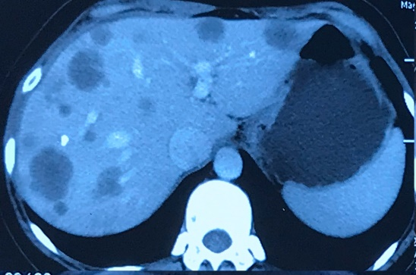 | 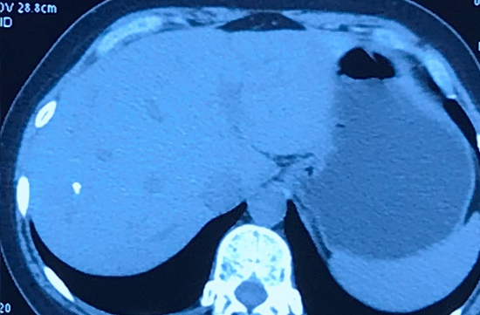
2# Complete Response
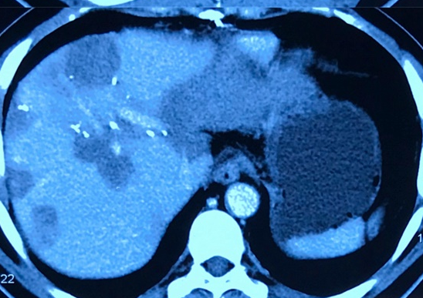 | 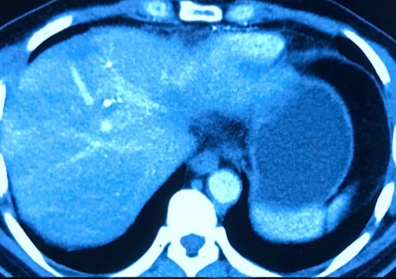
3# Partial Response
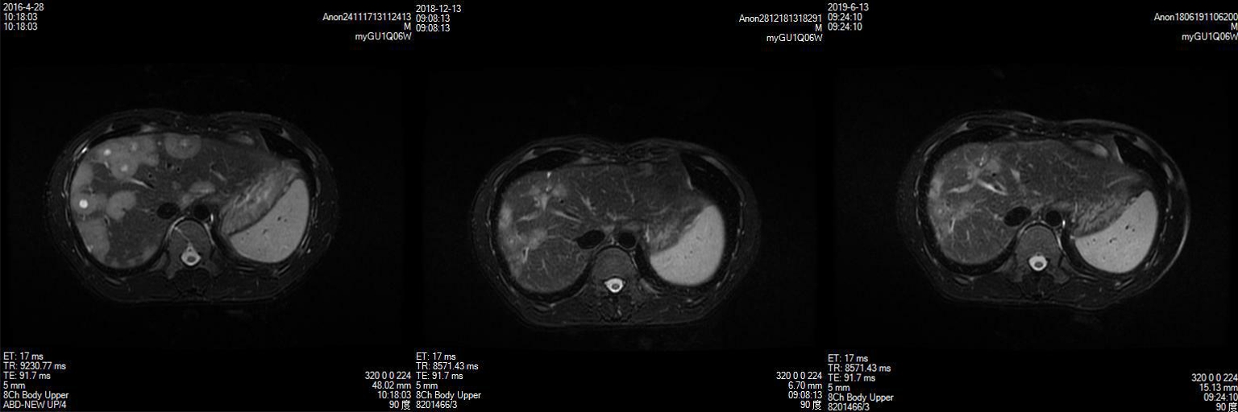
4# Partial Response
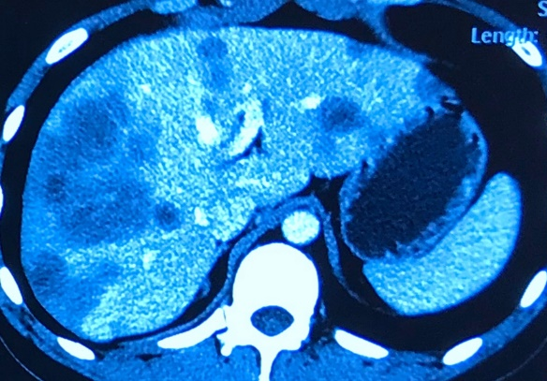 | 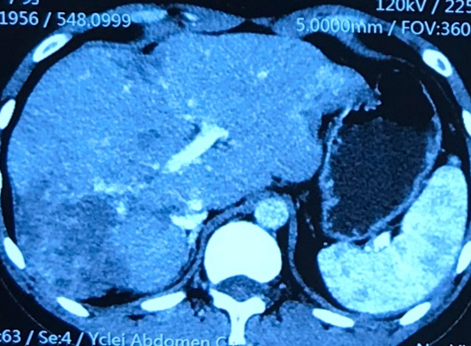
5# Partial Response
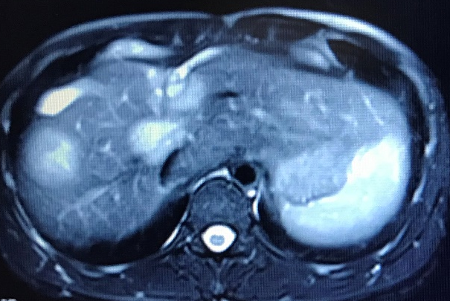 | 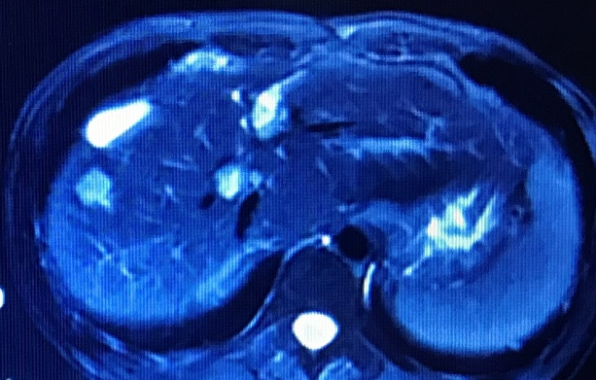
6# Partial Response
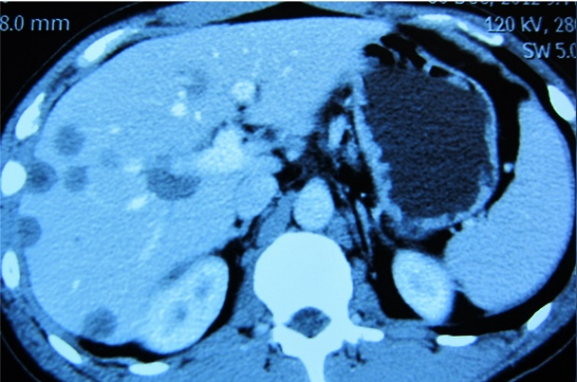 | 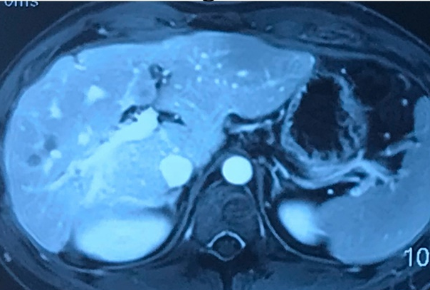
7# Partial Response
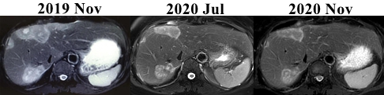
8# Partial Response
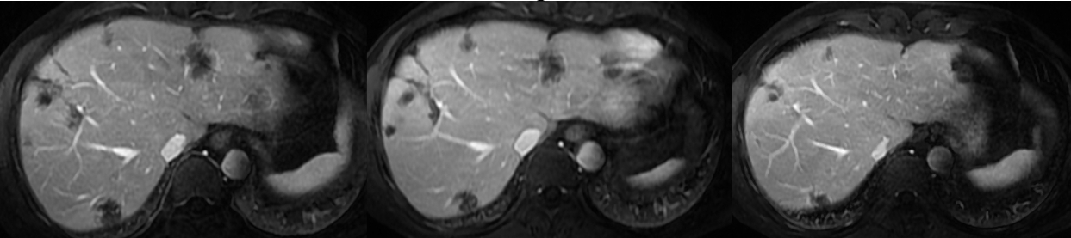
9# Partial Response
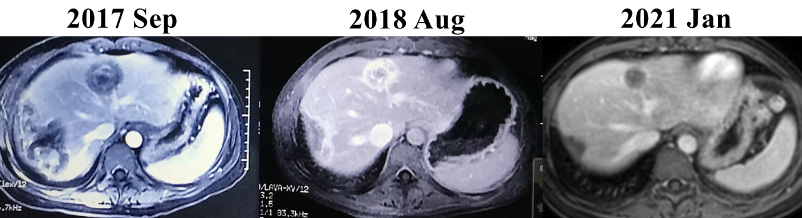
10# Partial Response
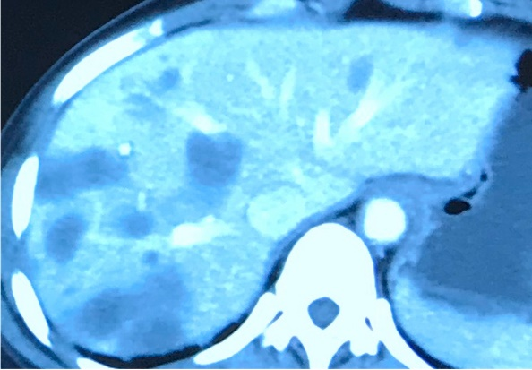 | 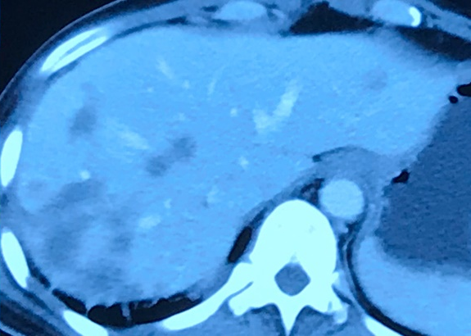
11# Partial Response
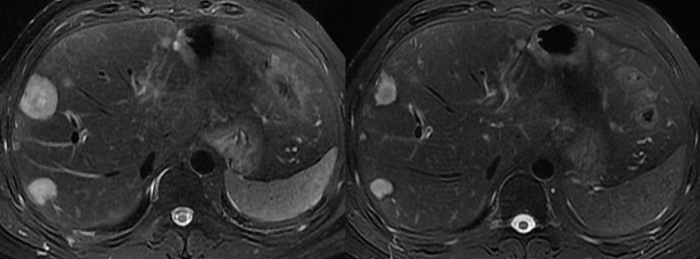
12# Partial Response
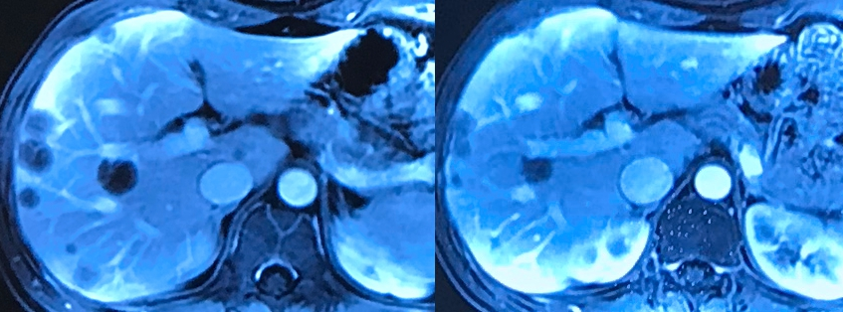
13# Partial Response
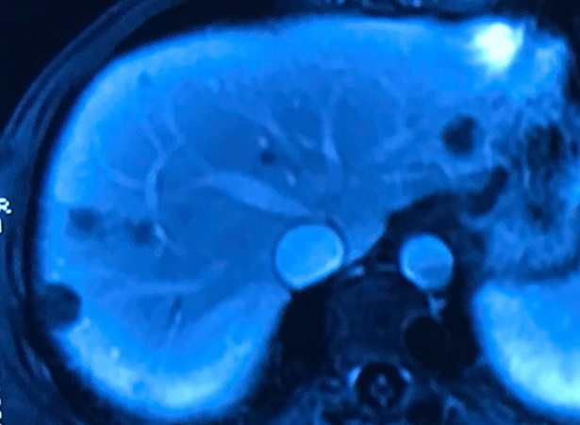 | 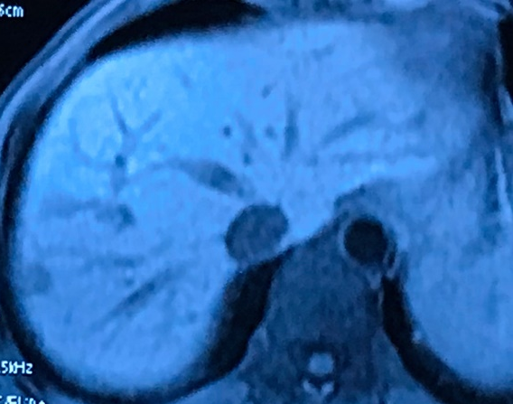
14# Partial Response
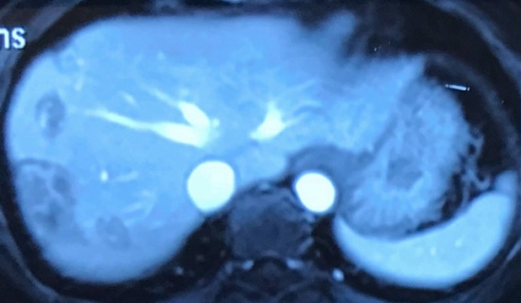 | 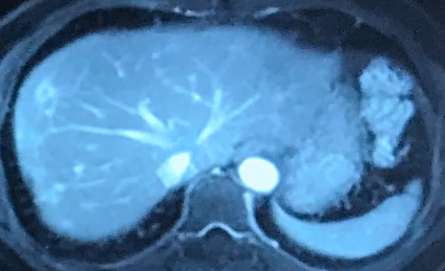
15# Partial Response
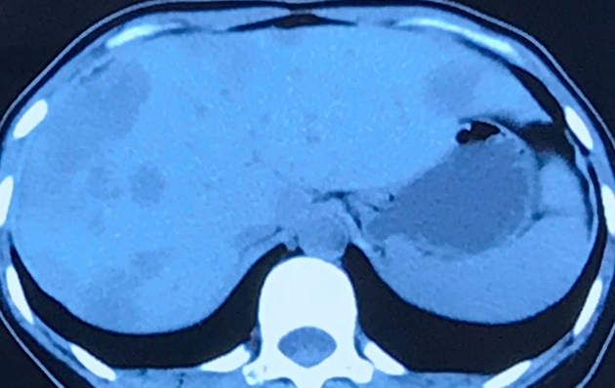 | 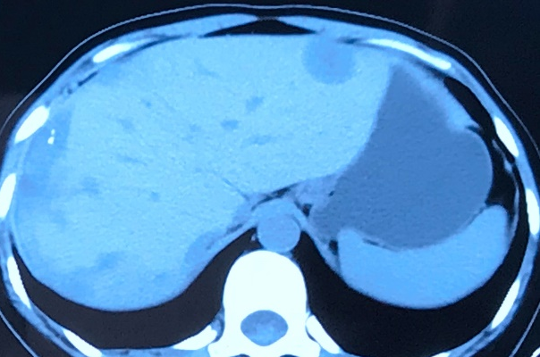
16# Partial Response
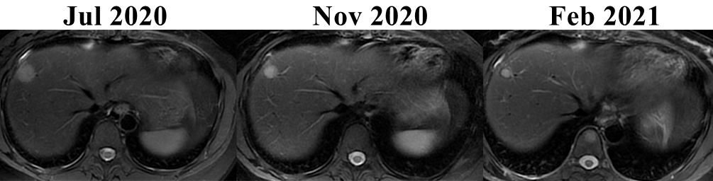
17# Partial Response
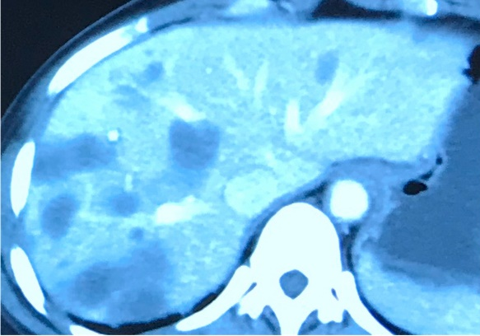 | 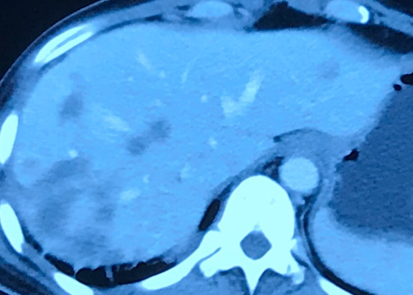
18# Partial Response
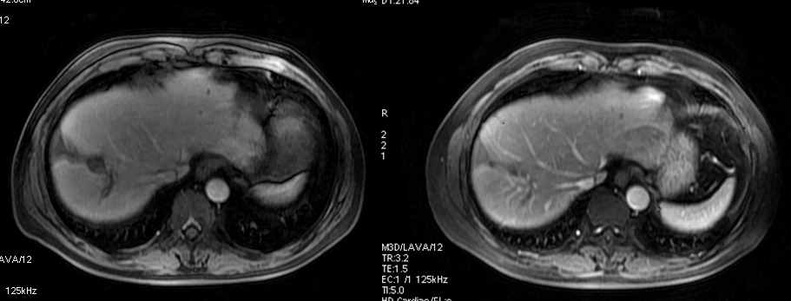
19# Partial Response (Comparison of lesion marked with white arrow)
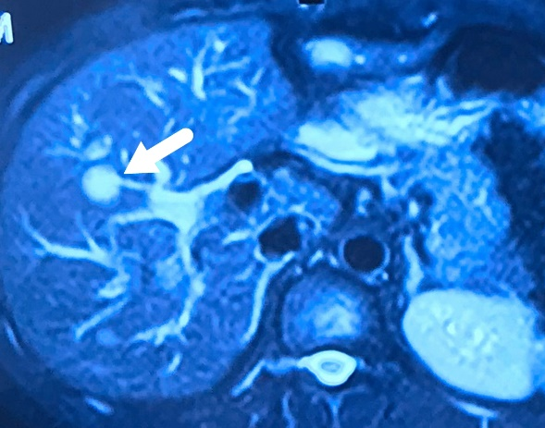 | 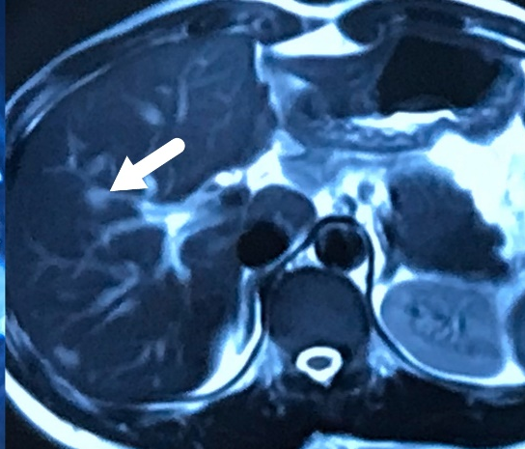
20# Partial Response
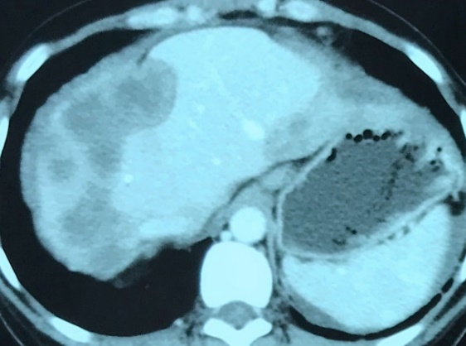 | 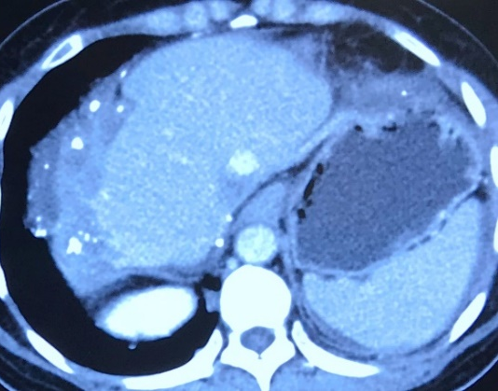
21# Partial Response
22# Partial Response
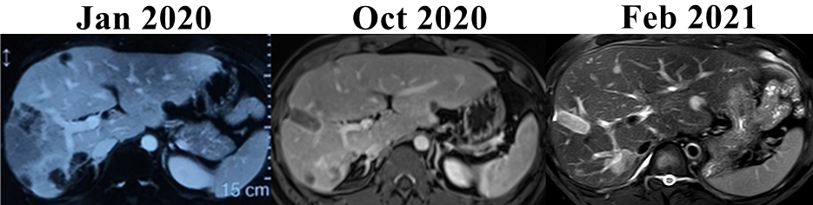
23# Stable Disease
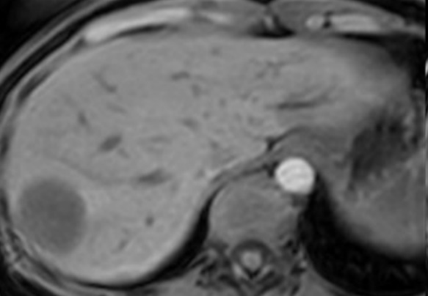 | 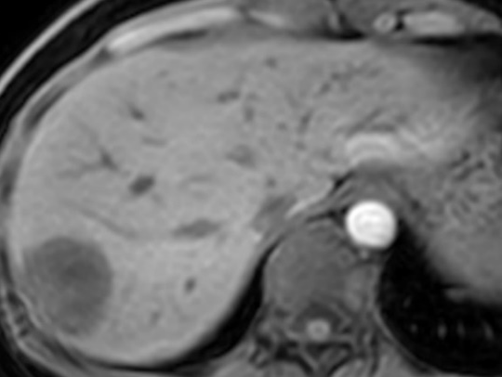
24# Stable Disease
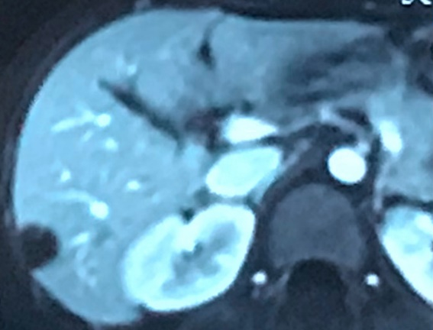 | 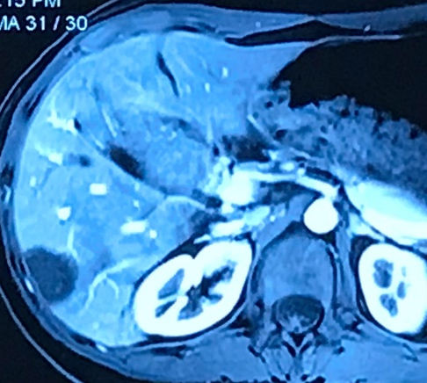
25# Stable Disease
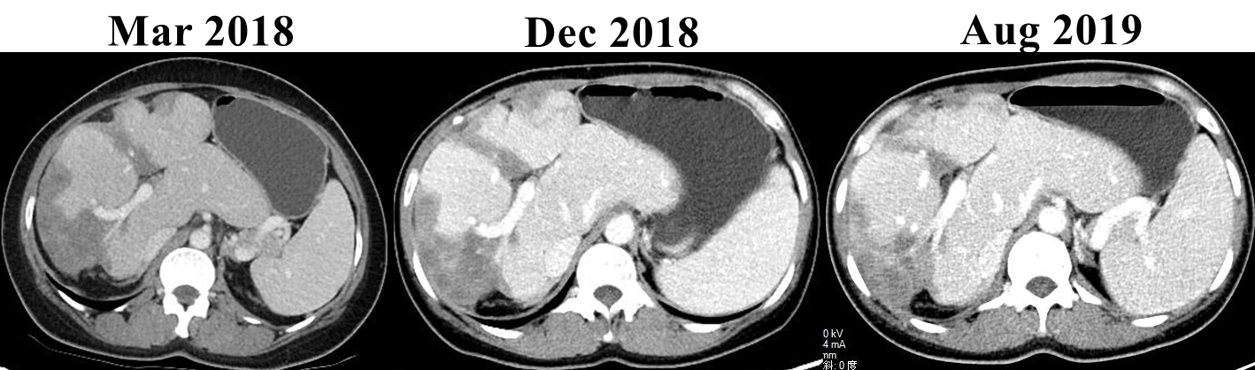
26# Stable Disease
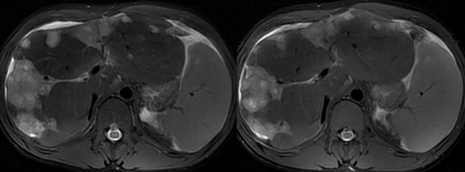
27# Stable Disease
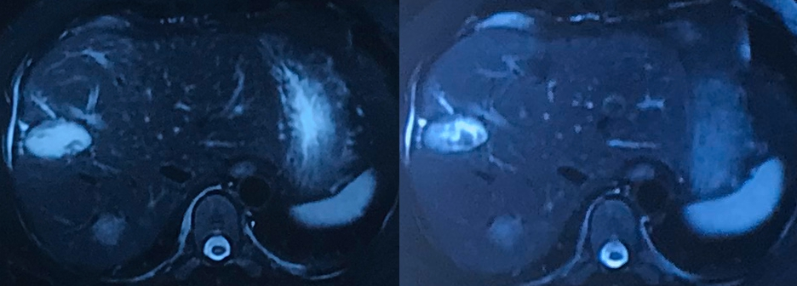
28# Stable Disease
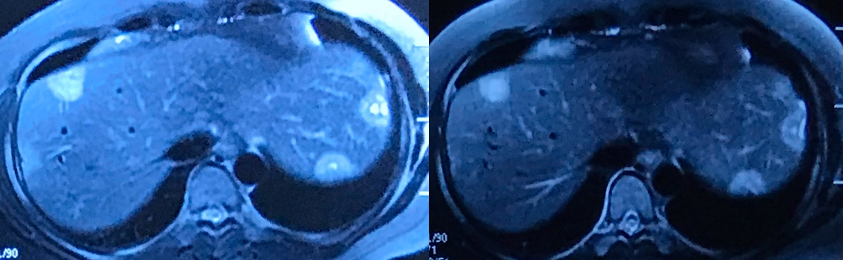
29# Stable Disease
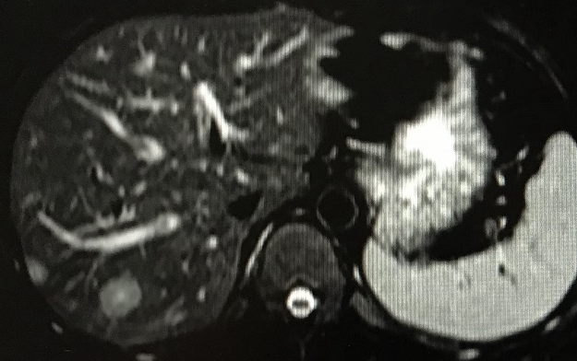 | 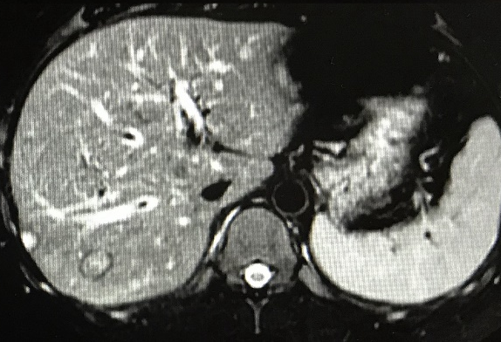
30# Stable Disease
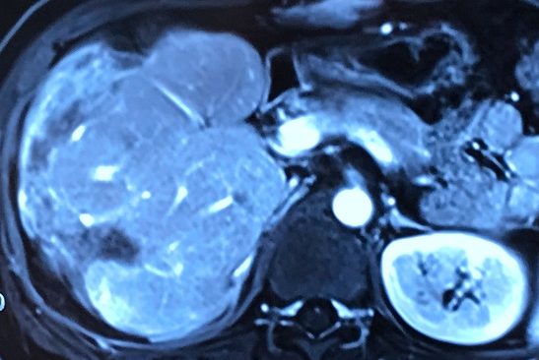 | 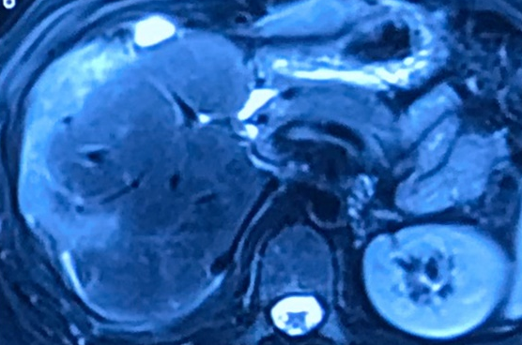
31# Stable Disease
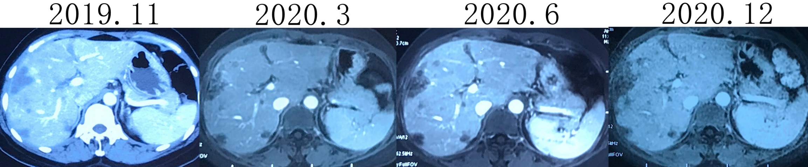
32# Stable Disease
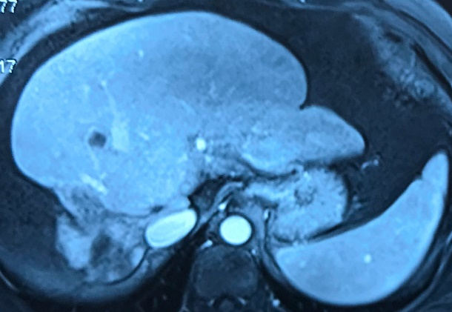 | 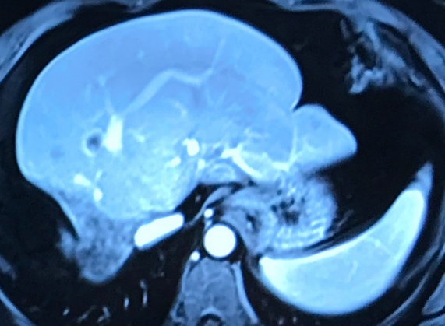
33# Stable Disease
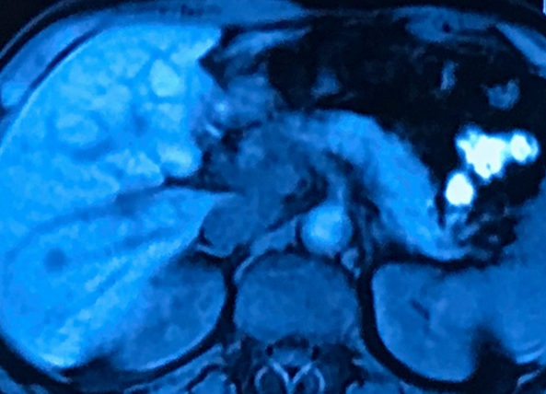 | 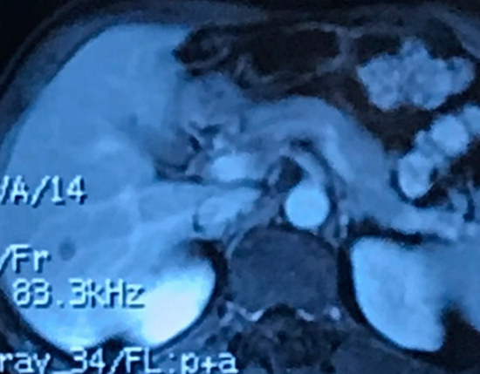
34# Stable Disease
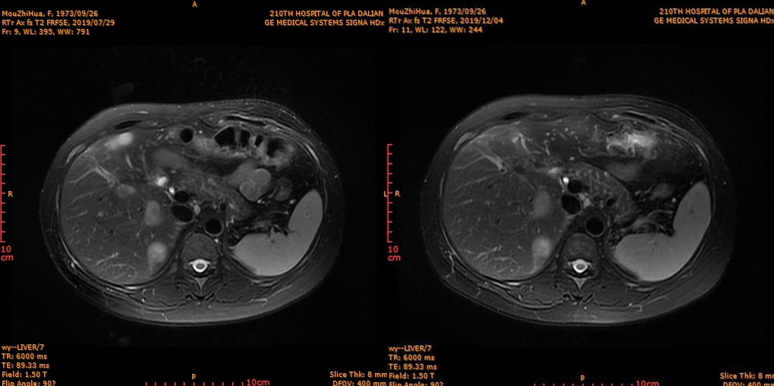
35# Progressed Disease
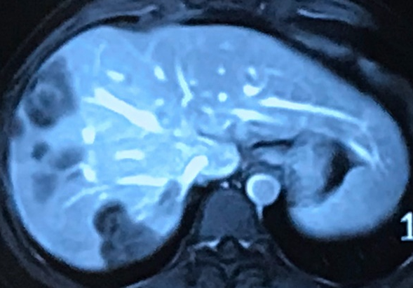 | 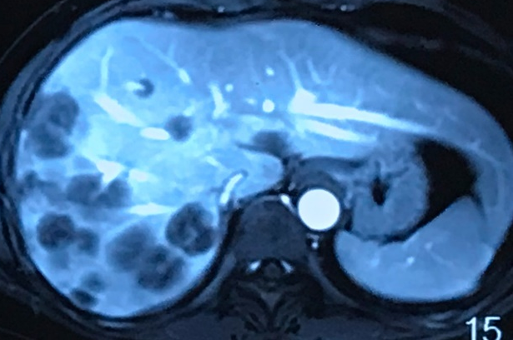
36# Progressed Disease
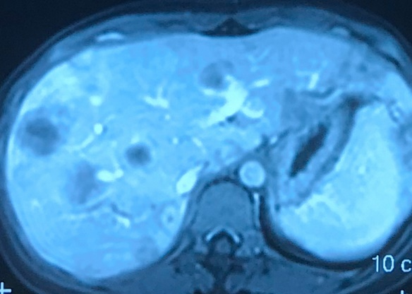 | 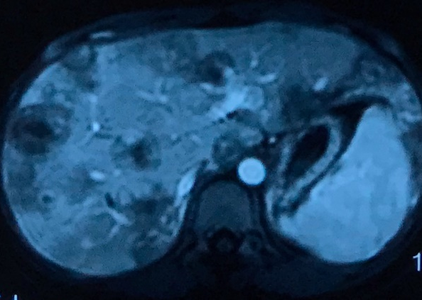
37# Progressed Disease (Progressed lesions marked with red arrows)
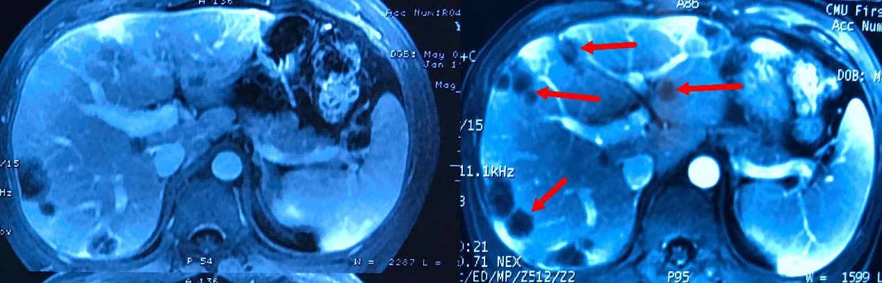
38# Progressed Disease
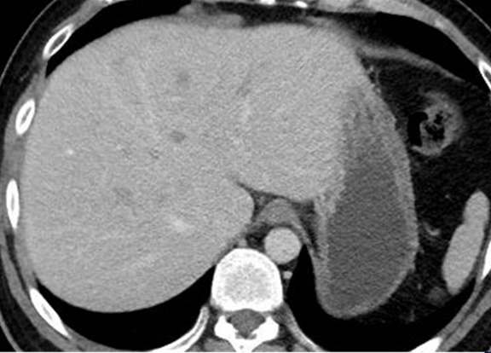 | 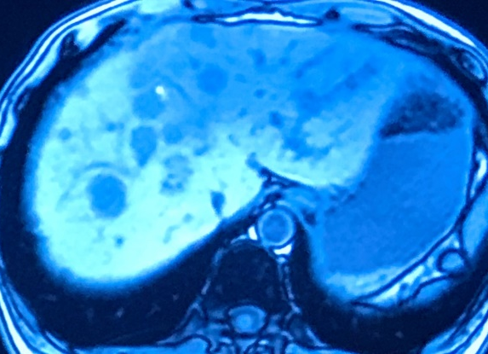
39# Progressed Disease
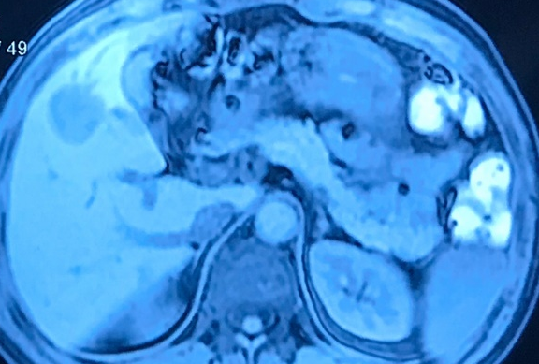 | 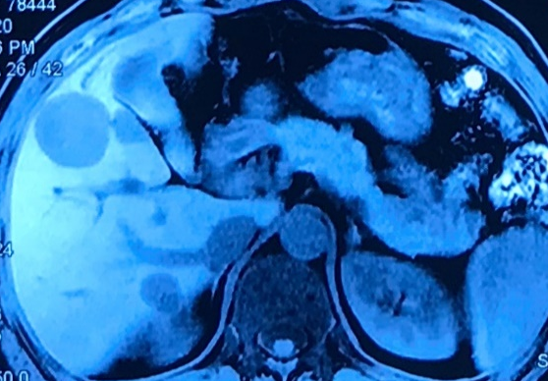
40# Progressed Disease
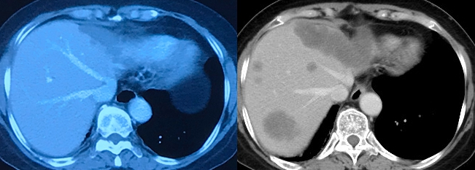
41# Progressed Disease
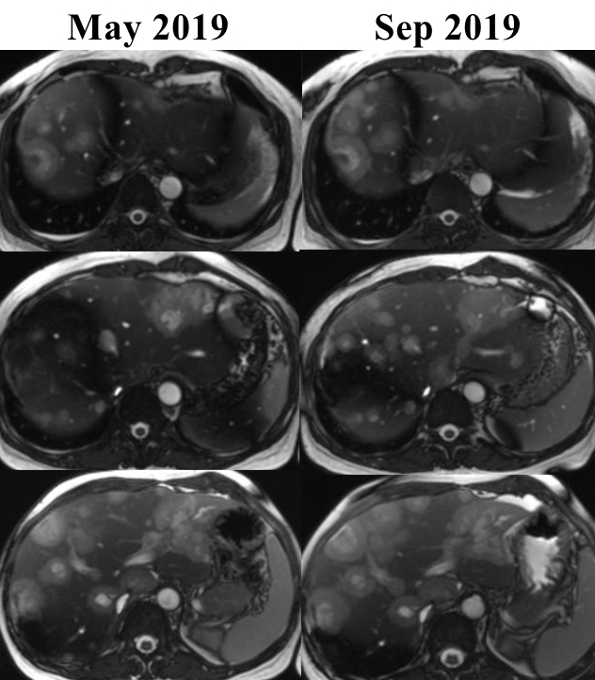
42# Progressed Disease
