Appendix:

First Section: participants demographic data
- Sex:
- Female
- Male

- How old are you:
- Specify please ………….

- The region you are living in now:
- Northern region
- Western region
- Eastern region
- Southern region
- Central region

- Educational level:
- High school
- Bachelor
- Master
- Other: ………….

- Total monthly income:
- <10000 (less than ten thousand)
- 10000-20000 (between ten thousand and twenty thousand)
- >20000 (more than twenty thousand)

- Do you have dental insurance?
- Yes
- No

- If your answer in the previous question was (Yes), approximately how much is it?
- Less than 2000 (less than 2000)
- 2000-4000 (between two thousand and four thousand)
- 4000-6000 (between four thousand and six thousand)
- More than 6000

Second Section: dentists

- Do you prefer your dentist to be:
- Saudi
- Non-Saudi
- Does not matter

- For the following dental specialties, what is your preference regarding the sex of the dentist?

Specialty: | Sex:
Oral maxillofacial surgeon | Female \ male\ doesn’t matter
Pedodontist | Female \ male\ doesn’t matter
General dentist | Female \ male\ doesn’t matter

- Which age do you prefer your dentist to be?
- Young dentist
- Older dentist
- Doesn’t matter

- Which dentist’s rank do you prefer?
- General dentists
- Specialist
- Consultant
- Does not matter

- Based on dentist’s reputation would you prefer:
- Well known dentist
Not known dentist (not famous)
- Does not matter

- Which style of communication do you prefer your dentist to have?
- Listener
- Explanatory

- From the following different types of attires, which one would you prefer?

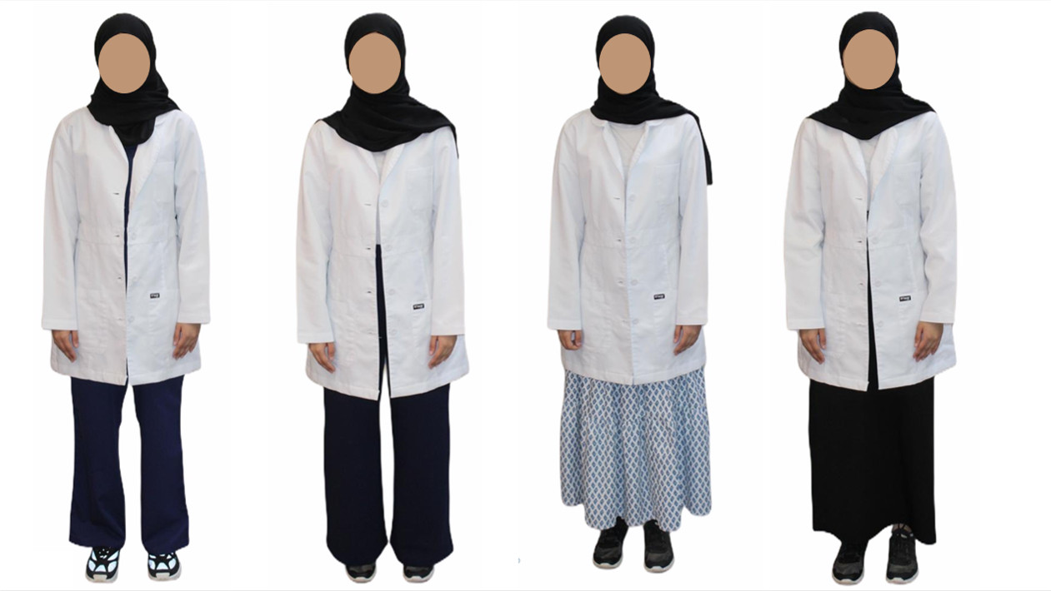

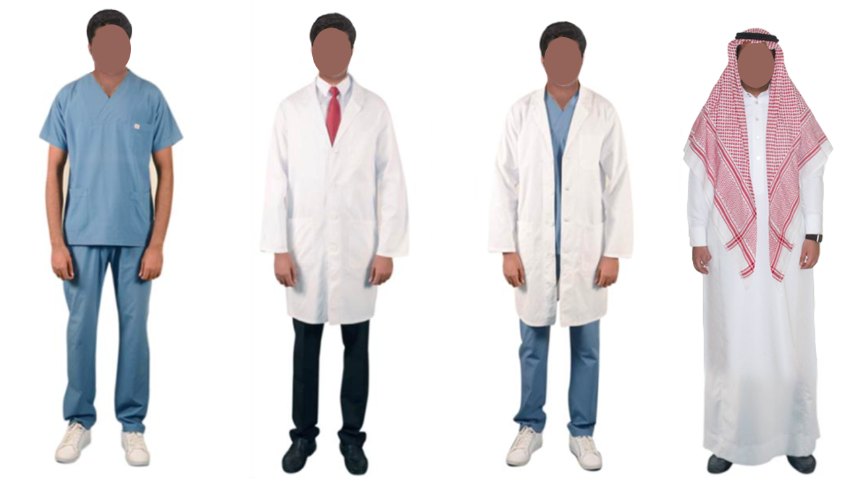

- Do you prefer your dentist to have an account on social media?
- Yes
- No
- Does not matter

- If your answer in the previous question was (Yes), which social media platform you prefer the most?
- Twitter
- Instagram
- Snapchat
- Other …………..

Third Section:
From the following pictures, which dental clinic setting design you prefer the most:







Last section:
How important are the following factors when you choose your dentist?

Does not matter | Important | Very important
 |  |  | Dentist’s nationality
 |  |  | Dentist’s sex
 |  |  | Dentist’s age
 |  |  | Dentist’s rank
 |  |  | Dentist’s reputation
 |  |  | Dentist’s characteristic
 |  |  | Dentist’s attire
 |  |  | Dentist’s social media account
 |  |  | Cost of treatment
 |  |  | Location
 |  |  | Clinic Colore

