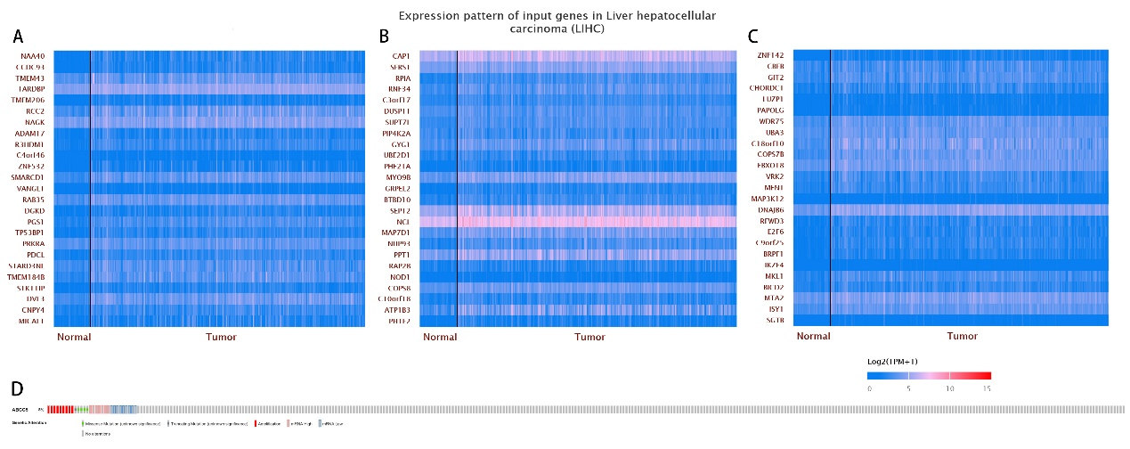
Supplementary Figure 1: (A)The heatmap of the top 25 to 50 co-expressed genes with ABCC5. (B) The heatmap of the top 50 to 75 co-expressed genes with ABCC5. (C) The heatmap of the top 75 to 100 co-expressed genes with ABCC5. (D) Altered ABCC5 gene copy numbers was significantly correlated with the immune infiltration levels of several types of immune cell in LIHC (Firehose legacy).

