Supporting Information
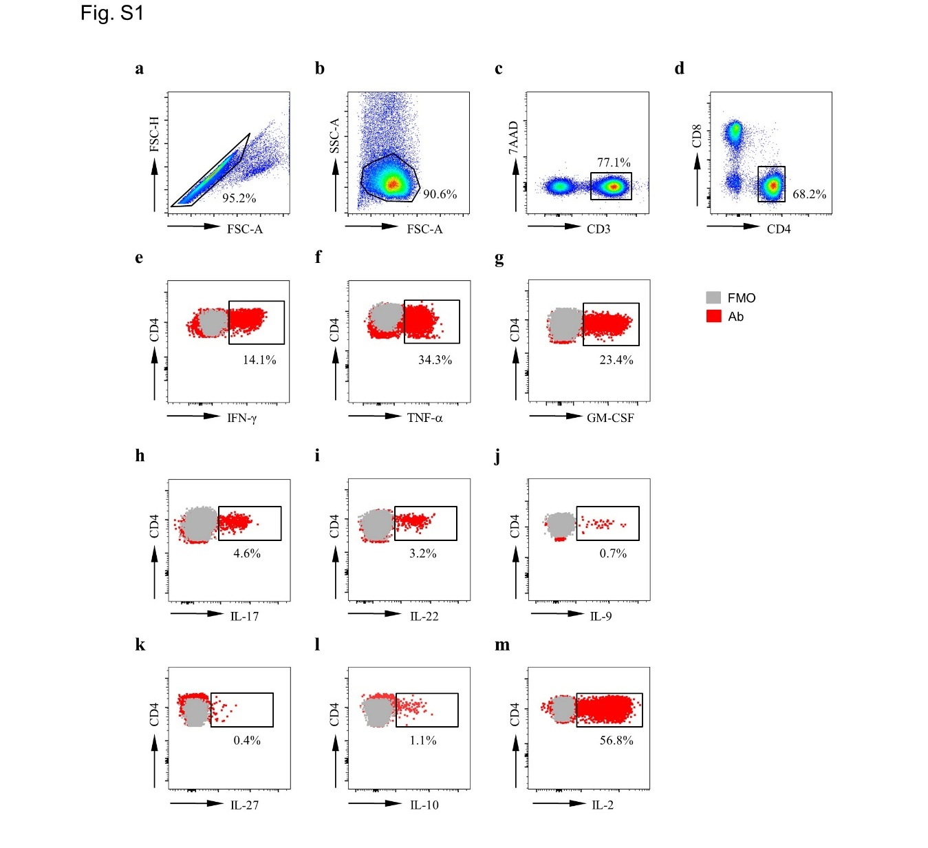
Figure S1. Flow cytometry gating strategy for cytokine-producing CD4⁺ T cells from PLHIV.
a-d. Analytic gating of flow cytometry data: single-cells were selected based on FSC-A and FSC-H (a); lymphocytes were identified from singlet cells (b); cells expressing high levels of CD3 were selected (c); CD4⁺ T cells were separated in CD3⁺ T cell population (d). e-m. Representative flow data of IFN-γ (e), TNF-α (f), GM-CSF (g), IL-17 (h), IL-22 (i), IL-9 (j), IL-27 (k), IL-10 (l), and IL-2 (m) expression (red) on CD4⁺ T cells and fluorescence minus one (FMO) controls (gray) from one representative PLHIV.
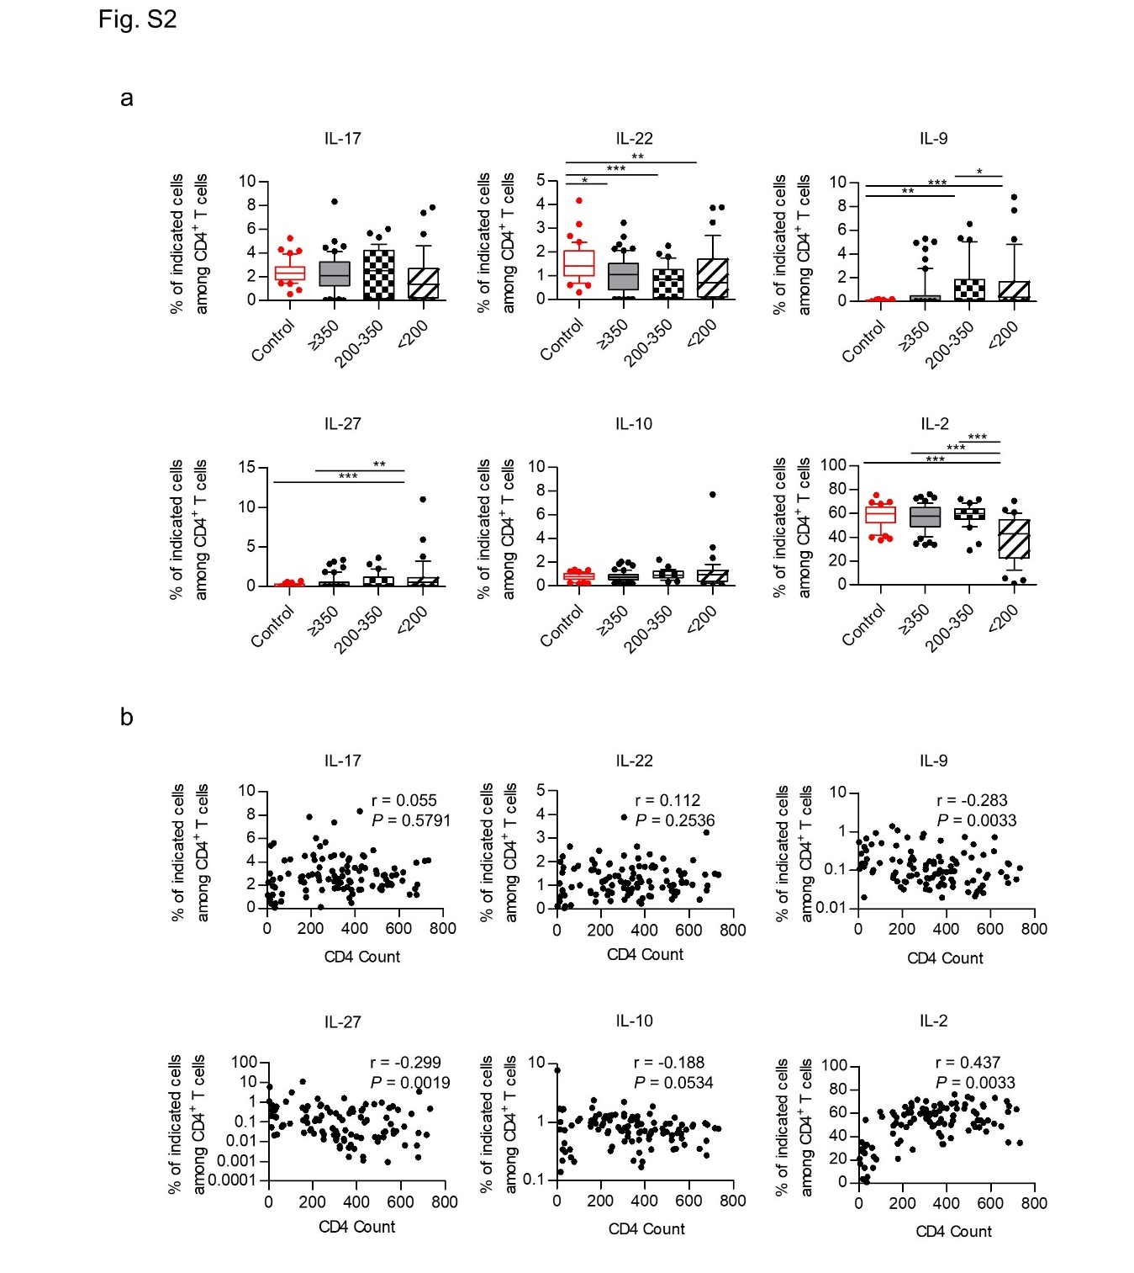
Figure S2. The frequencies of IL-17⁺, IL-22⁺, IL-9⁺, IL-27⁺, IL-10⁺, IL-2⁺ CD4⁺ T cells in healthy controls and different PLHIV groups, and correlation analysis between these cells and CD4 count.
a. Box plots of the frequencies of IL-17⁺, IL-22⁺, IL-9⁺, IL-27⁺, IL-10⁺ and IL-2⁺ CD4⁺ T cells from healthy controls and different PLHIV groups (CD4 count≥350 cells/µl, 200–350 cells/µl, <200 cells/µl). P values were obtained by Kruskal-Wallis test followed by Dunn’s multiple comparisons test. b. Correlation analysis of the percentages of cytokine-producing CD4⁺ T cells and CD4 count. *P < 0.05, **P < 0.01, ***P < 0.001.
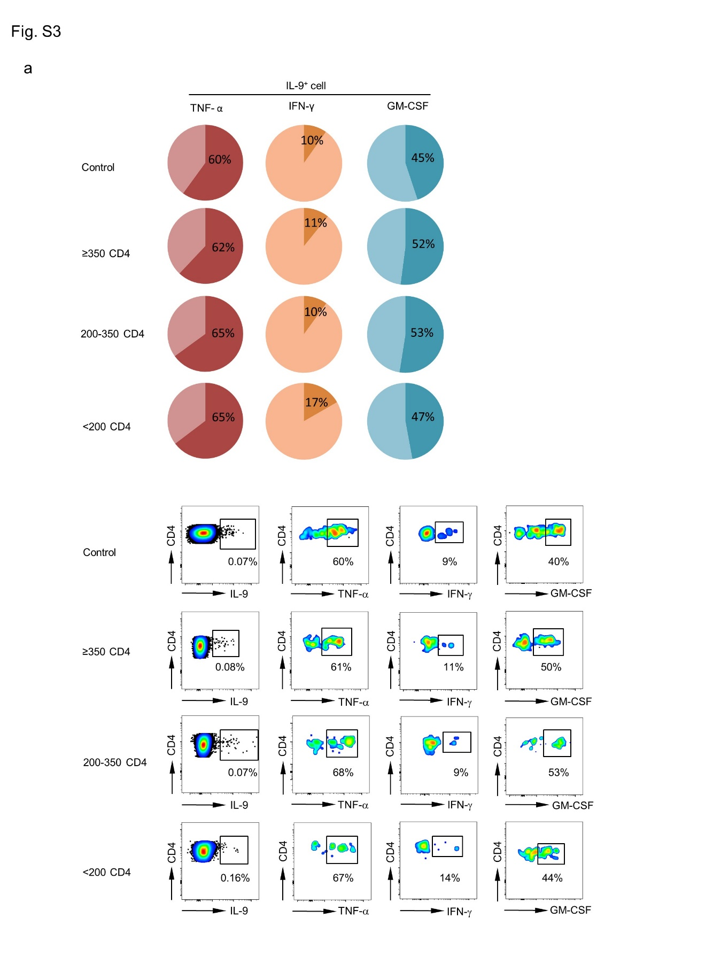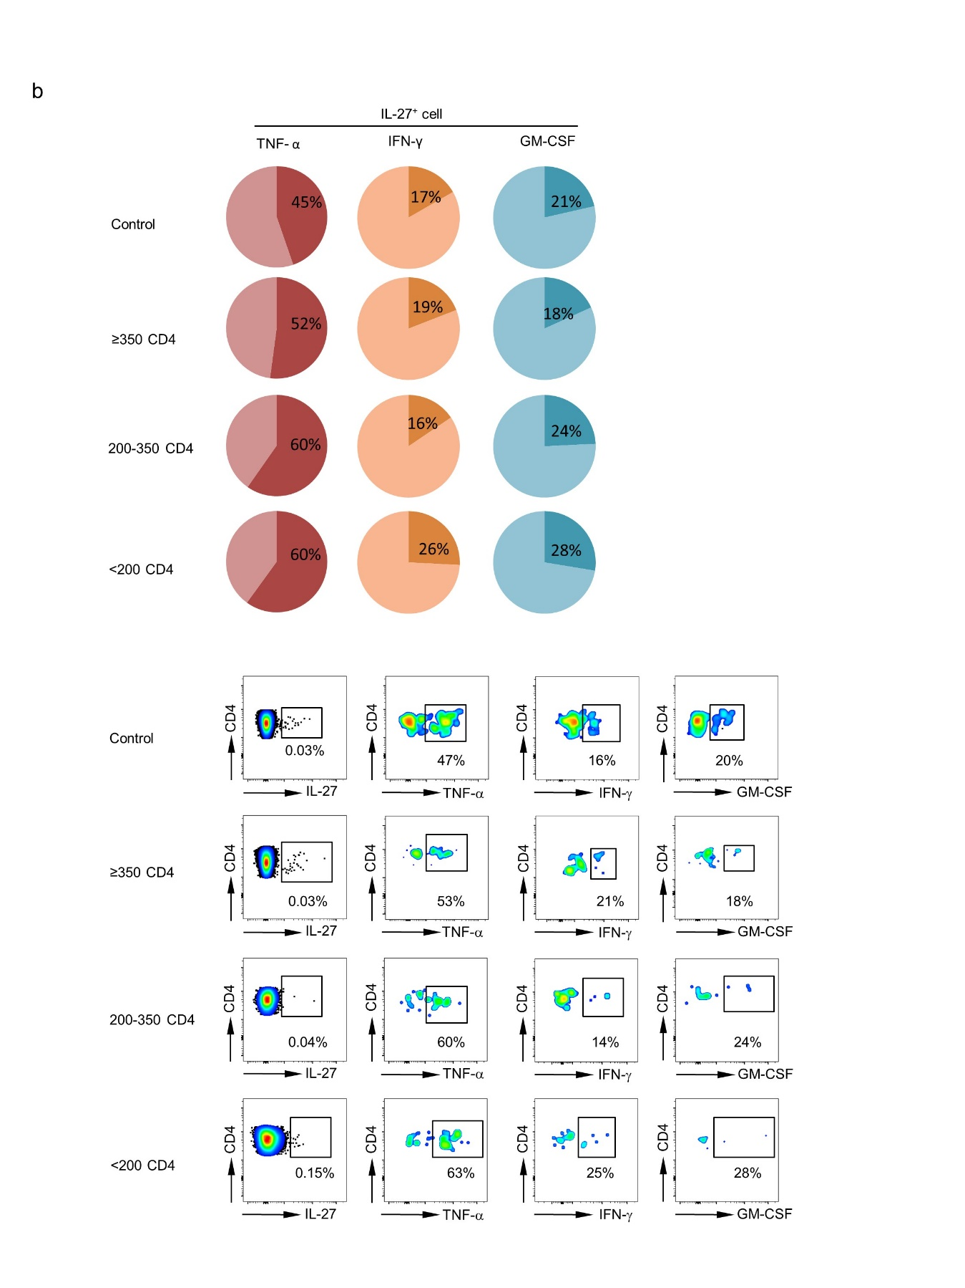
Fig S3. IL-9⁺ and IL-27⁺ CD4⁺ T cells from healthy controls and different PLHIV groups exhibited high levels of IFN-γ, TNF-α, and GM-CSF expression.
Pie charts and representative flow data of the percentage of IFN-γ, TNF-α, and GM-CSF expression on IL-9⁺ (a) or IL-27⁺ (b) CD4⁺ T cells among healthy controls and different PLHIV groups (CD4 count≥350 cells/µl, 200–350 cells/µl, <200 cells/µl).
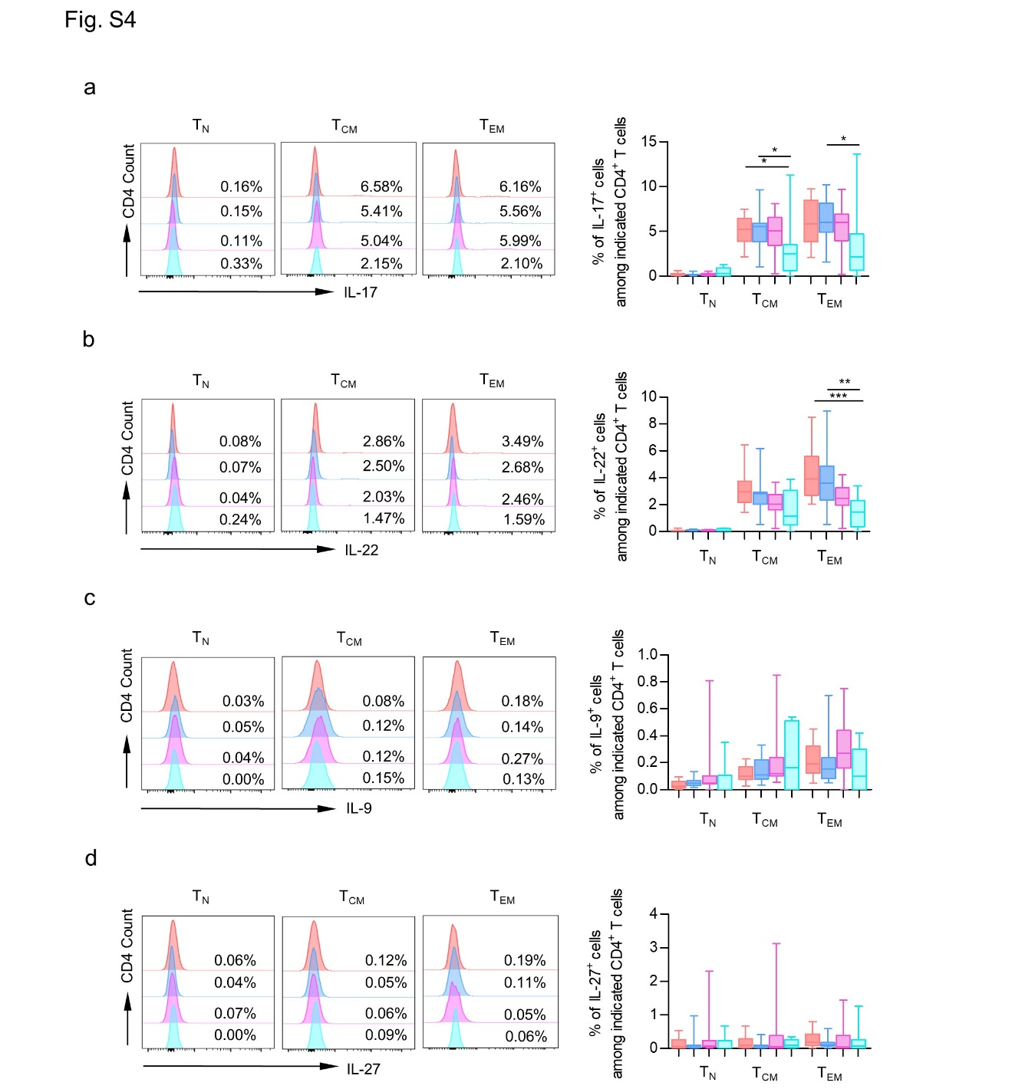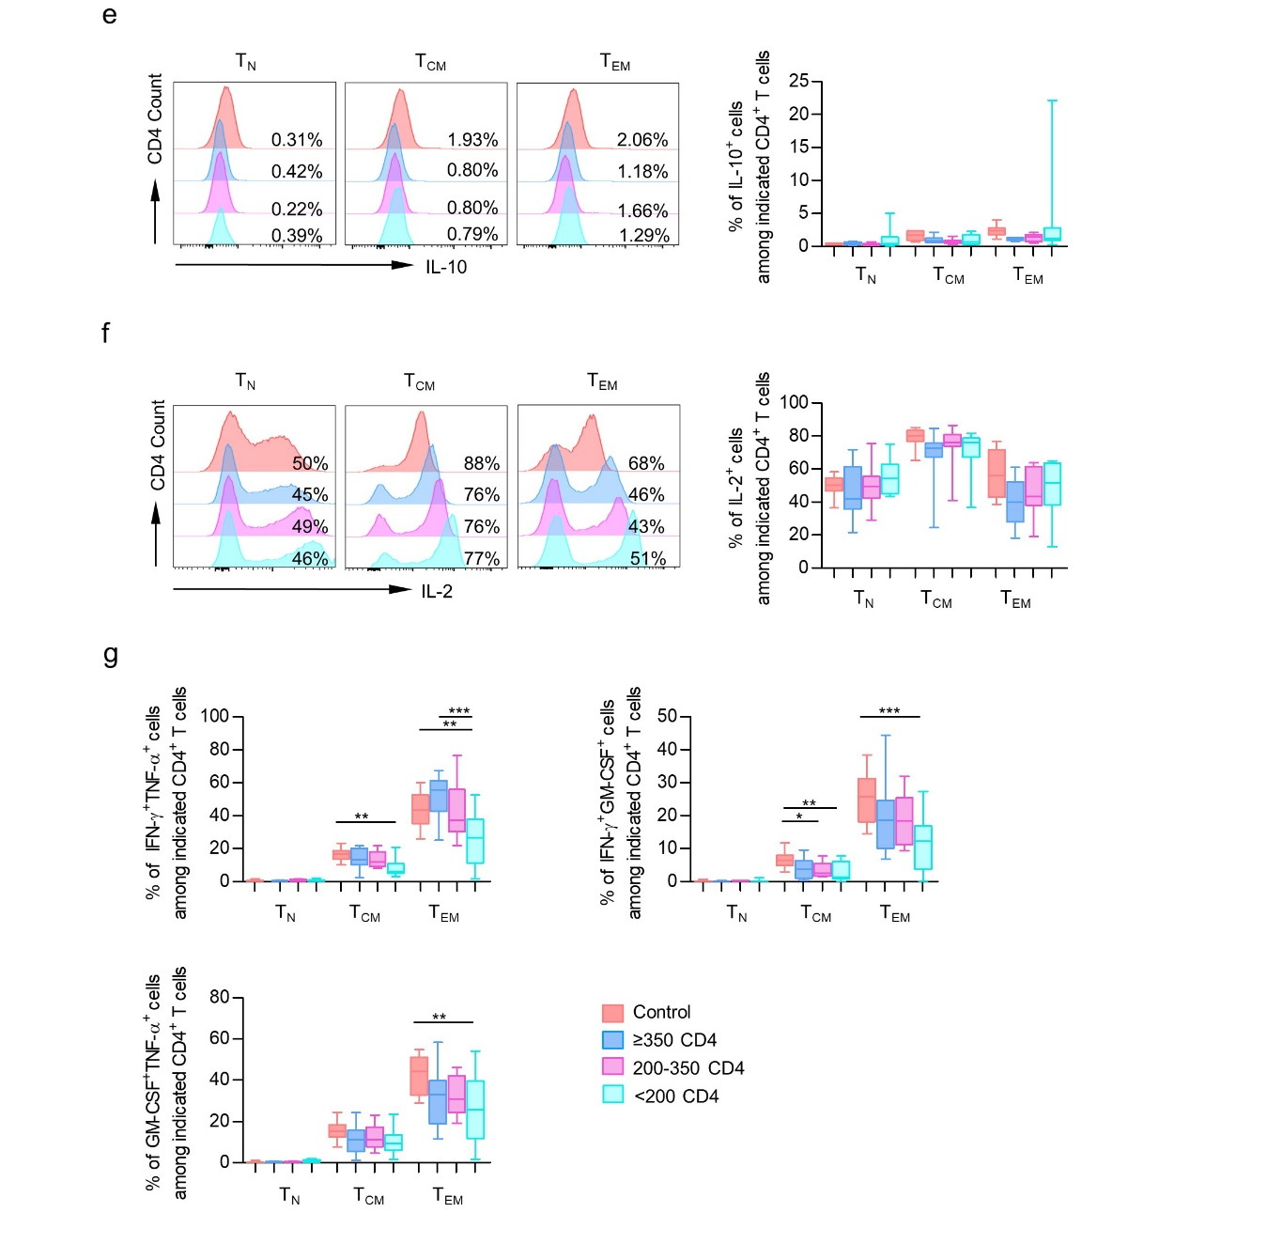
Fig S4. The frequencies of CD4⁺ cytokine-producing cells in different CD4⁺ T-cell compartments among healthy controls and different PLHIV groups.
a-f. Data were represented as histograms (left) and box plots (right) comparing median frequency in CD4⁺ cytokine-producing (IL-17, IL-22, IL-9, IL-27, IL-10, IL-2) cells in different CD4⁺ T-cell compartments (T_{N}, T_{CM}, T_{EM}) among healthy controls and different PLHIV groups (CD4 count≥350 cells/µl, 200–350 cells/µl, <200 cells/µl). g. Data were represented as box plots comparing median frequency in IFN-γ, TNF-α and GM-CSF double-positive producing CD4⁺ T cells in different CD4⁺ T cell subsets among healthy controls and different PLHIV groups. P values were obtained by Kruskal-Wallis test followed by Dunn’s multiple comparisons test. *P < 0.05, **P < 0.01, ***P < 0.001.
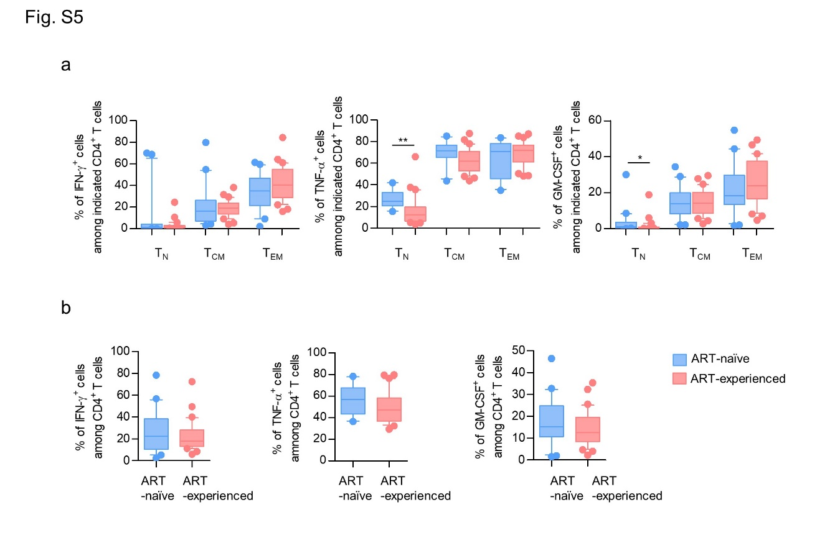
Figure S5. ART could not alter cytokine secretion in both CD4⁺ T-cell subsets and total CD4⁺ T-cells.
a. Box plots of the frequencies of IFN-γ⁺, TNF-α⁺, and GM-CSF⁺ CD4⁺ T cells in ART-naive subjects with CD4 cell count<200 cells/μl and PLHIV who experienced 3-year ART with matched baseline CD4 cell count. P values were obtained by Kruskal-Wallis test followed by Dunn’s multiple comparisons test. b. The expression of IFN-γ, TNF-α, and GM-CSF in CD4⁺ T cells from ART-naive and ART-experienced PLHIV. P values were obtained by unpaired t-test. *P < 0.05, **P < 0.01.
Supplementary Table 1. Demographic and clinical characteristics of ART-naïve and ART-experienced PLHIV
Characteristics | ART-naïve, n=20 | ART-experienced, n=34 | P-value
Sex (M/F) | 17/3 | 31/3 | 0.6588
Age (mean, yrs) | 32±5 | 39±9 | 0.0035
Transmission route
MSM | 14 | 27 | -
Heterosexual | 4 | 5 | -
Blood | 0 | 1 | -
Other/unknown | 2 | 1 | -
Nadir CD4 count (cells/mm³), median (IQR) | 66 (25-148) | 57 (21-137) | 0.5307
CD4 count (cells/mm³) after ART, median (IQR) | - | 286 (212-549) | -
Pretreatment HIV RNA viral load (copies/mL), median (IQR) | 95608  (40058-232974) | 121850  (62422-254453) | 0.5757
ART regimen  TDF+3TC+EFV  Other | -  - | 33  1 | -  -
Time of full virological suppression (month) | - | 6 | -
Time since HIV diagnosis (years), median (IQR) | - | 2.8 (2.0-3.4) | -

