Supplementary Material
An extensive literature search was performed using PubMed to identify research addressing the use of registry data for identifying cases of recurrent stroke with particular emphasis on recurrent intracerebral hemorrhage.

We used the following search query which combines free-text terms with established Medical Subject Headings (MeSH). No filters were applied to the search query.

("validity" OR "validate" OR "validation" OR "validation study" OR "positive predictive value") AND ("register-based" OR "claims-based" OR "administrative data" OR "administrative database" OR "administrative register" OR "administrative registry" OR "routinely collected health data" OR "routinely collected health data"[MeSH Terms] OR "claims data" OR "claims database" OR "claims registry" OR "register data" OR "registry data" OR "national register" OR "national registry" OR "inpatient register" OR "inpatient registry" OR "patient register" OR "patient registry" OR "stroke register" OR "stroke registry" OR "hospital register" OR "hospital registry" OR "discharge register" OR "discharge registry" OR "discharge codes" OR "diagnostic codes") AND ("recurrent stroke" OR "stroke recurrence" OR "recurrent intracerebral hemorrhage" OR "intracerebral hemorrhage recurrence" OR "recurrent intracranial hemorrhage" OR "intracranial hemorrhage recurrence" OR "recurrent hemorrhagic stroke" OR "hemorrhagic stroke recurrence" OR "recurrent ischemic stroke" OR "ischemic stroke recurrence" OR "recurrent cerebral infarction" OR "cerebral infarction recurrence" OR "stroke" OR "stroke"[MeSH Terms] OR "hemorrhagic stroke" OR "hemorrhagic stroke"[MeSH Terms] OR "intracerebral hemorrhage" OR "intracranial hemorrhage" OR "intracranial hemorrhages"[MeSH Terms] OR "ischemic stroke" OR "ischemic stroke"[MeSH Terms])

The search was last performed May 31, 2021 and yielded 314 results. The title and abstract of all 314 articles were screened to identify literature relevant to the objective of the literature search. 41 articles were selected for a full readthrough.

Reasons for articles being discarded:
- The study exclusively assessed the use of registry data for identifying first-ever stroke and not recurrent stroke.
- The study was not of relevance for the objective of this literature search.
- The article was not written in English.

To identify additional literature of relevance that was not captured by our search query, we screened the reference lists of all the articles selected for a full readthrough. This yielded another 30 articles.

A total of 71 articles were selected for a full read-through (Figure S1). Of these articles, we found one article that assessed the use of registry data for identifying recurrent stroke reporting results on recurrent intracerebral hemorrhage and recurrent ischemic stroke separately (Jones, S. A. et al., 2014).

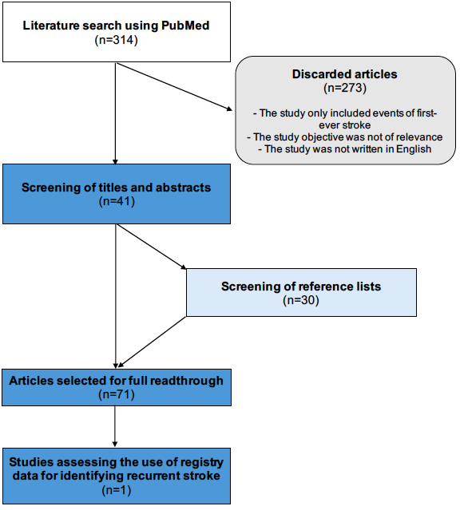

Figure S1 Flow-chart illustrating the performed literature search on the use of registry data for identifying cases of recurrent stroke.

