Proteomics of Streptococcus mutans to Reveal the Antibiofilm Formation Mechanism of Ag/ZnO Nanocomposites with Light-emitting Diode Radiation

Nan Jiang¹, Shuaiwei Zhao¹, Shilei Wang¹, Zhong Lu¹*

¹ Key Laboratory for Green Chemical Process of Ministry of Education, School of Environmental Ecology and Biological Engineering, Wuhan Institute of Technology, Wuhan 430205, P. R. China

Correspondence: Zhong Lu
Wuhan Institute of Technology, Wuhan 430205, P. R. China
Tel +86-18062036269
Fax +86-027-67905262
Email zhonglu@wit.edu.cn

Characterization of Ag/ZnO nanocomposite
The Ag/ZnO nanocomposite has been fully characterized in our former study¹. In brief, Ag/ZnO is rodlike with nanoscale at 300−500 nm, observed by a Hitachi S4800 scanning electron microscope (SEM) (V=5 eV) and a Philips Tecnai 20 transmission electron microscope (TEM) (V=200 kV) (Figure S1A and B). Furthermore, a Bruker axs D8 Discover X-ray diffraction (XRD) demonstrated that the spectra of this materials acted the same as the hexagonal wurtzite phase of ZnO (JCPDS 36-1451) with three additional peaks 2θ = 38.1°, 44.3°, and 64.4°, which belongs to the Ag pattern (JCPDS 04-0783) (Figure S1C). Finally, the percentage of Ag in Ag/ZnO nanocomposite was determined as 7.04%, using a Perkin Elmer IRIS Intrepid IIXSP inductively coupled plasma-atomic emission spectrometry (ICP-AES).

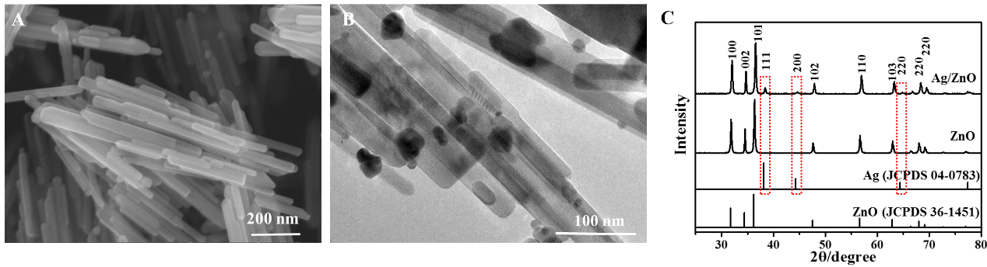
Figure S1 The characterizations for Ag/ZnO nanocomposite.
Notes: (A) SEM images, (B) TEM images, and (C) XRD patterns. This Figure is from Reference 1 with the permission of Springer Nature.
Abbreviations: SEM, scanning electron microscope; TEM, transmission electron microscope; XRD, X-ray diffraction.

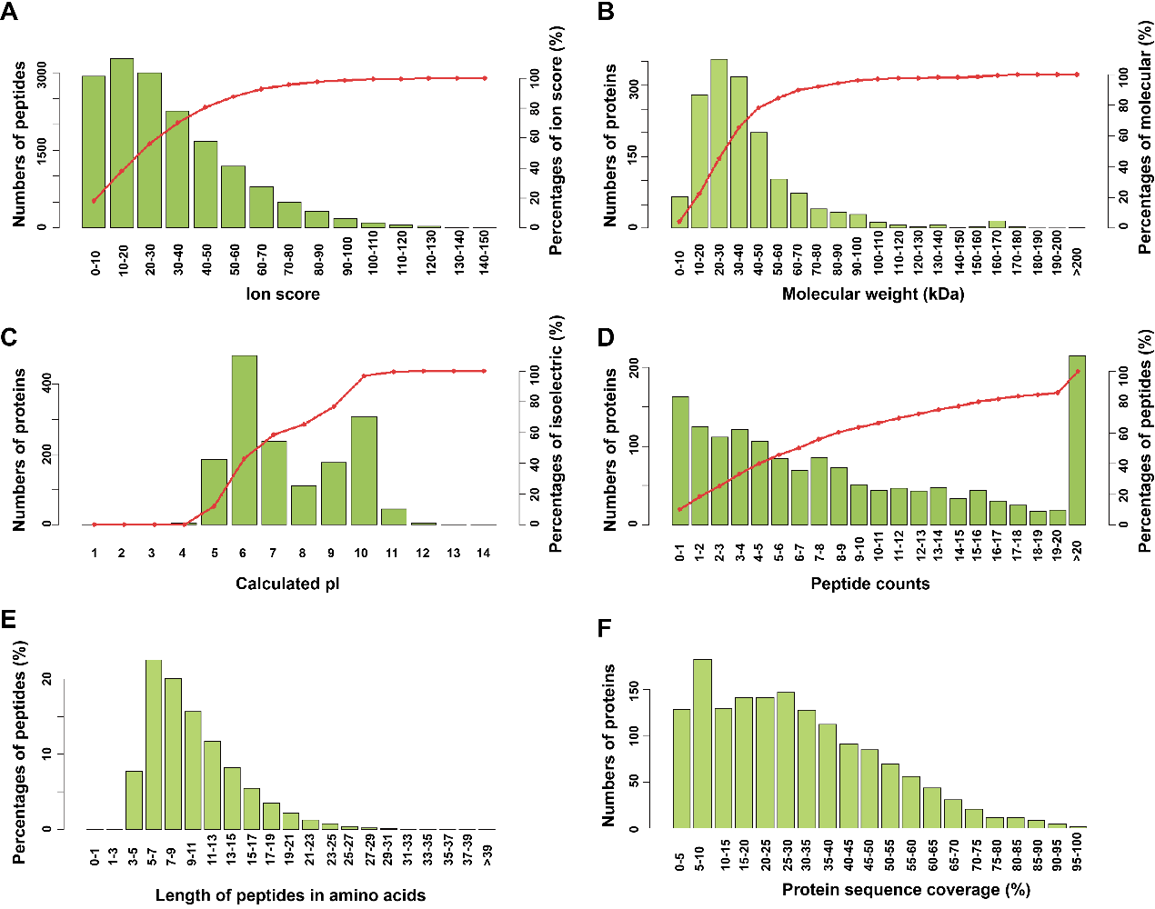
Figure S2 Quantitative analysis of protein mass spectrometry by using MASCOT.
Notes: (A) ion score distribution, (B) molecular weight distribution, (C) isoelectric point (pI) distribution, (D) peptide count distribution, (E) peptide length distribution, and (F) protein sequence coverage distribution.
Abbreviations: pI, isoelectric point.
Table S1 The identification list for proteins with the most 55 differential expression levels after synergistic therapy (fold change>1.2 and p<0.05)
Accession | Protein name | Gene name | Fold change | Reference
A0A0A8K7X7 | CRISPR-associated endonuclease Cas9 | cas9 | 0.07
A0A0E2EKL2 | Multiple promoter invertase | mpi | 0.26
A0A0E2ER88 | Elongation factor Ts | tsf | 0.30 | 2
A0A0E2EG41 | DNA polymerase III subunit  alpha | SMU29_09019 | 0.39
A0A0E2EP90 | 50S ribosomal protein L33 | rpmG | 0.51
Q5TLL6 | Modifying enzyme for proSmb | smbM1 | 0.53
Q8DSM3 | Uncharacterized protein | SMU_1755c | 0.54
A0A0E2EPZ2 | Uncharacterized protein | SMU82_06704 | 0.57
O70055 | D-alanine--  poly(phosphoribitol) ligase | dltC | 0.58 | 3
A0A0E2EK19 | Uncharacterized protein |  | 0.58
A0A0E2EJT2 | Uncharacterized protein | SMU29_02576 | 0.64
A0A0E2ENH3 | Putative membrane protein | SMU82_06314 | 0.66
A0A0E2ERU3 | Glucan-binding protein A, GbpA | SMU82_00485 | 0.68
Q8DTU7 | Uncharacterized protein | SMU_1226c | 0.68
A0A0E2EQE3 | Putative transcriptional  regulator | SMU82_03716 | 0.68 | 4
A0A0E2ES33 | Uncharacterized protein | SMU82_02931 | 0.69
A0A0E2EIJ1 | Putative Zn-dependent  protease | SMU29_04639 | 0.69
A0A0E2ER74 | Ribosomal RNA small subunit methyltransferase E | SMU82_04443 | 0.70
A0A0E2EMR7 | Putative ferredoxin (4Fe-4S) | SMU82_07571 | 0.71
A0A0E2EM32 | Glucosyltransferase-SI  (Fragment) | SMU82_09792 | 0.71 | 5, 6
A0A0E2ENF9 | Acyl carrier protein | acpP(Rename as acpP-1) | 0.72
A0A0E2EQE2 | Acyl carrier protein | acpP(Rename as acpP-2) | 0.72
A0A0E2ERD4 | Putative transcription regulator | SMU82_01250 | 0.74 | 4
Q8DV86 | Uncharacterized protein | SMU_618 | 0.75 | 7
M4JBQ8 | Glucosyltransferase-SI | gtfC | 0.75 | 5, 6
A0A0E2EK69 | Lactoylglutathione lyase | SMU29_02221 | 0.76
A0A0E2EQ70 | Putative thioredoxin H1 | SMU82_03156 | 0.76
A0A0E2ENK6 | Putative PTS system, sorbitol-  specific enzyme IIA | SMU82_07124 | 0.77 | 4, 8
A0A0E2EMS0 | Putative methylated-DNA-protein-cysteine | SMU82_08385 | 0.79
A0A0E2EHM6 | Uncharacterized protein | SMU29_06449 | 0.79
Q8DT80 | Uncharacterized protein | SMU_1486c | 0.79
A0A0E2ENG4 | Putative peptidoglycan  hydrolase | SMU82_07344 | 0.80
A0A0E2F2H0 | Uncharacterized protein | SMU82_01447 | 0.81
A0A0D6A7T5 | Sortase | srtA | 0.81 | 8
Q8DUW9 | Glucan-binding protein D with lipase activity BglB-like | gbpD | 0.81 | 9, 10
Q8DW34 | Uncharacterized protein | SMU_243 | 0.82
A0A0E2EQC0 | tRNA-specific adenosine  deaminase | tadA | 0.82
A0A0E2ERQ6 | Uncharacterized protein | SMU82_00710 | 0.82
A0A0E2EGD9 | Putative Mg²⁺/citrate  transporter | SMU29_08849 | 0.83
Q8DSL9 | Uncharacterized protein | SMU_1761c | 0.83
Q93D88 | MepR | mepR | 0.83
A0A0E2EQ31 | Levansucrase | SMU82_04583 | 0.83 | 11
A0A0E2EI55 | Putative acetyltransferase | SMU29_05419 | 0.83 | 4
Q8DUG9 | 50S ribosomal protein L7/L12 | rplL | 1.21 | 4
A0A0E2EM53 | Uncharacterized protein | SMU29_02081 | 1.22
Q8DUX7 | Uncharacterized protein | SMU_757 | 1.22
Q8DVW8 | Ribonuclease M5 | rnmV | 1.23
A0A0E2F065 | ATP/GTP hydrolase | SMU82_05767 | 1.24
A0A0A0R886 | PA | -- | 1.25 | 12, 13
A0A0E2ESP8 | Uncharacterized protein | SMU82_00275 | 1.27
A0A0A0RAT8 | PA | -- | 1.30 | 12, 13
Q54443 | Dextranase | dexA | 1.30 | 14, 15
A0A0E2EIA8 | Putative hemolysin III | SMU29_05049 | 1.34
A0A0E2F0B5 | Glucan-binding protein C | SMU82_05402 | 1.84 | 9, 10
A0A0E2EI35 | Uncharacterized protein | SMU29_07061 | 2.40

Table S2 The GO terms for these differentially expressed proteins in Table S1.

 | Pathway ID | GO term | Protein Number | The protein showed by the gene name
Biological Process | GO:0002376 | immune system process | 2 | SMU_1755c, cas9
Biological Process | GO:0051179 | localization | 4 | SMU29_08849, acpP-2, acpP-1, SMU82_07124
Biological Process | GO:0044699 | single-organism process | 11 | SMU82_03156, gtfC, SMU_1486c, SMU82_09792, SMU29_08849, SMU82_04583, dltC, acpP-1, acpP-2, SMU29_02221, SMU82_07124
Biological Process | GO:0050896 | response to stimulus | 3 | SMU_1755c, SMU82_08385, cas9
Biological Process | GO:0065007 | biological regulation | 6 | SMU82_03156, SMU82_03716, dltC, mepR, tsf, SMU82_01250
Biological Process | GO:0050789 | regulation of biological process | 6 | SMU82_03156, SMU82_03716, dltC, tsf, mepR, SMU82_01250,
Biological Process | GO:0071840 | cellular component organization or biogenesis | 7 | SMU_1755c, SMU82_04443, dltC, cas9, rnmV, rplL, rpmG
Biological Process | GO:0032502 | developmental process | 1 | dltC
Biological Process | GO:0009987 | cellular process | 26 | SMU82_03156, SMU82_09792, SMU82_04583, SMU82_04443, mpi, rplL, mepR, SMU82_03716, tadA, acpP-2, cas9, SMU29_05049, rpmG, gtfC, dltC, SMU29_05419, SMU82_08385
Biological Process | GO:0008152 | metabolic process | 28 | SMU82_03156, SMU82_09792, SMU82_04583, dltC, acpP-1, rpmG, SMU82_04443, mpi, mepR, rplL, SMU29_04639, SMU82_02931, SMU82_03716, tadA, acpP-2, cas9, SMU29_05419, SMU82_08385, gtfC, SMU_1486c, SMU82_05767, SMU29_02221, tsf, SMU_1755c, rnmV, dexA, SMU82_01250, SMU29_09019
Molecular Function | GO:0005215 | transporter activity | 2 | SMU29_08849, SMU82_07124
Molecular Function | GO:0036370 | D-alanyl carrier activity | 1 | dltC
Molecular Function | GO:0003824 | catalytic activity | 24 | SMU82_03156, SMU82_09792, SMU82_04443, SMU82_04583, dltC, dexA, mpi, SMU29_04639, SMU82_02931, SMU82_01447, SMU82_07344, cas9, gbpD, tadA, SMU29_05419, SMU82_08385, gtfC, SMU_1486c, SMU29_02221, SMU82_05767, SMU82_07124, SMU_1755c, rnmV, SMU29_09019
Molecular Function | GO:0005198 | structural molecule activity | 2 | rplL, rpmG
Molecular Function | GO:0005488 | binding | 16 | dltC, acpP-1, rnmV, SMU29_02221, SMU29_04639, SMU82_02931, tsf, mepR, SMU_1755c, SMU82_03716, tadA, cas9, acpP-2, SMU82_01250, SMU29_09019,  mpi
Molecular Function | GO:0001071 | nucleic acid binding transcription factor activity | 1 | mepR
Cellular Component | GO:0032991 | macromolecular complex | 6 | rplL, tsf, mepR, SMU29_09019, rpmG, SMU82_07124
Cellular Component | GO:0016020 | membrane | 15 | SMU29_02081, SMU29_07061, SMU82_04583, SMU29_04639, A0A0A0RAT8, SMU82_06314, SMU82_07124, SMU82_00275, SMU29_08849, srtA, SMU_243, A0A0A0R886, SMU29_05049, gbpD, SMU_618
Cellular Component | GO:0044425 | membrane part | 14 | SMU29_02081, SMU29_07061, SMU82_04583, SMU29_04639, A0A0A0RAT8, SMU82_06314, SMU82_07124, SMU82_00275, SMU29_08849, srtA, SMU_243, A0A0A0R886, SMU29_05049, SMU_618
Cellular Component | GO:0005576 | extracellular region | 6 | gtfC, gbpD, dexA SMU82_04583, SMU29_04639, A0A0A0RAT8,
Cellular Component | GO:0043226 | organelle | 3 | rplL, tsf, rpmG
Cellular Component | GO:0044421 | extracellular region part | 1 | SMU29_04639
Cellular Component | GO:0005623 | cell | 15 | SMU29_07061, SMU82_03156, SMU82_04443, rplL, tsf, mepR, A0A0A0RAT8, SMU82_07124, acpP-2, acpP-1, A0A0A0R886, rnmV, dexA, rpmG, SMU29_09019
Cellular Component | GO:0044464 | cell part | 14 | SMU29_07061, SMU82_04443, rplL, tsf, mepR, A0A0A0RAT8, SMU82_07124, acpP-2, acpP-1, A0A0A0R886, rnmV, dexA, rpmG, SMU29_09019

Abbreviations: GO, gene ontology.

Table S3 The top 20 enriched GO terms

 | Pathway ID | GO term | p-value | R- factors | The protein showed by the gene name
Biological Process | GO:0002252 | immune system process | 0.0071 | 0.5 | SMU_1755c, cas9
Biological Process | GO:0051607 | defense response to virus | 0.0071 | 0.5 | SMU_1755c, cas9
Biological Process | GO:0043570 | maintenance of DNA repeat elements | 0.0071 | 0.5 | SMU_1755c, cas9
Biological Process | GO:0009615 | response to virus | 0.0071 | 0.5 | SMU_1755c, cas9
Biological Process | GO:0043571 | maintenance of CRISPR repeat elements | 0.0071 | 0.5 | SMU_1755c, cas9
Biological Process | GO:0002376 | immune system process | 0.012 | 0.4 | SMU_1755c, cas9
Biological Process | GO:0071840 | cellular component organization or biogenesis | 0.012 | 0.4 | SMU_1755c, cas9
Biological Process | GO:0032502 | developmental process | 0.012 | 0.4 | SMU_1755c, cas9
Biological Process | GO:0009987 | cellular process | 0.012 | 0.4 | SMU_1755c, cas9
Biological Process | GO:0008152 | metabolic process | 0.012 | 0.4 | SMU_1755c, cas9
Biological Process | GO:0044260 | cellular macromolecule metabolic process | 0.021 | 0.053 | SMU82_08385, gtfC, SMU82_09792, dltC, SMU82_04443, SMU82_04583, SMU82_05767, mpi, rplL, tsf, mepR, SMU_1755c, SMU82_03716, acpP-2, tadA, cas9, acpP-1, rnmV, SMU82_01250, SMU29_09019, rpmG, SMU29_05419
Biological Process | GO:0043170 | macromolecule metabolic process | 0.030 | 0.051 | SMU82_08385, gtfC, SMU82_09792, dltC, SMU82_04443, SMU82_04583, SMU82_05767, mpi, rplL, SMU29_04639, tsf, mepR, SMU_1755c, SMU82_03716, acpP-2, tadA, cas9, acpP-1, rnmV, SMU82_01250, SMU29_09019, rpmG, SMU29_05419
Molecular Function | GO:0051192 | prosthetic group binding | 0.0012 | 1 | acpP-2, acpP-1
Molecular Function | GO:0044620 | ACP phosphopantetheine attachment site binding | 0.0012 | 1 | acpP-2, acpP-1
Molecular Function | GO:0000036 | ACP phosphopantetheine attachment site binding involved in fatty acid biosynthetic process | 0.0012 | 1 | acpP-2, acpP-1
Molecular Function | GO:0031177 | phosphopantetheine binding | 0.071 | 0.5 | acpP-1, SMU82_02931
Molecular Function | GO:0072341 | modified amino acid binding | 0.012 | 0.4 | acpP-1, SMU82_02931
Cellular Component | GO:0005576 | extracellular region | 1.38E-5 | 0.35 | gtfC, gbpD, SMU82_04583, SMU29_04639, A0A0A0RAT8, dexA
Cellular Component | GO:0016020 | external encapsulating structure | 0.00025 | 0.4 | SMU29_07061, A0A0A0R886, A0A0A0RAT8, dexA
Cellular Component | GO:0005576 | extracellular region | 0.00025 | 0.4 | SMU29_07061, A0A0A0R886, A0A0A0RAT8, dexA

Abbreviations: GO, gene ontology.

References
1. Wang S, Wu J, Yang H, et al. Antibacterial activity and mechanism of Ag/ZnO nanocomposite against anaerobic oral pathogen Streptococcus mutans. J Mater Sci-Mater M. 2017;28(1):23.
2. Yi L, Wang Y, Ma Z, et al. Biofilm formation of Streptococcus equi ssp. zooepidemicus and comparative proteomic analysis of biofilm and planktonic cells. Curr Microbiol. 2014;69(3):227–233.
3. Nilsson M, Rybtke M, Givskov M, et al. The dlt genes play a role in antimicrobial tolerance of Streptococcus mutans biofilms. Int J Antimicrob Ag. 2016;48(3):298–304.
4. Shemesh M, Tam A, Steinberg D. Differential gene expression profiling of Streptococcus mutans cultured under biofilm and planktonic conditions. Microbiology. 2007;153(5):1307–1317.
5. Bowen W, Koo H. Biology of Streptococcus mutans-derived glucosyltransferases: role in extracellular matrix formation of cariogenic biofilms. Caries Res. 2011;45(1):69–86.
6. Scharnow AM, Solinski AE, Wuest WM. Targeting S. mutans biofilms: a perspective on preventing dental caries. Med Chem Comm. 2019;10(7):1057–1067.
7. Shemesh M, Tam A, Kott-Gutkowski M, et al. DNA-microarrays identification of Streptococcus mutans genes associated with biofilm thickness. BMC Microbiol. 2008;8(1):236.
8. Hu P, Huang P, Chen MW. Curcumin reduces Streptococcus mutans biofilm formation by inhibiting sortase A activity. Arch Oral Biol. 2013;58(10):1343–1348.
9. Lynch DJ, Fountain TL, Mazurkiewicz JE, et al. Glucan-binding proteins are essential for shaping Streptococcus mutans biofilm architecture. FEMS Microbiol Lett. 2007;268(2):158–165.
10. Matsumoto-Nakano M. Role of Streptococcus mutans surface proteins for biofilm formation. Jpn Dent Sci Rev. 2018;54(1):22–29.
11. Xu W, Ni D, Zhang W, et al. Recent advances in levansucrase and inulosucrase: evolution, characteristics, and application. Crit Rev Food Sci. 2019;59(22):3630–3647.
12. Rivera-Quiroga RE, Cardona N, Padilla L, et al. In silico selection and in vitro evaluation of new molecules that inhibit the adhesion of Streptococcus mutants through antigen I/II. Int J Mol Sci. 2021;22(1):377.
13. Lapirattanakul J, Nomura R, Matsumoto-Nakano M, et al. Variation of expression defects in cell surface 190-kDa protein antigen of Streptococcus mutans. Int J Med Microbiol. 2015;305(3):383–391.
14. Yang Y, Mao M, Lei L, et al. Regulation of water-soluble glucan synthesis by the Streptococcus mutans dexA gene effects biofilm aggregation and cariogenic pathogenicity. Mol Oral Microbiol. 2019;34(2):51–63.
15. Ebaya MMA, El-Mowafy M, Adel El-Sokkary MM, et al. Purification, characterization, and biocatalytic and antibiofilm activity of a novel dextranase from Talaromyces sp. Int J Microbiol. 2020;2020(9):9198048.

