Supplementary Materials for
ORIGINAL RESEARCH
Lingling Wu et al
Platelet-tumor cell hybrid membrane-camouflaged nanoparticles for enhancing therapy efficacy in glioma
Lingling Wu²
Qin Li¹
Junjie Deng^{3,4}
Jinglan Shen¹
Weide Xu³
Wei Yang⁵
Bingyu Chen¹
Yaoqiang Du¹
Wei Zhang⁶
Feihang Ge⁶
Siyun Lei¹
Kaiqiang Li¹
Zhen Wang¹

¹Department of Transfusion medicine, Allergy Center, Ministry of Education Key Laboratory of Laboratory Medicine, Zhejiang Provincial People's Hospital People's Hospital of Hangzhou Medical College, Hangzhou 310014, China; ²Women's Hospital, School Of Medicine, Zhejiang University, Hangzhou 310014, China; ³Zhejiang Engineering Research Center for Tissue Repair Materials, Wenzhou Institute, University of Chinese Academy of Sciences, Wenzhou, Zhejiang 325000, China; ⁴Oujiang Laboratory, Wenzhou, Zhejiang 325000, China; ⁵Department of Biophysics, and Department of Neurosurgery of the First Affiliated Hospital, Zhejiang University School of Medicine, Hangzhou, P. R. China; ⁶Hangzhou Chinese Academy of Sciences-Hangzhou Medical College Advanced Medical Technology Institute, Hangzhou 310014, China

Correspondence: Kaiqiang Li & Zhen Wang
Zhejiang Provincial People's Hospital, China
Tel: 0571-87666666
Fax: 0571-85131448
Email: likaiqiang@hmc.edu.cn; wangzhen@hmc.edu.cn

Table S1. β-Mangostin NMR data
Atomic number | δ_{H} | δ_{C}
1 | 13.42 (1H, s) | 159.7
2 |  | 111.5
3 |  | 163.5
4 | 6.34 (1H, s) | 88.8
4a |  | 154.4
5 | 6.83 (1H, s) | 101.4
6 |  | 155.7
7 |  | 142.6
8 |  | 137.0
8a |  | 112.4
9 |  | 181.9
9a |  | 103.8
10a |  | 155.2
11 | 3.35 (2H, d, 7.2Hz) | 21.3
12 | 5.23 (1H, t, 7.2Hz) | 122.3
13 |  | 132.0
14 | 1.83 (3H, s) | 25.1
15 | 1.69 (3H, s) | 18.1
16 | 4.09 (2H, d, 7.2Hz) | 31.9
17 | 5.26 (1H, t, 7.2Hz) | 123.2
18 |  | 131.6
19 | 1.68 (3H, s) | 17.7
20 | 1.80 (3H, s) | 26.5
OMe-3 | 3.90 (3H, s) | 55.8
OMe-7 | 3.81 (3H, s) | 62.0
Figure S1. The ¹H NMR spectrum of β-Mangostin in Chloroform-d.

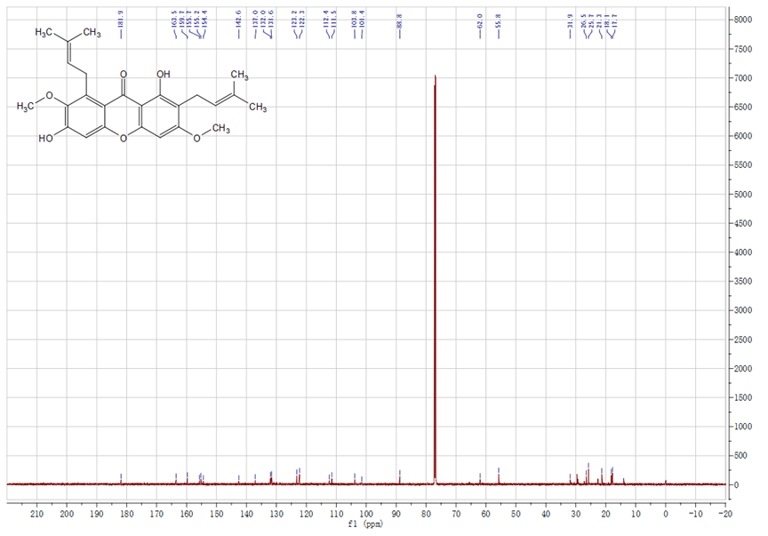
Figure S2. The ¹³C NMR spectrum of β-Mangostin in Chloroform-d.

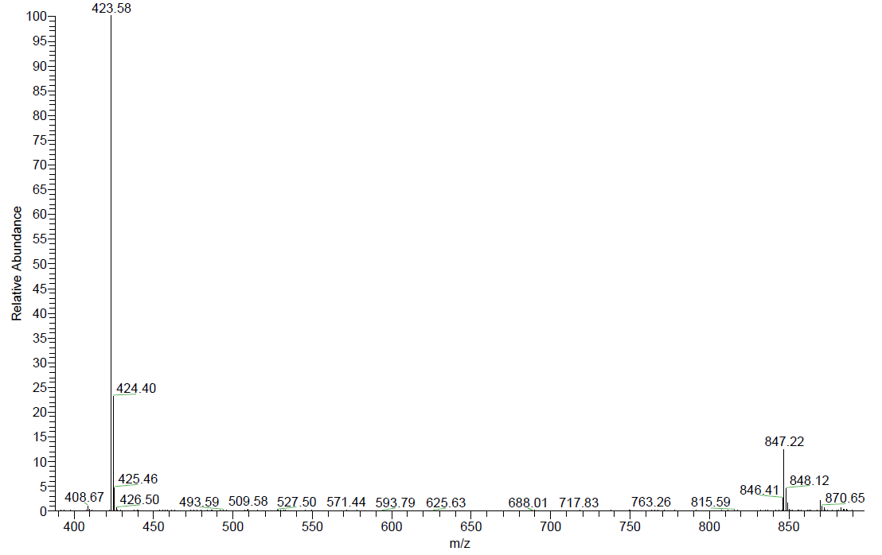
Figure S3. The mass spectrum of β-Mangostin.

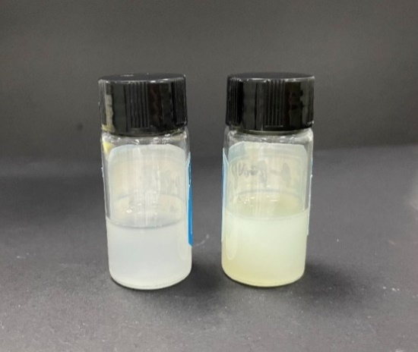
Figure S4. Schematic diagram of PCNPs(left) and β-PCNPs(right).

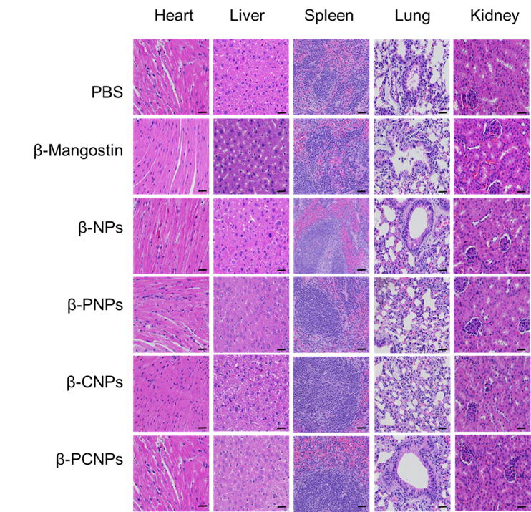
Figure S5. H&E sections of main organs from C6 glioma-bearing mice.

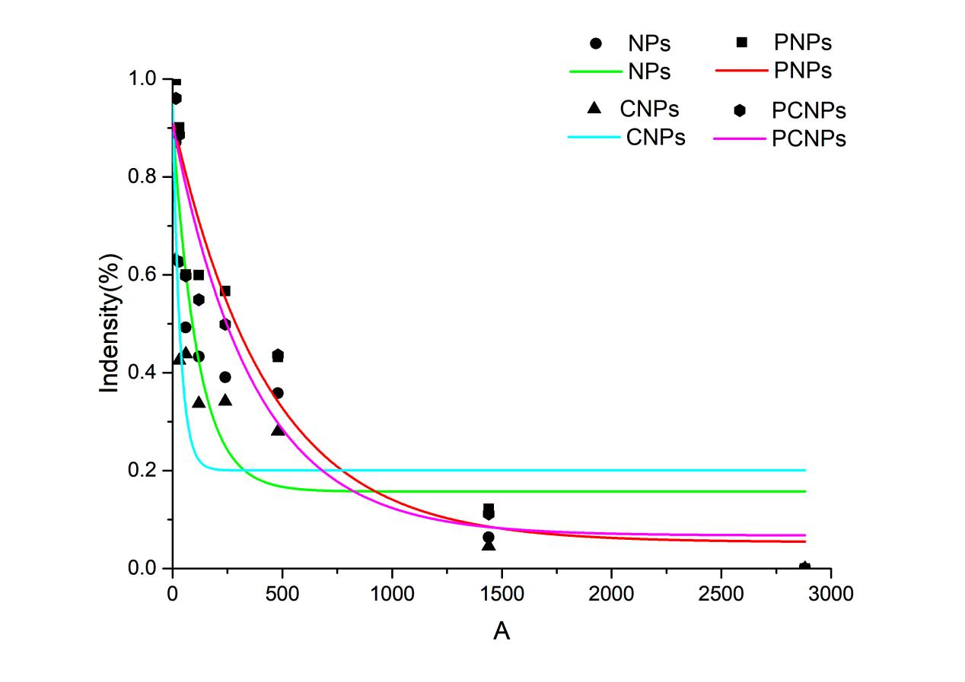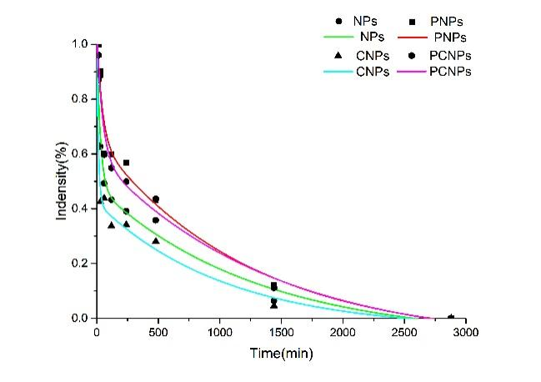

Figure S6. Blood circulation time of fluorescently labeled NPs, PNPs, CNPs and PCNPs.
T_{1/2}（NPs）=114.47min; T_{1/2}（PNPs）=435.83min; T_{1/2}（CNPs）=33.67min; T_{1/2}（PCNPs）=369.80min
Tave（NPs）=1259.06min; Tave（PNPs）=1214.07min; Tave（CNPs）=1030.16min; Tave（PCNPs）=1376.61min

