Supplementary file

Supplementary Figure 1
Statistics on Missing Data
All features had less than 20% of missing rate, of which PPM had the highest missing rate (18.86%), followed by pre-Pgmean (5.53%), annulus area (5.38%), anesthesia (4.04%). All other variables had little or no missing data (<3%). AR = aortic regurgitation; BMI = body mass index; LV = left ventricular; LVEF = left ventricular ejection fraction; MR = mitral regurgitation; NYHA = New York Heart Association; Pgmean = aortic valve mean gradient; PPM = Permanent pacemaker; STS = Society of Thoracic Surgeons.

Supplementary Figure 2
Average Feature Importance Identified by Captum Interpretation Library.
Feature importance in the proposed BLeNet model was evaluated by the Captum interpretation library. The average feature importance of all features was shown in A and B.
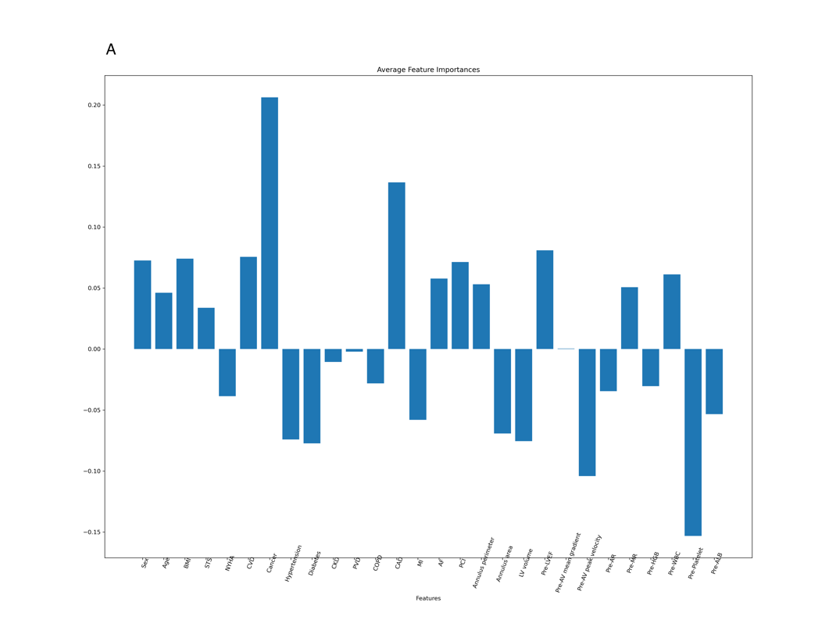
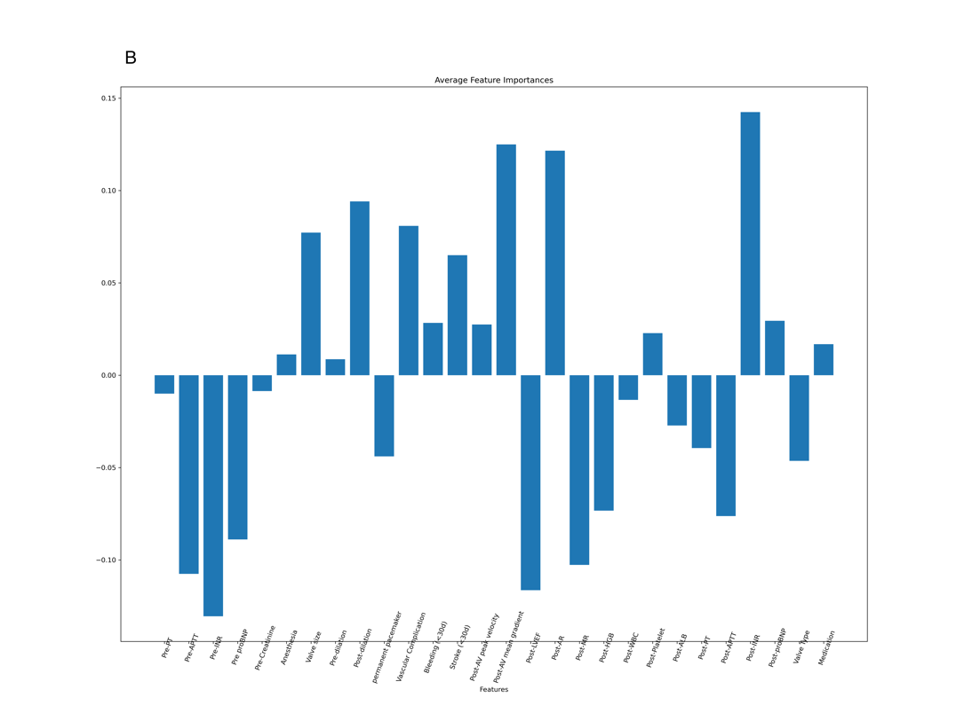

Supplementary Figure 3
Comparison of Receiver Operating Characteristics Curve for BLeNet, Cox-PH and Random Survival Forest Models Built with the Same Features.
The Cox-PH and random survival forest models here were built with the same features as the BLeNet model. RSF = random survival forest

