Additional file 1 The PRISMA network meta-analysis checklist.
Additional file 2 Main characteristics of included RCTs.
Additional file 3 Details of electrical stimulation.
Additional file 4 Risk of Bias Assessment.
Additional file 5 Pairwise Meta-Analysis.
Additional file 6 Assessment of inconsistency results.
Additional file 7 Assessment of convergence of the model results.
Additional file 8 Treatment ranking and SUCRA for outcome data.
Additional file 1 The PRISMA network meta-analysis checklist.
Notes: From Annals of Internal Medicine, Brian Hutton, Georgia Salanti, Deborah M. Caldwell, et al , The PRISMA Extension Statement for Reporting of Systematic Reviews Incorporating Network Meta-analyses of Health Care Interventions: Checklist and Explanations, 2015;162(11):777–784. Copyright © 2015 American College of Physicians. All Rights Reserved. Reprinted with the permission of American College of Physicians, Inc.²⁴
Section/Topic | Item # | Checklist Item | Reported on Page #
TITLE
Title | 1 | Identify the report as a systematic review incorporating a network meta-analysis (or related form of meta-analysis). | Page 1
ABSTRACT
Structured summary | 2 | Provide a structured summary including, as applicable:  Background: main objectives  Methods: data sources; study eligibility criteria, participants, and interventions; study appraisal; and synthesis methods, such as network meta-analysis.  Results: number of studies and participants identified; summary estimates with corresponding confidence/credible intervals; treatment rankings may also be discussed. Authors may choose to summarize pairwise comparisons against a chosen treatment included in their analyses for brevity.  Discussion/Conclusions: limitations; conclusions and implications of findings.  Other: primary source of funding; systematic review registration number with registry name. | Page 2-3
INTRODUCTION
Rationale | 3 | Describe the rationale for the review in the context of what is already known, including mention of why a network meta-analysis has been conducted. | Page 3-6
Objectives | 4 | Provide an explicit statement of questions being addressed, with reference to participants, interventions, comparisons, outcomes, and study design (PICOS). | Page 5-6
METHODS
Protocol and registration | 5 | Indicate whether a review protocol exists and if and where it can be accessed (e.g., Web address); and, if available, provide registration information, including registration number. | Page 6
Eligibility criteria | 6 | Specify study characteristics (e.g., PICOS, length of follow-up) and report characteristics (e.g., years considered, language, publication status) used as criteria for eligibility, giving rationale. Clearly describe eligible treatments included in the treatment network, and note whether any have been clustered or merged into the same node (with justification). | Page 6-9
Information sources | 7 | Describe all information sources (e.g., databases with dates of coverage, contact with study authors to identify Additional file studies) in the search and date last searched. | Page 6-7
Search | 8 | Present full electronic search strategy for at least one database, including any limits used, such that it could be repeated. | Page 6-7 (Table 1)
Study selection | 9 | State the process for selecting studies (i.e., screening, eligibility, included in systematic review, and, if applicable, included in the meta-analysis). | Page 10-11; Page 13 (Figure 1)
Data collection process | 10 | Describe method of data extraction from reports (e.g., piloted forms, independently, in duplicate) and any processes for obtaining and confirming data from investigators. | Page 10-11
Data items | 11 | List and define all variables for which data were sought (e.g., PICOS, funding sources) and any assumptions and simplifications made. | Page 10 (Figure 1)
Geometry of the network | S1 | Describe methods used to explore the geometry of the treatment network under study and potential biases related to it. This should include how the evidence base has been graphically summarized for presentation, and what characteristics were compiled and used to describe the evidence base to readers. | Page 10-11; Page 12 (Additional file 2)
Risk of bias within individual studies | 12 | Describe methods used for assessing risk of bias of individual studies (including specification of whether this was done at the study or outcome level), and how this information is to be used in any data synthesis. | Page 11-12
Summary measures | 13 | State the principal summary measures (e.g., risk ratio, difference in means). Also describe the use of Additional file summary measures assessed, such as treatment rankings and surface under the cumulative ranking curve (SUCRA) values, as well as modified approaches used to present summary findings from meta-analyses. | Page 10-12
Planned methods of analysis | 14 | Describe the methods of handling data and combining results of studies for each network meta-analysis. This should include, but not be limited to:  - Handling of multi-arm trials;  - Selection of variance structure;  - Selection of prior distributions in Bayesian analyses; and  - Assessment of model fit. | Page 7-12
Assessment of Inconsistency | S2 | Describe the statistical methods used to evaluate the agreement of direct and indirect evidence in the treatment network(s) studied. Describe efforts taken to address its presence when found. | Page 11-12
Risk of bias across studies | 15 | Specify any assessment of risk of bias that may affect the cumulative evidence (e.g., publication bias, selective reporting within studies). | Page 11-12; Page 18
Additional file analyses | 16 | Describe methods of Additional file analyses if done, indicating which were pre-specified. This may include, but not be limited to, the following:  - Sensitivity or subgroup analyses;  - Meta-regression analyses;  - Alternative formulations of the treatment network; and  - Use of alternative prior distributions for Bayesian analyses (if applicable). | Page 11-12
RESULTS†
Study selection | 17 | Give numbers of studies screened, assessed for eligibility, and included in the review, with reasons for exclusions at each stage, ideally with a flow diagram. | Page 13 (Figure 1)
Presentation of network structure | S3 | Provide a network graph of the included studies to enable visualization of the geometry of the treatment network. | Page 4-6
Summary of network geometry | S4 | Provide a brief overview of characteristics of the treatment network. This may include commentary on the abundance of trials and randomized patients for the different interventions and pairwise comparisons in the network, gaps of evidence in the treatment network, and potential biases reflected by the network structure. | Page 15-16 (Figure 4-6)
Study characteristics | 18 | For each study, present characteristics for which data were extracted (e.g., study size, PICOS, follow-up period) and provide the citations. | Page  13-14(Additional file 2 and 3)
Risk of bias within studies | 19 | Present data on risk of bias of each study and, if available, any outcome level assessment. | Page 14-15 (Figure 2 and 3; Additional file 4)
Results of individual studies | 20 | For all outcomes considered (benefits or harms), present, for each study: 1) simple summary data for each intervention group, and 2) effect estimates and confidence intervals. Modified approaches may be needed to deal with information from larger networks. | Page 15 (Additional file 5; Table 2)
Synthesis of results | 21 | Present results of each meta-analysis done, including confidence/credible intervals. In larger networks, authors may focus on comparisons versus a particular comparator (e.g. placebo or standard care), with full findings presented in an appendix. League tables and forest plots may be considered to summarize pairwise comparisons. If Additional file summary measures were explored (such as treatment rankings), these should also be presented. | Page 15-18 (Additional file 5 and 8; Table 2; Figure 7-11)
Exploration for inconsistency | S5 | Describe results from investigations of inconsistency. This may include such information as measures of model fit to compare consistency and inconsistency models, P values from statistical tests, or summary of inconsistency estimates from different parts of the treatment network. | Page 17 (Additional file 6 and 7)
Risk of bias across studies | 22 | Present results of any assessment of risk of bias across studies for the evidence base being studied. | Page 14-15 (Figure 2 and 3; Additional file 4)
Results of Additional file analyses | 23 | Give results of Additional file analyses, if done (e.g., sensitivity or subgroup analyses, meta-regression analyses, alternative network geometries studied, alternative choice of prior distributions for Bayesian analyses, and so forth). | Page 18-19(Figure 12-14)
DISCUSSION
Summary of evidence | 24 | Summarize the main findings, including the strength of evidence for each main outcome; consider their relevance to key groups (e.g., healthcare providers, users, and policy-makers). | Page 19-21
Limitations | 25 | Discuss limitations at study and outcome level (e.g., risk of bias), and at review level (e.g., incomplete retrieval of identified research, reporting bias). Comment on the validity of the assumptions, such as transitivity and consistency. Comment on any concerns regarding network geometry (e.g., avoidance of certain comparisons). | Page 24
Conclusions | 26 | Provide a general interpretation of the results in the context of other evidence, and implications for future research. | Page 25
FUNDING
Funding | 27 | Describe sources of funding for the systematic review and other support (e.g., supply of data); role of funders for the systematic review. This should also include information regarding whether funding has been received from manufacturers of treatments in the network and/or whether some of the authors are content experts with professional conflicts of interest that could affect use of treatments in the network. | Page 26

 | Country | Type of stroke(CH:Cerebral Infarction;CI:Cerebral Hemorrhage) | Stroke stage | Brunnstrom | Course of disease(days) |  |  | Sample size | Allocation ratio | Age | Gender (M:F) | (A) | (B) | (C) | Duration of treatment(days) | Outcome Measure | Main Results
 |  |  |  |  | Treatment Group(A) | Control Group I(B) | Control Group II(C) |  |  |  |  | Treatment Group(A) | Control Group I(B) | Control Group II(C) | Duration of treatment(days) | Outcome Measure | Main Results
Chen Y 2018 | China | A:(CH:CI=8:18);B=(CH:CI=6:21) | Sequelae period | Ⅲ-Ⅴ | 275.95±59.11 | 271.43±74.01 | - | 53 | 1:1 | A:60.75±16.62 B:60.45±11.25 | A:(19:7） B:(20:7) | RT+TEAS | RT | - | 42 | 1.FMA;2.MBI;3.MAS | 1.A=B;2.A=B;3.A=B
Yan Y 2019 | China | - | Sequelae period | - | - | - | - | 120 | 1:1 | A:62.40±? B:60.90±? | A:(33:27） B:(39:21) | RT+TEAS | RT | - | 120 | 1.MBI | 1.A＞B
Chen Y 2019 | China | A:(CH:CI=5:23);B=(CH:CI=9:19) | - | ＜V | 152.39±123.46 | 156.36±123.60 | - | 60(Fall off 4 cases) | 1:1 | A:64.50±12.95 B:64.57±9.35 | A:(22:6) B:(21:7) | RT+TEAS | RT | - | 42 | 1.FMA;2.MBI;3.MAS | 1.A＞B;2.A=B;3.A＞B
Liu Z 2005 | China | A:(CH:CI=16:42);B=(CH:CI=19:39) | Acute stage | - | ＜30 | ＜30 | - | 116 | 1:1 | A:61.80±12.20 B:60.60±13.70 | A:(34:24) B:(32:26) | RT+FES | RT | - | 78.4±30.8 | 1.FMA | 1.A＞B
Chen Y 2021 | China | - | Sequelae period | - | 141±75 | 126± 69 | - | 75 | 1:1 | A:59.2±2.1 B:58.7±5.7 | A:(25:12) B:(26:12) | RT+FES | RT | - | 20 | 1.FMA | 1.A＞B
Zhao M 2016 | China | A:(CH:CI=15:15);B=(CH:CI=17:13) | - | - | - | - | - | 60 | 1:1 | A:58.16±8.47 B:60.27±7.02 | A:(16:14) B:(17:13) | RT+FES | RT | - | 20 | 1.FMA;2.MBI | 1.A＞B;2.A＞B
Zuo X 2014 | China | A:(CH:CI=19:21);B=(CH:CI=17:23) | - | ＜V | 31.55±20.13 | 35.90±19.60 | - | 80 | 1:1 | A:55.70±12.32 B:57.68±13.54 | A:(27:13) B:(30:10) | RT+tDCS | RT+SS | - | 20 | 1.FMA;2.MBI;3.MAS | 1.A＞B;2.A=B;3.A=B
Zheng C 2019 | China | A:(CH:CI=13:36);B=(CH:CI=16:31) | - | ≤V | 31.4±11.4 | 35.3±12.2 | - | 96(Fall off 15 cases) | 1:1 | A:59.80±8.30 B:61.10±7.40 | A:(27:22) B:(28:19) | RT+tDCS | RT+SS | - | 28 | 1.FMA;2.MBI | 1.A＞B;2.A＞B
Wang C 2016 | China | A:(CH:CI=23:21);B=(CH:CI=20:23) | - | - | 98.51±32.42 | 97.83±34.37 | - | 93 | 1:1 | A:43.29±12.45 B:44.52±12.28 | A:(25:22) B:(23:23) | RT+tDCS | RT | - | 60 | 1.FMA;2.MBI | 1.A＞B;2.A＞B
Zhang L 2019 | China | A:(CI=20);B:(CI=20) | - | Ⅱ-Ⅳ | 52.42±17.31 | 49.29±16.28 | - | 40 | 1:1 | A:54.52±8.02 B:55.34±7.82 | A:(14:6) B:(13:7) | RT+tDCS | RT+SS | - | 21 | 1.FMA;2.MAS | 1.A＞B;2.A＞B
Liu C 2018 | China | A:(CH:CI=16:34);B=(CH:CI=15:35) | - | - | 54±21 | 48±15 | - | 100 | 1:1 | A:59.70±3.30 B:60.2±3.5 | A:(35:15) B:(33:17) | RT+TENS | RT | - | 30 | 1.FMA | 1.A＞B
Zhou J 2020 | China | A:(CH:CI=10:10);B=(CH:CI=6:14) | - | Ⅰ-Ⅳ | 41.53±3.84 | 41.48±1.66 | - | 40 | 1:1 | A:66.90±8.77 B:67.80±8.53 | A:(15:5) B:(14:6) | RT+TEAS | RT+SS | - | 42 | 1.FMA;2.MBI | 1.A=B;2.A＞B
Peng Y 2015 | China | A:(CH:CI=7:14);B=(CH:CI=7:13) | - | ＜4 | 67.5±26.1 | 60.6±31.5 | - | 46(Fall off 5 cases) | 1:1 | A:66.4±10.8 B:65.5±11.2 | A:(9:12) B:(10:10) | RT+TEAS | RT+SS | - | 21 | 1.FMA;2.MBI | 1.A＞B;2.A＞B
Jia J 2018 | China | A:(CH:CI=22:32);B=(CH:CI=20:34) | - | Ⅰ-Ⅴ | 144±51 | 150±48 | - | 108 | 1:1 | A:64.7±9.8 B:64.2±9.5 | A:(29:25) B:(32:22) | RT+TEAS | RT | - | 84 | 1.MBI | 1.A＞B
Zheng W 2020 | China | A:(CH:CI=15:19);B=(CH:CI=13:21) | - | Ⅰ-Ⅴ | 186±54 | 177±21 | - | 68 | 1:1 | A:58.9±1.3 B:58.8±1.1 | A:(23:11) B:(22:12) | RT+TEAS | RT | - | 28 | 1.FMA;2.MAS | 1.A＞B;2.A＞B
Mao Z 2017 | China | A:(CH:CI=12:14);B=(CH:CI=11:15) | - | Ⅰ-Ⅴ | 177.60±72.00 | 186.90±96.30 | - | 52 | 1:1 | A:59.52±7.35 B:58.92±6.21 | A:(14:12) B:(18:8) | RT+TEAS | RT | - | 28 | 1.FMA;2.MAS | 1.A＞B;2.A＞B
Yu L 2020 | China | A:(CH:CI=24:30);B=(CH:CI=22:32) | Sequelae period | - | - | - | - | 108 | 1:1 | A:62.5±6.5 B:61.8±5.8 | A:(30:24) B:(29:25) | RT+TEAS | RT | - | 30 | 1.MBI | 1.A＞B
Chen Y 2015 | China | A:(CH:CI=7:13);B=(CH:CI=8:15) | - | Ⅰ-Ⅴ | 186.00±85.50 | 185.10±92.40 | - | 43 | 1:1 | A:61.05±9.24 B:57.69±8.79 | A:(17:3) B:(19:4) | RT+TEAS | RT | - | 28 | 1.FMA;2.MBI;3.MAS | 1.A＞B;2.A＞B;3.A=B
Gu Z 2019 | China | A:(CH:CI=6:15);B=(CH:CI=8:13) | - | - | - | - | - | 42 | 1:1 | A:63.8±7.1 B:62.9±8.3 | A:(14:7) B:(12:9) | RT+TEAS | RT | - | 28 | 1.FMA;2.MAS | 1.A＞B;2.A＞B
Xie J 2019 | China | A:(CI=:42);B=(CI=:40) | - | - | 40.28±9.28 | 41.95±10.88 | - | 82 | 1:1 | A:50.38±10.76 B:49.68±10.52 | A:(23:19) B:(24:16) | RT+TEAS | RT | - | 28 | 1.FMA;2.MBI | 1.A＞B;2.A＞B
Zhang H 2012 | China | A:(CI=:45);B=(CI=:40) | Acute stage | - | - | - | - | 85 | 1:1 | A:65.23±9.21 B:64.89±7.73 | A:(25:20) B:(21:19) | RT+TEAS | RT | - | 14 | 1.FMA;2.MBI | 1.A＞B;2.A＞B
Ren H 2014 | China | CH;CI(Not specified) | - | - | - | - | - | 40 | 1:1 | 53.9±6.7(Not grouping) | 26:14（Not grouping） | RT+FES | RT | - | 21 | 1.FMA;2.MBI | 1.A＞B;2.A＞B
Yang Y 2016 | China | A:(CH:CI=15:25);B=(CH:CI=17:23) | Acute stage | - | ＜7 | ＜7 | - | 80 | 1:1 | A:62.73±12.47 B:63.62±12.81 | A:(22:18) B:(22:18) | RT+NMES | RT | - | 56 | 1.FMA;2.MBI | 1.A＞B;2.A＞B
Jiang Z 2010 | China | A:(CH:CI=10:20);B=(CH:CI=9:21) | - | Ⅰ-Ⅴ | 69.03±69.64 | 72.37±48.81 | - | 60 | 1:1 | A:60.83±12.27 B:59.16±13.97 | A:(21:9) B:(20:10) | RT+NMES | RT | - | 42 | 1.FMA;2.MBI | 1.A＞B;2.A=B
Sun D 2015 | China | A:(CI=20);B=(CI=20) | - | - | 7-180 | 7-180 | - | 40 | 1:1 | A:53.87±7.03 B:55.23±6.62 | A:(7:13) B:(10:10) | RT+TEAS | RT | - | 14 | 1.FMA | 1.A＞B
Xie J 2020 | China | - | - | - | 39.73±5.86 | 41.43±6.47 | - | 132 | 1:1 | A:55±9 B:56±7 | A:(45:21) B:(40:26) | RT+TEAS | RT | - | 28 | 1.FMA;2.MBI | 1.A＞B;2.A＞B
Wang J 2016 | China | A:(CH:CI=12:28);B=(CH:CI=11:29) | - | - | - | - | - | 80 | 1:1 | A:49.7±11.5 B:48.9±10.7 | A:(27:13) B:(30:10) | RT+TENS | RT | - | 30 | 1.FMA | 1.A＞B
Lin Z 2011 | China | A:(CH:CI=6:13);B=(CH:CI=6:12) | - | - | 43.50±25.20 | 41.30±26.5 | - | 46(Fall off 9 cases) | 1:1 | A:62.2±8.7 B:66.0±9.6 | A:(11:8) B:(11:7) | RT+NMES | RT | - | 21 | 1.FMA;2.MBI;3.MAS | 1.A＞B;2.A＞B;3.A=B
Zhou M 2016 | China | A:(CH:CI=8:12);B=(CH:CI=14:8);C=(CH:CI=7:13) | - | - | 65.30±60.56 | 91.23±56.45 | 90.30±56.70 | 66(Fall off 4 cases) | 1:1:1 | A:59.65±11.92 B:56.14±8.77 C:62.60±9.94 | A:(11:9) B:(14:5) C:(14:4) | RT+NMES | RT+TENS | RT | 28 | 1.FMA;2.MBI | 1.A=B=C;2.A=B=C
Zhou M 2018 | China | A:(CH:CI=12:19);B=(CH:CI=19:13);C=(CH:CI=6:12) | - | - | 73.61±53.40 | 100.88±103.32 | 105.89±142.80 | 90(Fall off 9 cases) | 1:1:1 | A:59.35±10.78 B:58.50±9.07 C:63.78±11.17 | A:(21:10) B:(26:6) C:(3:15) | RT+NMES | RT+TENS | RT | 28 | 1.FMA;2.MBI;3.MAS | 1.A=B=C;2.A=B=C;3.A=B=C
Nak Y 2017 | Turkey | A:(CH:CI=4:11);B=(CH:CI=2:13) | - | - | 138±39.9 | 145.8±44.7 | - | 30 | 1:1 | A:60.20±12.20 B:57.66±10.63 | A:(8:7) B:(9:6) | RT+FES | RT | - | 28 | 1.MBI | 1.A＞B
Ali D 2020 | Turkey | A:(CH:CI=5:11);B=(CH:CI=3:13) | - | - | 352.62±390.32 | 442.75±687.43 | - | 32 | 1:1 | A: 63.56±10.19 B:63.50±12.60 | A:(6:10) B:(7:9) | RT+tDCS | RT+SS | - | 21 | 1.FMA | 1.A＞B
Jiang Y 2020 | China | A:(CH:CI=8:7);B=(CH:CI=9:6) | - | - | 21.84±13.81 | 22.09±12.05 | - | 30 | 1:1 | A:53.19±5.95 B:52.35±6.03 | A:(10:5) B:(11:4) | RT+tDCS | RT+SS | - | 14 | 1.FMA;2.MBI | 1.A＞B;2.A＞B
Wang Q 2012 | China | A:(CH:CI=10:15);B=(CH:CI=8:17) | - | ≤Ⅱ | 25.2±2.58 | 25.16±2.56 | - | 50 | 1:1 | A:57.16±4.19 B:57.40±4.33 | A:(14:11) B:(15:10) | RT+NMES | RT | - | 28 | 1.MAS | A=B
Additional file 2 Main characteristics of included RCTs.
Additional file 3 Details of electrical stimulation.
Author year | Frequency(Hz)/intensity(mA) of electrical stimulation | The site of electrical stimulation | Duration of electrical stimulation | Number of treatments | Frequency of treatment(weeks/days)
Chen Y 2018 | BrunnstromⅢ~Ⅳ:10-15 Hz BrunnstromⅤ:4Hz | Acupuncture points:Shousanli;Waiguan | 30min | RT+TEAS:26 RT:27 | 5'/W
Yan Y 2019 | General condition:10Hz;The disease is serious:4Hz | Acupuncture points:Shousanli;Waiguan | 30min | CT+TEAS:60 CT:60 | -
Chen Y 2019 | BrunnstromI～Ⅱ:2Hz;BrunnstromIII～Ⅳ:4-15Hz | Acupuncture points:Shousanli;Waiguan | 30min | RT+TEAS:28 RT:28 | 5'/W
Liu Z 2005 | - | Triceps brachii muscle;Anterior wall muscle group;Radial head;Deltoid muscle;Supraspinatus muscle | 30min | RT+FES:58 RT:58 | 2'/D
Chen Y 2021 | 20~80 Hz | Shoulder muscles | 20min | RT+FES:37 RT:38 | 1'/D
Zhao M 2016 | 35Hz/8mA | Upper forearm | 30min | RT+FES:30 RT:30 | 1'/D
ZUO X 2014 | 1mA | Upper limb area of anterior central gyrus | 20min | RT+tDCS:40 RT+SS:40 | 5'/W
Zheng C 2019 | 1.5mA | Motor area of cerebral hemisphere(M1) | 20min | RT+tDCS:41 RT+SS:40 | 5'/W
Wang C 2016 | 20~40 Hz | Upper limb skin | 30min | RT+tDCS:47 RT:46 | 5'/W
Zhang L 2019 | 1.75mA | Motor area of cerebral hemisphere(M1) | 20min | RT+tDCS:20 RT+SS:20 | 6'/W
Liu C 2018 | 90Hz | Shoulder joint | 20min | RT+TENS:50 RT:50 | 2'/D
Zhou J 2020 | BrunnstromI - II:2Hz;Brunnstrom III - IV:10Hz | Acupuncture points:Shousanli;Waiguan | 30min | RT+TEAS:20 RT+SS:20 | 5'/W
Peng Y 2015 | 100Hz | Acupuncture points:Waiguan;Jianyu;Quchi;Hegu | 30min | RT+TEAS:21 RT+SS:20 | 5'/W
Jia J 2018 | BrunnstromⅠ-Ⅱ:2Hz;Brunnstrom Ⅲ-Ⅳ:4-15Hz;Brunnstrom Ⅴ-Ⅵ:4Hz | Acupuncture points:Shousanli;Waiguan | BrunnstromⅠ-Ⅱ:25-30min;Brunnstrom Ⅲ-Ⅳ:20-30min;Brunnstrom Ⅴ-Ⅵ:30min | RT+TEAS:54 RT:54 | 5'/W
Zheng W 2020 | - | Acupuncture points:Shousanli;Waiguan | 30min | RT+TEAS:34 RT:34 | 5'/W
Mao Z 2017 | - | Acupuncture points:Shousanli;Waiguan | 30min | RT+TEAS:26 RT:26 | 5'/W
Yu L 2020 | 100Hz/10-40mA | Acupuncture points:Eight evil points | 30min | RT+TEAS:54 RT:54 | 1'/D
Chen Y 2015 | - | Acupuncture points:Shousanli;Waiguan | - | RT+TEAS:20 RT:23 | 5'/W
Gu Z 2019 | 35Hz/10-50mA | Acupuncture points:Shousanli;Waiguan | 15min | RT+TEAS:21 RT:21 | 1'/D
Xie J 2019 | 2Hz | Acupuncture points:Waiguan;Jianyu;Quchi;Shousanli | 30min | RT+TEAS:42 RT:40 | 5'/W
Zhang H 2012 | 4Hz/0-100mA | Acupuncture points:Waiguan;Jianyu;Quchi;Shousanli | 30min | RT+TEAS:45 RT:40 | 2'/D
Ren H 2014 | 30Hz/0-90mA | Middle part of supraspinatus muscle; Middle deltoid | 30min | RT+FES:20 RT:20 | 5'/W
Yang Y 2016 | 50Hz/20-30mA | Extensor carpi muscle | 20min | RT+NMES:40 RT:40 | 5'/W
Jiang Z 2010 | 35Hz/10-50mA | Extensor carpi radialis muscle;Musculus extensor digitorum communis | 30min | RT+NMES:30 RT:30 | 5'/W
Sun D 2015 | 50Hz | Acupuncture points:Waiguan;Binao;Shouwuli;Quchi;Shousanli | 30min | RT+TEAS:20 RT:20 | 2'/D
Xie J 2020 | 2-15 Hz/(12±2)mA | Acupuncture points:Waiguan;Jianyu;Quchi;Shousanli | 30min | RT+TEAS:66 RT:66 | 5'/W
Wang J 2016 | 50-100Hz | Shoulder joint | 30min | RT+TENS:40 RT:40 | 1'/D
Lin Z 2011 | 30Hz | The supraspinatus muscle and the deltoid muscle on the paretic side | 30min | RT+NMES:19 RT:18 | 5'/W
Zhou M 2016 | NMES:15Hz;TENS:100Hz | The trapezius muscle;The supraspinatus muscle;The deltoid | 60min | RT+NMES:20;RT+TENS:22;RT:20 | 5'/W
Zhou M 2018 | NMES:15Hz;TENS:100Hz/20-50mA | The trapezius muscle;The supraspinatus muscle;The deltoid | 60min | RT+NMES:31;RT+TENS:32;RT:18 | 5'/W
Nak Y 2017 | 30Hz | Motor points of the extensor carpi radialis longus;Extensor carpi radialis brevis;Extensor carpi ulnaris;Extensor digitorum communis | 30min | RT+FES:15 RT:15 | 5'/W
Ali D 2020 | 2mA | The C3 motor point of the ipsilesional hemisphere | 30min | RT+tDCS:16 RT+SS:16 | 5'/W
Jiang Y 2020 | 1-1.5mA | Diseased lateral cerebral hemisphere | 20min | RT+tDCS:15 RT+SS:15 | 5'/W
Wang Q 2012 | 0.2Hz | The supraspinatus muscle;The deltoid | 25min | RT+NMES:25 RT:25 | 5'/W

Additional file 4 Risk of Bias Assessment.
author year | Random sequence generation (selection bias) | Allocation concealment (selection bias) | Blinding of participants and personnel (performance bias) | Blinding of outcome assessment (detection bias) | Incomplete outcome data (attrition bias) | Selective reporting (reporting bias) | Other bias | overall risk of bias
Chen Y 2015 | L | N | N | L | L | L | L | L
Chen Y 2018 | L | N | N | L | L | L | L | L
Chen Y 2019 | L | N | N | L | L | L | H | N
Chen Y 2021 | N | N | N | N | L | L | N | N
Gu Z 2019 | L | N | N | N | L | N | N | N
Jia J 2018 | L | N | N | N | L | N | L | N
Jiang Z 2010 | N | N | H | N | L | L | L | N
Lin Z 2011 | L | N | H | L | L | L | L | N
Liu C 2018 | N | N | N | N | L | N | L | N
Liu Z 2005 | N | N | N | N | L | N | L | N
Mao Z 2017 | L | N | N | N | L | L | H | N
Peng Y 2015 | N | N | H | N | L | L | L | N
Ren H 2014 | L | N | N | N | L | N | N | N
Sun D 2015 | H | N | N | N | L | N | H | H
Wang C 2016 | N | N | N | N | L | N | L | N
Wang J 2016 | H | N | N | N | L | N | N | N
Xie J 2019 | L | L | H | N | L | L | L | N
Xie J 2020 | L | N | N | N | L | L | N | N
Yang Y 2016 | L | N | N | N | L | L | L | N
Yan Y 2019 | N | N | N | N | N | N | H | N
Yu L 2020 | L | N | N | N | L | L | N | N
Zhang H 2012 | N | N | N | N | L | L | N | N
Zhang L 2019 | L | N | N | L | L | N | L | N
Zhao M 2016 | H | N | N | N | L | N | N | N
Zheng C 2019 | N | L | L | L | L | L | L | L
Zheng W 2020 | L | N | N | N | L | L | L | N
Zhou J 2020 | N | N | N | L | L | N | H | N
Zhou M 2016 | N | N | N | L | L | N | H | N
Zhou M 2018 | L | N | H | L | L | L | H | H
Zuo X 2014 | L | N | N | N | L | N | L | N
Nak Y 2017 | H | N | N | N | L | N | L | N
Ali D 2020 | L | N | N | N | L | L | H | N
Jiang Y 2020 | N | N | N | N | L | N | L | N
Wang Q 2012 | H | N | N | L | L | N | L | N

Additional file 5 Pairwise Meta-Analysis.

FMA-UE(RT+tDCS vs RT+SS)
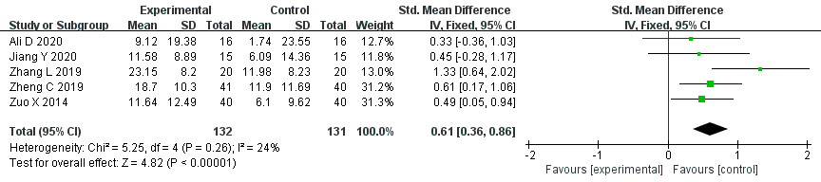

FMA-UE(RT+FES vs RT)
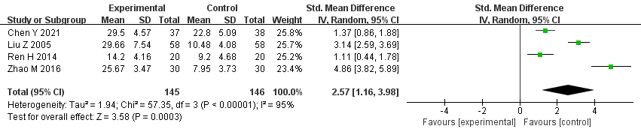

FMA-UE(RT+NMES vs RT)
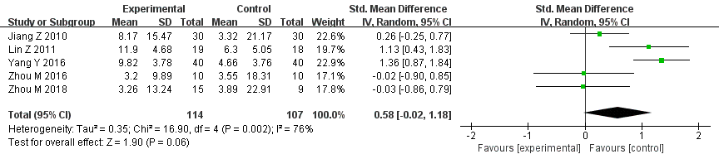

FMA-UE(RT+tDCS vs RT)
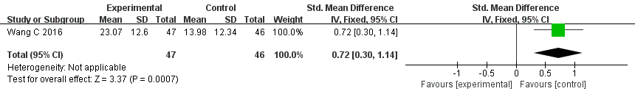

FMA-UE(RT+TEAS vs RT+SS)
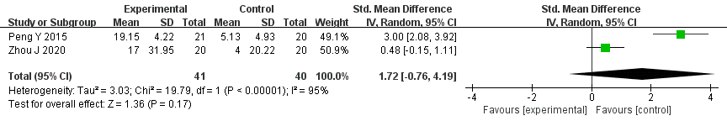

FMA-UE(RT+TEAS vs RT)
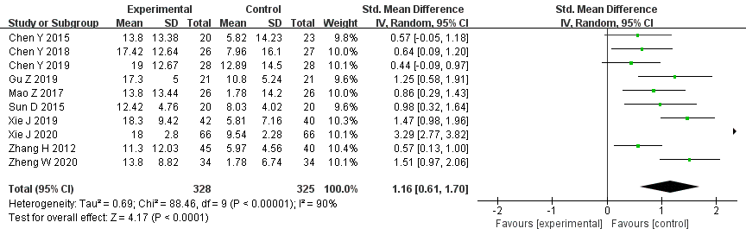

FMA-UE(RT+TENS vs RT)
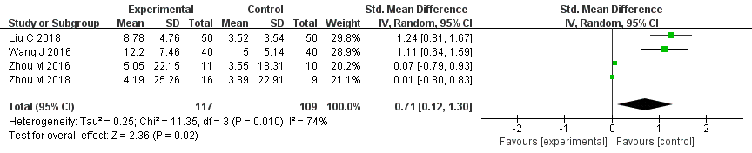

FMA-UE(RT+TENS vs RT+NMES)
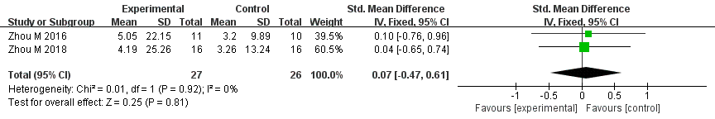

MAS(RT+NMES vs RT)
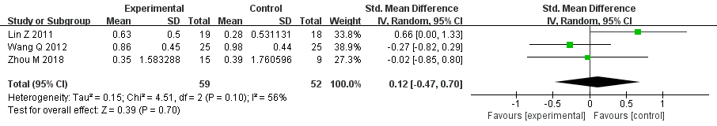

MAS(RT+tDCS vs RT+SS)
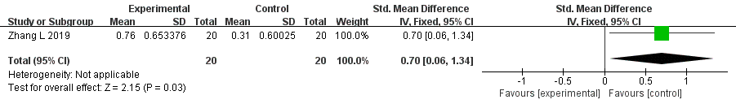

MAS(RT+TEAS vs RT)
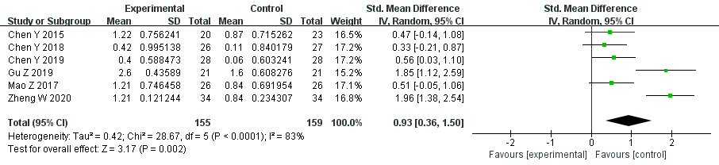

MAS(RT+TENS vs RT)
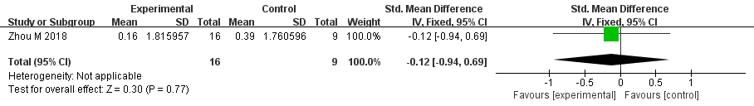

MAS(RT+TENS vs RT+NMES)
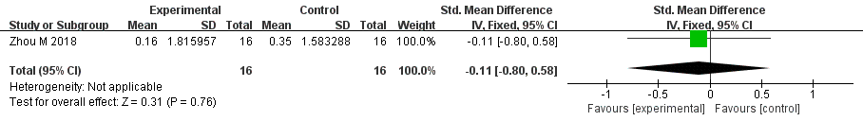

MBI(RT+NMES vs RT)
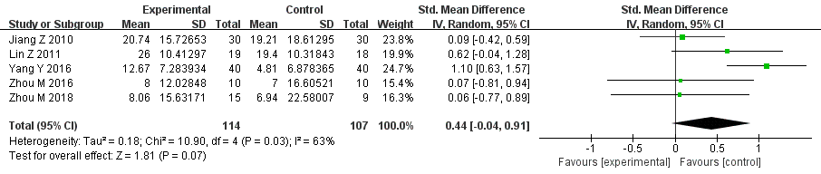

MBI(RT+tDCS vs RT)
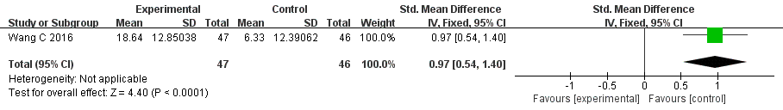

MBI(RT+FES vs RT)
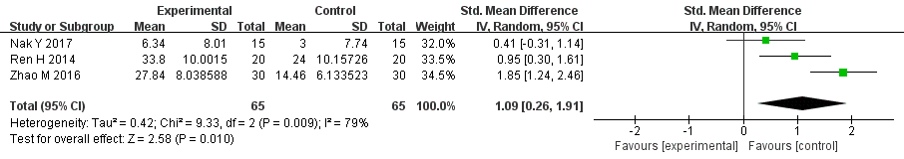
MBI(RT+tDCS vs RT+SS)
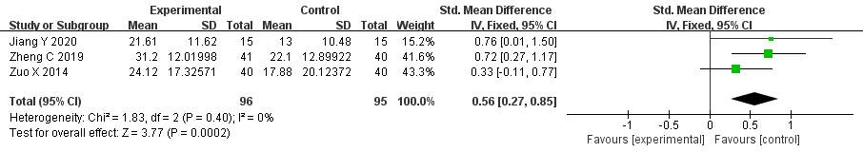

MBI(RT+TEAS vs RT)
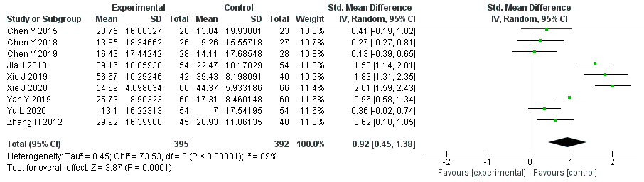

MBI(RT+TEAS vs RT+SS)
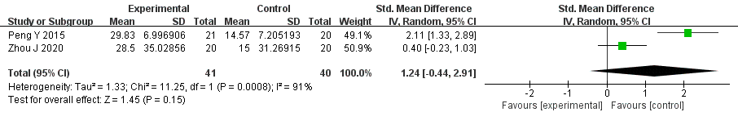

MBI(RT+TENS vs RT)
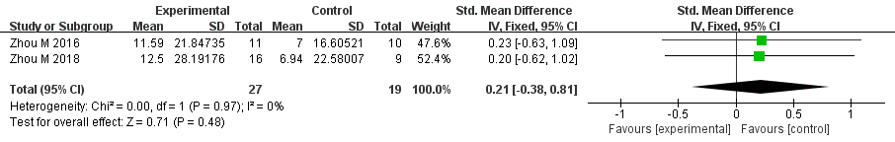

MBI(RT+TENS vs RT+NMES)
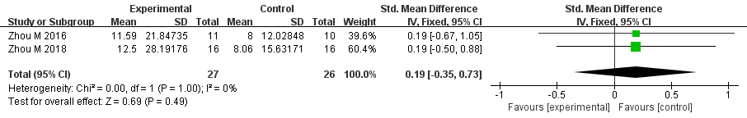

Additional file 6 Assessment of inconsistency results.
- Node-splitting test result in FMA-UE.
Name | Direct Effect | Indirect Effect | Overall | P-Value
RT,RT+tDCS | 9.04 (-0.36, 18.25) | 1.84 (-7.59, 11.04) | 5.50 (-1.42, 12.13) | 0.27
RT, RT+TEAS | 8.32 (5.41, 11.18) | 15.46 (2.52, 28.03) | 8.65 (5.83, 11.43) | 0.27
RT+NMES, RT+TENS | 0.79 (-8.13, 10.01) | 2.35 (-5.06, 9.80) | 1.42 (-4.38, 7.20) | 0.79
RT+SS, RT+tDCS | 7.45 (2.86, 12.18) | 14.66 (2.06, 26.82) | 8.30 (4.02, 12.60) | 0.28
RT+SS, RT+TEAS | 13.83 (6.45, 21.54) | 6.73 (-4.02, 17.45) | 11.50 (5.02, 17.63) | 0.28

- Node-splitting test result in MBI.
Name | Direct Effect | Indirect Effect | Overall | P-Value
RT, RT+TEAS | 10.30 (6.79, 13.41) | 19.07 (5.59, 32.72) | 10.71 (7.36, 13.80) | 0.20
RT, RT+tDCS | 12.23 (2.78, 21.61) | 3.44 (-7.46, 14.04) | 8.56 (1.35, 15.66) | 0.20
RT+SS, RT+TEAS | 15.00 (6.61, 23.18) | 6.17 (-5.59, 17.41) | 11.93 (5.04, 18.57) | 0.21
RT+SS, RT+tDCS | 8.08 (2.10, 14.14) | 17.09 (3.94, 30.30) | 9.77 (4.17, 15.32) | 0.20
Additional file 7 Assessment of convergence of the model results.
- PSRF value in FMA-UE.
Parameter | PSRF
d.RT.RTFES | 1.00
d.RT.RTNMES | 1.00
d.RT.RTTENS | 1.00
d.RTSS.RTTEAS | 1.00
d.RTtDCS.RT | 1.00
d.RTtDCS.RTSS | 1.00
d.RT.RTTEAS.dir | 1.00
sd.d | 1.00

- PSRF value in MBI.
Parameter | PSRF
d.RT.RTFES | 1.00
d.RT.RTNMES | 1.00
d.RT.RTTENS | 1.00
d.RTSS.RTTEAS | 1.00
d.RTtDCS.RT | 1.00
d.RTtDCS.RTSS | 1.00
d.RT.RTTEAS.dir | 1.00
sd.d | 1.00
Additional file 8 Treatment ranking and SUCRA for outcome data.
- Treatment ranking and SUCRA for FMA-UE.
Treatment | SUCRA | PrBest | MeanRank
RT+TEAS | 76.80 | 0.50 | 2.40
RT+FES | 99.80 | 99.10 | 1.00
RT+tDCS | 42.50 | 0.20 | 4.50
RT+TENS | 54.70 | 0.20 | 3.70
RT+NMES | 50.50 | 0.10 | 4.00
RT+SS | 8.40 | 0.00 | 6.50
RT | 17.30 | 0.00 | 6.00

- Treatment ranking and SUCRA for MBI.
Treatment | SUCRA | PrBest | MeanRank
RT+TEAS | 82.60 | 27.50 | 2.00
RT+FES | 86.40 | 53.70 | 1.80
RT+tDCS | 61.60 | 12.90 | 3.30
RT+TENS | 46.20 | 4.80 | 4.20
RT+NMES | 43.80 | 1.00 | 4.40
RT+SS | 14.90 | 0.00 | 6.10
RT | 14.50 | 0.00 | 6.10
- Treatment ranking and SUCRA for MAS.
Treatment | SUCRA | PrBest | MeanRank
RT+TEAS | 96.50 | 90.70 | 1.10
RT+TENS | 30.30 | 6.40 | 3.10
RT+NMES | 42.10 | 2.80 | 2.70
RT | 31.10 | 0.00 | 3.10

