Supplemental Materials
Supplemental Table S1. Geographic Distribution of Respondents at Baseline and Follow-up
US state, n | Baseline  (n=100) | Follow-up  (n=46)
Arizona | 2 | 0
California | 16 | 9
Connecticut | 1 | 1
Delaware | 1 | 1
District of Columbia | 2 | 2
Florida | 2 | 0
Georgia | 4 | 2
Hawaii | 1 | 1
Idaho | 1 | 1
Illinois | 4 | 1
Indiana | 1 | 0
Maine | 1 | 1
Maryland | 2 | 1
Massachusetts | 3 | 1
Michigan | 3 | 0
Minnesota | 1 | 1
Mississippi | 3 | 1
Missouri | 1 | 0
New Jersey | 4 | 0
New York | 9 | 4
North Carolina | 5 | 3
Ohio | 5 | 2
Pennsylvania | 4 | 1
Rhode Island | 2 | 1
South Carolina | 1 | 1
Tennessee | 2 | 1
Texas | 13 | 8
Virginia | 2 | 1
Washington | 2 | 0
Wisconsin | 2 | 1

Supplemental Figure S1. HIVTSQs total scores by subgroups.
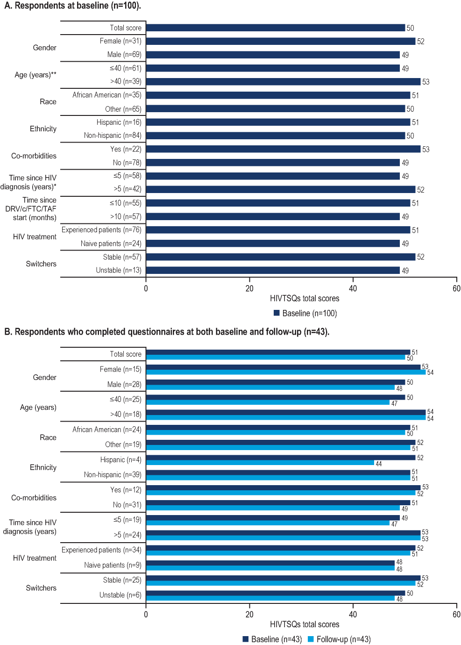
HIVTSQs, HIV Treatment Satisfaction Questionnaire status version; HIV, human immunodeficiency virus; DRV/c/FTC/TAF, darunavir/cobicistat/emtricitabine/tenofovir alafenamide.
*Significant p-value (<0.05).
**Significant p-value (<0.01).
Supplemental Figure S2. HIV-SDM total scores by subgroups.
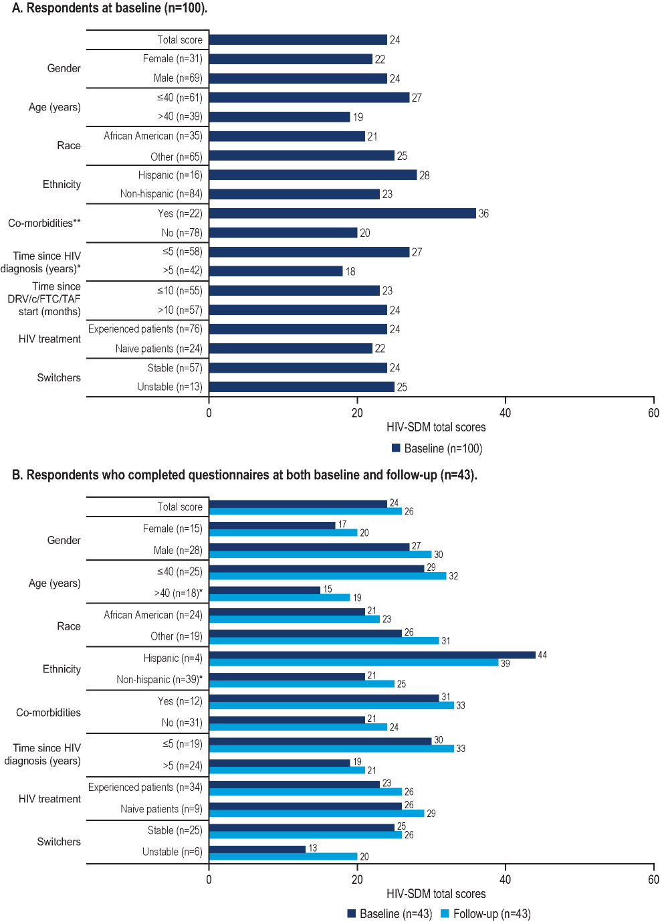
HIV-SDM, HIV Symptom Distress Module; HIV, human immunodeficiency virus; DRV/c/FTC/TAF, darunavir/cobicistat/emtricitabine/tenofovir alafenamide.
*Significant p-value (<0.05).
**Significant p-value (<0.01).
Supplemental Figure S3. Percentage of respondents reporting symptoms on HIV-SDM among those who completed questionnaires at both baseline and follow-up.ª
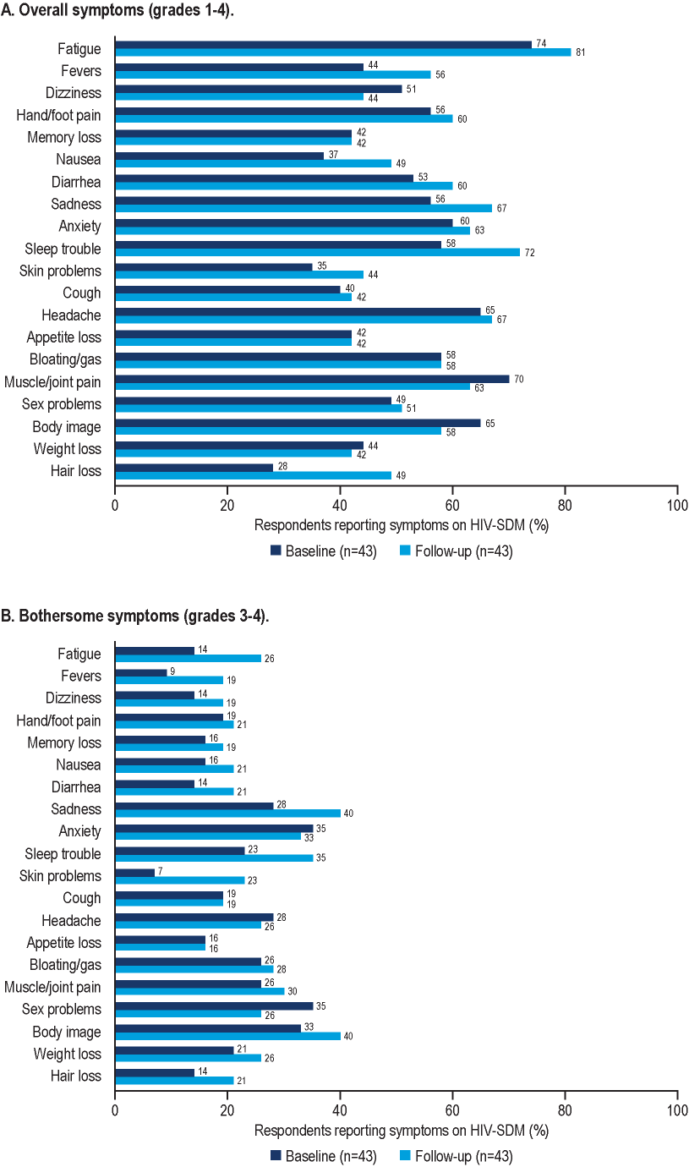
HIV-SDM, HIV Symptom Distress Module.
ªHIV-SDM item names abbreviated as in prior studies.¹
Supplemental Figure S4. HIVTSQs according to symptom grades experienced (HIV-SDM) at baseline.
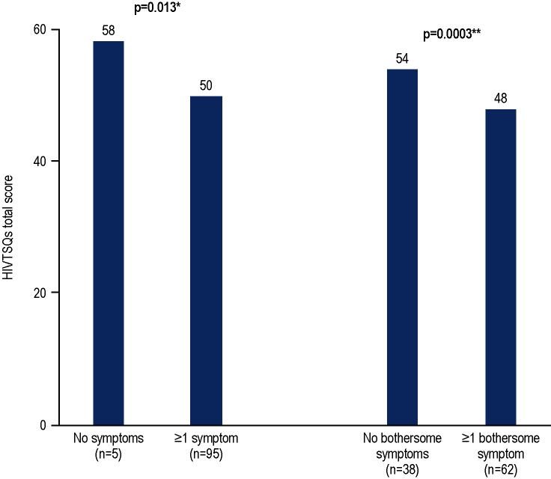
HIVTSQs, HIV Treatment Satisfaction Questionnaire status version; HIV-SDM, HIV Symptom Distress Module.
*Significant p-value (<0.05).
**Significant p-value (<0.01).

References
- Justice AC, Holmes W, Gifford AL, et al. Development and validation of a self-completed HIV symptom index. J Clin Epidemiol. 2001;54 Suppl 1:S77-90.

