Supplementary materials
Machine learning analysis reveals abnormal static and dynamic low-frequency oscillations indicative of long-term menstrual pain in primary dysmenorrhea patients

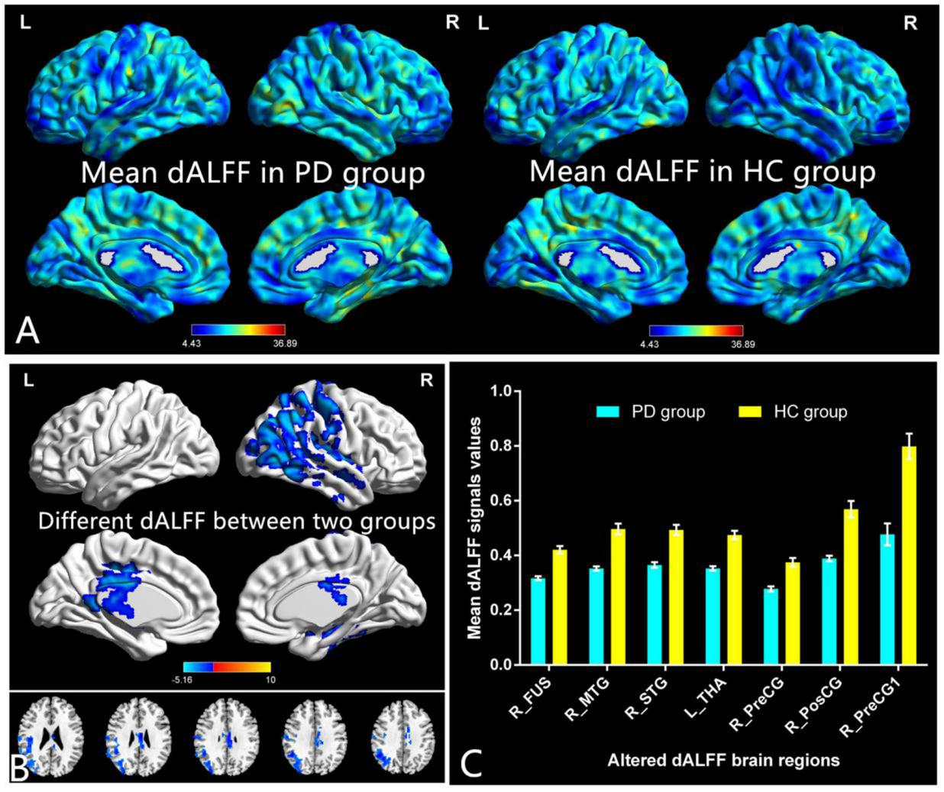
FigureS1:Note:Distribution patterns of dALFF variance (window lengths (30 TRs [60s]) were observed at the group level in PD and HC groups in the typical frequency band (0.01–0.08 Hz).(A) Different dALFF values between two groups.(B) The mean values of altered dALFF between the two groups were shown with a histogram.(C)
Abbreviations: dALFF, dynamic amplitude of low-frequency fluctuation; PD,Primary Dysmenorrhea; HC, health controls; L, left; R, right ;

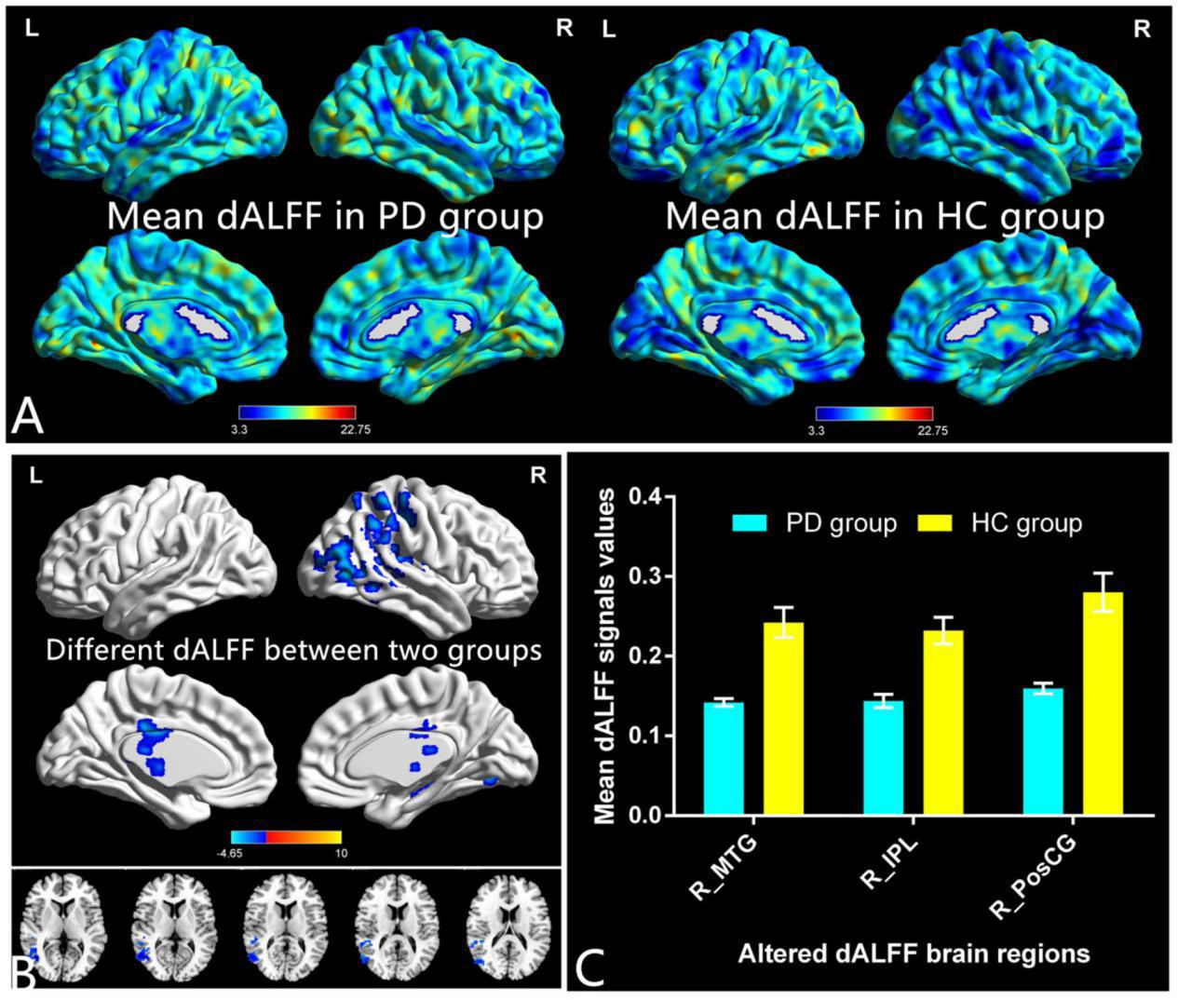
Figure S2: Note:Distribution patterns of dALFF variance (window lengths (100 TRs [200s]) were observed at the group level in PD and HC groups in the typical frequency band (0.01–0.08 Hz).(A) Different dALFF values between two groups.(B) The mean values of altered dALFF between the two groups were shown with a histogram.(C)
Abbreviations: dALFF, dynamic amplitude of low-frequency fluctuation; PD,Primary Dysmenorrhea; HC, health controls; L, left; R, right ;

TableS1: Different dALFF values between two groups window lengths (30 TRs [60 s] )
Condition | Brain regions | BA | Peak T-scores | MNI coordinates (x,y,z) | Cluster size (voxels)
PD<HC | Fusiform_R | - | -4.3703 | -3 -45 -27 | 306
PD<HC | Temporal_Mid_R | - | -5.1628 | 42 -66 6 | 1781
PD<HC | Temporal_Sup_R | - | -3.971 | 51 -9 -6 | 66
PD<HC | Thalamus_L | - | -5.1187 | -6 -12 27 | 354
PD<HC | Precentral_R | - | -4.3405 | 33 -15 48 | 56
PD<HC | Postcentral_R | - | -4.9757 | 42 -42 63 | 447
PD<HC | Precentral_R | - | -4.3845 | 9 -21 78 | 63
Note:The statistical threshold was set at the voxel level with p<0.01 for multiple comparisons using Gaussian random-field theory.(voxel-level P<0.01, GRF correction, cluster-level P<0.05).
Abbreviations: dALFF, dynamic amplitude of low-frequency fluctuation; PD, Primary Dysmenorrhea; HC, health controls; L, left; R, right ; GRF, Gaussian random field;

Table S2: Different dALFF values between two groups window lengths (100 TRs [200 s])
Condition | Brain regions | BA | Peak T-scores | MNI coordinates (x,y,z) | Cluster size (voxels)
PD<HC | Temporal_Mid_R | - | -4.6528 | 45 -66 6 | 256
PD<HC | Parietal_Inf_R | - | -4.1517 | 51 -42 30 | 84
PD<HC | Postcentral_R | - | -4.0971 | 33 -60 60 | 158
Note:The statistical threshold was set at the voxel level with p<0.01 for multiple comparisons using Gaussian random-field theory.(voxel-level P<0.01, GRF correction, cluster-level P<0.05).
Abbreviations: dALFF, dynamic amplitude of low-frequency fluctuation; PD, Primary Dysmenorrhea; HC, health controls; L, left; R, right; GRF,Gaussian random field;

