Supplementary Material
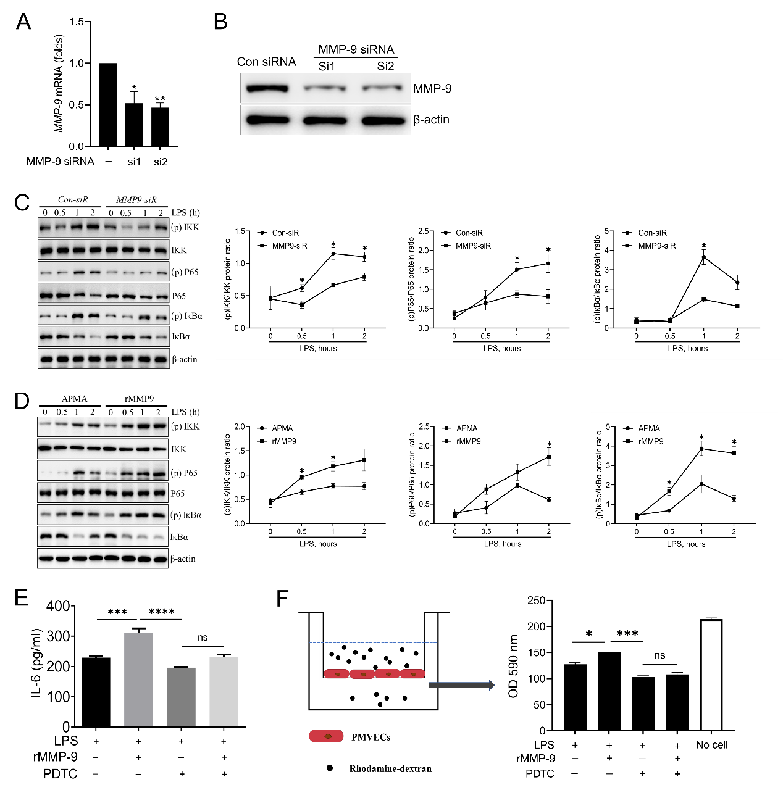
Figure S1
Figure S1. NF-kB inhibitor, PDTC, blocks inflammation and permeability in LPS/rMMP-9 treated PMVECs. The knockdown efficiency of MMP-9-specific siRNAs (40 nM) in (A) mRNA level and (B) protein level. (C) PMVECs were transfected with control siRNA, or MMP-9 siRNA for 48 h, and then cells were treated with LPS (1μg/ml) in a time course. NF-κB signaling proteins (p-IKK, IKKβ, p-P65, P65, IκBα, and p-IκBα) were measured by western blot. (D) PMVECs were treated by APMA or active rMMP9（10 ng/ml）1 h prior to LPS challenged at indicated times, and then NF-κB signaling proteins were detected. Supernatant IL-6 (E) secretions were measured by ELISA. (F) The permeability of treated PMVECs was determined by the appearance of rhodamine-dextran. *P＜0.05, **P＜0.01, ***P＜0.001, ****P＜0.0001, ns means no significance. All the results are from at least three independent experiments; Data represent means ±SEM.

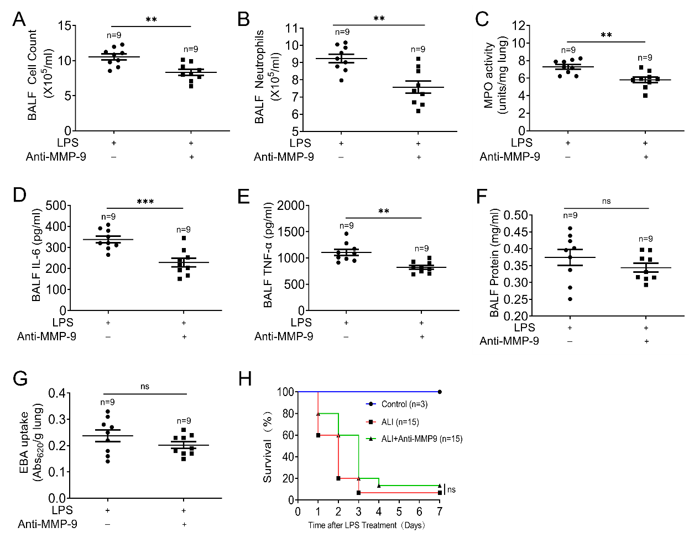
Figure S2
Figure S2. MMP-9 blocking antibody attenuates LPS-induced lung inflammation. (A) total cell counts, (B) neutrophils, (D) IL-6, (E) TNF-α and (F) protein concentrations from BAL fluid and (C) MPO activity and (G) EBA uptake from the lung of mice intratracheally treated with LPS with or without MMP-9 neutralizing antibody (i.v.). Data and means ± SEM pooled of 3 mice per group are from 3 independent experiments. (H) Survival rates of mice treated as indicated. **P＜0.01, ***P＜0.001, ns means no significance.

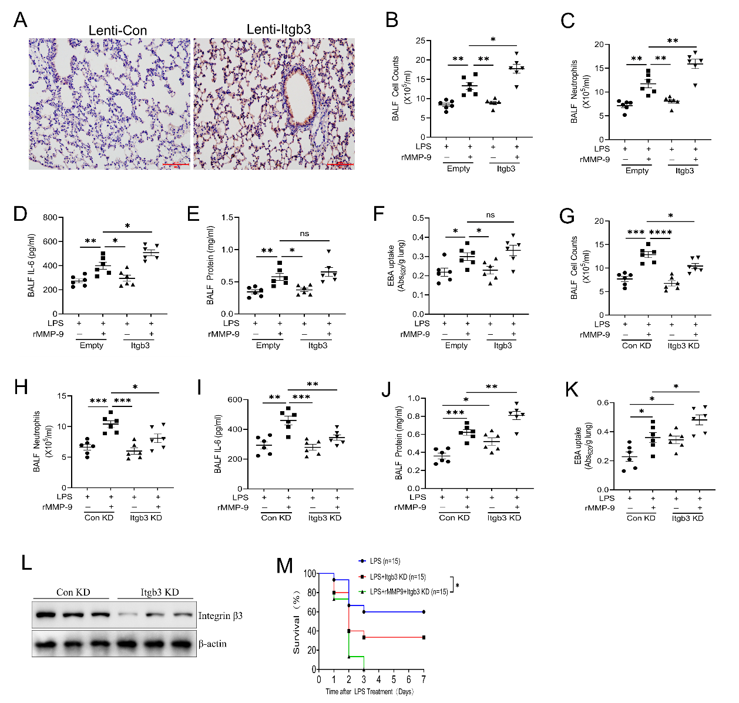
Figure S3
Figure S3. Integrin β3 regulates inflammatory response and permeability in vivo. (A) The expression of integrin β3 in lungs was detected by immunochemistry staining. Lung tissues were stained with integrin β3 antibody. (B) total cell counts, (C) neutrophils, (D) IL-6 from BAL fluid and (E) protein concentrations, and (F) EBA uptake from the lung of mice intratracheally treated with Lenti-Empty or Lenti-Itgb3 and then treated with LPS and PBS or recombinant MMP-9, as indicated. (G) total cell counts, (H) neutrophils, (I) IL-6 from BAL fluid and (J) protein concentrations, and (K) EBA uptake from the lung of mice intratracheally treated with Lenti-control shRNA or Lenti-Itgb3 shRNA and then treated with LPS and PBS or recombinant MMP-9, as indicated. (L) The silencing intervention of integrin β3 in lungs was measured by western blot. Data and means ± SEM pooled of 3 mice per group are from 2 independent experiments. (M) Survival rates of mice treated as indicated. *P＜0.05, **P＜0.01, ***P＜0.001, ****P＜0.0001, ns means no significance.

Figure S4
Figure S4. ROS scavenger, Nac, inhibits endothelial inflammation and leakage in LPS/rMMP-9 treated PMVECs. Supernatant IL-6 (A) and CXCL-1 (B) secretions were measured by ELISA. (C) The permeability of treated PMVECs was determined by the appearance of rhodamine-dextran. *P＜0.05. All the results are from at least three independent experiments; Data represent means ±SEM.

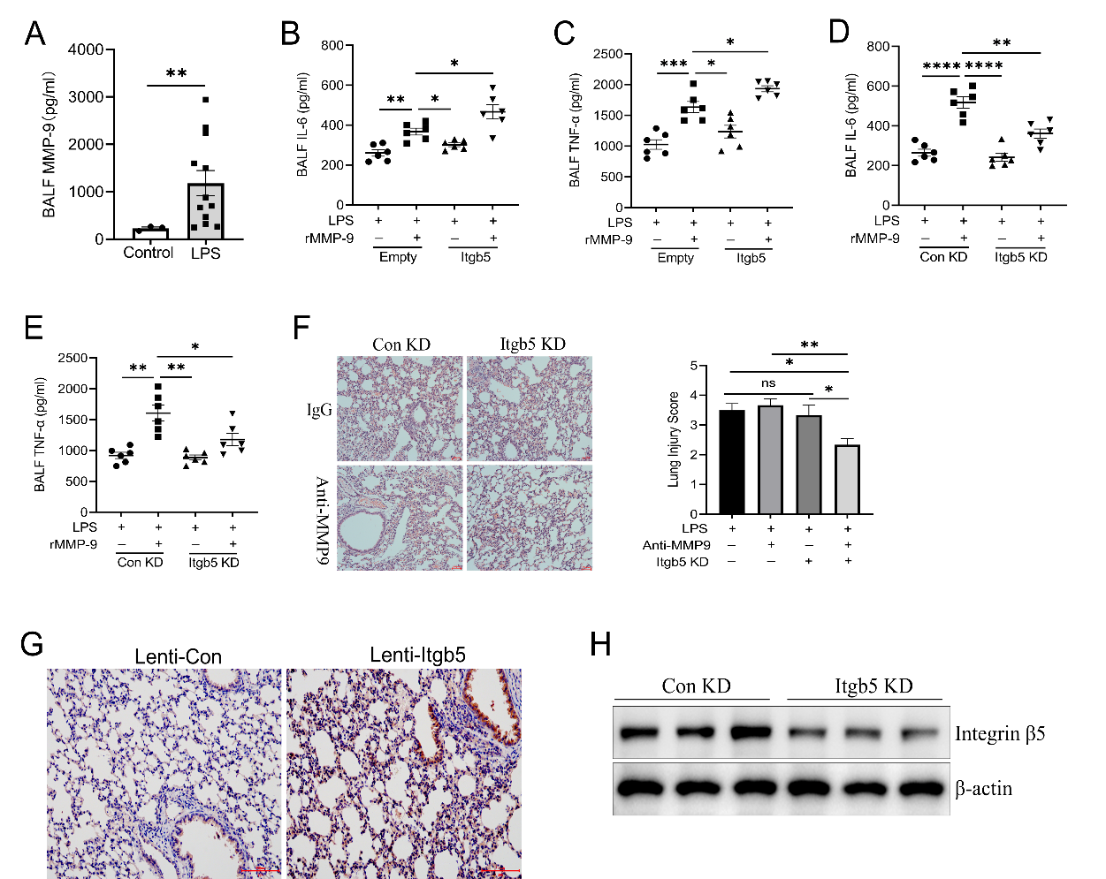
Figure S5
Figure S5. β5 Integrin/MMP-9 axis regulates lung inflammation in vivo. (A) ELISA analysis of MMP-9 in BALF from mice intratracheally treated with control (n=3) or LPS (n=12) for 18 h. (B) IL-6 and (C) TNF-α from BALF of mice intratracheally treated with Lenti-Empty or Lenti-Itgb3 and then treated with LPS and PBS or recombinant MMP-9, as indicated. (D) IL-6 and (E) TNF-α from BALF of mice intratracheally treated with Lenti-control shRNA or Lenti-Itgb3 shRNA and then treated with LPS and PBS or recombinant MMP-9, as indicated. (F) Histological analysis of lung tissues from mice intratracheally treated with Lenti-control shRNA or Lenti-Itgb5 shRNA, and then treated with LPS with or without neutralizing anti-MMP-9 antibody. (G) The expression of integrin β5 in lungs was detected by immunochemistry staining. Lung tissues were stained with integrin β5 antibody. (H) The silencing intervention of integrin β5 in lungs was measured by western blot. Data and means ± SEM pooled of 3 mice per group are from 2 independent experiments. *P＜0.05, **P＜0.01, ***P＜0.001, ****P＜0.0001.

Supplementary Table 1. List of primer sequences
 | Forward (5′-3′) | Reverse (5′-3′)
MMP-1a | AACTACATTTAGGGGAGAGGTGT | GCAGCGTCAAGTTTAACTGGAA
MMP-2 | ACTTTGAGAAGGATGGCAAGTA | CTTCTTATCCCGGTCATAGTCC
MMP-3 | TGTCACTGGTACCAACCTATTC | TCTCAGGTTCCAGAGAGTTAGA
MMP-7 | CACTAATGCCAAACAGTCCAAA | TCACGATTTGATCCACTACGAT
MMP-8 | TTGAGAAAGCTTTTCACGTCTG | CTTGAGACGAAAGCAATGTTGA
MMP-9 | CAAAGACCTGAAAACCTCCAAC | GACTGCTTCTCTCCCATCATC
MMP-10 | ACAAATGTGATCCTGCTTTGTC | ATCAAATGAAATTCAGGCTCGG
MMP-13 | CTTCCTGATGATGACGTTCAAG | GTCACACTTCTCTGGTGTTTTG
MT1-MMP | TATGGTTTACAAGTGACAGGCA | AAACTTATCCGGAACACCACAG
TIMP-1 | GCAAAGAGCTTTCTCAAAGACC | CTCCAGTTTGCAAGGGATAGAT
IL-6 | CTCCCAACAGACCTGTCTATAC | CCATTGCACAACTCTTTTCTCA
CXCL-1 | CTGGGATTCACCTCAAGAACATC | CAGGGTCAAGGCAAGCCTC
ICAM-1 | CTGAAAGATGAGCTCGAGAGTG | AAACGAATACACGGTGATGGTA
VCAM-1 | GACATTTACCCAGTTTACAGGC | TGACGGGAGTAAAGGTTACTTC
GAPDH | CATGTTCCAGTATGACTCCACT | GTAGACTCCACGACATACTCAG

