Supplementary information
Patient letter

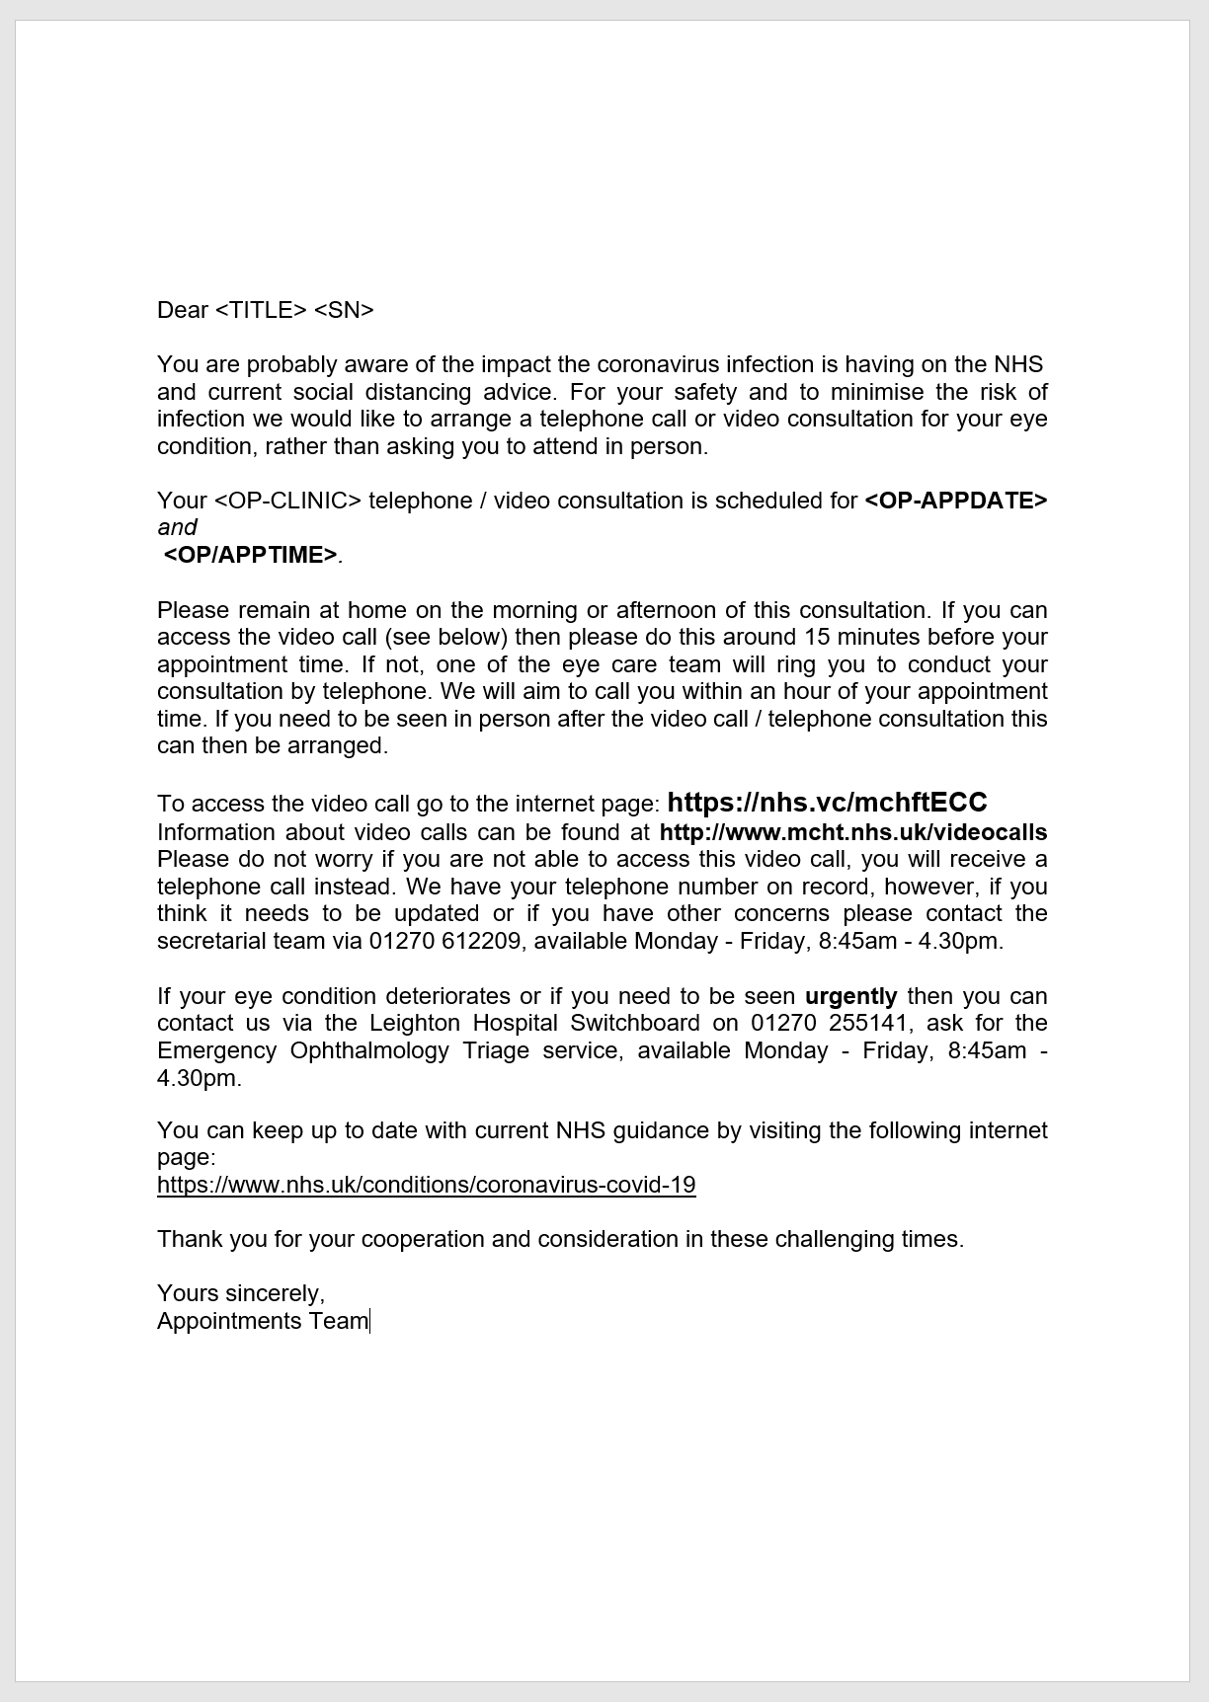
Attend Anywhere URL
https://www.attendanywhere.com

Diagnoses of remote consultation clinic Diagnosis | Number
Dry eyes | 13
Fuchs endothelial dystrophy | 7
Meibomian gland disease | 6
Corneal graft | 4
Conjunctivitis | 3
Corneal dystrophy | 3
Corneal scarring | 3
Herpes Simplex Keratitis | 3
Corneal vascularisation | 2
Pterygium | 2
Blepharitis | 1
Cataract | 1
Concretions | 1
Mucous membrane pemphigoid | 1
Post-YAG posterior capsulotomy | 1
TOTAL | 51
Patient follow-up

Patient follow-up duration

