Supporting Information

Antitumor activity of α-linolenic acid-paclitaxel conjugate nanoparticles: in vitro and in vivo
Mei-Qi Xu^{1,2}, Yan-Li Hao^{1,2}, Jing-Ru Wang^{1,2}, Zhuo-Yue Li^{1,2}, Hui Li¹, Zhen-Han Feng^{1,2}, Hui Wang^{1,2}, Jing-Wen Wang^{1,2}, Xuan Zhang ^{1,2} *

¹ Beijing Key Laboratory of Molecular Pharmaceutics and New Drug Delivery Systems, School of Pharmaceutical Sciences, Peking University, Beijing 100191, China; ² Department of Pharmaceutics, School of Pharmaceutical Sciences, Peking University, Beijing 100191, China

Correspondence: Dr. Xuan Zhang Professor
Department of Pharmaceutics, School of Pharmaceutical Sciences, Peking University, Xueyuan Road 38, Beijing 100191, China
Tel: +86-10-82805765
Fax: +86-10-8280576
Email: xuanzhang@bjmu.edu.cn

Table S1 HPLC gradient elution condition for ALA-PTX.
Time (min) | Mobile phase A (%) | Mobile phase B (%)
0→10 | 60 | 40
10→12 | 60→100 | 40→0
12→28 | 100 | 0
28→30 | 100→60 | 0→40
30→40 | 60 | 40

Table S2 Concentrations of the endocytosis inhibitors.
Inhibitors | Function | Concentration
EIPA | Inhibitor of macropinocytosis | 20 μM
CPZ | Inhibitor of clathrin | 30 μM
Filipin | Inhibitor of lipid raft | 0.5 μg/mL
Hypertonic sucrose | Inhibitor of clathrin | 0.4 M

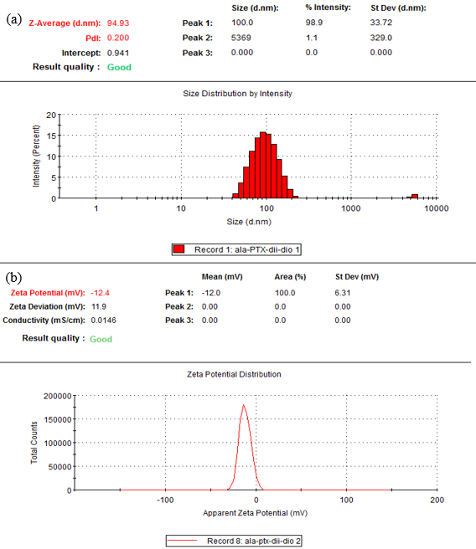
Figure S1 Particle size (a) and zeta potential (b) of DiO&DiI-ALA-PTX NPs.

