Supplementary Figure 1. The survival rate of 6 VV isolates during anti-complement killing test.
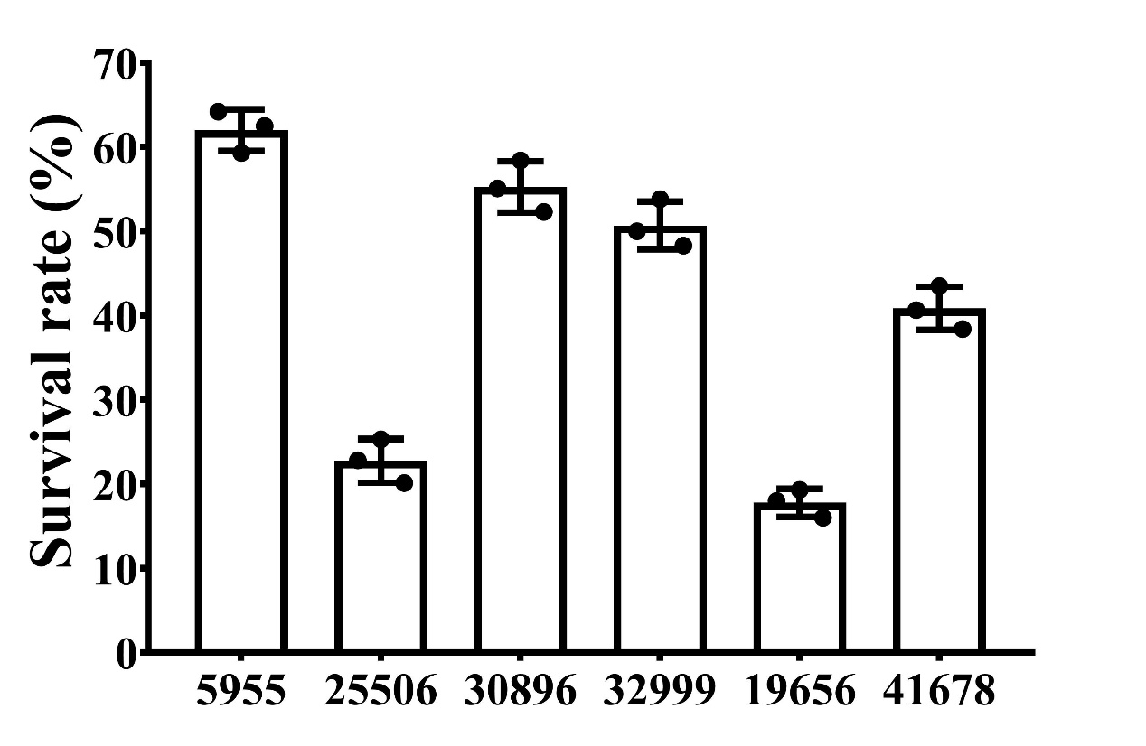

Supplementary Table 1. List of 157 publicly available clinical VV isolates used for comparative genomic analysis.
BioSample | Source | Location | MLST | Date
SAMN07739071 | Environmental | Denmark | 139 | 1995
SAMN07739093 | Environmental | Spain | 526 | 2003
SAMN07739090 | Environmental | Spain | 112 | 2003
SAMN07739083 | Environmental | China (Taiwan) | 500 | 1993
SAMN07739080 | Environmental | China (Taiwan) | New | NA
SAMN07739074 | Environmental | Spain | 139 | 2002
SAMN07739073 | Environmental | Denmark | 9 | 1996
SAMN07739069 | Clinical | Denmark | 122 | 1994
SAMN07739072 | Environmental | Denmark | 139 | 1995
SAMN07739070 | Environmental | Denmark | 139 | 1995
SAMN07739076 | Clinical | Denmark | New | 1994
SAMN07739097 | Environmental | USA | 501 | NA
SAMN03470190 | Environmental | Germany | 132 | 1995
SAMN03486854 | Environmental | Germany | 128 | 2010
SAMN03483416 | Environmental | Germany | 113 | 2010
SAMN03486856 | Clinical | Germany | 117 | 2010
SAMN03483332 | Environmental | Germany | 105 | 1999
SAMN07739081 | Environmental | Denmark | 140 | 2004
SAMN07739079 | Environmental | Spain | 489 | 1990
SAMN11552938 | Environmental | USA | 222 | 2015
SAMN07739077 | Clinical | USA | 1 | 1977
SAMN07739078 | Environmental | Spain | 112 | 1990
SAMN07739096 | Environmental | USA | 484 | NA
SAMN07739066 | Clinical | Israel | 8 | 1996
SAMN07739065 | Clinical | Israel | 8 | 1996
SAMN07739089 | Clinical | USA | 511 | NA
SAMN07739085 | Clinical | USA | 478 | 1994
SAMN07739084 | Environmental | USA | 462 | 2005
SAMN07739075 | Environmental | USA | 470 | 2005
SAMN07739095 | Environmental | USA | 509 | 2005
SAMN07739094 | Environmental | USA | 483 | 2004
SAMN11538979 | Environmental | USA | 58 | 2015
SAMN11552945 | Environmental | USA | New | 2015
SAMN07739098 | Environmental | USA | 517 | 2005
SAMN03483372 | Clinical | Germany | 135 | 2010
SAMN07739067 | Clinical | Spain | 135 | 2001
SAMN07739086 | Clinical | USA | 16 | 1995
SAMN07739068 | Environmental | USA | 487 | NA
SAMN03486858 | Clinical | Germany | 118 | 2010
SAMN03486932 | Clinical | Germany | 118 | 2011
SAMN07739082 | Environmental | Japan | New | 1979
SAMN09270178 | Environmental | China (Taiwan) | 432 | 1997
SAMN09270229 | Environmental | China (Taiwan) | 76 | 2008
SAMN13500489 | Clinical | NA | New | NA
SAMN13500488 | Clinical | NA | New | NA
SAMN13500487 | Clinical | NA | New | NA
SAMN02469425 | Clinical | USA | New | 1994
SAMN03371459 | Environmental | South Korea | 503 | 1905
SAMN03371454 | Environmental | China (Taiwan) | 507 | 2011
SAMN03371452 | Environmental | China (Taiwan) | 508 | 2011
SAMN04125838 | Environmental | NA | New | NA
SAMN03996332 | Clinical | NA | 466 | NA
SAMN03092747 | Environmental | Japan | 112 | 1979
SAMN03349353 | Environmental | South Korea | 491 | 2011
SAMN03371453 | Environmental | China (Taiwan) | 480 | 2011
SAMN03371455 | Environmental | South Korea | 481 | 2011
SAMN03371457 | Environmental | South Korea | 474 | 2011
SAMN03371458 | Environmental | South Korea | 471 | 2011
SAMN03371456 | Environmental | South Korea | 504 | 2011
SAMN04193762 | Environmental | USA | 509 | 1999
SAMN04194063 | Environmental | USA | 514 | 1999
SAMN04194080 | Clinical | USA | 478 | 1994
SAMN04219563 | Environmental | NA | 487 | NA
SAMN04219564 | Environmental | USA | 509 | 2004
SAMN03273306 | Environmental | Spain | 140 | 2004
SAMN03486945 | Environmental | Spain | New | 1999
SAMN08939840 | Environmental | China (Mainland) | New | 2016
SAMN08939838 | Environmental | China (Mainland) | New | 2016
SAMN08939839 | Environmental | China (Mainland) | New | 2016
SAMN09386753 | Environmental | USA | 518 | 2016
SAMN09386818 | Environmental | USA | 488 | 2007
SAMN09386620 | Environmental | USA | 475 | 2007
SAMN09386618 | Environmental | USA | 518 | 2007
SAMN03996331 | Clinical | USA | 467 | NA
SAMN03996333 | Clinical | USA | 16 | NA
SAMEA3121334 | Environmental | NA | 466 | NA
SAMEA3121336 | Environmental | NA | 3 | NA
SAMN03293314 | Environmental | Denmark | 112 | 1994
SAMEA5852038 | Environmental | Bangladesh | 487 | NA
SAMN00216032 | Environmental | NA | 482 | NA
SAMN02990647 | Environmental | Israel | 59 | 1997
SAMN02990648 | Environmental | Israel | New | 1997
SAMN04193761 | Clinical | USA | 16 | 1995
SAMN04193760 | Clinical | USA | 16 | 1995
SAMN04194078 | Clinical | USA | 21 | 1996
SAMN08213428 | Environmental | USA | 496 | 2012
SAMN09386735 | Environmental | USA | 222 | 2007
SAMN09386734 | Environmental | USA | 505 | 2006
SAMN09386754 | Environmental | USA | 493 | 2007
SAMN09386622 | Environmental | USA | 515 | 2007
SAMN09386759 | Environmental | USA | 502 | 2007
SAMN09386736 | Environmental | USA | 498 | 2006
SAMN09386756 | Environmental | USA | 473 | 2007
SAMN09386767 | Environmental | USA | 495 | 2007
SAMN09386757 | Environmental | USA | 472 | 2006
SAMN09386764 | Environmental | USA | 520 | 2007
SAMN09386763 | Environmental | USA | 520 | 2007
SAMN09386765 | Environmental | USA | 490 | 2006
SAMN09386766 | Environmental | USA | 522 | 2006
SAMN09386815 | Environmental | USA | 506 | 2007
SAMN09386768 | Environmental | USA | 497 | 2007
SAMN09386621 | Environmental | USA | 477 | 2006
SAMN09386614 | Environmental | USA | 476 | 2006
SAMN09386611 | Environmental | USA | 498 | 2006
SAMN09386612 | Environmental | USA | 479 | 2007
SAMN09386619 | Environmental | USA | 469 | 2007
SAMN09386737 | Environmental | USA | 479 | 2007
SAMN09386750 | Environmental | USA | 23 | 2007
SAMN09386776 | Environmental | USA | 499 | 2007
SAMN09386816 | Environmental | USA | 512 | 2007
SAMN09386781 | Environmental | USA | 22 | 2007
SAMN09386770 | Environmental | USA | 486 | 2007
SAMN09386771 | Environmental | USA | 523 | 2007
SAMN09386616 | Environmental | USA | New | 2007
SAMN09386615 | Environmental | USA | 519 | 2007
SAMN11489491 | Environmental | India | New | NA
SAMN03273308 | Environmental | Spain | 112 | 2002
SAMEA104200660 | Clinical | USA | 467 | 1964
SAMN02471155 | Clinical | China (Mainland) | 3 | 2010
SAMD00046713 | Environmental | NA | 3 | NA
SAMN03395192 | Clinical | Israel | 8 | 1996
SAMN06062368 | Environmental | USA | 136 | 2016
SAMN06062369 | Environmental | USA | 136 | 2016
SAMN06062372 | Environmental | USA | 136 | 2016
SAMN06140069 | Environmental | USA | 136 | 2016
SAMN06140070 | Environmental | USA | 136 | 2016
SAMN06090785 | Clinical | USA | 136 | NA
SAMN06062373 | Environmental | USA | 136 | 2016
SAMN03292655 | Clinical | France | 112 | 1980
SAMN03293315 | Clinical | Australia | 112 | 1997
SAMN06062367 | Environmental | USA | 492 | 2016
SAMN06062374 | Environmental | USA | 492 | 2016
SAMN06062370 | Environmental | USA | 492 | 2016
SAMN06062366 | Environmental | USA | 492 | 2016
SAMN06062371 | Environmental | USA | 492 | 2016
SAMN14342352 | Environmental | NA | 521 | NA
SAMN02471035 | Environmental | Israel | New | NA
SAMN03571538 | Environmental | Israel | 468 | 2005
SAMN03073547 | Clinical | Israel | 494 | 2004
SAMN07660997 | Clinical | Brazil | 513 | 2016
SAMN09386749 | Environmental | USA | 516 | 2007
SAMN09386738 | Environmental | USA | 171 | 2007
SAMN09386758 | Environmental | USA | 1 | 2007
SAMN09386624 | Environmental | USA | 1 | 2007
SAMN04194077 | Clinical | USA | 15 | 1997
SAMN09386780 | Environmental | USA | New | 2007
SAMN09386817 | Environmental | USA | New | 2007
SAMN02990646 | Clinical | Israel | 8 | 1997
SAMN09386708 | Environmental | USA | 485 | 2007
SAMN09386617 | Environmental | USA | 479 | 2007
SAMN09386733 | Environmental | USA | 510 | 2007
SAMN08939837 | Environmental | China (Mainland) | 521 | 2016
SAMN09396656 | Environmental | Mexico | 527 | 2011
SAMN09396655 | Environmental | Mexico | 528 | 2011
SAMN02990644 | Clinical | Israel | 8 | 2009
SAMN02990645 | Clinical | Israel | 8 | 2003
SAMN03292494 | Environmental | Spain | 444 | 1990
MLST, multi-locus sequence typing; NEW, novel STs; NA, not available.

Supplementary Table 2. The virulence genes identified in 6 VV isolates
Genes | 5955  (Blood)  (n=141) | 25506  (Blood)  (n=144) | 30896  (Blood)  (n=149) | 32999  (Blood)  (n=141) | 19656  (Puncture fluid)  (n=146) | 41678  (Puncture fluid)  (n=142)
luxS | + | + | + | + | + | +
cpsA-D,F,H-J | + | + | + | + | + | +
wza-c | + | + | + | + | + | +
wbfY | + | + | + | + | + | +
wecB | + | - | - | - | + | -
wecC | - | - | - | - | + | -
wbfV | + | + | + | + | + | +
wbfT | - | - | - | - | + | -
wbuB | - | - | - | - | + | -
wcaJ | - | + | + | - | - | +
epsA,C-J,I-N | + | + | + | + | + | +
epsH | + | + | + | - | + | +
cheZ,Y | + | + | + | + | + | +
flaA,B,E,I,G | + | + | + | + | + | +
flaC | - | - | - | - | - | +
flaD | - | + | + | + | - | -
flhA,B,F,G | + | + | + | + | + | +
fliA,E,F,I-S | + | + | + | + | + | +
fliD | - | + | + | + | + | +
fliG | + | + | + | + | + | -
flgA-N | + | + | + | + | + | +
flrA-C | + | + | + | + | + | +
motA,B,Y | + | + | + | + | + | +
motX | + | + | + | + | + | -
cheA,B,R,W,V | + | + | + | + | + | +
VV2_0087 ATPase | + | + | + | + | + | +
tadA,B,D-F,G,Z | + | + | + | + | + | +
tadB | + | + | + | + | + | +
tadC | - | + | + | - | - | -
rcpA,C | + | + | + | + | + | +
flp | - | + | + | - | - | -
pilA | - | - | + | - | - | -
pilB-F,M,N,O-Q,T,U | + | + | + | + | + | +
fimT | - | - | + | - | - | -
hutA | - | - | + | - | + | +
hutR | + | + | + | + | + | +
tlh | + | + | + | + | + | +
ilpA | + | + | + | + | + | +
mshA | + | - | + | - | - | -
mshB-N | + | + | + | + | + | +
vvp | + | + | + | + | + | +
vctC,D,G | + | + | + | + | + | +
rtxC-D | + | + | + | + | + | +
vibA-C,E,F,H | + | + | + | + | + | +
vibD | - | + | + | + | + | +
viuA | - | - | + | + | - | +
viuB | - | - | + | - | + | -
vctP | + | - | + | + | + | +
vuuA | + | + | - | - | + | -
vuuB | + | + | - | + | - | +
VVA1305-1307,1295,1298 | + | + | + | + | + | +
vvhA | + | + | + | + | + | +
n, number of virulence genes.

