Supplementary Materials

Supplementary Table 1: ICD codes for OUD diagnosis:

Disease | ICD-9-CM | ICD-10-CM
OUD Diagnosis | 292.0, 292.81, 292.84, 292.85, 292.89, 304.00, 304.01, 304.02,  04.03, 304.70, 304.71, 304.72, 304.73, 305.50, 305.51, 305.52,  305.53, E9350, E9351, E9352, E9401, 96500, 96501, 96502, 96509,  9701, E9500, E8501, E8502 | F11.10, F11.120, F11.121, F11.122, F11.129, F11.14, F11.150,  F11.151, F11.159, F11.181, F11.182, F11.188, F11.19, F11.20,  F11.21, F11.220, F11.221, F11.222, F11.229, F11.23, F11.24,  F11.250, F11.251, F11.252, F11.259, F11.281, F11.282, F11.288,  F11.29, F11.90, F11.920, F11.921, F11.922, F11.929, F11.93,  F11.94, F11.950, F11.951, F11.959, F11.981, F11.982, F11.988,  F11.99, T40.0X1A, T40.0X1D, T40.0X2A, T40.0X2D, T40.0X3A, T40.0X3D, T40.0X4A, T40.0X4D, T40.1X1A, T40.1X1D, T40.1X2A, T40.1X2D, T40.1X3A, T40.1X3D, T40.1X4A, T40.1X4D, T40.2X1A, T40.2X1D, T40.2X2A, T40.2X2D, T40.2X3A, T40.2X3D, T40.2X4A, T40.2X4D, T40.3X1A, T40.3X1D, T40.3X2A, T40.3X2D, T40.3X3A, T40.3X3D, T40.3X4A, T40.3X4D, T40.4X1A, T40.4X1D, T40.4X2A, T40.4X2D, T40.4X3A, T40.4X3D, T40.4X4A, T40.4X4D, T40.601A,  T40.601D, T40.602A, T40.602D, T40.603A, T40.603D, T40.604A, T40.604D, T40.691A, T40.691D, T40.692A, T40.692D, T40.693A, T40.693D, T40.694A, T40.694D, T40.0X5A, T40.0X5D, T40.2X5A, T40.2X5D, T40.3X5A, T40.3X5D, T40.4X5A, T40.4X5D, T40.605A, T40.695A, T40.695D, Z79.891

Supplementary Table 2: ICD codes for other SUD diagnoses

Disease |  | ICD-9-CM | ICD-10-CM
Alcohol-Related Disorders | 291.0, 291.1, 291.2, 291.3, 291.4, 291.5, 291.81, 291.82, 291.89, 291.9, 303.00, 303.01, 303.02, 303.03, 303.90, 303.91, 303.92, 303.93, 305.00, 305.01, 305.02, 305.03, 980.0, 980.1, 980.2, 980.8, 980.9 |  | F10.1, F10.10, F10.11, F10.12, F10.120, F10.121, F10.129, F10.13, F10.130, F10.131, F10.132, F10.139, F10.14, F10.15, F10.150, F10.151, F10.159, F10.18, F10.180, F10.181, F10.182, F10.188, F10.19, F10.2, F10.20, F10.21, F10.22, F10.220, F10.221, F10.229, F10.23, F10.230, F10.231, F10.232, F10.239, F10.24, F10.25, F10.250, F10.251, F10.259, F10.26, F10.27, F10.28, F10.280, F10.281, F10.282, F10.288, F10.29, F10.9, F10.2, F10.920, F10.921, F10.929, F10.93, F10.930, F10.931, F10.932, F10.939, F10.94, F10.95, F10.950, F10.951, F10.959, F10.96, F10.97, F10.98, F10.980, F10.981, F10.982, F10.988, F10.99
Cannabis-Related Disorders | 304.30, 305.2, 305.20, 305.21, 305.22, 305.23 |  | F12.1, F12.10, F12.11, F12.12, F12.120, F12.121, F12.122, F12.129, F12.13, F12.15, F12.150, F12.151, F12.159, F12.18, F12.180, F12.188, F12.19, F12.2, F12.20, F12.21, F12.22, F12.220, F12.221, F12.222, F12.229, F12.23, F12.25, F12.250, F12.252, F12.259, F12.28, F12.280, F12.288, F12.29, F12.9, F12.90, F12.92, F12.920, F12.921, F12.922, F12.929, F12.93, F12.95, F12.950, F12.951, F12.959, F12.98, F12.980, F12.988, F12.99
Stimulant-Related Disorders | 304.2, 304.20, 304.21, 304.22, 304.23, 304.4, 304.40, 304.41, 304.42, 304.43, 305.6, 305.60, 305.61, 305.62, 305.63, 305.7, 305.70, 305.71, 305.72, 305.73 |  | F14.10, F14.11, F14.12, F14.120, F14.121, F14.122, F14.129, F14.13, F14.14, F14.15, F14.150, F14.151, F14.159, F14.18, F14.180, F14.181, F14.182, F14.188, F14.19, F14.2, F14.20, F14.21, F14.22, F14.220, F14.221, F14.222, F14.229, F14.23, F14.24, F14.25, F14.250, F14.219, F14.259, F14.28, F14.280, F14.281, F14.282, F14.288, F14.29, F14.9, F14.90, F14.92, F14.920, F14.921, F14.922, F14.929, F14.93, F14.94, F14.95, F14.950, F14.951, F14.959, F14.98, F14.980, F14.981, F14.982, F14.988, F14.99, F15.1, F15.10, F15.11, F15.12, F15.120, F15.121, F15.122, F15.129, F15.13, F15.14, F15.15, F15.150, F15.151, F15.159, F15.18, F15.180, F15.181, F15.182, F15.188, F15.19, F15.2, F15.20, F15.21, F15.22, F15.220, F15.221, F15.222, F15.229, F15.23, F15.24, F15.25, F15.250, F15.251, F15.259, F15.28, F15.280, F15.281, F15.282, F15.288, F15.9, F15.90, F15.92, F15.920, F15.921, F15.922, F15.929, F15.93, F15.94, F15.95, F15.950, F15.951, F15.959, F15.98, F15.980, F15.981, F15.982, F15.988, F15.99
Sedative-, Hypnotic-, or Anxiolytic-Related Disorders | 304.1, 304.10, 304.11, 304.12, 304.13, 305.40 |  | F13.1, F13.10, F13.11, F13.12, F13.120, F13.121, F13.129, F13.13, F13.130, F13.131, F13.132, F13.139, F13.14, F13.15, F13.150, F13.151, F13.159, F13.18, F13.180, F13.181, F13.182, F13.188, F13.19, F13.2, F13.20, F13.21, F13.22, F13.220, F13.221, F13.229, F13.23, F13.230, F13.231, F13.232, F13.239, F13.24, F13.25, F13.250, F13.251, F13.259, F13.26, F13.27, F13.28, F13.280, F13.281, F13.282, F13.288, F13.29, F13.9, F13.90, F13.92, F13.920, F13.921, F13.929, F13.93, F13.930, F13.931, F13.932, F13.939, F13.94, F13.95, F13.950, F13.951, F13.959, F13.96, F13.97, F13.98, F13.980, F13.981, F13.982, F13.988, F13.99
Hallucinogen-Related Disorders | 304.50, 304.51, 304.52, 304.53, 305.30, 305.31, 305.32, 305.33 |  | F16.1, F16.10, F16.11, F16.12, F16.120, F16.121, F16.122, F16.129, F16.14, F16.15, F16.150, F16.151, F16.159, F16.18, F16.180, F16.183, F16.188, F16.19, F16.2, F16.20, F16.21, F16.22, F16.220, F16.221, F16.229, F16.24, F16.25, F16.250, F16.251, F16.259, F16.28, F16.280, F16.283, F16.288, F16.29, F16.9, F16.90, F16.92, F16.920, F16.921, F16.929, F16.94, F16.95, F16.950, F16.951, F16.959, F16.98, F16.980, F16.983, F16.988, F16.99
Inhalant-Related Disorders |  |  | F18.1, F18.10, F18.11, F18.12, F18.120, F18.121, F18.129, F18.14, F18.15, F18.150, F18.151, F18.159, F18.17, F18.18, F18.180, F18.188, F18.19, F18.2, F18.20, F18.21, F18.22, F18.220, F18.221, F18.229, F18.24, F18.25, F18.250, F18.251, F18.259, F18.27, F18.28, F18.280, F18.288, F18.29, F18.9, F18.90, F18.92, F18.920, F18.921, F18.929, F18.94, F18.95, F18.950, F18.951, F18.959, F18.97, F18.98, F18.980, F18.988, F18.99

Supplementary Table 3: ICD codes for other mental health diagnoses

comorbidity | ICD-9-CM & ICD-10-CM codes
Anxiety | 300.00, 300.01, 300.02, 300.09, F300.10, F300.11, F300.12, F300.13, F300.14, F300.15, F300.16, F300.19, 300.20, 300.21, 300.22, 300.23, 300.29  F300.3, F300.4, F300.5, F300.6, F300.7, F300.81, F300.82, F300.89, F300.9, F40.00, F40.01, F40.02, F40.10, F40.11, F40.210, F40.218, F40.220, F40.228, F40.230, F40.231, F40.232, F40.233, F40.240, F40.241, F40.242, F40.243, F40.248, F40.290, F40.291, F40.298, F40.8, F40.9, F41.0, F41.1, F41.3, F41.8, F41.9
ADHD | 314.00, 314.01  F90.0, F90.1, F90.2, F90.8, F90.9
Bipolar | 296.0, 296.1, 296.40, 296.41, 296.42, 296.43, 296.44, 296.45, 296.46, 296.50, 296.51, 296.52, 296.53, 296.54, 296.55, 296.56, 296.60, 296.61, 296.62, 296.63, 296.64, 296.65, 296.66, 296.7, 296.80, 296.81, 296.89,  F31.0, F31.10, F31.11, F31.12, F31.13, F31.2, F31.30, F31.31, F31.32, F31.4, F31.5, F31.60, F31.61, F31.62, F31.63, F31.64, F31.70, F31.71, F31.72, F31.73, F31.74, F31.75, F31.76, F31.77, F31.78, F31.81, F31.89, F31.9
MDD | 296.20, 296.21, 296.22, 296.23, 296.24, 296.25, 296.26, 296.30, 296.31, 296.32, 296.33, 296.34, 296.35, 296.36, 311,  F32.0, F32.1, F32.2, F32.3, F32.4, F32.5, F32.81, F32.89, F32.9, F33.0, F33.1, F33.2, F33.3, F33.40, F33.41, F33.42, F33.8, F33.9, F34.0, F34.1, F34.81, F34.89, F34.9, F39
Adjustment | 309.0, 309.1, 309.21, 309.22, 309.23, 309.24, 309.28, 309.29, 309.3, 309.4, 309.82, 309.83, 309.89, 309.9,  F43.20, F43.21, F43.22, F43.23, F43.24, F43.25, F43.29, F43.8, F43.9
Conduct | 312.00, 312.01, 312.02, 312.03, 312.10, 312.11, 312.12, 312.13, 312.20, 312.21, 312.22, 312.23, 312.30, 312.31, 312.32, 312.33, 312.34, 312.35, 312.39, 312.4, 312.81, 312.82,  312.89, 312.9,  F91.0, F91.1, F91.2, F91.3, F91.8, F91.9, F93.0, F93.8, F93.9, F94.0, F94.1, F94.2, F94.8, F94.9, F95.0, F95.1, F95.2, F95.8, F95.9, F98.0, F98.1, F98.21, F98.29, F98.3, F98.4, F98.5, F98.8, F98.9
Schizophrenia | 294.20, 295.00, 295.01, 295.02, 295.03, 295.04, 295.05, 295.10, 295.11, 295.12, 295.13, 295.14, 295.15, 295.20, 295.21, 295.22, 295.23, 295.24, 295.25, 295.30, 295.31, 295.32, 295.33, 295.34, 295.35, 295.40, 295.41, 295.42, 295.43, 295.44, 295.45, 295.50, 295.51, 295.52, 295.53, 295.54, 295.55, 295.60, 295.61, 295.62, 295.63, 295.64, 295.65,  295.70, 295.71, 295.72, 295.73, 295.74, 295.75, 295.80, 295.81, 295.82, 295.83, 295.84, 295.85, 295.90, 295.91, 295.92, 295.93, 295.94, 295.95, 298.9, 299.80, 299.81, 299.90, 299.91,  F20.0, F20.1, F20.2, F20.3, F20.5, F20.81, F20.89, F20.9, F21, F23, F25.0, F25.1, F25.8, F25.9, F28, F29, F32.89, F84.5
Personality Disorder | 300.14, 301.0, 301.10, 301.11, 301.12, 301.13, 301.20, 301.21, 301.22, 301.3, 301.4, 301.50, 301.51, 301.59, 301.6, 301.7, 301.81, 301.82, 301.83, 301.84, 301.89, 301.9,  301.10, 302.9, 310.1,F07.0, F34.0, F34.1, F44.81, F60.0, F60.1, F60.2, F60.3, F60.4, F60.5, F60.6, F60.7, F60.81, F60.89, F60.9, Z73.1
PTSD | 300.9, 308.3, 309.81,  F43.10, F43.11, F43.12
Pervasive Developmental Disorders | 299.00, 299.01, 299.10, 299.11, 299.80, 299.81, 299.90, 299.91, 315.00, 315.01, 315.02, 315.09, 315.1, 315.2, 315.31, 315.32, 315.34, 315.35, 315.39, 315.4, 315.5, 315.8, 315.9,  317, 318.0, 318.1, 318.2, 319,  F80.0, F80.1, F80.2, F80.4, F80.81, F80.82, F80.89, F80.9, F81.0, F81.2, F81.81, F81.89, F81.9, F82, F84.0, F84.2, F84.3, F84.5, F84.8, F84.9, F88, F89

Supplementary Table 4: Drug categorization

Drug Type | Drug Names
Non-psychotropic | almotriptan, Butorphanol, dextropropoxyphene, Diflunisal, dihydrocodeine, Dihydroergotamine, eletriptan, erenumab, Ergotamine, Fentanyl, frovatriptan, galcanezumab, Hydromorphone, Levorphanol, Meperidine, Methadone, Methoxyflurane, Methysergide, Morphine, Nalbuphine, naratriptan, Oxycodone, Oxymorphone, paracetamol, Pentazocine, pethidine, phenazone, Propoxyphene, rizatriptan, salicylamide, Salsalate, Sumatriptan, tapentadol, Tramadol, ziconotide, zolmitriptan, alfaxalone, Articaine, Benzocaine, Bupivacaine, chloroprocaine, Cocaine, dyclonine, Ethyl Chloride, Halothane, Isoflurane, Mepivacaine, Prilocaine, Propofol, ropivacaine, sevoflurane, Amantadine, Benztropine, Biperiden, Bromocriptine, entacapone, Levodopa, Pergolide, Pramipexole, Procyclidine, ropinirole, Rotigotine, Selegiline, tolcapone, Trihexyphenidyl, Brivaracetam, Ethosuximide, eslicarbazepine, felbamate, fosphenytoin, lacosamide, Mephenytoin, mesuximide, phenobarbital, Phenytoin, Primidone, rufinamide, tiagabine, Trimethadione, Vigabatrin, zonisamide, Ambenonium, Betahistine, Bethanechol, Carbachol, cevimeline, fampridine, L-methylfolate, Neostigmine, Pilocarpine, Pyridostigmine, Riluzole, Tetrabenazine, valbenazine, valerian
Psychotropic | Donepezil, Galantamine, Memantine, rivastigmine, Tacrine, Cannabidiol, Clonidine, Carbamazepine, Clonazepam, gabapentin, lamotrigine, pregabalin, oxcarbazepine, Valproate, Amitriptyline, Amoxapine, Bupropion, Citalopram, Clomipramine, Desipramine, Desvenlafaxine, dosulepin, Doxepin, duloxetine, Escitalopram, esketamine, Fluoxetine, Fluvoxamine, Imipramine, Iprindole, Isocarboxazid, Ketamine, levomilnacipran, Maprotiline, Mianserin, milnacipran, Mirtazapine, nefazodone, Nortriptyline, Paroxetine, Phenelzine, Protriptyline, reboxetine, Sertraline, Tranylcypromine, Trazodone, Trimipramine, Tryptophan, topiramate, venlafaxine, vilazodone, Vortioxetine, Amisulpride, aripiprazole, Asenapine, brexpiprazole, cariprazine, Chlorpromazine, Clozapine, Droperidol, Fluphenazine, Haloperidol, iloperidone, Lithium, Loxapine, lurasidone, Mesoridazine, Molindone, olanzapine, paliperidone, Perphenazine, pimavanserin, Pimozide, Prochlorperazine, Promazine, quetiapine, Risperidone, Sulpiride, Thioridazine, Thiothixene, tiotixene, Trifluoperazine, ziprasidone, Zuclopenthixol, Alprazolam, Buspirone, Chlordiazepoxide, clobazam, clorazepate, Diazepam, halazepam, Hydroxyzine, Lorazepam, Meprobamate, Oxazepam, Prazepam, Amobarbital, butabarbital, clomethiazole, Dexmedetomidine, Dichloralphenazone, Estazolam, Eszopiclone, Ethchlorvynol, Flurazepam, Melatonin, Midazolam, Paraldehyde, quazepam, Ramelteon, suvorexant, tasimelteon, Temazepam, Thiopental, Triazolam, zaleplon, zolpidem, zopiclone, amfetamine, Amphetamine, armodafinil, atomoxetine, Caffeine, dexamfetamine, dexmethylphenidate, Lisdexamfetamine, metamfetamine, Methamphetamine, Methylphenidate, modafinil, Pemoline, phendimetrazine, Solriamfetol, acamprosate, Disulfiram, nalmefene, Naltrexone, Nicotine, varenicline

Supplemental Figure 1: Survival curves based on initial GAF and CGI-S scores for IP/IOP and OP groups

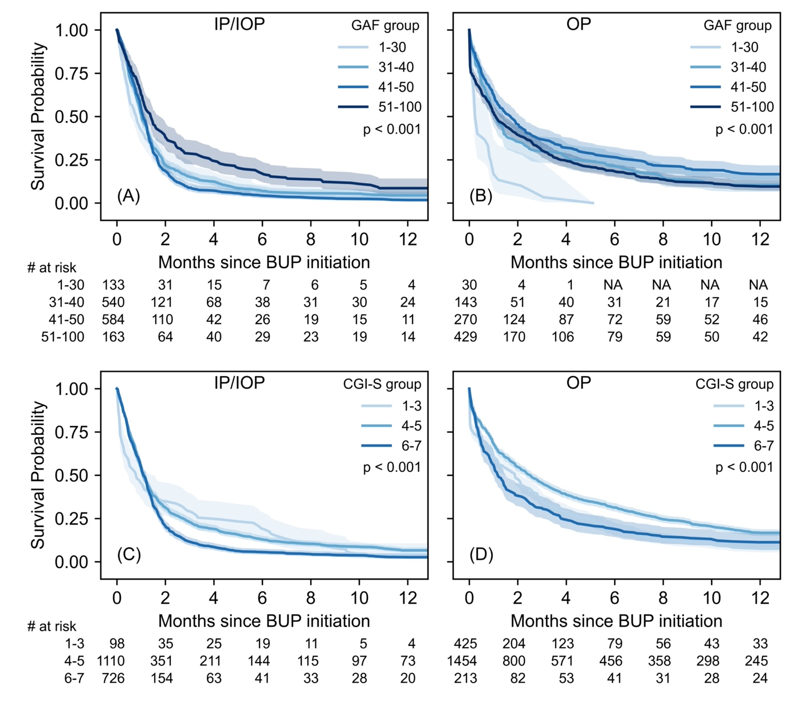

Supplemental Figure 2: Survival curves stratified by sex for IP/IOP and OP groups

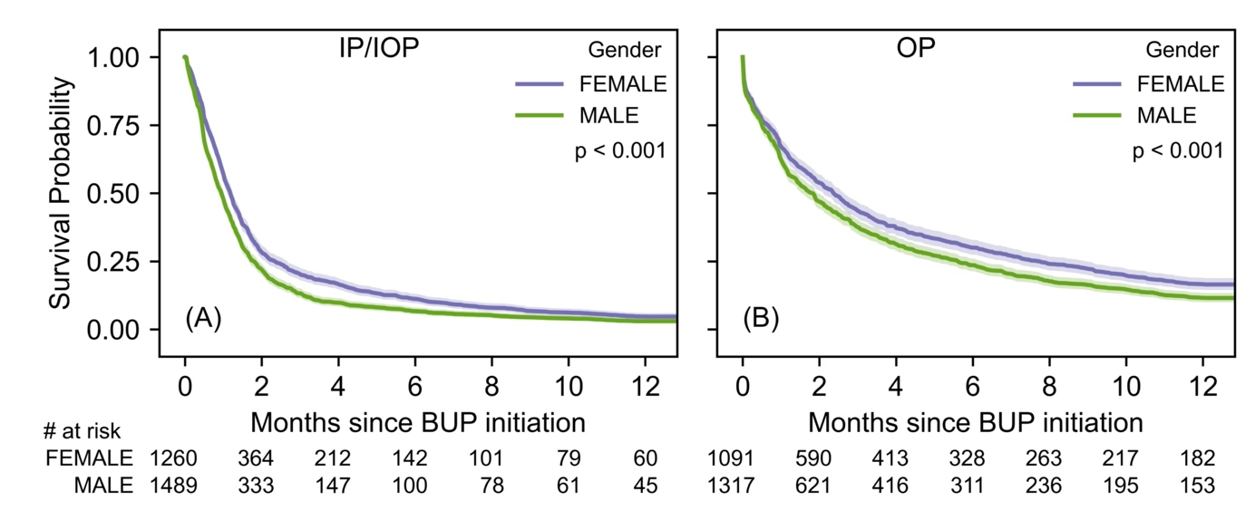

Supplemental Figure 3: Survival curves stratified by age group for IP/IOP and OP groups

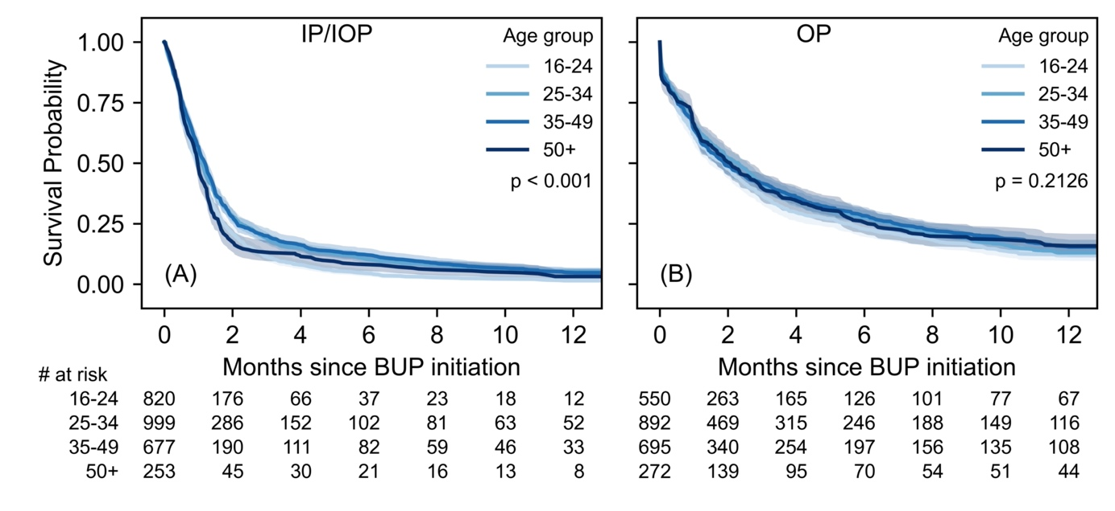

Supplemental Figure 4: Survival curves stratified by presence (1) or absence (0) of comorbid substance use (alcohol and stimulants) disorder for IP/IOP and OP groups

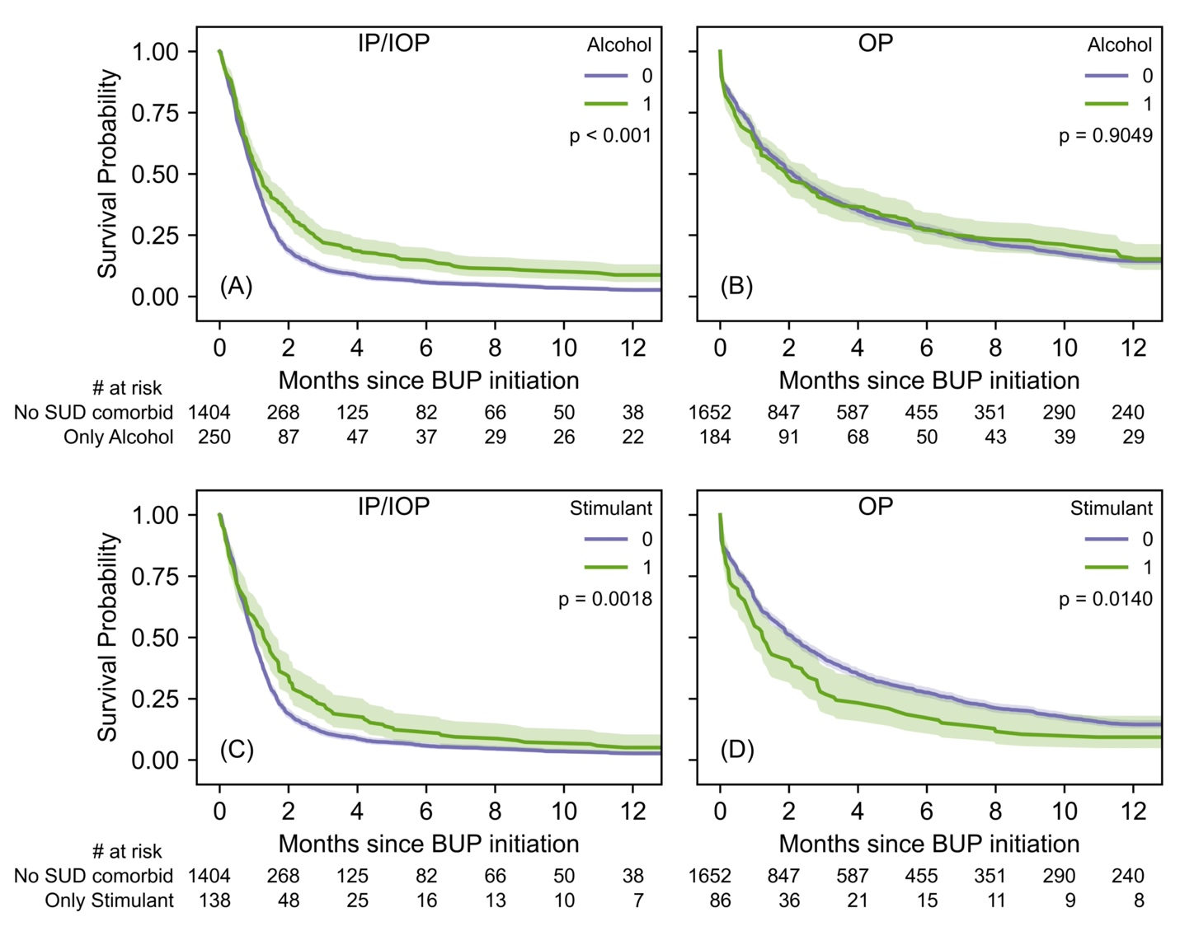

Supplemental Figure 5: Survival curves stratified by number of comorbid psychiatric disorders for IP/IOP and OP groups

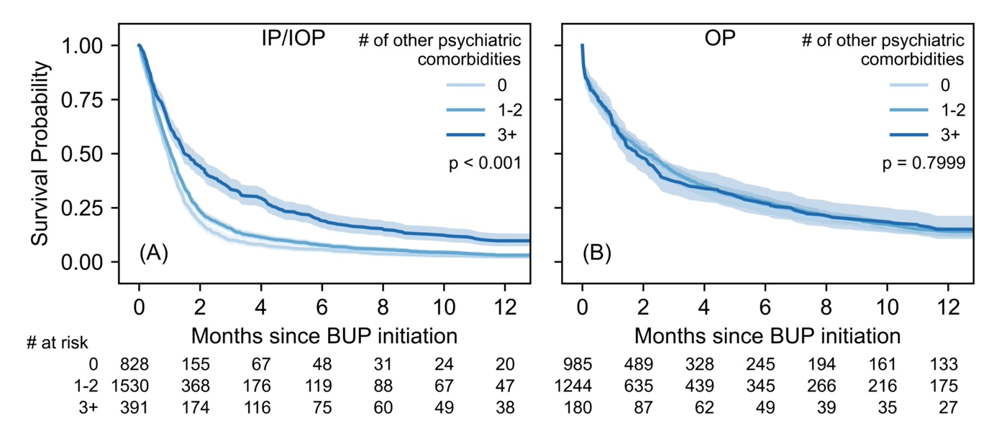

Supplemental Figure 6: Survival curves stratified by number of concomitant psychotropic and non-psychotropic drugs recorded in the electronic health record for IP/IOP and OP groups

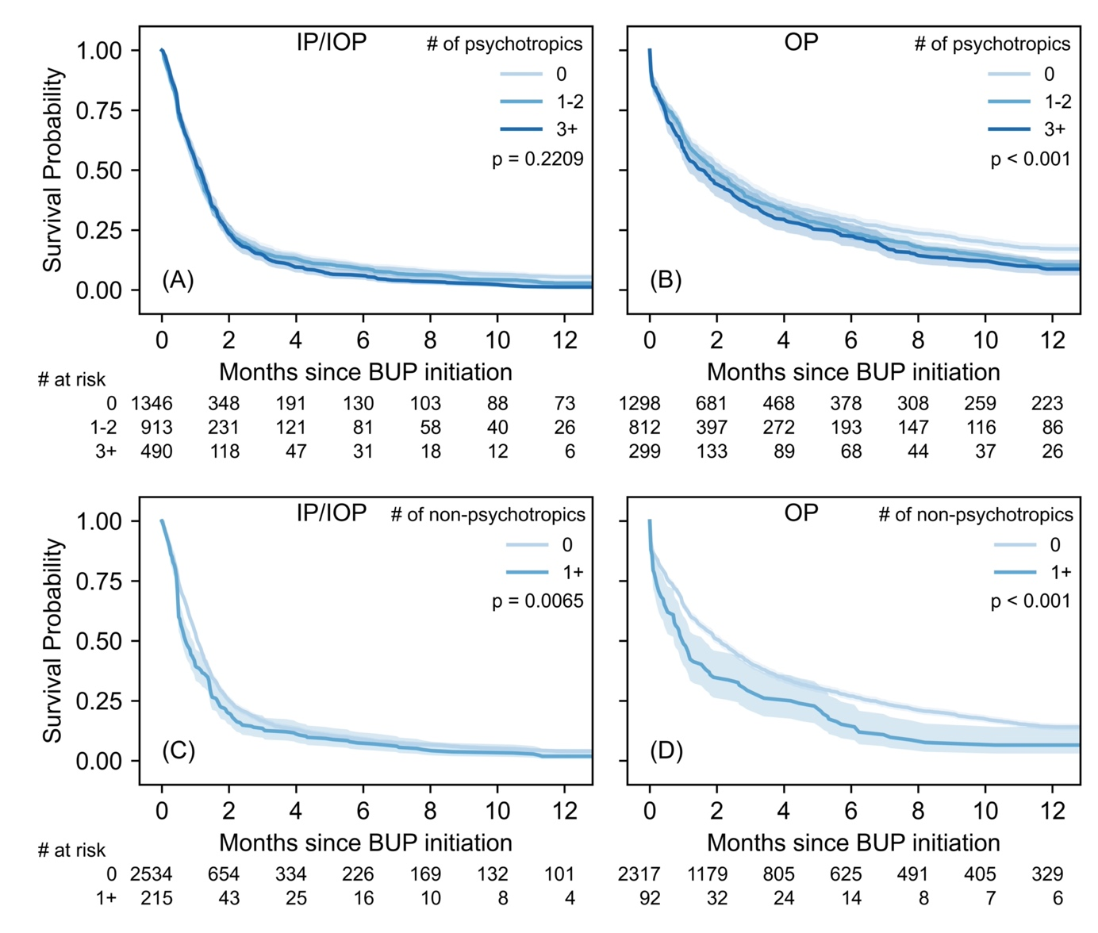

Supplemental Figure 7: Percentage of patients undergoing BUP dose changes for IP/IOP and OP groups

