Supplementary Material

Supplementary Table S1. PRISMA 2009 Checklist 1
Supplementary Data S2. Search strategy 4
Supplementary Figure S3. Risk of bias across studies 9
Supplementary Table S4. Risk of bias in individual studies 10
Supplementary Figure S5. Pooling estimation of physical endurance 18
Supplementary Figure S6. Pooling estimation of quality of life 18
Supplementary Figure S7. Sensitivity analysis results 19

Section/topic | # | Checklist item | Reported on page #
TITLE
Title | 1 | Identify the report as a systematic review, meta-analysis, or both. | 1
ABSTRACT
Structured summary | 2 | Provide a structured summary including, as applicable: background; objectives; data sources; study eligibility criteria, participants, and interventions; study appraisal and synthesis methods; results; limitations; conclusions and implications of key findings; systematic review registration number. | 1-2
INTRODUCTION
Rationale | 3 | Describe the rationale for the review in the context of what is already known. | 2-3
Objectives | 4 | Provide an explicit statement of questions being addressed with reference to participants, interventions, comparisons, outcomes, and study design (PICOS). | 3
METHODS
Protocol and registration | 5 | Indicate if a review protocol exists, if and where it can be accessed (e.g., Web address), and, if available, provide registration information including registration number. | 4
Eligibility criteria | 6 | Specify study characteristics (e.g., PICOS, length of follow-up) and report characteristics (e.g., years considered, language, publication status) used as criteria for eligibility, giving rationale. | 4
Information sources | 7 | Describe all information sources (e.g., databases with dates of coverage, contact with study authors to identify additional studies) in the search and date last searched. | 4
Search | 8 | Present full electronic search strategy for at least one database, including any limits used, such that it could be repeated. | 4
Study selection | 9 | State the process for selecting studies (i.e., screening, eligibility, included in systematic review, and, if applicable, included in the meta-analysis). | 4
Data collection process | 10 | Describe method of data extraction from reports (e.g., piloted forms, independently, in duplicate) and any processes for obtaining and confirming data from investigators. | 4
Data items | 11 | List and define all variables for which data were sought (e.g., PICOS, funding sources) and any assumptions and simplifications made. | 4
Risk of bias in individual studies | 12 | Describe methods used for assessing risk of bias of individual studies (including specification of whether this was done at the study or outcome level), and how this information is to be used in any data synthesis. | 4
Summary measures | 13 | State the principal summary measures (e.g., risk ratio, difference in means). | 4
Synthesis of results | 14 | Describe the methods of handling data and combining results of studies, if done, including measures of consistency (e.g., I²) for each meta-analysis. | 4-5

Section/topic | # | Checklist item | Reported on page #
Risk of bias across studies | 15 | Specify any assessment of risk of bias that may affect the cumulative evidence (e.g., publication bias, selective reporting within studies). | 4
Additional analyses | 16 | Describe methods of additional analyses (e.g., sensitivity or subgroup analyses, meta-regression), if done, indicating which were pre-specified. | 5
RESULTS
Study selection | 17 | Give numbers of studies screened, assessed for eligibility, and included in the review, with reasons for exclusions at each stage, ideally with a flow diagram. | 5
Study characteristics | 18 | For each study, present characteristics for which data were extracted (e.g., study size, PICOS, follow-up period) and provide the citations. | 5
Risk of bias within studies | 19 | Present data on risk of bias of each study and, if available, any outcome level assessment (see item 12). | 5
Results of individual studies | 20 | For all outcomes considered (benefits or harms), present, for each study: (a) simple summary data for each intervention group (b) effect estimates and confidence intervals, ideally with a forest plot. | 6-8
Synthesis of results | 21 | Present results of each meta-analysis done, including confidence intervals and measures of consistency. | 6-8
Risk of bias across studies | 22 | Present results of any assessment of risk of bias across studies (see Item 15). | 5
Additional analysis | 23 | Give results of additional analyses, if done (e.g., sensitivity or subgroup analyses, meta-regression [see Item 16]). | 6
DISCUSSION
Summary of evidence | 24 | Summarize the main findings including the strength of evidence for each main outcome; consider their relevance to key groups (e.g., healthcare providers, users, and policy makers). | 8, 9
Limitations | 25 | Discuss limitations at study and outcome level (e.g., risk of bias), and at review-level (e.g., incomplete retrieval of identified research, reporting bias). | 9, 10
Conclusions | 26 | Provide a general interpretation of the results in the context of other evidence, and implications for future research. | 10
FUNDING
Funding | 27 | Describe sources of funding for the systematic review and other support (e.g., supply of data); role of funders for the systematic review. | 12
From: Moher D, Liberati A, Tetzlaff J, Altman DG, The PRISMA Group (2009). Preferred Reporting Items for Systematic Reviews and Meta-Analyses: The PRISMA Statement. PLoS Med 6(7): e1000097. doi:10.1371/journal.pmed1000
For more information, visit: www.prisma-statement.org.

Supplementary Data S2. Search strategy

Medline:
(("Pulmonary Disease, Chronic Obstructive"[Mesh]) OR ((((((((((((((((((((((((((((("pulmonary disease, chronic obstructive"[MeSH Terms]) OR (Pulmonary Disease, Chronic Obstructive)) OR (Chronic Obstructive Pulmonary Diseases)) OR (Chronic Airflow Obstruction)) OR (Chronic Airflow Obstructions)) OR (Airflow Obstructions, Chronic)) OR (Airflow Obstruction, Chronic)) OR (Chronic Obstructive Pulmonary Disease)) OR (Chronic Obstructive Airway Disease)) OR (COPD)) OR (COAD)) OR (Chronic Obstructive Lung Disease)) OR (chronic airway obstruction)) OR (chronic obstructive bronchitis)) OR (chronic obstructive lung disorder)) OR (chronic obstructive bronchopulmonary disease)) OR (chronic obstructive pulmonary disorder)) OR (chronic obstructive respiratory disease)) OR (lung chronic obstructive disease)) OR (lung disease, chronic obstructive)) OR (lung diseases, obstructive)) OR (obstructive lung disease)) OR (obstructive lung disease, chronic)) OR (obstructive lung diseases)) OR (obstructive pulmonary disease)) OR (obstructive respiratory disease)) OR (obstructive respiratory tract disease)) OR (pulmonary disorder, chronic obstructive)))) AND (("Fatty Acids, Omega-3"[Mesh]) OR ((((((((((((((((((((((((((((((((((((((((((((((((((("Omega-3 Fatty Acid") OR ("Acid, Omega-3 Fatty")) OR ("Fatty Acid, Omega-3")) OR ("Omega-3 Fatty Acid")) OR ("Omega-3 Fatty Acids")) OR ("n-3 Oil")) OR ("Oil, n-3")) OR ("n-3 Oil")) OR ("n3 Oil")) OR ("Oil, n3")) OR ("n-3 Fatty Acids")) OR ("n-3 Fatty Acids")) OR ("Omega-3 Fatty Acids")) OR ("n-3 PUFA")) OR ("PUFA, n-3")) OR ("n-3 PUFA")) OR ("n3 Fatty Acid")) OR ("Fatty Acid, n3")) OR ("n3 PUFA")) OR ("PUFA, n3")) OR ("n3 Polyunsaturated Fatty Acid")) OR ("n3 Oils")) OR ("n-3 Oils")) OR ("n-3 Oils")) OR ("N-3 Fatty Acid")) OR ("Acid, N-3 Fatty")) OR ("Fatty Acid, N-3")) OR ("N-3 Fatty Acid")) OR ("n-3 Polyunsaturated Fatty Acid")) OR ("n-3 Polyunsaturated Fatty Acid")) OR ("bilantin omega")) OR ("conchol-36")) OR ("eicosa e")) OR ("eicosapen")) OR ("epaisdin")) OR ("epanova")) OR ("fatty acids, omega-3")) OR ("fatty acids, omega-3")) OR ("n-3 fatty acid")) OR ("n-3 polyunsaturated fatty acid")) OR ("omega-3")) OR ("omega-3 carboxylic acid")) OR ("omega-3 carboxylic acids")) OR ("omega-3 feingold")) OR ("omega-3 plus")) OR ("omega-3 polyunsaturated fatty acid")) OR ("omega forte")) OR ("omega-3-carboxylic acids")) OR ("omega3 polyunsaturated fatty acid")) OR ("sakana")) OR ("sanhelios omega-3"))) Filters: Randomized Controlled Trial

Embase:
('chronic obstructive lung disease'/exp OR 'Pulmonary Disease, Chronic Obstructive' OR 'Chronic Obstructive Pulmonary Diseases' OR 'Chronic Airflow Obstruction' OR 'Chronic Airflow Obstructions' OR 'chronic obstructive lung disease' OR 'Airflow Obstructions, Chronic' OR 'Airflow Obstruction, Chronic' OR 'Chronic Obstructive Pulmonary Disease' OR 'Chronic Obstructive Airway Disease' OR 'COPD' OR 'COAD' OR 'Chronic Obstructive Lung Disease' OR 'chronic airway obstruction' OR 'chronic obstructive bronchitis' OR 'chronic obstructive lung disorder' OR 'chronic obstructive bronchopulmonary disease' OR 'chronic obstructive pulmonary disorder' OR 'chronic obstructive respiratory disease' OR 'lung chronic obstructive disease' OR 'lung disease, chronic obstructive' OR 'lung diseases, obstructive' OR 'obstructive lung disease' OR 'obstructive lung disease, chronic' OR 'obstructive lung diseases' OR 'obstructive pulmonary disease' OR 'obstructive respiratory disease' OR 'obstructive respiratory tract disease' OR 'pulmonary disorder, chronic obstructive') AND ('Omega-3 Fatty Acid'/exp OR 'Acid, Omega-3 Fatty' OR 'Fatty Acid, Omega-3' OR 'Omega 3 Fatty Acid' OR 'Omega-3 Fatty Acids' OR 'n-3 Oil' OR 'Oil, n-3' OR 'n 3 Oil' OR 'n3 Oil' OR 'Oil, n3' OR 'n-3 Fatty Acids' OR 'n 3 Fatty Acids' OR 'Omega 3 Fatty Acids' OR 'n-3 PUFA' OR 'PUFA, n-3' OR 'n 3 PUFA' OR 'n3 Fatty Acid' OR 'Fatty Acid, n3' OR 'n3 PUFA' OR 'PUFA, n3' OR 'n3 Polyunsaturated Fatty Acid' OR 'n3 Oils' OR 'n-3 Oils' OR 'n 3 Oils' OR 'N-3 Fatty Acid' OR 'Acid, N-3 Fatty' OR 'Fatty Acid, N-3' OR 'N 3 Fatty Acid' OR 'n-3 Polyunsaturated Fatty Acid' OR 'n 3 Polyunsaturated Fatty Acid' OR 'bilantin omega' OR 'conchol 36' OR 'eicosa e' OR 'eicosapen' OR 'epaisdin' OR 'epanova' OR 'fatty acids, omega 3' OR 'fatty acids, omega-3' OR 'n 3 fatty acid' OR 'n 3 polyunsaturated fatty acid' OR 'omega 3' OR 'omega 3 carboxylic acid' OR 'omega 3 carboxylic acids' OR 'omega 3 feingold' OR 'omega 3 plus' OR 'omega 3 polyunsaturated fatty acid' OR 'omega forte' OR 'omega-3-carboxylic acids' OR 'omega3 polyunsaturated fatty acid' OR 'sakana' OR 'sanhelios omega 3') AND ('randomized controlled trial'/exp OR 'controlled trial, randomized' OR 'randomised controlled study' OR 'randomised controlled trial' OR 'randomized controlled study' OR 'randomized controlled trial' OR 'trial, randomized controlled')

ClinicalTrials.gov:
Available, Completed Studies | Studies With Results | Interventional Studies | Chronic Obstructive Pulmonary Disease | Omega-3 Fatty Acid | Adult

Cochrane Library:
ID Search
#1 MeSH descriptor: [Pulmonary Disease, Chronic Obstructive] explode all trees
#2 (“Pulmonary Disease, Chronic Obstructive” OR “Chronic Obstructive Pulmonary Diseases” OR “Chronic Airflow Obstruction” OR “Chronic Airflow Obstructions” OR “chronic obstructive lung disease” OR “Airflow Obstructions, Chronic” OR “Airflow Obstruction, Chronic” OR “Chronic Obstructive Pulmonary Disease” OR “Chronic Obstructive Airway Disease” OR “COPD” OR “COAD” OR “Chronic Obstructive Lung Disease” OR “chronic airway obstruction” OR “chronic obstructive bronchitis” OR “chronic obstructive lung disorder” OR “chronic obstructive bronchopulmonary disease” OR “chronic obstructive pulmonary disorder” OR “chronic obstructive respiratory disease” OR “lung chronic obstructive disease” OR “lung disease, chronic obstructive” OR “lung diseases, obstructive” OR “obstructive lung disease” OR “obstructive lung disease, chronic” OR “obstructive lung diseases” OR “obstructive pulmonary disease” OR “obstructive respiratory disease” OR “obstructive respiratory tract disease” OR “pulmonary disorder, chronic obstructive”) (Word variations have been searched) in Trials
#3 MeSH descriptor: [Fatty Acids, Omega-3] explode all trees
#4 (“Omega-3 Fatty Acid” OR “Acid, Omega-3 Fatty” OR “Fatty Acid, Omega-3” OR “Omega 3 Fatty Acid” OR “Omega-3 Fatty Acids” OR “n-3 Oil” OR “Oil, n-3” OR “n 3 Oil” OR “n3 Oil” OR “Oil, n3” OR “n-3 Fatty Acids” OR “n 3 Fatty Acids” OR “Omega 3 Fatty Acids” OR “n-3 PUFA” OR “PUFA, n-3” OR “n 3 PUFA” OR “n3 Fatty Acid” OR “Fatty Acid, n3” OR “n3 PUFA” OR “PUFA, n3” OR “n3 Polyunsaturated Fatty Acid” OR “n3 Oils” OR “n-3 Oils” OR “n 3 Oils” OR “N-3 Fatty Acid” OR “Acid, N-3 Fatty” OR “Fatty Acid, N-3” OR “N 3 Fatty Acid” OR “n-3 Polyunsaturated Fatty Acid” OR “n 3 Polyunsaturated Fatty Acid” OR “bilantin omega” OR “conchol 36” OR “eicosa e” OR “eicosapen” OR “epaisdin” OR “epanova” OR “fatty acids, omega 3” OR “fatty acids, omega-3” OR “n 3 fatty acid” OR “n 3 polyunsaturated fatty acid” OR “omega 3” OR “omega 3 carboxylic acid” OR “omega 3 carboxylic acids” OR “omega 3 feingold” OR “omega 3 plus” OR “omega 3 polyunsaturated fatty acid” OR “omega forte” OR “omega-3 carboxylic acids” OR “omega3 polyunsaturated fatty acid” OR “sakana” OR “sanhelios omega 3”)
#5 (#1 OR #2) AND (#3 OR #4) in Trials

CNKI:
主题=慢性阻塞性肺疾病+慢阻肺+慢阻肺病+慢性阻塞性肺气肿+慢性阻塞性肺部疾病+慢性阻塞性肺病 AND
主题=不饱和脂肪酸+多烯脂肪酸+必需脂肪酸+长链脂肪酸+“n-3”+ ω-3”

Supplementary Figure S3. Risk of bias across studies.
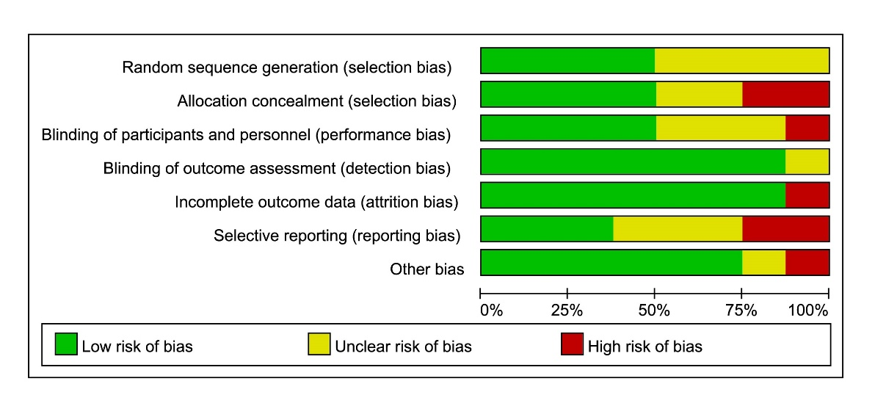
a. Risk of bias graph
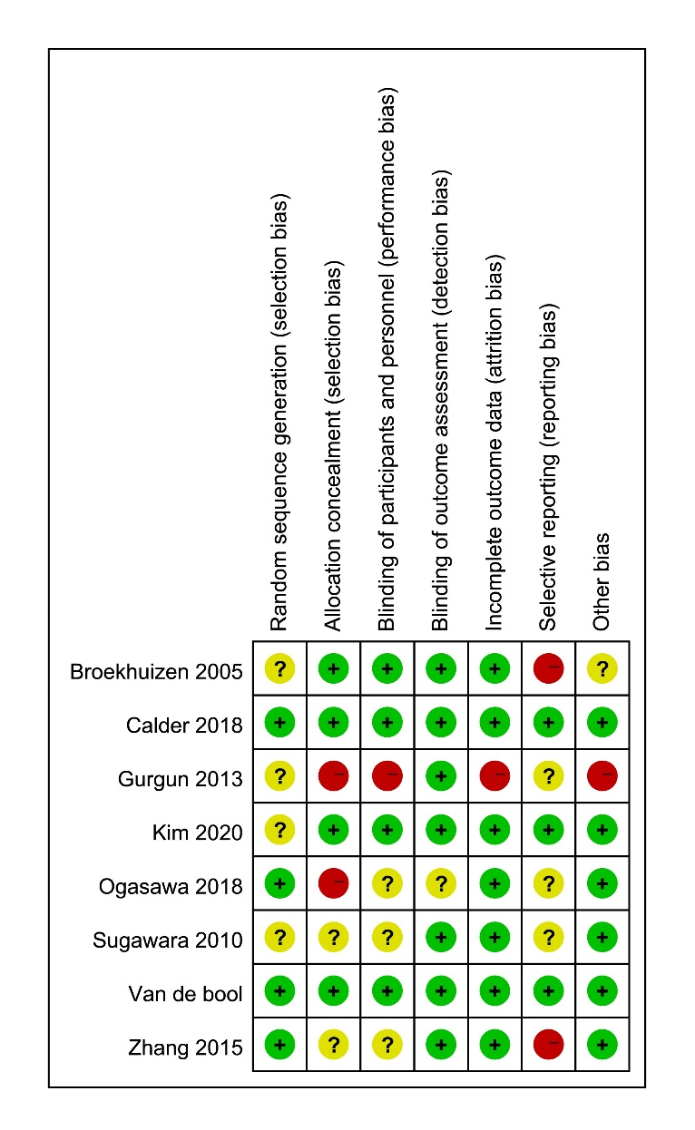

b. Risk of bias summary
Supplementary Table S4. Risk of bias in individual studies
Broekhuizen 2005
Bias | Authors' judgement | Support for judgement
Random sequence generation  (selection bias) | Unclear risk | Claimed randomization and double blind but with no detailed description.
Allocation concealment  (selection bias) | Low risk | “During an 8-week training programme all patients received nine capsules daily, each capsule containing 1 g of either a blend of PUFA or placebo.”
Blinding of participants and personnel (performance bias) | Low risk | We believe the identical capsule used in both groups can maintain the blinding of participants and personnel.
Blinding of outcome assessment  (detection bias) | Low risk | Blinding or not may not affect the outcome measurements for the majority of them are objective.
Incomplete outcome data  (attrition bias) | Low risk | Discontinued cases were analyzed and described in detail.  “Four hundred and twenty-nine patients were admitted to the rehabilitation centre during the study period which lasted from July 2000 until October 2002; 258 did not meet the inclusion criteria and 69 patients did not want to participate.  The intent-to-treat group therefore consisted of 102 patients (71 men and 31 women; 51 PUFA and 51 placebo).  - Three patients in the placebo group had to discontinue the study because of admission to hospital due to exacerbation (n=2) or pneumothorax (n=1).  - One patient in the PUFA group discontinued the intervention due to enteric fever. Four patients (PUFA: n=2, placebo: n=2) resigned from the rehabilitation centre because of personal problems and four patients (PUFA: n=3, placebo: n=1) were not willing to cooperate further with the study. In the placebo group, three patients discontinued because of an increase in complaints such as belching and nausea, while in the PUFA group seven patients discontinued the study due to belching, nausea, vomiting, fishy taste in the mouth, and stomach ache.  - In total, nine patients in the placebo group and 13 in the PUFA group discontinued the intervention, leaving 80 patients to complete the study (PUFA: n=38, placebo: n=42; fig 1). There was no significant difference either in the number of patients dropping out of the study or in those with complaints due to the intervention between the PUFA and the placebo groups”
Selective reporting (reporting bias) | High risk | Not mentioned.
Other bias | Unclear risk | Not known.
Calder 2018
Bias | Authors' judgement | Support for judgement
Random sequence generation (selection bias) | Low risk | “Trial Form Support, AB (Lund, Sweden) implemented randomization by assigning patients a three-digit number allocating them to a treatment group; patients at each site were assigned numbers sequentially. Access to randomization details was restricted until study end.”
Allocation concealment  (selection bias) | Low risk | “Labelling conformed to local regulations and ensured that the contents were not identifiable.”
Blinding of participants and personnel  (performance bias) | Low risk | “Access to randomization details was restricted until study end.”
Blinding of outcome assessment  (detection bias) | Low risk | Blinding or not can not affect the outcome assessment for the majority of them are objective measurements.
Incomplete outcome data  (attrition bias) | Low risk | No discontinued objects at all.
Selective reporting  (reporting bias) | Low risk | Protocol registered preliminarily: ClinicalTrials.gov Identifier: NCT02442908. This article is basically cohesive to the protocol.
Other bias | Low risk | Not known.
Gurgun 2013
Bias | Authors' judgement | Support for judgement
Random sequence generation  (selection bias) | Unclear risk | Claimed randomization but with no detailed description.
Allocation concealment  (selection bias) | High risk | Not mentioned.
Blinding of participants and personnel (performance bias) | High risk | Not mentioned.
Blinding of outcome assessment  (detection bias) | Low risk | Blinding or not may not affect the outcome measurements for the majority of them are objective.
Incomplete outcome data  (attrition bias) | High risk | Not mentioned.
Selective reporting  (reporting bias) | Unclear risk | Protocol not online-available.  “The study was approved by Institutional Ethics Committee (approval acceptance number: 09-10.1/1) and Internal Review Board.”
Other bias | High risk | Based on its highly vague description of interventions, we cannot exclude the possibility of other bias.
Kim 2020
Bias | Authors' judgement | Support for judgement
Random sequence generation  (selection bias) | Unclear risk | "After screening, participants were randomized in a 1:1 ratio by research study coordinators"  Randomization mentioned but without detailed description.
Allocation concealment  (selection bias) | Low risk | “The placebo capsule had the same appearance and smell as the active capsule unless the capsule was broken or bitten.”
Blinding of participants and personnel  (performance bias) | Low risk | "All participants, investigators and study personnel were blinded to treatment assignment."  “At the last study visit, participants were asked in a questionnaire whether they thought they received placebo or the study treatment to assess adequacy of randomization.”
Blinding of outcome assessment (detection bias) | Low risk | "All participants, investigators and study personnel were blinded to treatment assignment." And blinding or not may not affect the outcome measurements for the majority of them are objective.
Incomplete outcome data  (attrition bias) | Low risk | "The randomized sample included 40 participants, 20 in each arm (Figure 1). Baseline characteristics are summarized in Table 1. All participants had at least moderate COPD and reported no active use of nicotine-containing products, which was confirmed by NicAlert testing. A total of 34 participants had CT data available, of which 27 (79%) had emphysema. At baseline, the fish oil arm had a higher mean 6MWD, lower systolic and diastolic blood pressure and fewer statin users than the placebo arm. On average at each visit, 3 participants in each treatment arm were unable to perform the 6MWT due to contraindications or requiring wheelchair assistance. EMP measurements were incomplete primarily due to insufficient blood collection, the participant refusing to provide blood at the study visit, or poor function of the antibodies for labeling."
Selective reporting  (reporting bias) | Low risk | "The study was registered at clinicaltrials.gov prior to enrollment (NCT00835289). " This article is basically cohesive to the protocol.
Other bias | Low risk | Not known.
Ogasawa 2018
Bias | Authors' judgement | Support for judgement
Random sequence generation  (selection bias) | Low risk | "Randomization was performed using a computer-generated randomization scheme with blocks of four."
Allocation concealment  (selection bias) | High risk | Provided the products utilized in the intervention, but without detailed description of the allocation of concealment.  "The patients were randomly assigned in a 1:1 ratio to the EPA group, which received EPA-enriched ONS (ProSure®; Abbott, Chicago, IL), and the control group, which received similar-energy ONS that was free of EPA (ENSURE®H; Abbott) (Table 1)."  #Two types of intervention may have different packages.  "Patients were asked to consume one pack or one can per day of the ONSs."
Blinding of participants and personnel  (performance bias) | Unclear risk | Not mentioned.
Blinding of outcome assessment  (detection bias) | Unclear risk | Blinding or not may not affect the outcome measurements for the majority of them are objective.
Incomplete outcome data  (attrition bias) | Low risk | "In total, 50 eligible patients were enrolled in the study and evaluated prospectively (Fig. 1). One patient in the EPA group was excluded, because his body weight at the time of admission was erroneously input to the BIA, resulting in the BMI and LBMI being characterized as overweight. Three patients in the control group were also excluded because they could not continue taking ONS orally due to dysphagia or intubation, and one patient withdrew informed consent. Baseline characteristics were similar between the EPA group (n = 24) and the control group (n = 21) (Table 2). There was no significant difference between the two groups in smoking history (60.4 ± 41.0 vs. 52.5 ± 35.2 pack-years, P = 0.50)."
Selective reporting (reporting bias) | Unclear risk | Claimed the existence of protocol but the information source is not available online.
Other bias | Low risk | Not known.
Sugawara 2010
Bias | Authors' judgement | Support for judgement
Random sequence generation  (selection bias) | Unclear risk | Claimed randomization but with no detailed description.  "All patients were randomly classified into two groups: a nutrition with low-intensity exercise group and a control group."
Allocation concealment  (selection bias) | Unclear risk | Not mentioned.
Blinding of participants and personnel  (performance bias) | Unclear risk | Not mentioned.
Blinding of outcome assessment  (detection bias) | Low risk | Blinding or not may not affect the outcome measurements for the majority of them are objective.
Incomplete outcome data  (attrition bias) | Low risk | No discontinued objectives.
Selective reporting (reporting bias) | Unclear risk | Claimed the existence of protocol but the information source is not available online.
Other bias | Low risk | Not noted.
Van de bool
Bias | Authors' judgement | Support for judgement
Random sequence generation  (selection bias) | Low risk | “The randomization sequence was generated using the PLAN procedure of SAS statistical software (Enterprise Guide version 4.3) by a statistician from Nutricia Research who had no further involvement in the conduct of the study. The permuted block randomization was stratified for site, with a 1:1 allocation ratio of NUTRITION and PLACEBO product. All details of the randomization, including block size, were unknown to the investigator, site staff, and study staff, except for the statistician who was responsible for generating the randomization sequence, and the supplies manager who needed to be unblinded in order to label the study products and to create unblinding envelopes, etc.”  From paper’s Online Supplementary Material
Allocation concealment  (selection bias) | Low risk | “The packaging of the test product and control product were identical in appearance.”  From paper’s Online Supplementary Material
Blinding of participants and personnel  (performance bias) | Low risk | “The study product was labelled using product numbers. Which product numbers corresponded to which treatment was only known to the statistician who was responsible for generating the randomization sequence and the clinical studies supplies manager of Nutricia Research.”  From paper’s Online Supplementary Material
Blinding of outcome assessment (detection bias) | Low risk | “The study product was labelled using product numbers. Which product numbers corresponded to which treatment was only known to the statistician who was responsible for generating the randomization sequence and the clinical studies supplies manager of Nutricia Research.”  From paper’s Online Supplementary Material
Incomplete outcome data  (attrition bias) | Low risk | “Two of the 81 randomized patients did not start the treatment. During the PR, the drop‐out rate was 9.5% (four patients) in NUTRITION and 5.4% (two patients) in PLACEBO. Mean supplement intake reached 2.1 ± 0.1 portions/day. Reported side‐effects included stomach‐ache (n =3in NUTRITION, n = 1 in PLACEBO), constipation (n =2 in NUTRITION), and undesirable weight loss (n = 5 in PLACEBO). Nonetheless, neutral or positive product rating was revealed in the majority of patients regarding taste, sweetness, mouthfeel, and thickness of the NUTRITION and PLACEBO supplement. The aftertaste of the NUTRITION supplement was equally rated pleasant or unpleasant. A high satiety after consuming the supplement was reported by ±70% in NUTRITION vs. ±17% in PLACEBO (P <0.001). Outcomes of the intervention are presented in Table 2.”
Selective reporting  (reporting bias) | Low risk | "The study was registered at clinicaltrials.gov (NCT01344135) and the Medical Ethics Committee from Maastricht University Medical Centre granted ethical approval (NL34927068.10/MEC 11‐3‐004)."
Other bias | Low risk | Not noted.

Zhang 2015
Bias | Authors' judgement | Support for judgement
Random sequence generation (selection bias) | Low risk | "According to the random number table, the patients were divided into two groups, 30 cases in the immune nutrition group and 30 cases in the standard nutrition group."
Allocation concealment (selection bias) | Unclear risk | Not mentioned.
Blinding of participants and personnel (performance bias) | Unclear risk | Not mentioned.
Blinding of outcome assessment (detection bias) | Low risk | Blinding or not can not affect the outcome assessment for the majority of them are objective measurements.
Incomplete outcome data (attrition bias) | Low risk | No discontinued objectives.
Selective reporting (reporting bias) | High risk | Protocol unavailable and not claimed in report.
Other bias | Low risk | Not noted.
Abbreviation：
CT, computing tomography.
COPD, chronic obstructive pulmonary disease.
EPA, Eicosapentaenoic Acid.
ONS, oral nutritional supplement.
PUFA, poly-unsaturated fatty acid.

Supplementary Figure S5. Pooling estimation of physical endurance
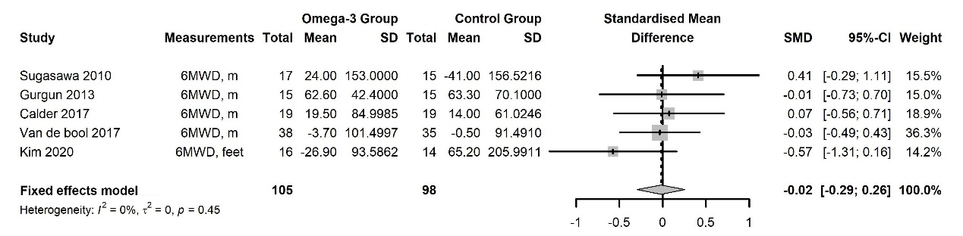
Supplementary Figure S6. Pooling estimation of quality of life
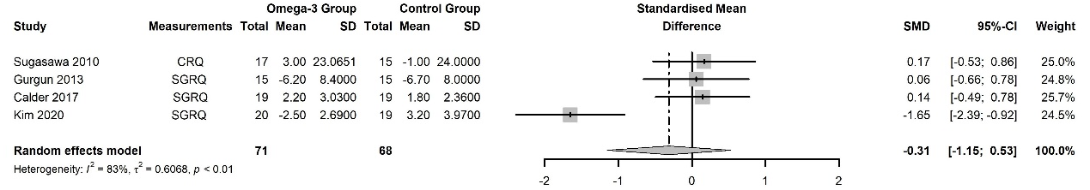
Supplementary Figure S7. Sensitivity analysis results.
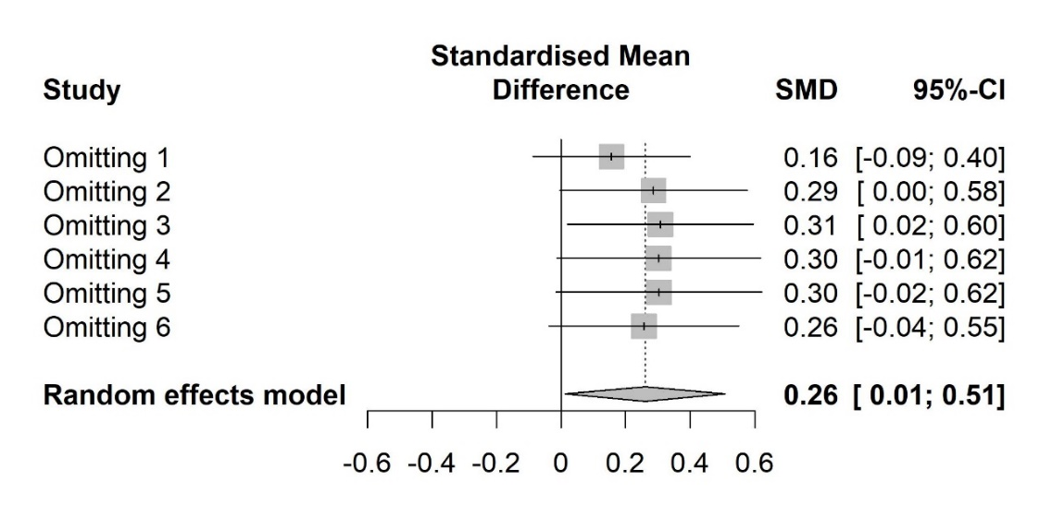
- Sensitivity analysis of Weight.
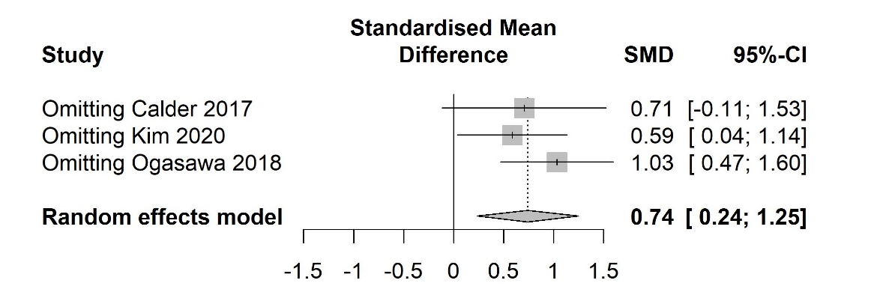
- Sensitivity analysis of low-density lipoprotein.
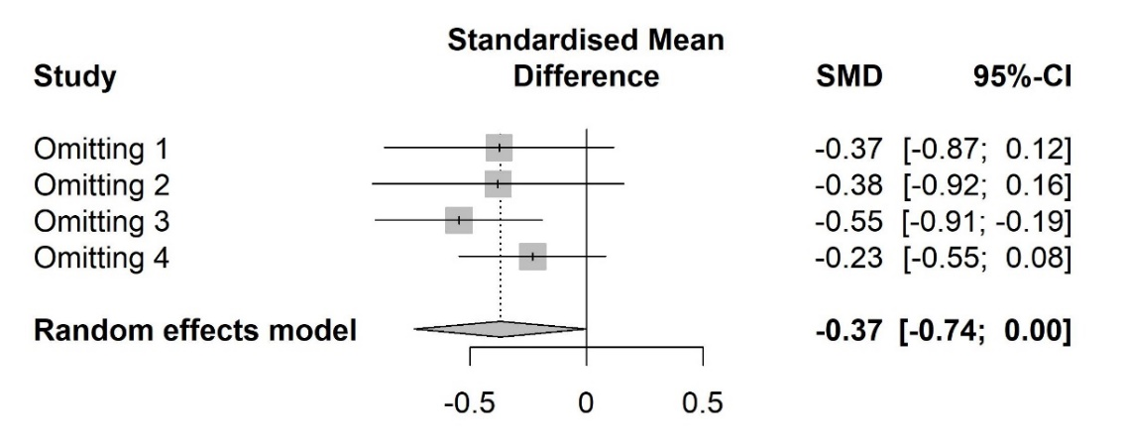
- Sensitivity analysis of interleukin-6.

