Supplementary materials
Prostate-Specific Membrane Antigen and Esterase Dual Responsive Camptothecin - Oligopeptide Self-Assembled Nanoparticles for Efficient Anticancer Drug Delivery
Materials
All chemical reagents were obtained from commercial suppliers and used without further purification unless otherwise mentioned. Camptothecin (CPT) was provided by Adamas Pharmaceuticals, Inc. (Shanghai, China). 1-Ethyl-3-(3-dimethylaminopropyl) carbodiimide (EDCI), 1-Hydroxybenzotriazole (HOBT), N, N-Diisopropylethylamine (DIPEA), 4-dimethylaminopyridine (DMAP) were purchased from Aladdin (Shanghai Aladdin Bio-Chem Technology Co., LTD). 1’-dioctadecyl-3, 3, 3’, 3’-tetramethylindotricarbocyanine iodide (DiR) was purchased from Sigma-Aldrich (USA). Fetal bovine serum (FBS), Roswell Park Memorial Institute 1640 Medium (RPMI 1640) were obtained from Corning (USA). All melting points were determined on a micro melting point apparatus and were uncorrected. NMR spectra were recorded on a BRUKER AVANCE 500 MHz and 400 MHz spectrometer (Fällanden, Switzerland) with tetramethylsilane (TMS) as an internal standard; chemical shifts δ were given in ppm and coupling constants J in Hz. HRMS were acquired using a Thermo Scientific TM LTQ Orbitrap XL hybrid FTMS instrument (Thermo Technologies, New York, NY, USA).

Chemical synthesis.
As shown in Scheme S1, WT-H (Asp-Glu*Glu*Glu*Glu) (“*” means the γ-glutamyl linkage; “-” means the α-glutamyl linkage), the penta-peptide employed as the hydrophilic part and tumor-targeting group, was prepared by liquid-phase peptide synthesis (LPPS).
Scheme S1. Synthesis of the penta-peptide WT-H. Reagents and Conditions: (a) EDCI, HOBt, DIPEA, DCM, 25°C, 4 h; (b) Piperidine, dimethylformamide (DMF), 0.5 h; (c) Wet Pd/C (5%), MeOH, 12 h.

General synthetic procedure of condensation reaction (method A)

The corresponding intermediate (1 equiv.) was dissolved in dry DCM (20 mL), EDCI (1.5 equiv.) and the corresponding protected amino acid (1.1 equiv.) were added. After addition of HOBt (1.5 equiv.) and DIPEA (2.5 equiv.), the mixture was stirred at 25°C for 4 h. The reaction mixture was diluted with 50 mL CH₂Cl₂, then successively washed with water and brine (10 mL each), dried over sodium sulphate and filtered, and the solvent was evaporated. Then the crude product was purified by flash chromatography (silica gel, petroleum ether: ethyl acetate =10: 1 to 3: 1).
General synthetic procedure of de-protection (method B)
To a solution of the Fmoc-protected compound (1 equiv.) in dry DMF (20 mL), piperidine (3 equiv.) was added. The mixture was allowed to stir at room temperature for 0.5 h. After completion of the reaction (as monitored by TLC), the solution was evaporated, and the residue was dissolved with ethyl acetate (50 mL). The organic extracts were washed with distilled water (3 × 25 mL) and brine (20 mL), dried over sodium sulfate, filtrated and evaporated. Purification was performed by flash chromatography (silica gel, petroleum ether: ethyl acetate = 3: 1 to 0: 1).
General synthetic procedure of de-protection (method C)
Pd/C (10%; 80 mg) was added to a solution of the Cbz-protected compound in 30 mL MeOH. The mixture was stirred at room temperature for 12 h. After completion of the reaction (as monitored by TLC), the solvent was filtered to remove Pd/C. The filtrate was concentrated in vacuum and the residue was purified by flash chromatography (silica gel, dichloromethane: methanol = 40: 1 to 10: 1).
Characterization of WT-A. Obtained from Fmoc-L-Glutamic acid 1-tert-butyl ester by method A as a white powder; Yield: 86.5%; mp 104.7-105.5°C; ¹H NMR (500 MHz, CDCl₃): δ 1.45 (m, 27H, 9 × -CH₃), 1.92 (m, 2H), 2.29 (m, 6H), 4.22 (t, J = 7.0 Hz, 2H), 4.39 (d, J = 7.0 Hz, 2H), 4.48 (m, 1H), 5.60 (d, J = 7.7 Hz, 1H), 6.39 (d, J = 7.3 Hz, 1H), 7.32 (t, J = 7.3 Hz, 2H), 7.40 (t, J = 7.3 Hz, 2H), 7.61 (d, J = 7.3 Hz, 2H), 7.75 (d, J = 7.3 Hz, 2H); ¹³C NMR (125 MHz, CDCl₃): δ 27.8, 28.1, 28.2, 28.9, 31.7, 32.5, 47.3, 52.5, 54.1, 67.1, 80.8, 82.4, 82.6, 120.1, 125.3, 127.2, 127.8, 141.4, 143.9, 144.1, 156.3, 171.2, 171.8, 172.4; HRMS (ESI) m/z: [M + H]⁺ calcd for C₃₇H₅₁N₂O₉, 667.3595; found, 667.3584.
Characterization of WT-B. Obtained from WT-A by method B as a white oily liquid; Yield: 85.0%; ¹H NMR (500 MHz, CDCl₃): δ 1.40 (d, 27H, 9 × -CH₃), 1.79 (m, 2H), 2.03 (m, 2H), 2.19 (m, 2H), 2.32 (m, 2H), 3.29 (m, 1H), 4.42 (m, 1H), 6.62 (d, J = 7.3 Hz, 1H); ¹³C NMR (125 MHz, CDCl₃): δ 27.8, 28.0, 28.1, 30.3, 31.6, 32.9, 52.3, 54.5, 80.7, 81.3, 82.2, 171.3, 172.3, 175.0; HRMS (ESI) m/z: [M + H]⁺ calcd for C₂₂H₄₁N₂O₇, 445.2914; found, 445.2919.
Characterization of WT-C. Obtained from WT-B by method A as a white powder; Yield: 90.2%; mp 63.0-63.5°C; ¹H NMR (500 MHz, CDCl₃): δ 1.46 (m, 36H, 12 × -CH₃), 1.88 (m, 4H), 2.08 (m, 1H), 2.28 (m, 8H), 4.22 (m, 2H), 4.45 (m, 4H), 5.57 (d, J = 7.5 Hz, 1H), 6.56 (d, J = 7.2 Hz, 1H), 6.71 (d, J = 7.1 Hz, 1H), 7.32 (t, J = 7.4 Hz, 2H), 7.40 (t, J = 7.4 Hz, 2H), 7.62 (brs, 2H), 7.76 (d, J = 7.4 Hz, 2H); ¹³C NMR (125 MHz, CDCl₃): δ 27.8, 28.1, 28.2, 28.8, 31.7, 32.1, 32.5, 47.4, 52.4, 52.5, 53.9, 67.1, 80.8, 82.3, 82.5, 82.6, 120.1, 125.3, 125.4, 127.2, 127.8, 141.5, 143.9, 156.5, 171.2, 171.4, 172.0, 172.2, 172.3; HRMS (ESI) m/z: [M + H]⁺ calcd for C₄₆H₆₆N₃O₁₂ 852.4646; found, 852.4642.
Characterization of WT-D. Obtained from WT-C by method B as a white oily liquid; Yield: 91.0%; ¹H NMR (500 MHz, CDCl₃): δ 1.43 (m, 36H, 12 × -CH₃), 1.79 (m, 1H), 1.90 (m, 2H), 2.07 (m, 4H), 2.30 (m, 4H), 2.38 (m, 2H), 3.36 (m, 1H), 4.42 (m, 2H), 5.28 (m, 1H), 6.70 (d, J = 7.5 Hz, 1H), 6.93 (d, J = 7.6 Hz, 1H); ¹³C NMR (125 MHz, CDCl₃): δ 27.7, 28.1, 28.2, 28.5, 30.2, 31.7, 32.6, 32.9, 52.5, 53.5, 54.5, 80.8, 81.5, 82.4, 171.2, 171.3, 172.1, 172.4, 172.7, 174.7; HRMS (ESI) m/z: [M + H]⁺ calcd for C₃₁H₅₅N₃O₁₀, 630.3966; found, 630.3970.
Characterization of WT-E. Obtained from WT-D by method B as a white powder; Yield: 87.5%; mp119.6-120.4°C; ¹H NMR (500 MHz, CDCl₃): δ 1.44 (m, 45H, 15 × -CH₃), 1.89 (m, 4H), 2.08 (m, 1H), 2.29 (m, 10H), 2.38 (m, 2H), 4.23 (m, 2H), 4.46 (m, 5H), 5.63 (d, J = 7.2 Hz, 1H), 6.52 (d, J = 6.9 Hz, 1H), 6.88 (d, J = 5.9 Hz, 1H), 6.98 (d, J =5.6 Hz, 1H), 7.32 (t, J = 7.4 Hz, 2H), 7.40 (t, J = 7.4 Hz, 2H), 7.62 (d, J = 7.4 Hz, 2H), 7.76 (d, J = 7.4 Hz, 2H); ¹³C NMR (125 MHz, CDCl₃): δ 28.1, 28.2, 28.8, 31.7, 47.4, 51.1, 52.4, 57.5, 67.2, 120.1, 125.3, 127.2, 127.9, 141.5, 171.4, 172.2; HRMS (ESI) m/z: [M + H]⁺ calcd for C₅₅H₈₁N₄O₁₅, 1037.5698; found, 1037.5691.
Characterization of WT-F. Obtained from WT-E by method B as a white oily liquid; Yield: 90.9%; ¹H NMR (500 MHz, CDCl₃): δ 1.44 (m, 45H, 15 × -CH₃), 1.85 (m, 4H), 2.32 (m, 12H), 2.38 (m, 2H), 3.40 (m, 1H), 4.43 (m, 3H), 6.97 (m, 1H), 7.11 (m, 1H); ¹³C NMR (125 MHz, CDCl₃): δ 27.7, 27.8, 28.1, 28.2, 28.5, 28.7, 29.8, 30.1, 31.7, 32.2, 32.5, 32.9, 52.2, 52.3, 52.4, 52.5, 81.6, 81.8, 82.1, 82.2, 82.5, 171.2, 171.3, 171.4, 172.2, 172.3, 172.4, 172.9, 173.0; HRMS (ESI) m/z: [M + H]⁺ calcd for C₄₀H₇₁N₄O₁₃, 815.5018; found, 815.5006.
Characterization of WT-G. Obtained from WT-F by method A as a white powder; Yield: 80.0%; mp 77.2-78.0°C; ¹H NMR (500 MHz, CDCl₃): δ 1.43 (m, 54H, 18 × -CH₃), 1.74 (m, 2H), 1.86 (m, 2H), 2.07 (m, 2H), 2.29 (m, 10H), 2.38 (m, 2H), 2.79 (m, 1H), 3.16 (m, 1H), 4.47 (m, 4H), 4.56 (s, 1H), 5.11 (d, J = 12.3 Hz, 1H), 5.18 (d, J = 12.3 Hz, 1H), 5.79 (d, J = 7.7 Hz, 1H), 6.54 (d, J = 6.7 Hz, 1H), 7.04 (m, 2H), 7.24 (m, 1H), 7.33 (s, 5H); ¹³C NMR (125 MHz, CDCl₃): δ 27.9, 28.1, 28.2, 28.4, 28.6, 29.0, 29.3, 29.8, 31.5, 31.7, 32.0, 32.5, 36.2, 51.1, 51.8, 51.9, 52.3, 67.1, 80.6, 80.8, 81.9, 82.2, 82.3, 82.7, 128.3, 128.5, 128.7, 135.4, 155.7, 170.9, 171.2, 171.4, 172.0, 172.1, 172.2, 172.3, 172.4; HRMS (ESI) m/z: [M + H]⁺ calcd for C₅₆H₉₀N₅O₁₈, 1120.6281; found, 1120.6281.
Characterization of WT-H. Obtained from WT-G by method C as a white powder; Yield: 92.7%; mp 82.9-83.5°C; ¹H NMR (500 MHz, CDCl₃): δ 1.43 (s, 9 H, 3 × -CH₃), 1.44 (s, 18 H, 6 × -CH₃), 1.45 (s, 9 H, 3 × -CH₃), 1.47 (s, 9 H, 3 × -CH₃), 1.87 (m, 2H), 1.98 (m, 2H), 2.12 (m, 4H), 2.30 (m, 8H), 2.65 (dd, J = 17.8 Hz, 4.3Hz, 1H), 3.29 (d, J = 17.8 Hz, 1H), 4.35 (m, 2H), 4.42 (m, 1H), 4.51 (m, 2H), 5.78 (d, J = 9.1 Hz, 1H), 6.79 (m, 2H), 7.10 (d, J = 8.1 Hz, 1H), 7.44 (d, J = 7.1 Hz, 1H); ¹³C NMR (125 MHz, CDCl₃): δ 27.6, 27.7, 28.1, 28.2, 28.4, 29.0, 31.4, 31.6, 32.3, 36.3, 50.9, 51.9, 52.5, 52.9, 81.0, 82.3, 82.5, 82.6, 82.7, 155.7, 170.6, 171.1, 171.2, 171.5, 172.5, 172.7, 173.7, 174.8; HRMS (ESI) m/z: [M + H]⁺ calcd for C₄₉H₈₄N₅O₁₈, 1130.5811; found, 1030.5803.
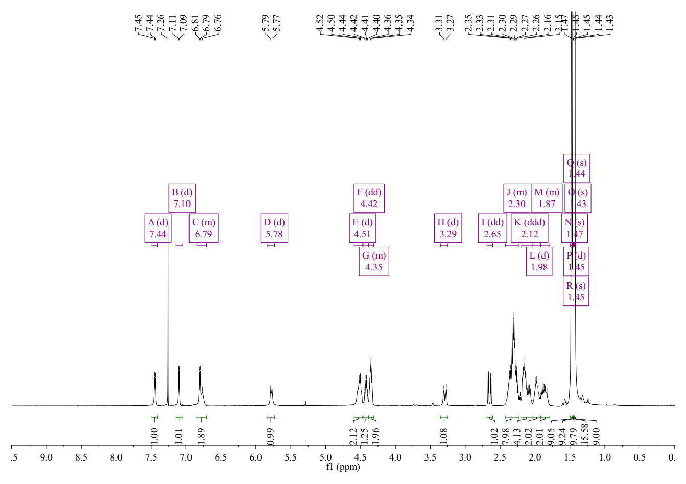
Figure S1. ¹H NMR spectra (CDCl₃ as solvent) of the important intermediate WT-H.
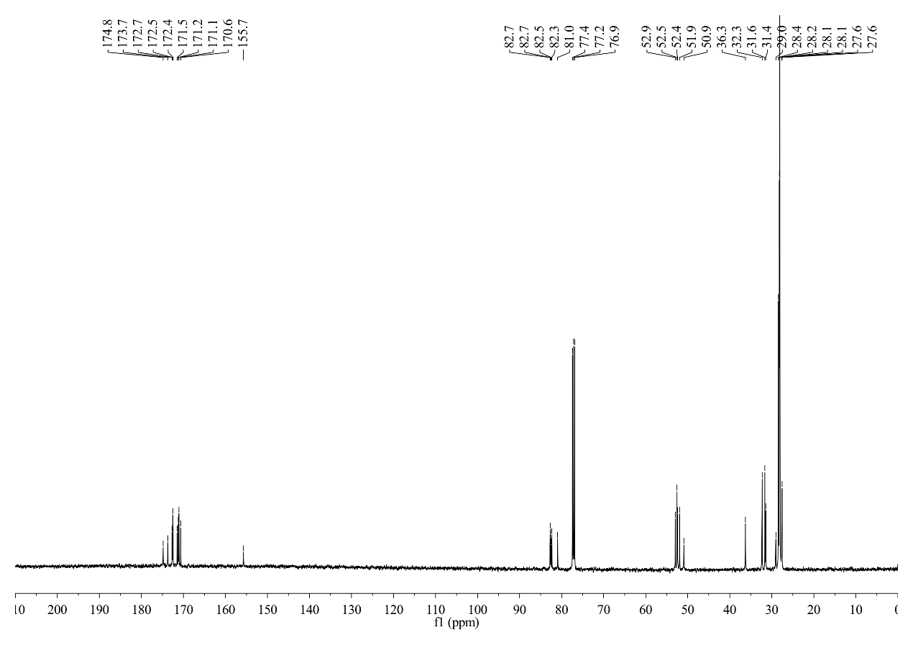
Figure S2. ¹³C NMR spectra (CDCl₃ as solvent) of the important intermediate WT-H.
Figure S3. HRMS of the important intermediate WT-H.
The PSMA-activated prodrug CPT-WT-H was synthesized as shown in Scheme S2.
Scheme S2. Synthesis of the PSMA-activated prodrugs CPT-WT-H. Reagents and Conditions: (d) EDCI, DMAP, DCM, 25°C, 12 h; (e) TFA, DCM, 25°C, 2 h; (f) EDCI, HOBt, DIPEA, DCM, 25°C, 3 h; (g) TFA: Thioanisole: H₂O = 95: 2.5: 2.5, 25°C, 3 h;

Synthesis of CPT-A-L₁₂ and CPT-B-L_{12.} The intermediates CPT-A-L₁₂ and CPT-B-L₁₂ were synthesized according to our previous report ^{[1]}.
Synthesis of CPT-WT-H-L_{12.} The CPT-B-L₁₂ (300 mg, 0.55 mmol) was dissolved in dry DCM (20 mL), EDCI (159.0 mg, 0.83 mmol) and WT-H (618.0 mg, 0.60 mmol) were added. After addition of HOBT (112.1 mg, 0.83 mmol) and DIPEA (178.0 mg, 1.38 mmol), the mixture was stirred at 25°C for 4 h. The reaction mixture was diluted with 50 mL CH₂Cl₂, then successively washed with water and brine (10 mL each), dried over sodium sulphate and filtered, and the solvent was evaporated. Then the crude product was purified by flash chromatography (silica gel, dichloromethane: methanol = 1: 0 to 50: 1).
Characterization of CPT-WT-H-L₁₂. Obtained as a faint yellow powder; Yield: 44.4%; mp 131.1-132.0°C; ¹H NMR (500 MHz, CDCl₃): δ 0.95 (t, J = 7.4 Hz, 3H, -CH₃), 1.18 (m, 12H), 1.30 (m, 4H), 1.41 (s, 27H, 9 × -CH₃), 1.42 (s, 27H, 9 × -CH₃), 1.61 (m, 4H), 1.87 (m, 2H), 2.08 (m, 1H), 2.14 (m, 2H), 2.32 (m, 10H), 2.48 (m, 4H), 2.94 (m, 1H), 3.05 (m, 1H), 3.32 (m, 1H), 4.42 (m, 2H), 4.48 (m, 3H), 5.27 (m, 2H), 5.39 (d, J = 17.2 Hz, 1H), 5.65 (d, J = 17.2 Hz, 1H), 6.20 (brs, 1H), 6.54 (d, J = 8.0 Hz, 1H), 6.61 (s, 1H), 6.82 (brs, 1H), 7.07 (brs, 1H), 7.21 (s, 1H), 7.47 (d, J = 8.0 Hz, 1H), 7.65 (t, J = 7.1 Hz, 1H), 7.81 (t, J = 7.1 Hz, 1H), 7.93 (d, J = 8.0 Hz, 1H), 8.19 (d, J = 8.0 Hz, 1H), 8.40 (s, 1H); ¹³C NMR (125 MHz, CDCl₃): δ 7.7, 24.7, 26.8, 27.0, 27.8, 28.1, 28.2, 28.4, 28.6, 29.1, 29.4, 29.5, 29.6, 31.2, 31.7, 31.9, 32.2, 32.6, 33.9, 36.9, 39.9, 50.0, 51.4, 51.5, 51.8, 52.3, 52.4, 67.2, 75.7, 80.6, 80.7, 82.1, 82.3, 82.5, 96.2, 120.5, 128.2, 128.3, 128.4, 128.6, 129.6, 130.8, 131.4, 146.1, 146.2, 148.8, 152.4, 155.9, 157.5, 167.7, 170.9, 171.2, 171.3, 171.4, 171.7, 171.9, 172.0, 172.3, 172.9; HRMS (ESI) m/z: [M + H]⁺ calcd for C₈₁H₁₂₁N₈O₂₂, 1557.8595; found, 1557.8596.
Synthesis of CPT-WT-H. To a solution of the intermediate CPT-WT-H (350 mg, 0.225 mmol) in 20 mL mixed solution (THF: Thioanisole: H₂O = 95: 2.5: 2.5), the mixture was stirred at room temperature for 2.5 h. After completion of the reaction (as monitored by RP-HPLC), the filtrate was concentrated in vacuum and the residue was purified by PR-HPLC (A = H₂O (0.2%HAc), and B = CH₃CN (0.2%HAc); solvent gradient: 35-80% B in 25 min).
Characterization of CPT-WT-H. Obtained from CPT-WT-H-L₁₂ by method G as a faint yellow powder; Yield: 30.3%; mp 154.2-154.9°C; ¹H NMR (400 MHz, DMSO-d₆): δ 0.92 (t, J = 7.4 Hz, 3H, -CH₃), 1.10 (m, 10H), 1.30 (m, 8H), 1.56 (m, 2H), 1.78 (m, 4H), 1.96 (m, 4H), 2.20 (m, 9H), 2.35 (m, 1H), 2.72 (m, 1H), 3.58 (s, 2H), 3.61 (s, 2H), 3.64 (s, 1H), 4.20 (m, 4H), 5.30 (brs, 2H), 5.49 (brs, 2H), 7.04 (s, 1H), 7.72 (t, J = 7.4 Hz, 1H), 7.86 (t, J = 7.4 Hz, 1H), 8.15 (m, 8H), 8.27 (m, 1H), 8.69 (s, 1H); ¹³C NMR (100 MHz, DMSO-d₆): δ 7.6, 24.5, 26.4, 27.0, 28.4, 28.7, 28.8, 29.0, 29.8, 30.3, 31.3, 31.5, 33.2, 35.6, 38.8, 49.2, 50.3, 51.0, 51.2, 51.4, 51.8, 66.3, 75.6, 94.7, 119.0, 127.8, 128.1, 128.6, 129.0, 129.8, 130.4, 131.6, 145.4, 146.0, 147.9, 152.3, 156.6, 167.3, 168.2, 168.3, 171.4, 171.5, 172.1, 172.5, 172.7, 173.3, 173.4, 173.7; HRMS (ESI) m/z: [M + H]⁺ calcd for C₅₆H₇₃N₈O₂₀, 1177.4941; found, 1177.4950.
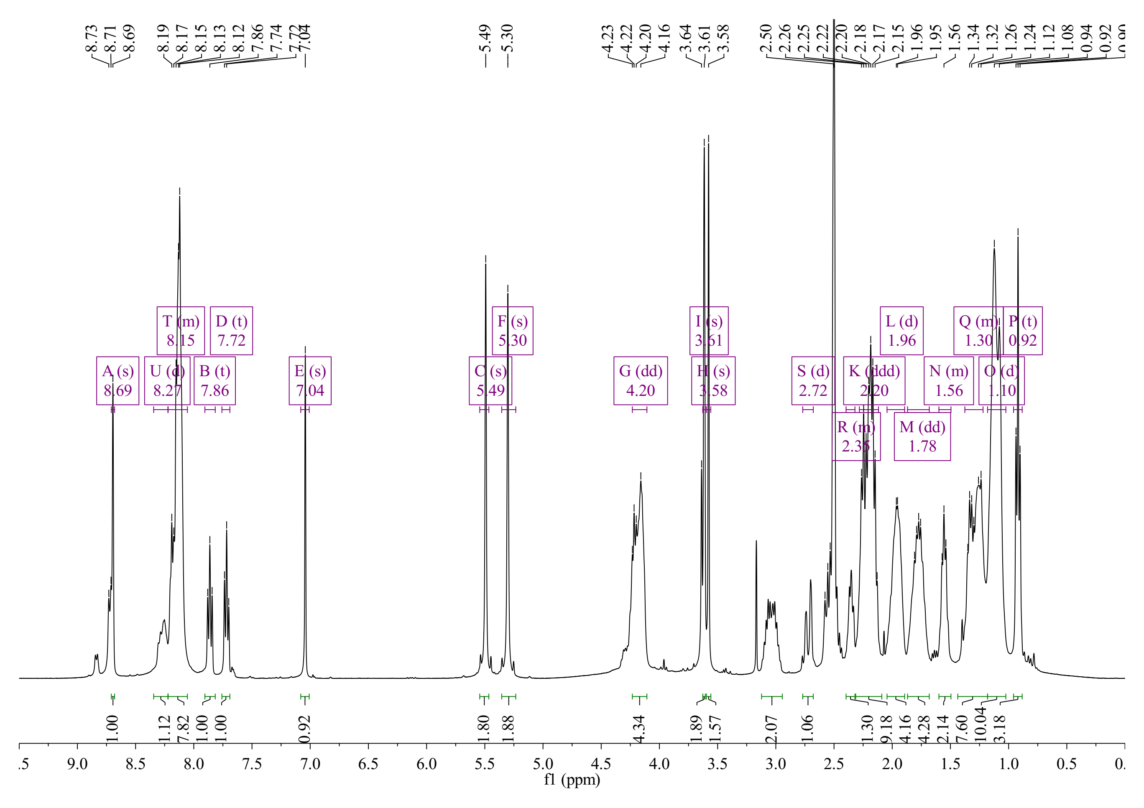
Figure S4. ¹H NMR spectra (DMSO-d₆ as solvent) of the important intermediate CPT-WT-H.
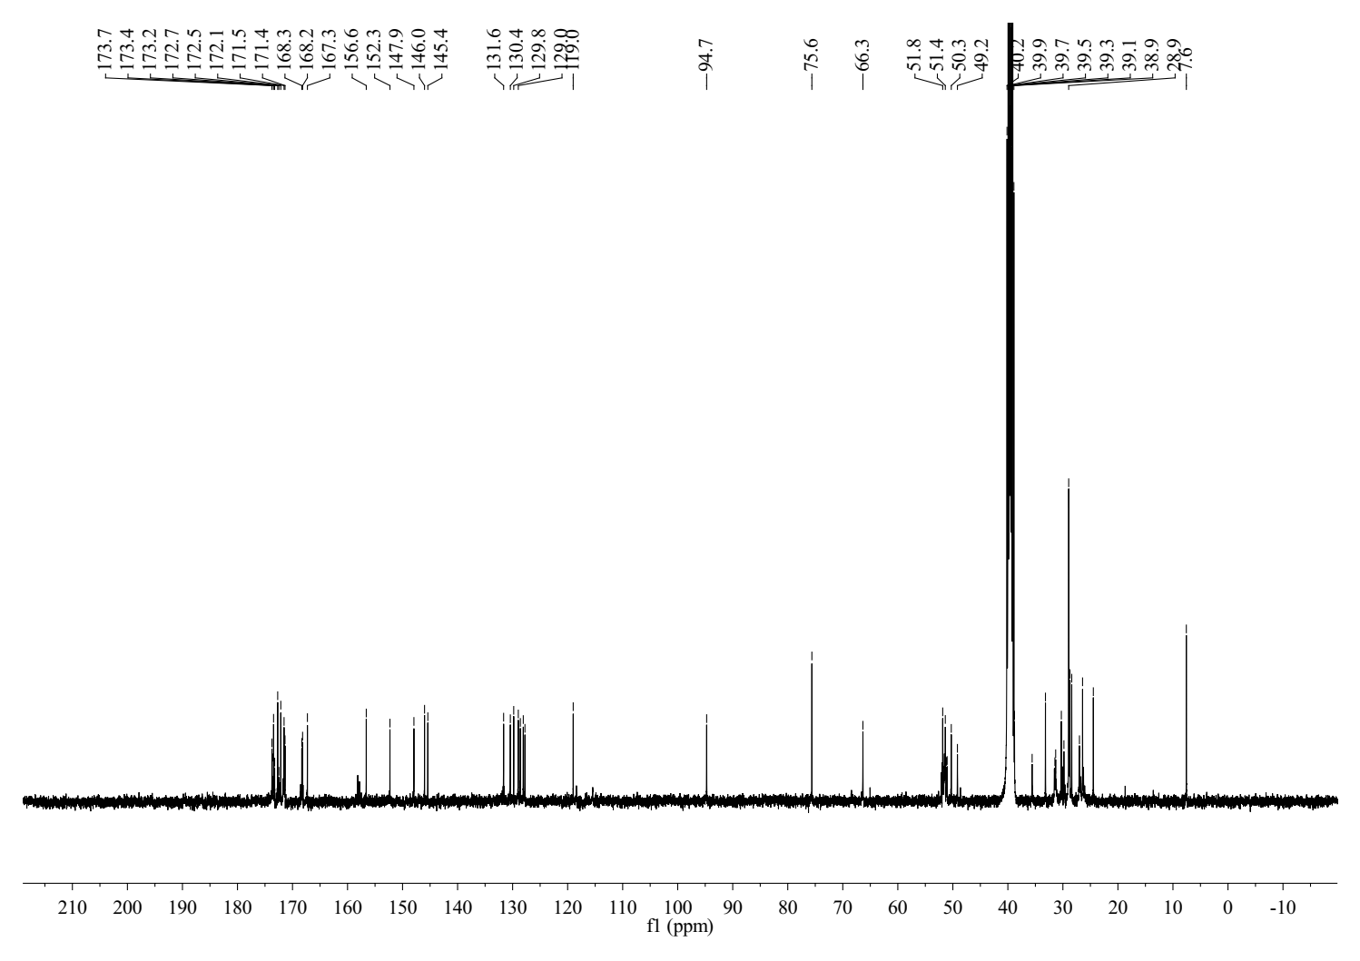
Figure S5. ¹³C NMR spectra (DMSO-d₆ as solvent) of the important intermediate CPT-WT-H.
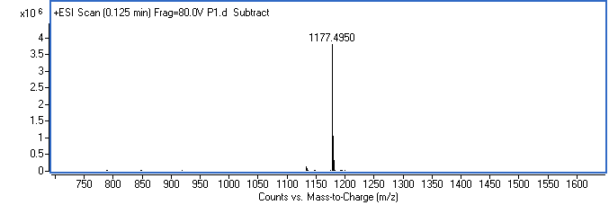
Figure S6. HRMS spectra of the important intermediate CPT-WT-H.
HPLC analysis. The concentration of CPT-WT-H in samples were measured by an Agilent 1260 HPLC with the following conditions: Waters XBridge C18 column (250 mm × 4.6 mm, 5 mm); temperature, 25°C; elution flow rate, 1.0 mL·min⁻¹; detection wavelength, 365 nm; mobile phase, 0.2% formic acid in water (A) and 0.2% formic acid in acetonitrile (B) using a gradient elution of 10-60% B at 0-5.0 min, 60-80% B at 5.0 min-15.0 min, 80% B at 15.0 min-17.0 min, and 10% B at 17.1 min-23.0 min.

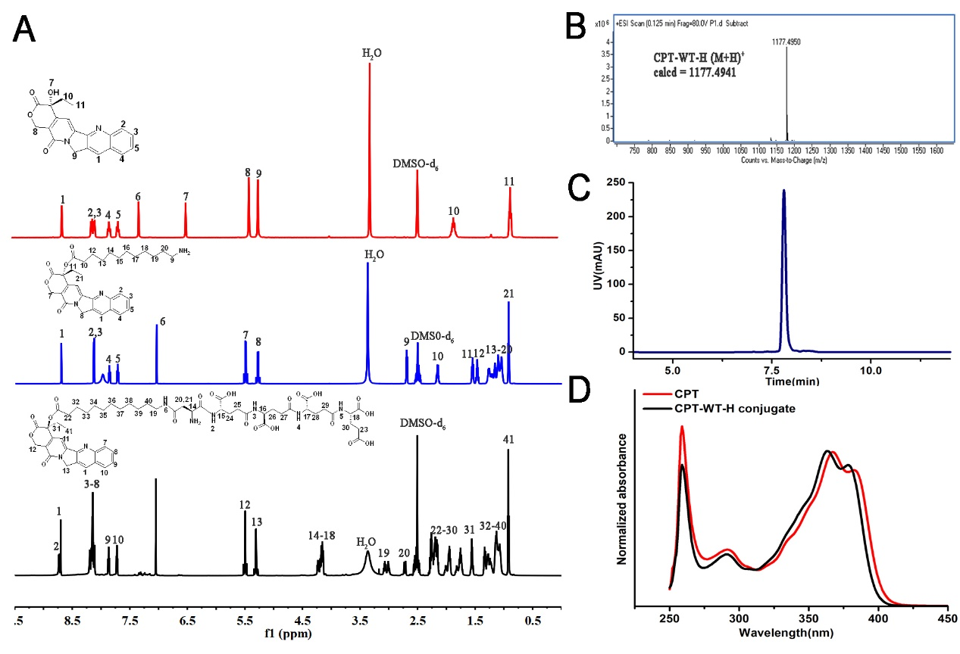
Figure S7. Characterization of CPT-WT-H conjugate. (A) ¹H NMR spectra (DMSO-d₆ as solvent). (B) HRMS spectrum of CPT-WT-H conjugate. The molecular weight of CPT-WT-H (m/z, [M + H]⁺) is 1177.4950, which is well in line with the calculated value (m/z, [M + H]⁺, 1177.4941). (C) HPLC of CPT-WT-H conjugate. (D) UV-vis absorbance spectra (DMSO as solvent) of CPT and CPT-WT-H conjugate.

Aqueous Solubility Study. The equilibrium solubility of CPT and CPT-WT-H NPs was determined in triplicate in PBS according to the reference method with some modifications.² An excess amount (~ 5 mg) of the tested compounds were placed into tubes, and 1 mL PBS was added to the tube. Then the tubes were incubated at 37°C for 24 h in a remonstrated oscillator (HZQ-QX, Harbin Donglian Instrument Co. Ltd., China). After incubation, samples were centrifuged at 10000 rpm for 10 min with high speed centrifuge (Sorvall™ Legend™ Micro 21, Thermo Fisher Scientific, USA). A 100 μL sample of the supernatant was diluted and the concentration was measured with HPLC according to our above-mentioned analytical method.
In Vitro Colloidal Stability. The colloidal in vitro stability of CPT-WT-H NPs was tested in PBS buffer (pH 7.4) by HPLC according to our above-mentioned analytical method. The stability of CPT-WT-H NPs in PBS (pH 7.4) for 120 h was also evaluated by monitoring the hydrodynamic diameter and zeta potential using DLS.
Figure S8. Characterization of the stability of CPT-WT-H NPs in PBS buffer (pH 7.4).
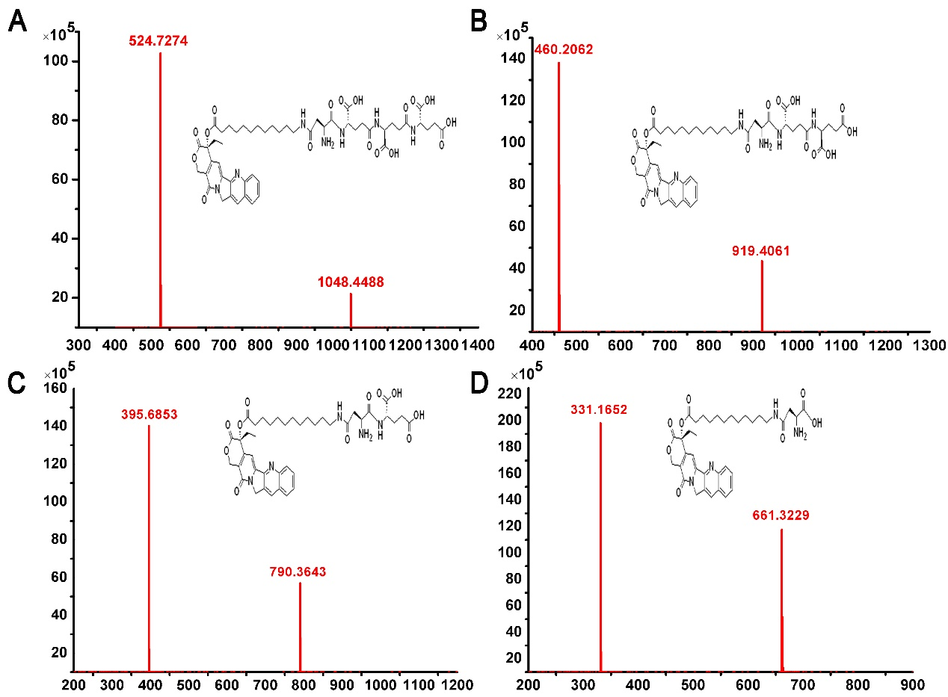
Figure S9. HRMS spectrum of sequential PSMA hydrolysis of CPT-WT-H. (A) HRMS spectrum of PSMA hydrolysis CPT12A-βAsp-GluγGluγGlu (peak 1). The molecular weight of CPT12A-βAsp-GluγGluγGlu (m/z, [M + H]⁺) is 1048.4488, which is well in line with the calculated value (m/z, [M + H]⁺, 1048.4515). (B) HRMS spectrum of PSMA hydrolysis CPT12A-βAsp-GluγGlu (peak 2). The molecular weight of CPT12A-βAsp-GluγGlu (m/z, [M + H]⁺) is 919.4061, which is well in line with the calculated value (m/z, [M + H]⁺, 919.4089). (C) HRMS spectrum of PSMA hydrolysis CPT12A-βAsp-Glu (peak 3). The molecular weight of CPT12A-βAsp-Glu (peak 3) (m/z, [M + H]⁺) is 790.3643, which is well in line with the calculated value (m/z, [M + H]⁺, 790.3663). (D) HRMS spectrum of PSMA hydrolysis CPT12A-βAsp (peak 4). The molecular weight of CPT12A-βAsp (peak 4) (m/z, [M + H]⁺) is 661.3229, which is well in line with the calculated value (m/z, [M + H]⁺, 661.3237).
Figure S10. Characterization of in vitro esterase response of CPT-WT-H NPs by HPLC
Cell culture. The non-PSMA-expressing cancer cell human prostate cancer cell (PC-3), human prostate cancer cell (DU-145), human breast cancer cell (MCF-7), human hepatocellular carcinoma cell (HepG2), human cervical cancer cell (Hela), the PSMA-expressing cancer cell human prostate cancer cell (LNCaP-FGC) and the human normal liver cells (LO2) were chosen for the following experiments, which were obtained from the Chinese Academy of Medical Sciences & Peking Union Medical College. The cells were grown in RPMI 1640 or DMEM supplemented with 10% (v/v) heat inactivated fetal bovine serum and 1% (v/v) enicillin/streptomycin (Corning, USA) and incubated at 37°C in a humidified atmosphere with 5% CO₂. The tested compounds were dissolved in DMSO (Sigma, St. Louis, MO, USA) and added at required concentrations to the cell culture.
Animals. BALB/c nude mice (5-6 weeks, female, 16-18 g) and BALB/c mice (5-6 weeks, ∼ 20 g) were provided from Beijing Vital River Laboratory Animal Technology Co., Ltd. The experiments were carried out according to the guidelines issued by the ethical committee of Beijing University of Chinese Medicine.
In vivo pharmacokinetic analysis. Sixty-six BALB/c mice (20 ± 2g) were randomly divided into eleven groups and were intravenously administered 30 mg·kg⁻¹ doses of CPT-WT-H NPs. 0.5 mL of blood was collected in a heparinized tube at predefined times of 0.083, 0.25, 0.5, 1, 2, 3, 4, 8, 12, and 24 h. And the blood samples were centrifuged at 12,000 rpm for 15 min at 4°C to harvest the plasma. Then, the plasma was extracted with 1 mL acetonitrile, the mixture was vortexed for 2 min and centrifuged at 12,000 rpm for 15 min, and the supernatant was collected and purged with a gentle stream of nitrogen. The resultant residue was dissolved in 200 μL methanol and stored at -20°C prior to analysis. The drug concentration in each plasma sample was determined by HPLC method. Pharmacokinetics parameters were estimated by fitting the blood drug pharmaceutical concentrations to a two-compartment model using the DAS pharmacokinetic software (2.0 version).

Table S1. Pharmacokinetic parameters of CPT-WT-H NPs after intravenous administration of the 30 mg·kg⁻¹
Parameter | Units | CPT-WT-H NPs
AUC(0-t) | mg/L*h | 466.36 ± 113.07
AUC(0-∞) | mg/L*h | 637.63 ± 114.2
MRT(0-t) | H | 8.72 ± 0.43
MRT(0-∞) | H | 15.8 ± 5.31
Tmax | H | 1.18 ± 0.73
CL | L/h/kg | 0.05 ± 0.01
V | L/kg | 1.08 ± 0.70
Cmax | mg/L | 59.0 ± 8.35
t_{1/2} | H | 10.9 ± 1.86
AUC: area under the curve; MRT: mean retention time; t_{1/2}: half-life; CL: clearance; V: apparent volume of distribution; Cmax: maximum drug concentration.
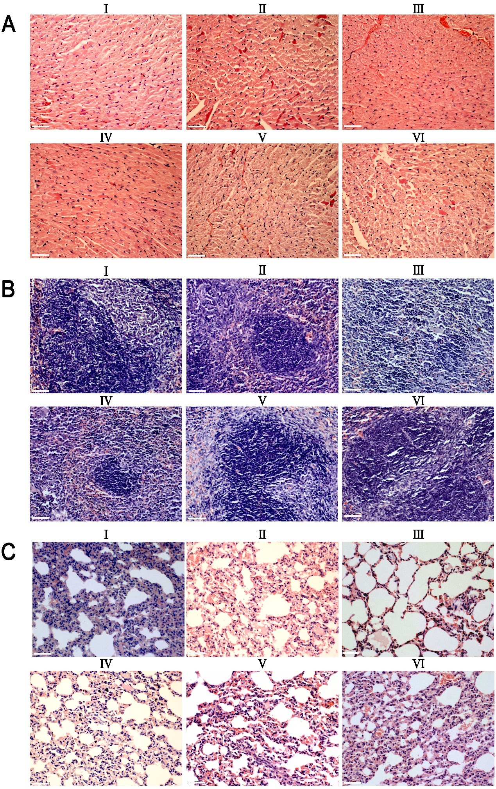
Figure S11. Representative H&E staining histological images obtained from heart (A), spleen (B) and lung (C) after intravenous administration of irinotecan (10 mg·kg⁻¹) and CPT-WT-H NPs (10, 30, 60 mg·kg⁻¹). The PBS treated group and the untreated group were used as the control. The scale bar is 50 µm. (I: PBS, II: CPT-WT-H NPs (10mg·kg⁻¹), III: CPT-WT-H NPs (30mg·kg⁻¹), IV: CPT-WT-H NPs (60mg·kg⁻¹), V: Irinotecan (10 mg·kg⁻¹), VI: Normal group)
References
[1] B. Xu, F. Zhou, M. M. Yan, D. S. Cai, W. B. Guo, Y. Q. Yang, X. H. Jia, W. X. Zhang, T. Li, T. M, P. L. Wang and H. M. Lei, Int. J. Mol. Sci. 2018, 19, 3251.

[2] J. Alsenz, M. Kansy, Adv. Drug Delivery Rev. 2007, 59, 546.

