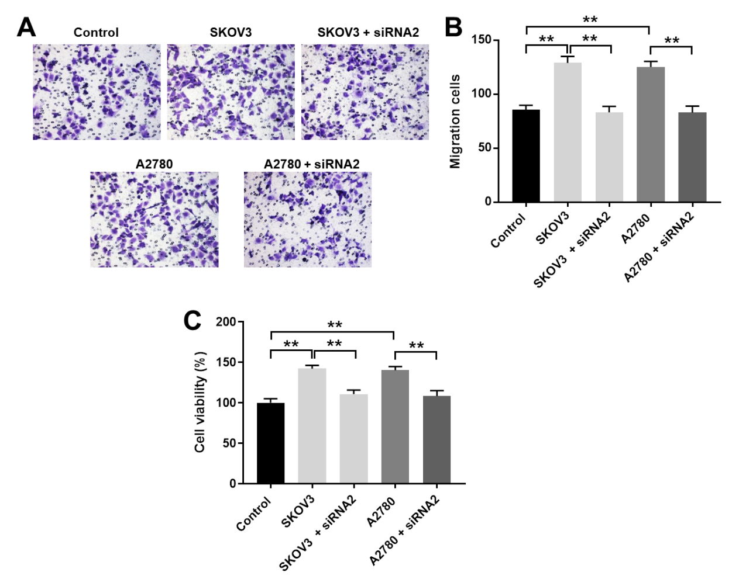
Supplementary Figure 1 Co-culture of ovarian cancer cells and HUVECs. The ovarian cancer cells (SKOV3 and A2780) were co-cultured with HUVECs for 48 h. (A, B) Transwell assay was performed to detect the migration of HUVECs. (C) CCK8 experiment was conducted to measure the viability of HUVECs. **P < 0.01 compared with control group; n = 3.

