Supplementary materials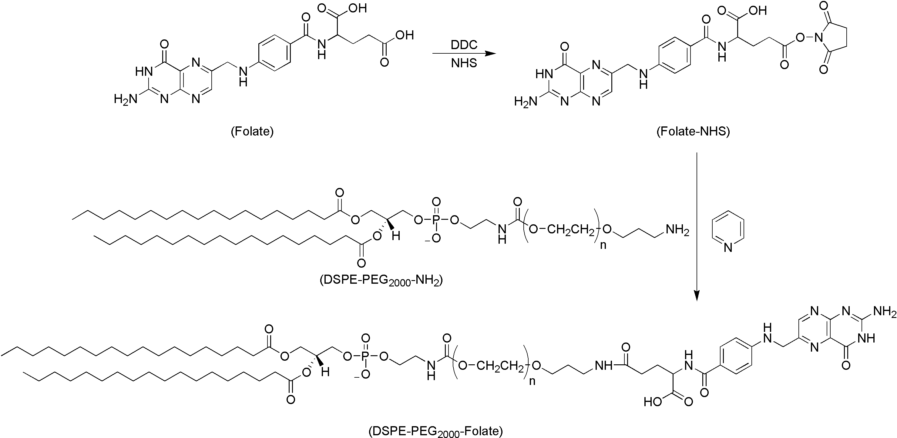
Figure S1. Synthetic scheme for preparation of DSPE-PEG-Folate. Reagents and conditions.

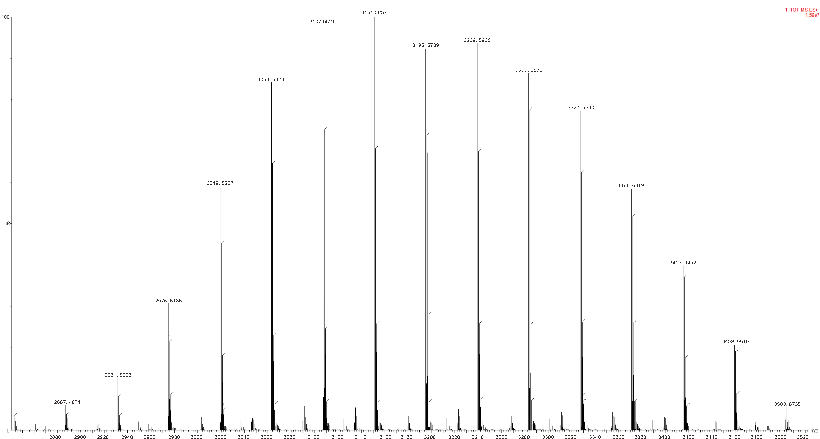
Figure S2. The mass spectra of DSPE-PEG₂₀₀₀-Folate.

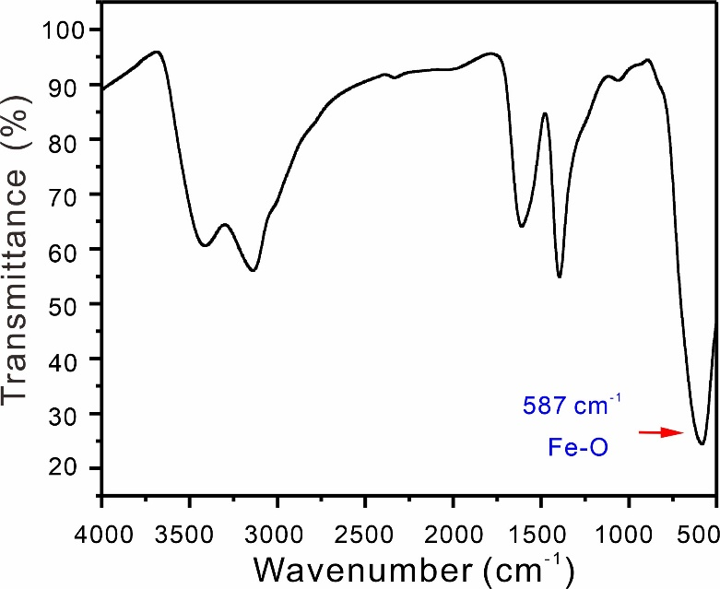
Figure S3. Infrared spectra of Fe₃O₄ Magnetic nanoparticles (MNPs).

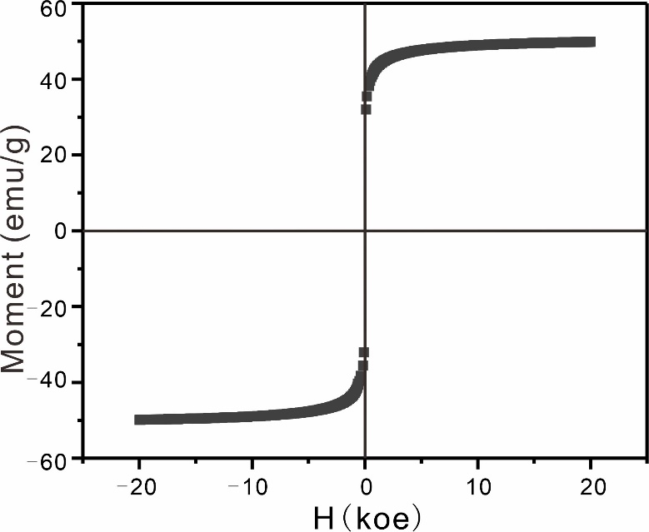
Figure S4. Magnetic hysteresis loop of the MNPs measured at room temperature.

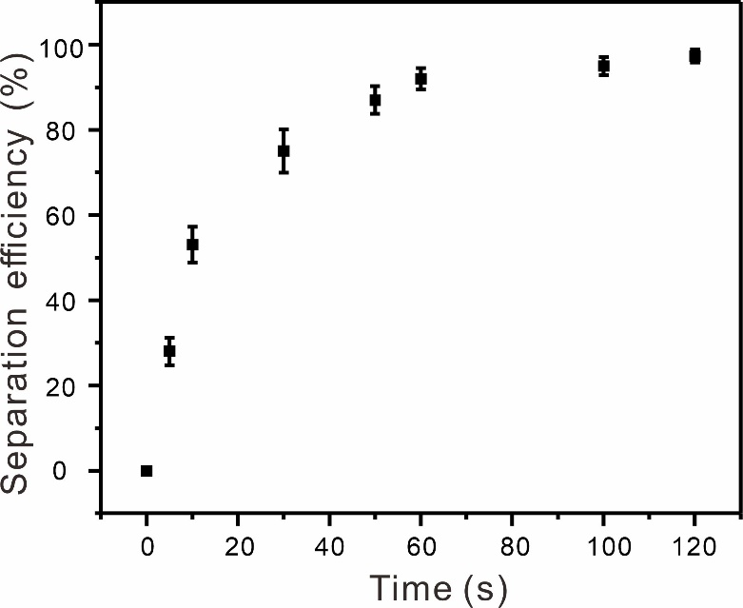
Figure S5. Capture efficiencies of MNPs at different attraction times with a commercial magnetic scaffold.

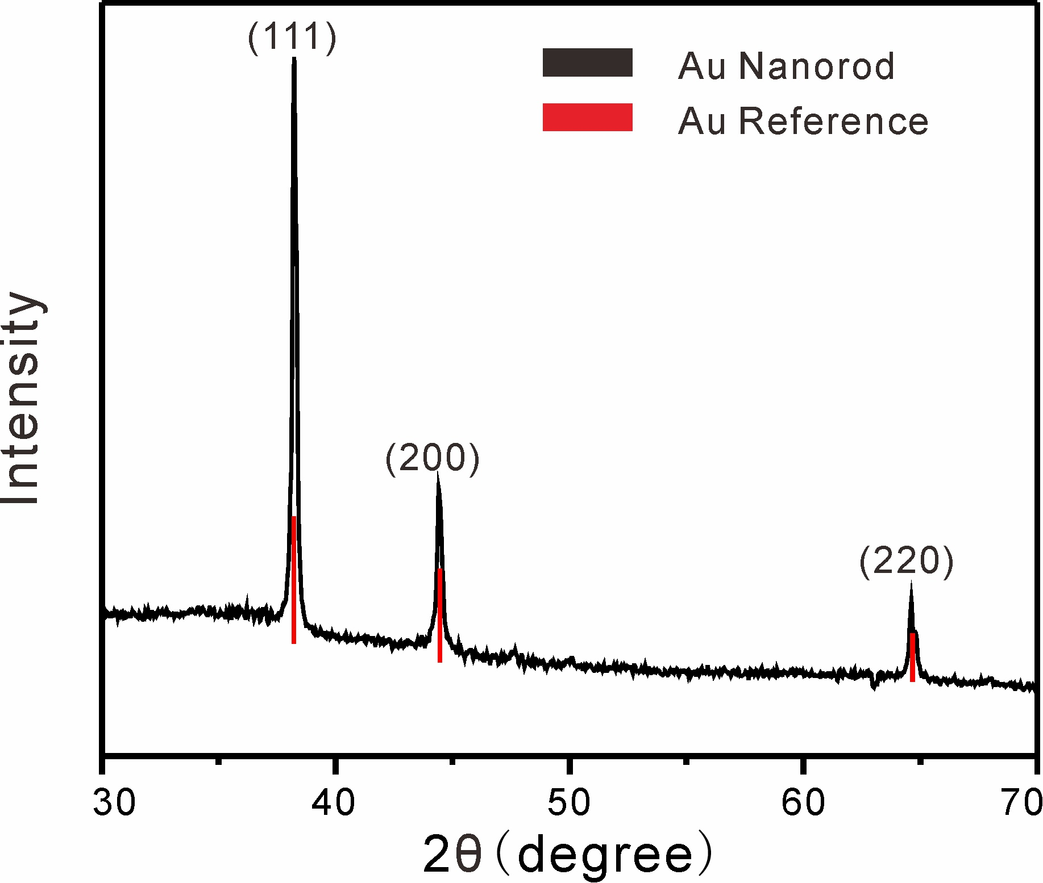
Figure S6. XRD patterns of GNRs obtained by using seed mediated growth method.
Note: Data from Nikoobakht and El-Sayed¹ was used for comparison.

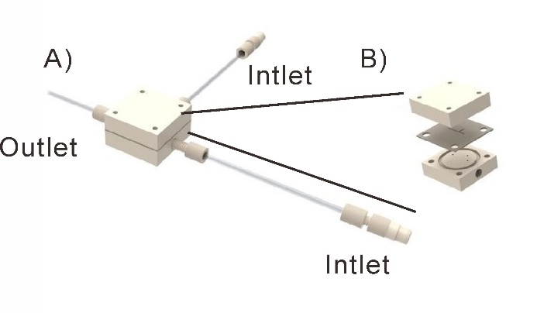
Figure S7. Schematic diagram of chip structure.

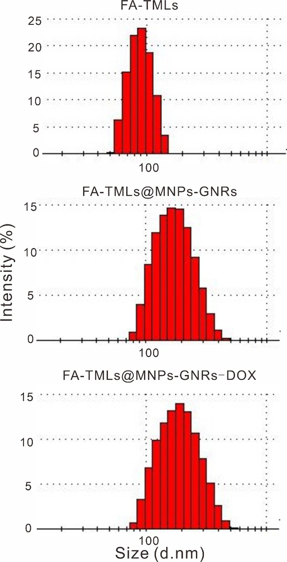
Figure S8. Size distribution of FA-TMLs, FA-TMLs@MNPs-GNRs, and FA-TMLs@MNPs-GNRs-DOX.

Table S1. Particle size distribution of liposomes (n=3)
Liposome | Size (nm) | PDI
FA-TMLs | 95 ± 4 | 0.02
FA-TMLs@MNPs-GNRs | 210 ± 5 | 0.14
FA-TMLs@MNPs-GNRs-DOX | 234 ± 5 | 0.11

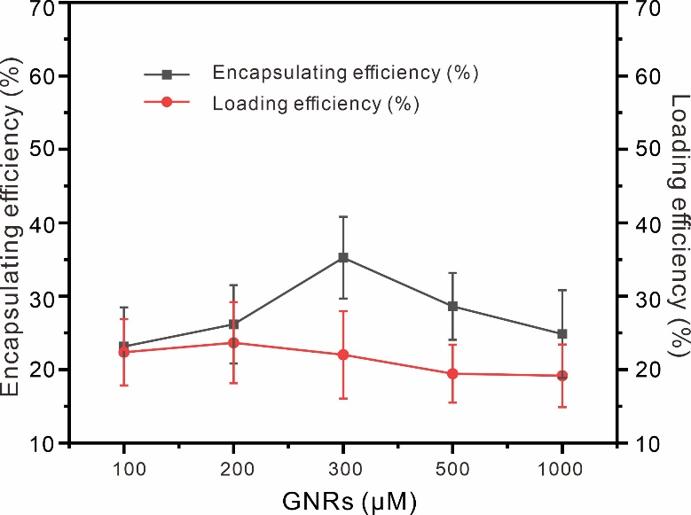
Figure S9. The effects of GNRs concentration on encapsulation efficiency and loading efficiency of DOX in FA-TMLs@MNPs-GNRs-DOX.

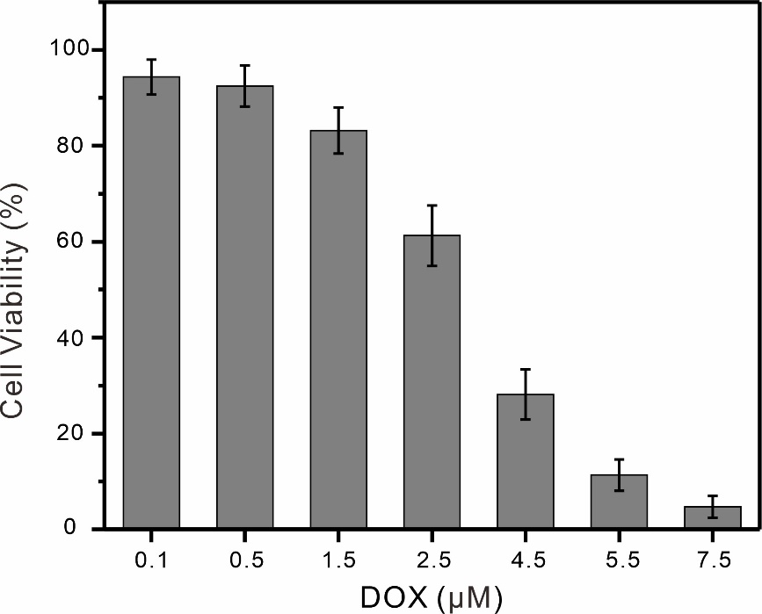
Figure S10. The Cytotoxicity of DOX with various concentrations towards bladder cancer cells.

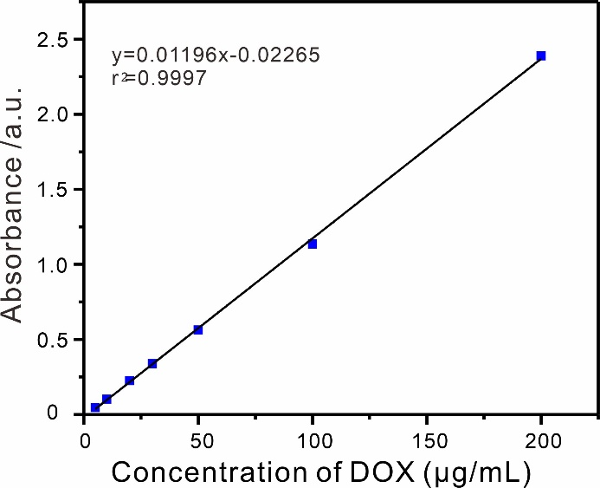
Figure S11. Standard curve of DOX.

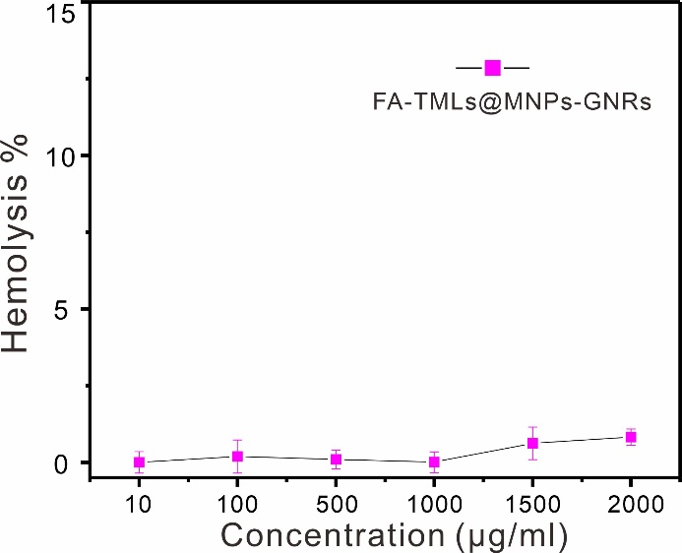
Figure S12. Hemolytic activity of FA-TMLs@MNPs-GNRs.

Reference:
1. Nikoobakht, B.; El-Sayed, M. A. Preparation and Growth Mechanism of Gold Nanorods (NRs) Using Seed-Mediated Growth Method. Chem. Mater. 2003, 15, 1957-1962.

