Supporting Information
Phenylboronic acid-modified polyamidoamine-mediated the transfection of Polo-like kinase-1 siRNA to achieve an anti-tumor efficacy

Gu Gong,^{a,1} Xiuhui Tang,^{b,1} Jiayuan Zhang,^{b} Xiao Liang,^{b}
Jiebing Yang,^{b,*} Quanshun Li^{b,*}

ªDepartment of Orthopaedic Surgery, China-Japan Union Hospital, Jilin University, Changchun 130031, China
^{b}Key Laboratory for Molecular Enzymology and Engineering of Ministry of Education, School of Life Sciences, Jilin University, Changchun 130012, China

*Corresponding authors.
Tel. and Fax: +86-431-85155200.
E-mail: quanshun@jlu.edu.cn (Q. Li); yangjiebing@lntu.edu.cn (J. Yang).
¹These authors contributed equally to the work.

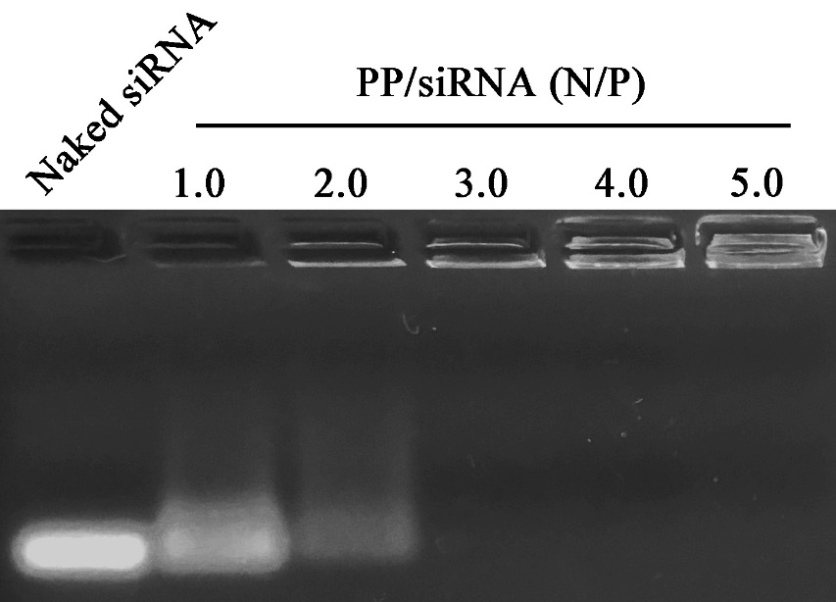
Figure S1. Gel retardation assay of PP/siPlk-1 nanoparticles at different N/P ratios.

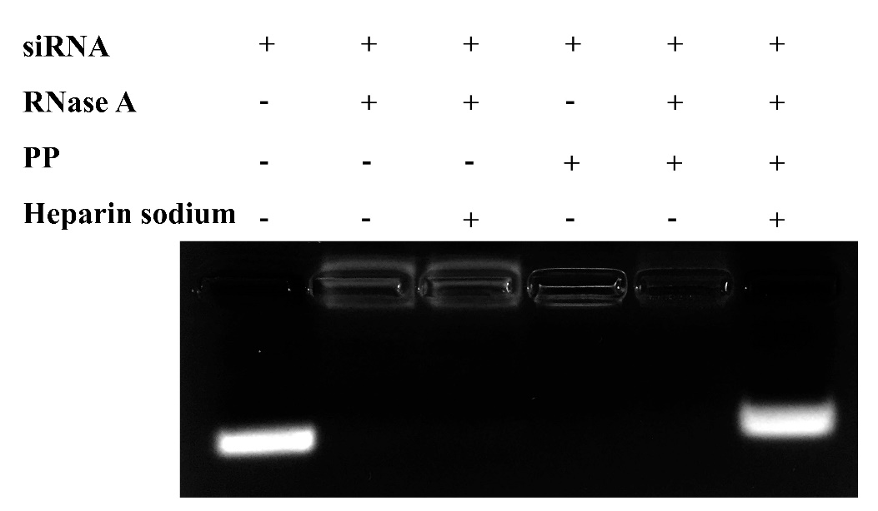
Figure S2. The protection assay of PP for siPlk-1 against the degradation of RNase A, in which PP/siPlk-1 nanoparticles were prepared at a N/P ratio of 3.0.

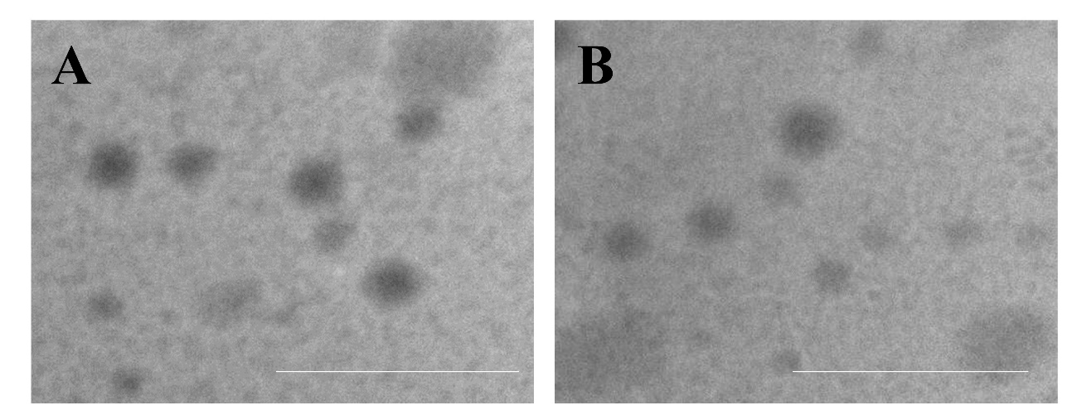
Figure S3. TEM images of PP/siPlk-1 (A) and PAMAM/siPlk-1 (B) nanoparticles (N/P ratio of 30, 0.5 μg/mL siPlk-1). The scale bar was 500 nm.

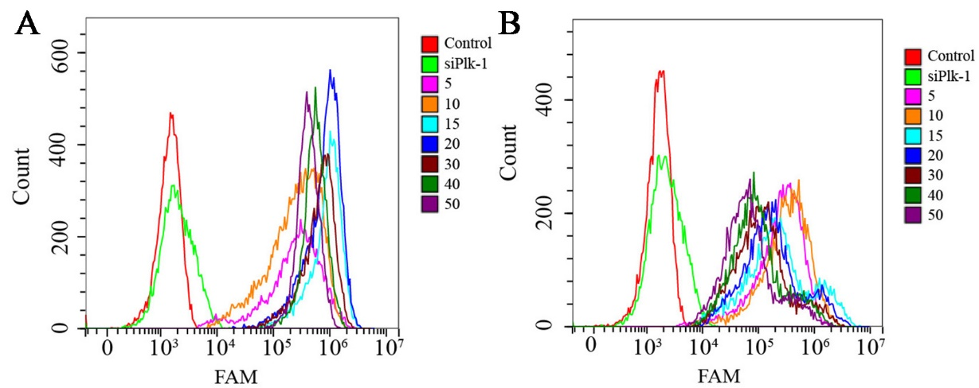
Figure S4. Transfection efficiency evaluation of PP/siPlk-1 (A) and PAMAM/siPlk-1 (B) nanoparticles at different N/P ratios (5 to 50).

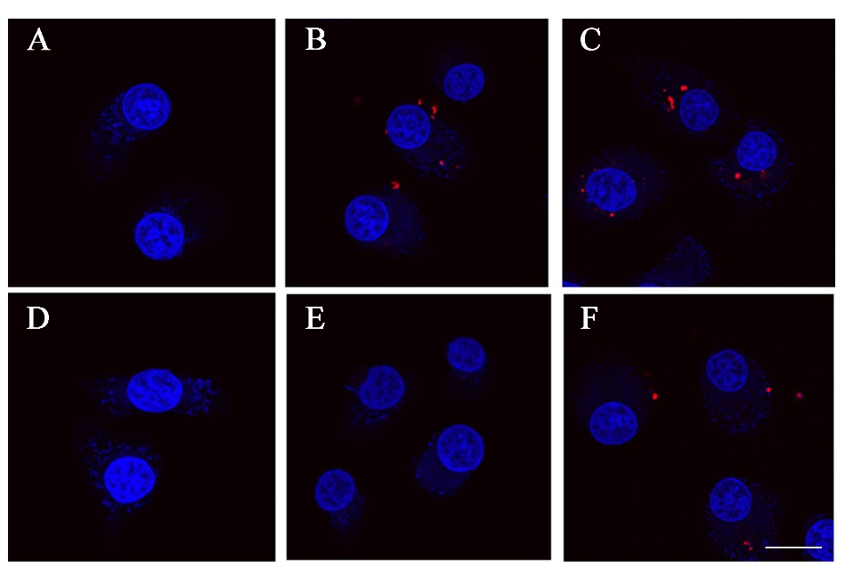
Figure S5. Tumor-targeting ability of PP/siPlk-1 nanoparticles evaluated by CLSM: (A) Control, (B) PP/siPlk-1, (C) PAMAM/siPlk-1, (D) siPlk-1, (E) PP/siPlk-1 with PBA pretreatment and (F) PAMAM/siPlk-1 with PBA pretreatment. The sale bar is 20 µm.
Blue: DAPI, nucleus; red: Cy5.5-labelled siPlk-1.
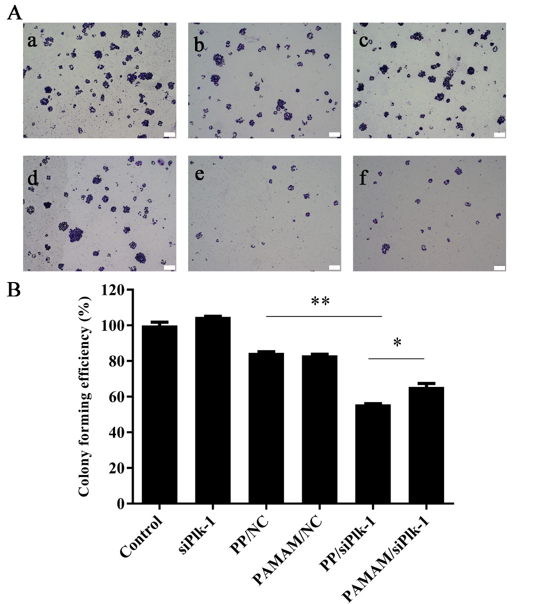
Figure S6. Colony formation assay of HepG2 cells after the transfection of siPlk-1 (A) and the quantitative analysis (B): (a) Control, (b) PP/NC, (c) PAMAM/NC, (d) siPlk-1, (e) PP/siPlk-1 and (f) PAMAM/siPlk-1. The scale bar was 200 µm. Data were presented as mean value ± SD of triplicate experiments (*p < 0.05, **p < 0.01).

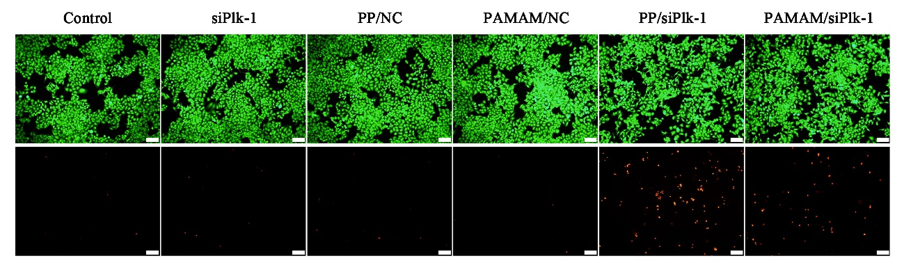
Figure S7. Live/dead staining of HepG2 cells after the siPlk-1 transfection. The upper images represented the live cells stained by calcein AM (green), and the lower ones were the dead ones stained by ethidium homodimer. The scale bar was 100 µm.

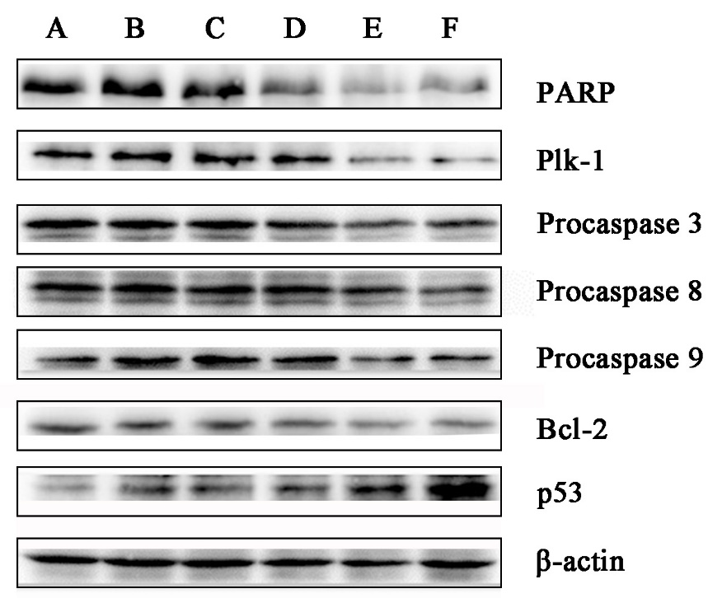
Figure S8. The expression levels of Plk-1 and the apoptosis-related proteins by western blotting analysis: (A) control, (B) siPlk-1, (C) PAMAM/NC, (D) PP/NC, (E) PAMAM/siPlk-1, (F) PP/siPlk-1.

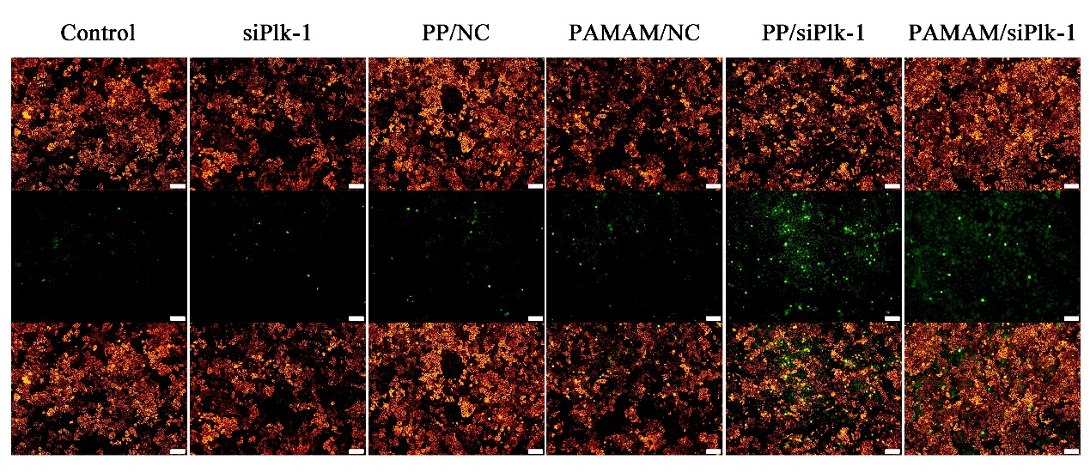
Figure S9. Mitochondrial membrane potential of HepG2 cells after the carriers-mediated siPlk-1 transfection. Images in the first row and the second row represented the cells with high and low mitochondrial membrane potential, respectively. The merged images were shown in the third row. The scale bar was 100 µm.

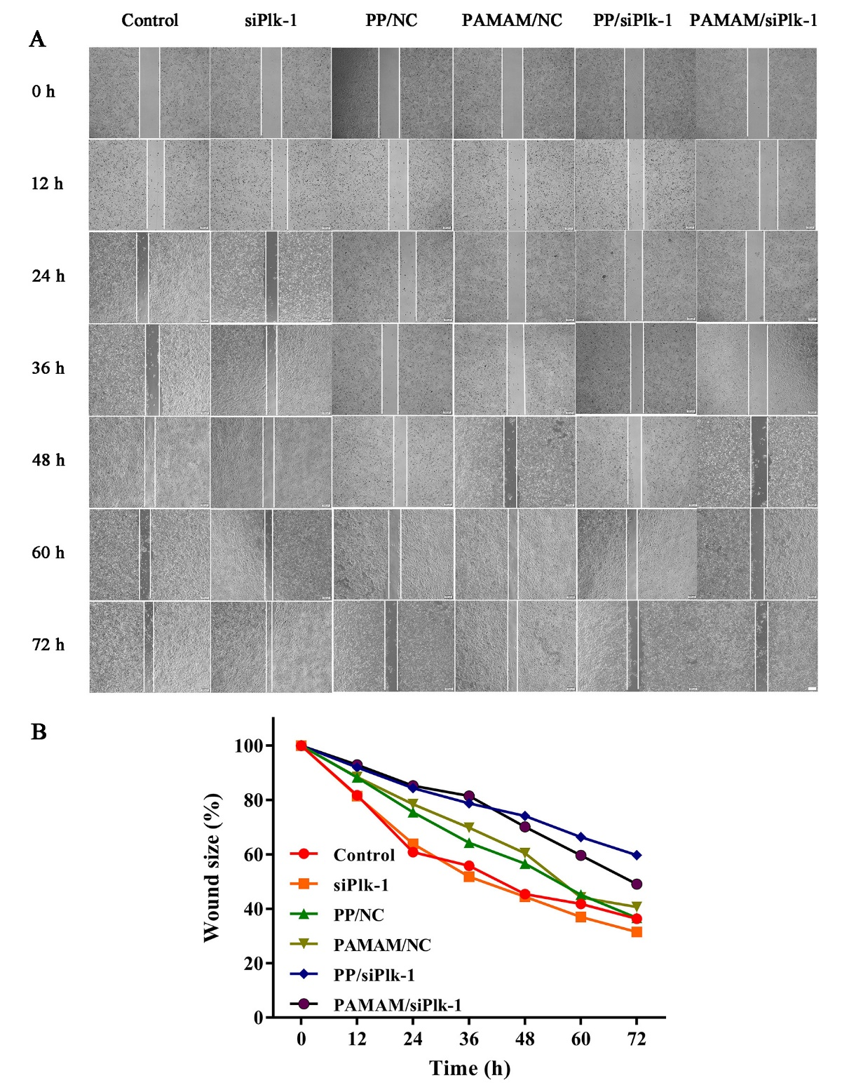
Figure S10. Wound healing assay of HepG2 cells after siPlk-1 transfection (A) and the quantification of wound size (B). The scale bar was 200 µm.

Table S1. Hydrodynamic diameter and zeta potential of PP/siPlk-1 and PAMAM/siPlk-1 nanoparticles at different N/P ratios. Data were presented as mean value ± SD of triplicate experiments.
Nanoparticles | N/P ratio | Hydrodynamic diameter (nm) | PDI | Zeta potential  (mV)
PAMAM/siPlk-1 | PAMAM | 474.37 ± 65.96 | 0.635 | +36.13 ± 4.63
PAMAM/siPlk-1 | 10:1 | 261.93 ± 5.14 | 0.369 | -4.58 ± 1.59
PAMAM/siPlk-1 | 20:1 | 216.43 ± 13.00 | 0.635 | +11.67 ± 1.01
PAMAM/siPlk-1 | 30:1 | 203.90 ± 33.34 | 0.473 | +16.03 ± 3.79
PAMAM/siPlk-1 | 40:1 | 187.50 ± 16.30 | 0.336 | +26.73 ± 1.00
PAMAM/siPlk-1 | 50:1 | 170.80 ± 18.26 | 0.392 | +30.67 ± 2.75
PP/siPlk-1
PP/siPlk-1 | PP | 520.67 ± 67.09 | 0.759 | +35.23 ± 2.33
PP/siPlk-1 | 10:1 | 252.70 ± 38.42 | 0.435 | -0.49 ± 1.96
PP/siPlk-1 | 20:1 | 226.30 ± 29.25 | 0.672 | +11.87 ± 2.83
PP/siPlk-1 | 30:1 | 209.40 ± 24.21 | 0.395 | +16.77 ± 2.35
PP/siPlk-1 | 40:1 | 187.77 ± 45.49 | 0.404 | +23.37 ± 3.94
PP/siPlk-1 | 50:1 | 185.40 ± 34.14 | 0.474 | +29.33 ± 0.90

