Supplementary Materials
Supplementary figures and legends
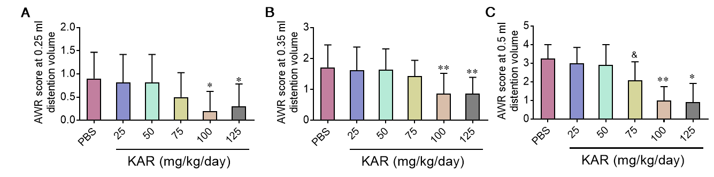
Supplementary Figure 1. Kurarinone (KAR) treatment reduced visceral hypersensitivity of mice with irritable bowel syndrome (IBS) in a dose-dependent manner. IBS was established as described in Figure 1. Different groups of IBS mice (n = 5 mice/group) were daily received intraperitoneally with PBS or KAR at indicated dosages beginning from 10 days post TNBS insults to the end of the experiment. The abdominal withdrawal reflex (AWR) test was performed to evaluate the visceral hypersensitivity in response to colorectal distention (CRD) in mice at distending volume of (A) 0.25, (B) 0.35, or (C)0.5 ml. &P = 0.0612, *P < 0.05, **P < 0.01 compared with the PBS-treated group, one-way analysis of variance (ANOVA). Representative results from one of three independent experiments were shown.

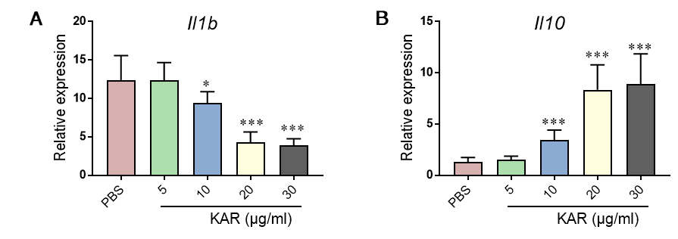
Supplementary Figure 2. KAR regulates inflammatory responses in macrophages in a dose-dependent manner. Mouse bone marrow-derived macrophages (BMDM) were stimulated with LPS (100 ng/ml) and incubated in vitro with different doses of KAR or PBS. After 2 days of stimulation, BMDM were collected and qRT-PCR was performed to determine the expression levels of (A) IL-1β and (B) IL-10. *P < 0.05, ***P < 0.001 compared with the PBS-treated group, one-way analysis of variance (ANOVA). Representative results from one of three independent experiments were shown.

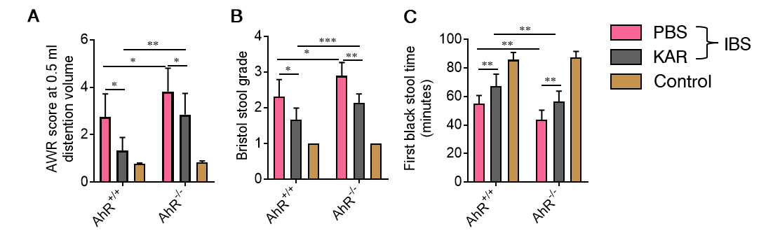
Supplementary Figure 3. AhR is involved in the effect of KAR on IBS. IBS was induced in AhR^{+/+} and AhR^{−/−} mice and KAR was administrated as described in Figure 1. AhR^{+/+} and AhR^{−/−} mice without TNBS exposure served as controls. (A) The AWR test was performed to evaluate the visceral hypersensitivity in response to CRD in mice at the distending volume of 0.5 ml. (B) Bristol stool grade. (C) The first black stool time. *P < 0.05, **P < 0.01, ***P < 0.001, one-way analysis of variance (ANOVA). n = 5 mice in each group. Representative results from one of three independent experiments were shown.

Supplementary Figure 4. AhR is up-regulated in macrophages of IBS mice with KAR treatment. IBS mouse model was established and KAR was administrated as described in Figure 1. Mice without TNBS exposure served as controls. Colonic lamina propria cell suspensions were prepared and CD45⁺ CD11b⁺ CD11c⁻ Ly6G⁻ F4/80⁺ macrophages were sorted by flow cytometry. qRT-PCR was performed to determine the expression levels of AhR. *P < 0.05, one-way analysis of variance (ANOVA). n = 8 mice in each group. Representative results from one of three independent experiments were shown.

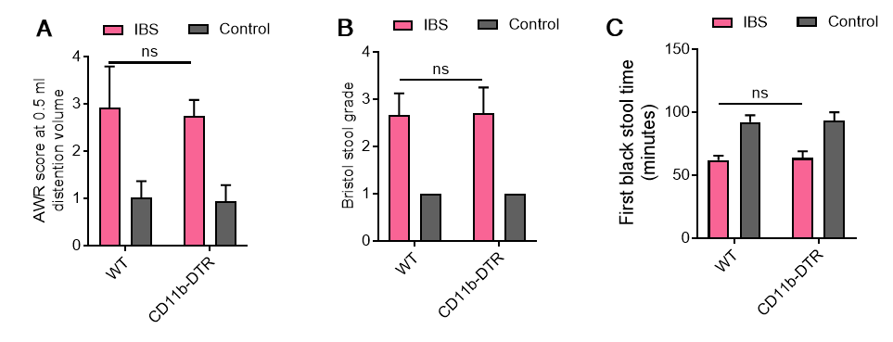
Supplementary Figure 5. CD11b-DTR transgenic and WT mice show no differences in the susceptibility to TNBS-induced IBS. IBS was induced in WT and CD11b-DTR transgenic mice as described in Figure 1. (A) The AWR test was performed to evaluate the visceral hypersensitivity in response to CRD in mice at the distending volume of 0.5 ml. (B) Bristol stool grade. (C) The first black stool time. ns, no statistical significance, one-way analysis of variance (ANOVA). n = 5 mice in each group. Representative results from one of three independent experiments were shown.

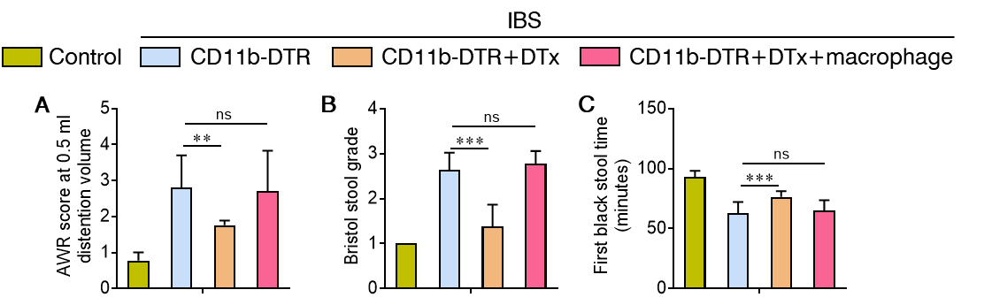
Supplementary Figure 6. Macrophage depletion alleviates TNBS-induced IBS. CD11b-DTR transgenic mice were divided into 4 groups (n = 5): mice without TNBS exposure as controls, TNBS-treated mice, mice injected with DTx (2 mg/g, i.p.) 7 days post TNBS exposure, DTx-treated IBS mice transferred with WT macrophages (2 × 10⁶/recipient mice, i.v.). (A) The AWR test was performed to evaluate the visceral hypersensitivity in response to CRD in mice at the distending volume of 0.5 ml. (B) Bristol stool grade. (C) The first black stool time. ns, no statistical significance, **P < 0.01, ***P < 0.001, one-way analysis of variance (ANOVA). Representative results from one of three independent experiments were shown.

Supplementary Table. 1 Primer sequences for qRT-PCR

Primers |  |  | Sequences
Mouse | IL-6 | Forward | GGCGGATCGGATGTTGTGAT
Mouse | IL-6 | Reverse | GGACCCCAGACAATCGGTTG
Mouse | TNF-α | Forward | CCCTCACACTCAGATCATCTTCT
Mouse | TNF-α | Reverse | GCTACGACGTGGGCTACAG
Mouse | IL-1β | Forward | GCAACTGTTCCTGAACTCAACT
Mouse | IL-1β | Reverse | ATCTTTTGGGGTCCGTCAACT
Mouse | IL-10 | Forward | GCTCTTACTGACTGGCATGAG
Mouse | IL-10 | Reverse | CGCAGCTCTAGGAGCATGTG
Mouse | IL-23p19 | Forward | ATGCTGGATTGCAGAGCAGTA
Mouse | IL-23p19 | Reverse | ACGGGGCACATTATTTTTAGTCT
Mouse | IL-12p35 | Forward | TAGTTGTGGCTCTTGCGA
Mouse | IL-12p35 | Reverse | ACAACCCACTGAGGAAAC
Mouse | Arg1 | Forward | CTCCAAGCCAAAGTCCTTAGAG
Mouse | Arg1 | Reverse | AGGAGCTGTCATTAGGGACATC
Mouse | Fizz1 | Forward | CCAATCCAGCTAACTATCCCTCC
Mouse | Fizz1 | Reverse | ACCCAGTAGCAGTCATCCCA
Mouse | Ym1 | Forward | CAGGTCTGGCAATTCTTCTGAA
Mouse | Ym1 | Reverse | GTCTTGCTCATGTGTGTAAGTGA
Mouse | iNOS | Forward | GTTCTCAGCCCAACAATACAAGA
Mouse | iNOS | Reverse | GTGGACGGGTCGATGTCAC
Mouse | AhR | Forward | CTTAGGCTCAGCGTCAGTTAC
Mouse | AhR | Reverse | CGTTTCTTTCAGTAGGGGAGGAT
Human | TNF-α | Forward | CCTCTCTCTAATCAGCCCTCTG
Human | TNF-α | Reverse | GAGGACCTGGGAGTAGATGAG
Human | IL-1β | Forward | ATGATGGCTTATTACAGTGGCAA
Human | IL-1β | Reverse | GTCGGAGATTCGTAGCTGGA
Human | IL-10 | Forward | GACTTTAAGGGTTACCTGGGTTG
Human | IL-10 | Reverse | TCACATGCGCCTTGATGTCTG
Human | AhR | Forward | ACATCACCTACGCCAGTCG
Human | AhR | Reverse | CGCTTGGAAGGATTTGACTTGA

