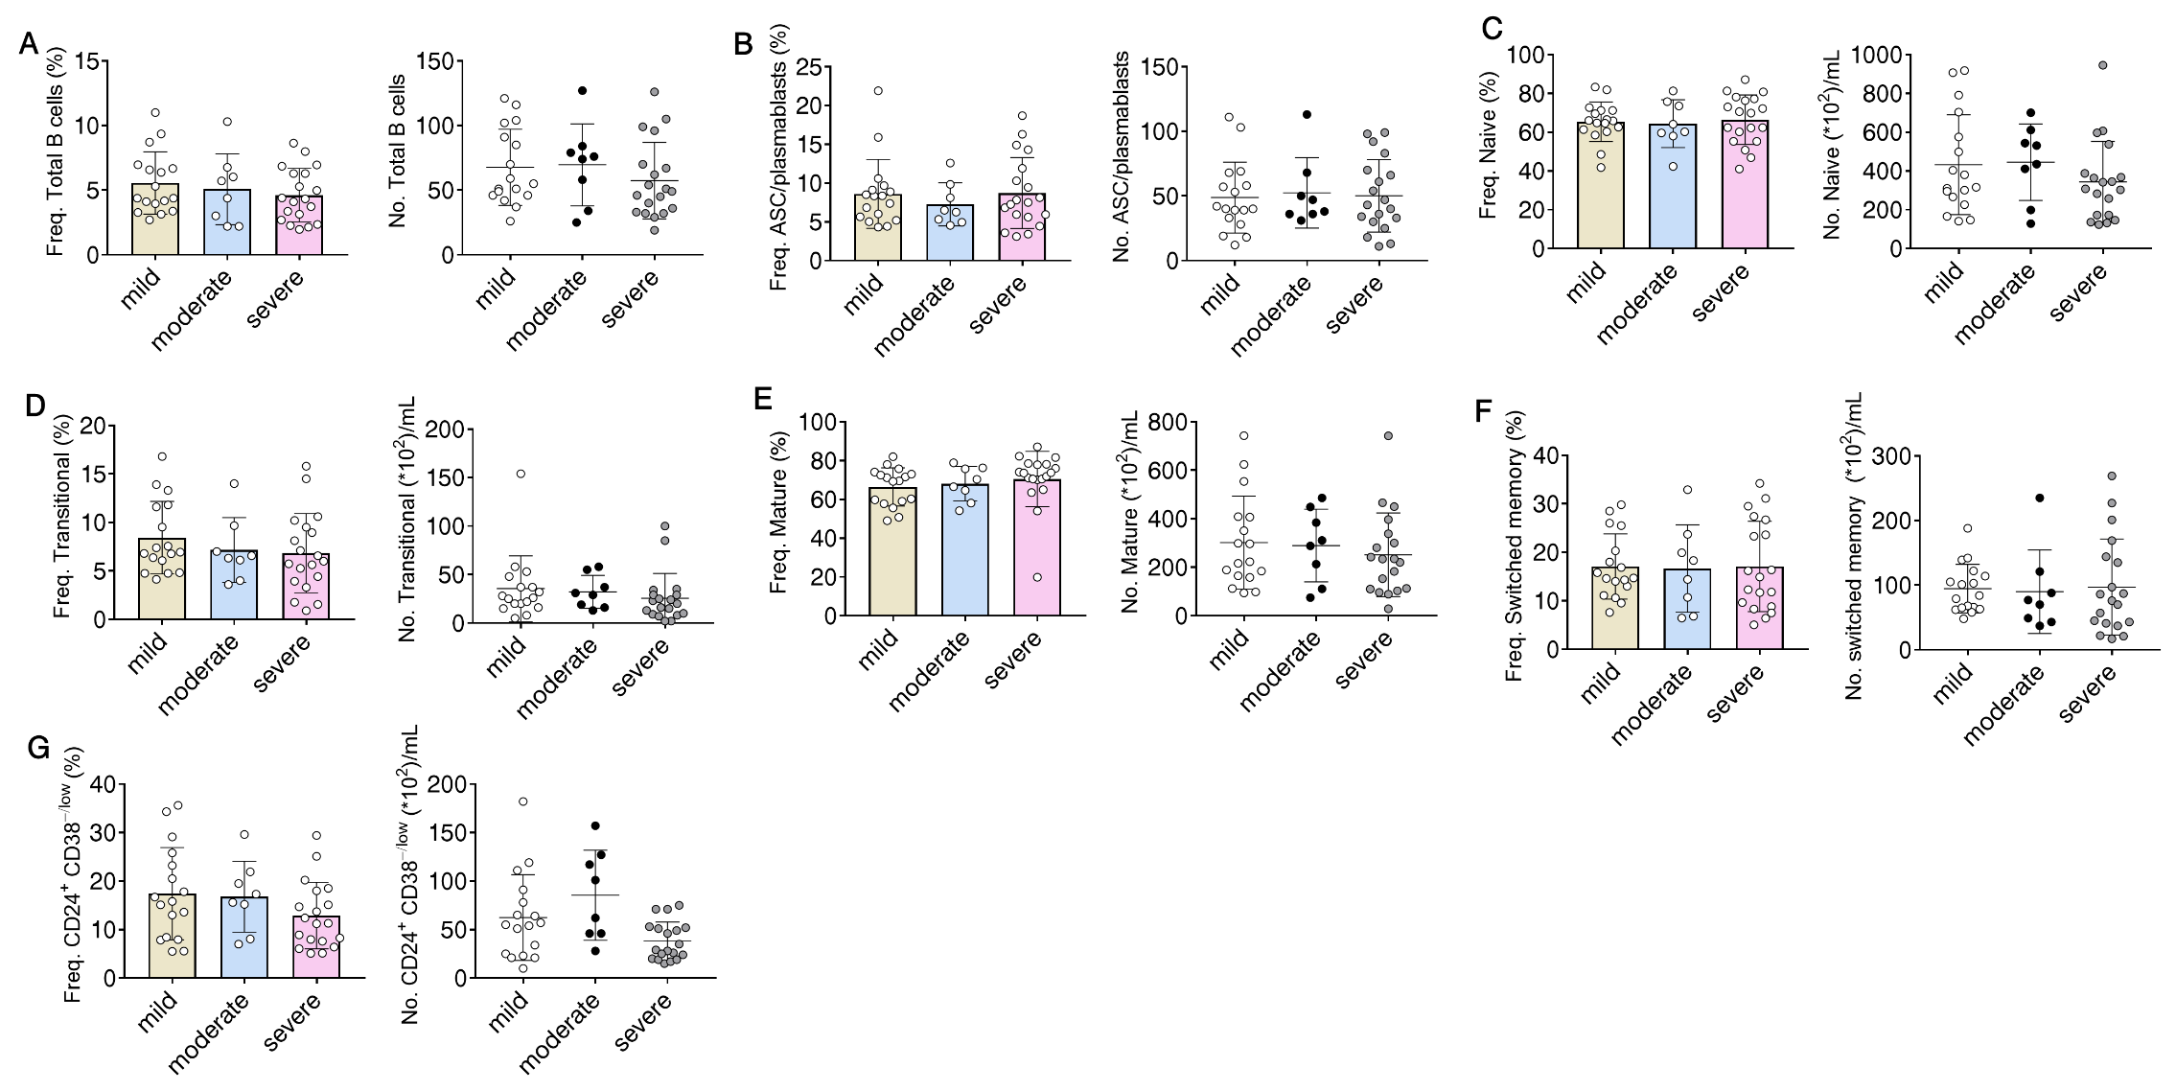
Supplementary Figure 1. B cell subsets in different clinical groups of glaucoma patients. The severity of glaucoma was determined as in Figure 5. The frequency (Freq.) and absolute number (No.) of (A) total B cells, (B) ASC/plasmablasts, (C) naïve, (D) transitional, (E) mature, (F) switched memory, and (G) CD24⁺ CD38^{−/low} subpopulations in 3 clinical categories of glaucoma patients. Statistic differences were determined by one-way analysis of variance (ANOVA) followed by Bonferroni Correction. The data are represented as means ± SD.

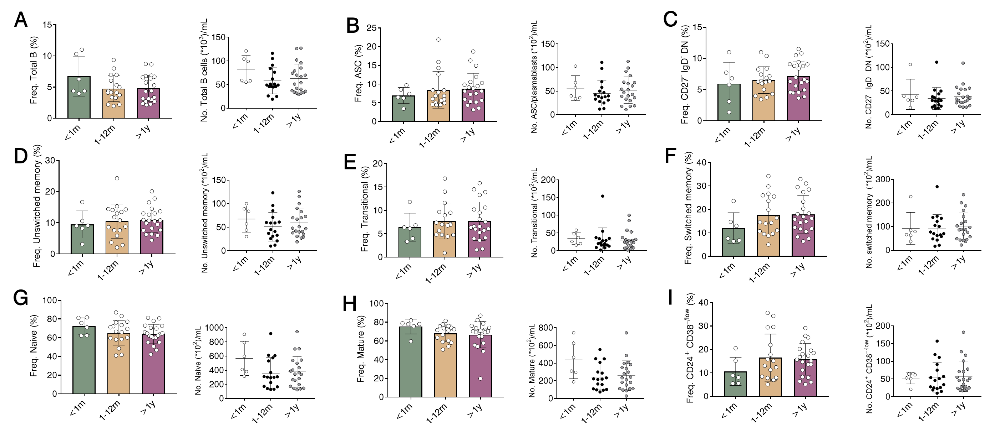
Supplementary Figure 2. B cell subsets in glaucoma patients with different disease duration. Patients were divided into 3 groups based on their disease duration: 1, duration of shorter than 1 month (n=6); 2, 1-12 months (n=17); 3, longer than 1 year (n=21). The frequency and absolute number of (A) total B cells, (B) ASC/plasmablasts, (C) CD27⁻ IgD⁻ DN, (D) unswitched memory, (E)transitional, (F) switched memory, (G) naïve, (H) mature, and (I) CD24⁺ CD38^{−/low} subpopulations in 3 groups of glaucoma patients with different disease duration. Statistic differences were determined by one-way analysis of variance (ANOVA) followed by Bonferroni Correction. The data are represented as means ± SD.

Supplementary Table 1. B cell subsets in different clinical types of glaucoma
Cell type | PACG | Freq. (%) | POAG | Freq. (%) | P value ª
Cell type | PACG | No. (*10²/mL) | POAG | No. (*10²/mL) | P value ª
Total B | 5.02 ± 2.39 |  | 5.33 ± 1.4 |  | 0.7650
Total B | 660.63 ± 300.65 |  | 480.66 ± 195.48 |  | 0.1728
ASC/plasmablasts | 8.26 ± 4.24 |  | 9.35 ± 3.43 |  | 0.5592
ASC/plasmablasts | 50.69 ± 27.09 |  | 46.29 ± 23.65 |  | 0.7152
Naïve | 66.04 ± 11.72 |  | 63.18 ± 8.36 |  | 0.5778
Naïve | 417.36 ± 229.11 |  | 262.2 ± 123.24 |  | 0.1205
Mature | 67.17 ± 12.03 |  | 70.52 ± 8.34 |  | 0.6551
Mature | 295.46 ± 176.99 |  | 165.4 ± 65.62 |  | 0.0892
Transitional | 7.46 ± 3.76 |  | 7.82 ± 3.79 |  | 0.8333
Transitional | 32.17 ± 28.44 |  | 20.92 ± 18.28 |  | 0.3644
CD24⁺ CD38^{−/low} | 15.34 ± 8.15 |  | 15.35 ± 7.59 |  | 0.9990
CD24⁺ CD38^{−/low} | 56.21 ± 39.15 |  | 55.42 ± 37.56 |  | 0.9640
Unswitched memory | 10.74 ± 4.88 |  | 9.66 ± 1.94 |  | 0.6033
Unswitched memory | 58.54 ± 28.76 |  | 48.86 ± 31.92 |  | 0.4651
Switched memory | 16.47 ± 7.99 |  | 20.43 ± 7.58 |  | 0.2727
Switched memory | 96.54 ± 60.73 |  | 83.77 ± 41.54 |  | 0.6297
CD27⁻ IgD⁻ DN | 6.76 ± 2.42 |  | 6.73 ± 2.4 |  | 0.9818
CD27⁻ IgD⁻ DN | 37.46 ± 24.07 |  | 39.65 ± 14.97 |  | 0.8332
Data are presented as mean ± SD when applicable.
Abbreviations: PACG, primary angle-closure glaucoma; POAG, primary open-angle glaucoma; Freq, frequency; No, number; ASC, antibody-secreting cells; DN, double negative
ª Student’s t test (unpaired, two-tailed)

