Effects of lateral patellar retinaculum release for recurrent patella dislocation: A prospective study

Supplementary Fig. 1.………………………………………………………………2

Supplementary Fig. 2.………………………………………………………………3

Supplementary Fig. 3.………………………………………………………………4

Supplementary Fig. 4.………………………………………………………………5

Supplementary Fig. 5.………………………………………………………………6

Supplementary Fig. 6.………………………………………………………………7

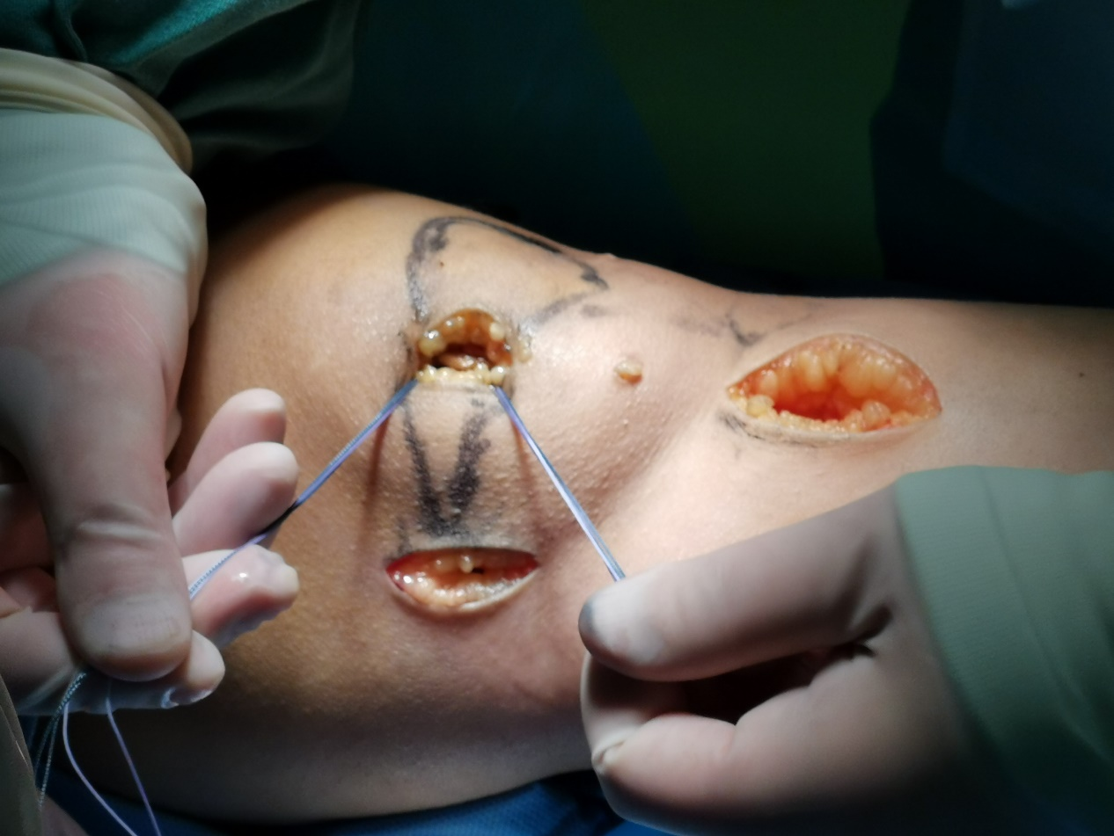

Supplementary Fig. 1. Surgical procedure of MPFL reconstruction. The incisions in the skin of the patella and medial femur are prepared for MPFL reconstruction and two suture anchors are screwed into the middle and upper third of the patella. MPFL, medial patellofemoral ligament.

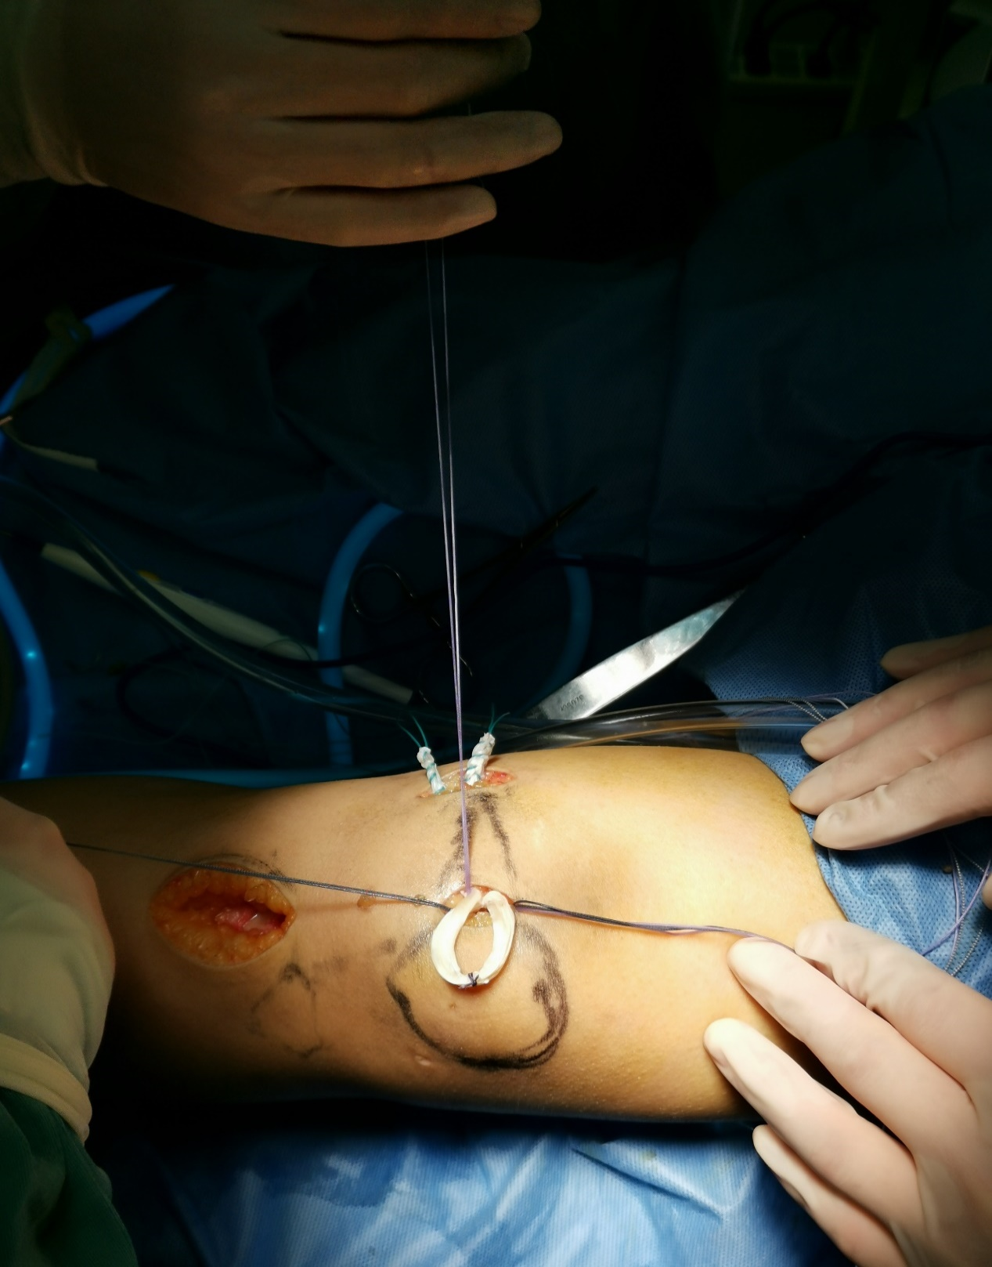

Supplementary Fig. 2. Surgical procedure of MPFL reconstruction. The subcutaneous fascia layer of the medial patella is bluntly separated and the prepared allogeneic tendon is placed between the fascia layer and the joint capsule. MPFL, medial patellofemoral ligament.

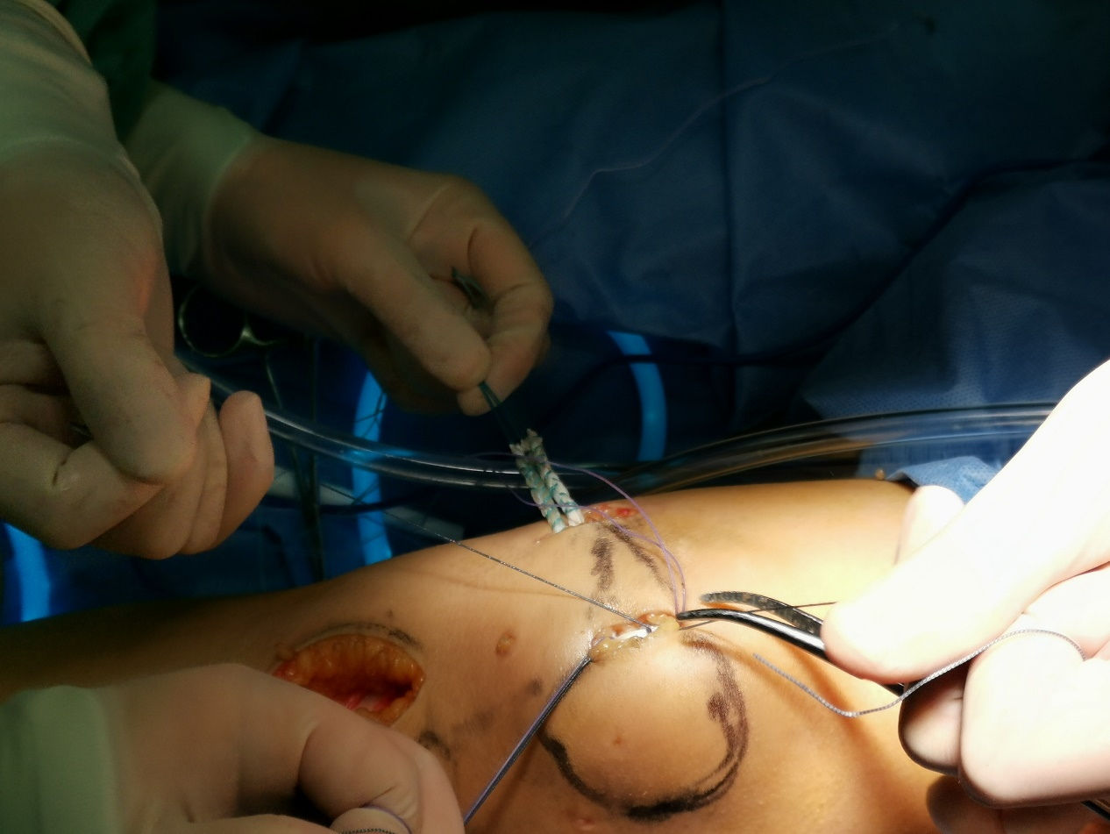

Supplementary Fig. 3. Surgical procedure of MPFL reconstruction. The middle part of the ligament is sutured and fixed between the two anchors on the medial side of the patella, and the femoral side is fixed with an extrusion screw. MPFL, medial patellofemoral ligament.

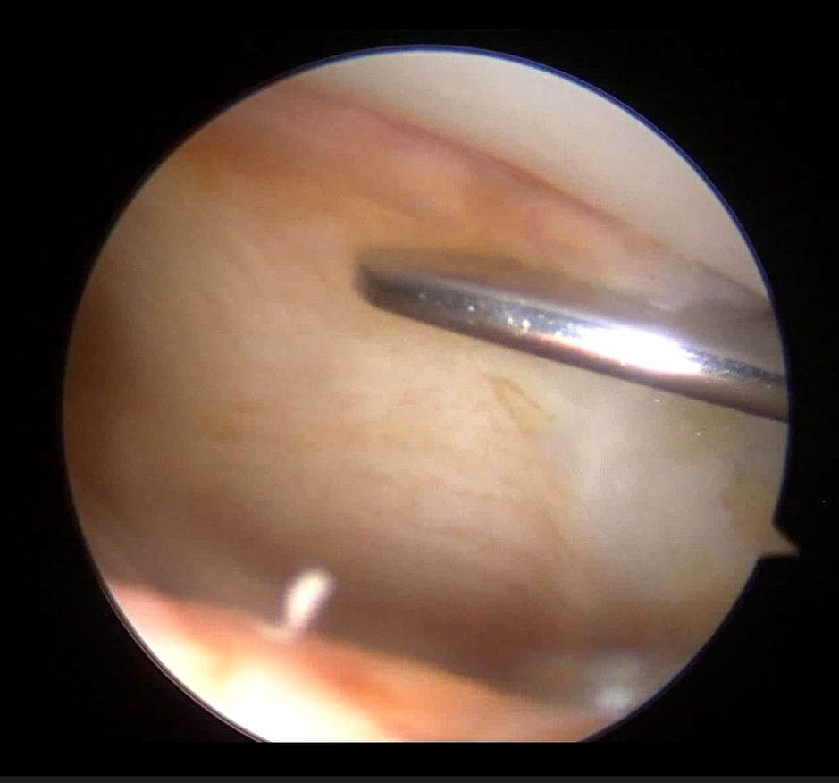

Supplementary Fig. 4. The lateral patellar retinaculum and the hook knife under arthroscopy.

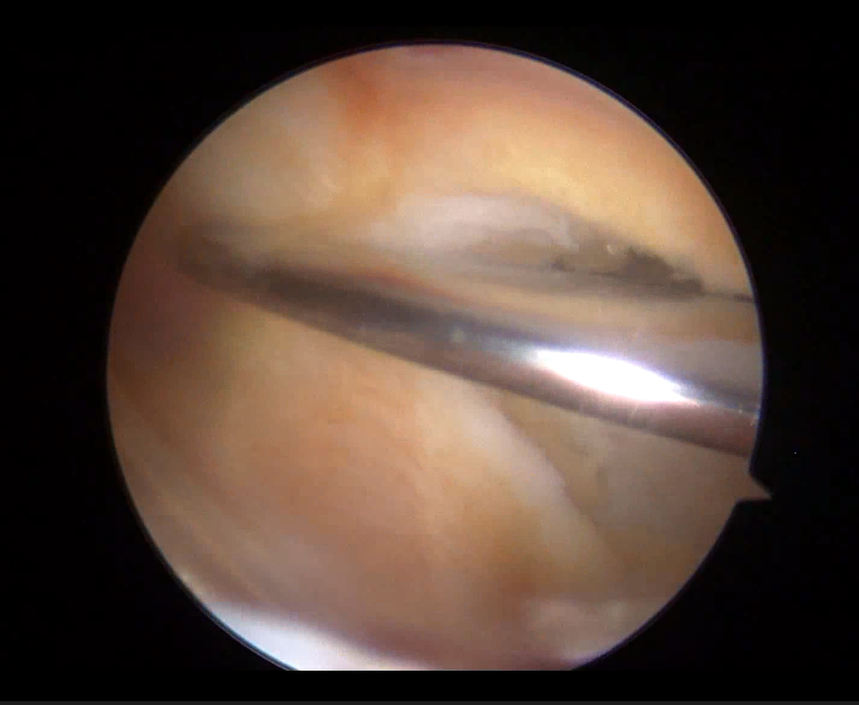

Supplementary Fig. 5. Surgical procedure of LPR release. The lateral patellar retinaculum is releasing by hook knife under arthroscopy. LPR, lateral patellar retinaculum.

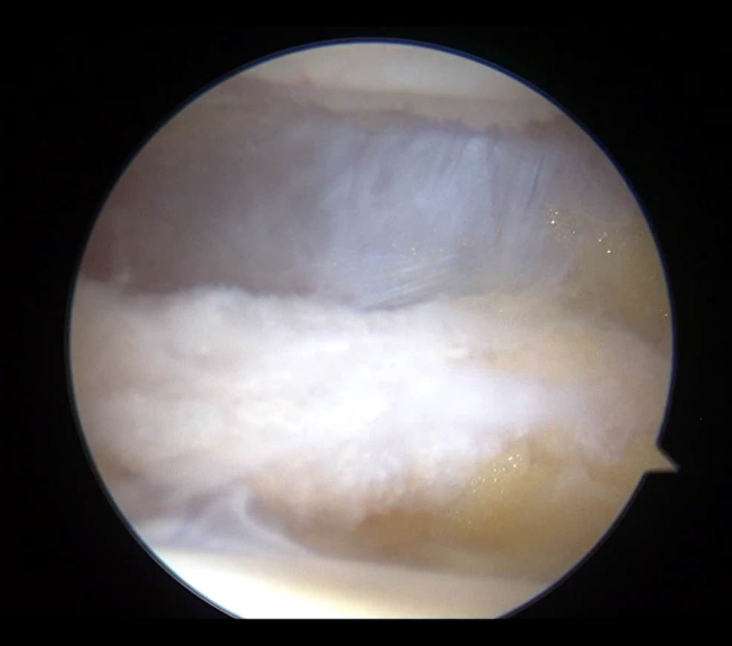

Supplementary Fig. 6. Surgical procedure of LPR release. The lateral patellar retinaculum has been completely released under arthroscopy. LPR, lateral patellar retinaculum.

