Divya-Herbal-Peya Decoction Harmonizes the Inflammatory Response in Lipopolysaccharide-Induced Zebrafish Model
Acharya Balkrishna^{1,2,5}, Savita Lochab³, Monali Joshi⁴, Jyotish Srivastava⁴, and Anurag Varshney^{1,2,6*}
¹Drug Discovery and Development Division, Patanjali Research Institute, NH-58, Haridwar 249405, Uttarakhand, India.
²Department of Allied and Applied Sciences, University of Patanjali, Patanjali Yog Peeth, Roorkee-Haridwar Road, Haridwar 249405, Uttarakhand, India.
³Department of Biology, Patanjali Research Institute, NH-58, Haridwar 249405, Uttarakhand, India.
⁴Department of Chemistry, Patanjali Research Institute, NH-58, Haridwar 249405, Uttarakhand, India.
⁵Patanjali Yog Peeth (UK) Trust, 40 Lambhill Street, Kinning Park, Glasgow G41 1AU, UK
⁶Special Centre for Systems Medicine, Jawaharlal Nehru University, New Delhi, India

*Correspondence:
Dr. Anurag Varshney
Drug Discovery and Development Division,
Patanjali Research Institute, NH-58,
Haridwar 249405, Uttarakhand, India
Email: anurag@prft.co.in

Supplementary

Table S1: Quality check analysis of Divya-Herbal-Peya (Batch # B-DHP109) as per the guidelines in “General Guidelines for Drug Development of Ayurvedic Formulations, First Edition-2018” issued by Central Council for Research in Ayurvedic Sciences, Ministry of AYUSH, Government of India¹.

PARAMETER | STANDARD LIMIT | OBSERVED VALUES | RESULT
Microbial Limit Test
TAMC | NMT# 10⁵ cfu/gm | 19350 | Complies
TY&MC | NMT# 10ᵌ cfu/gm | 770 | Complies
Test for Pathogens
Escherichia coli | Absent/ gm | Absent | Complies
Staphylococcus aureus | Absent/gm | Absent | Complies
Pseudomonas aeruginosa | Absent/gm | Absent | Complies
Salmonella sp. | Absent/gm | Absent | Complies
Heavy Metals
Lead | < 10ppm | 0.787 | Complies
Arsenic | <3.0ppm | 0.199 | Complies
Mercury | <1.0ppm | 0.781 | Complies
Cadmium | <0.3ppm | 0.077 | Complies
Test for Pesticide Residue
Organo-chloro group | <1.0ppm | <1.0 | Complies
Aflatoxins
B1 | <0.5ppm | <0.0005 | Complies
G1 | <0.5ppm | <0.0005 | Complies
B2 | <0.1ppm | <0.0005 | Complies
G2 | <0.1ppm | <0.0005 | Complies
# NMT: Not more than

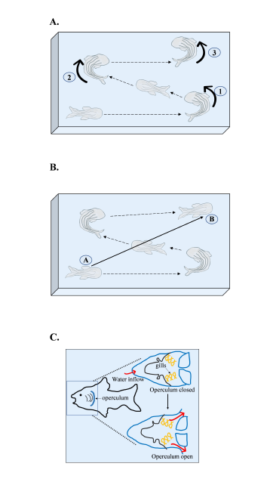
Figure 1S: Pictorial representation of behavioural activities in zebrafish model.
(A). Pictorial representation of the top view of study tank, showing fish movement from point A to B. Displacement for individual zebrafish was calculated by recording the distance between point A and B (in mm). Further calculations were performed on by dividing displacement by time (s) taken to attain that dis-placement in order to obtain the velocity (mm/sec) for each zebrafish. (B). Pictorial diagram showing the swim path of zebrafish. For 3 consecutive min the turns (shown with bold black arrow) taken by each zebrafish were recorded. (C). Pictorial representation showing phenotypic position of operculum in zebrafish. Operculum is closed when fish take up water inside the buccal cavity but development of pressure opens up the operculum to allow exit of water. The opening and closing of operculum lead to operculum movement which is noticeable phenotypically. These operculum movements are recorded as opercular beat.

Reference
1. General Guidelines for Drug Development. https://www.ayush.gov.in

