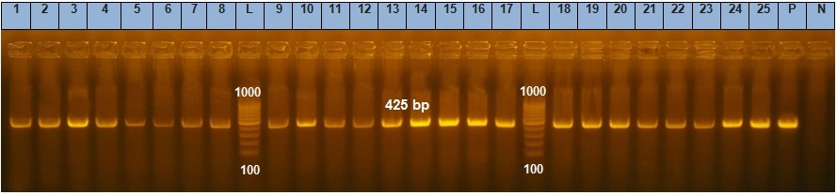

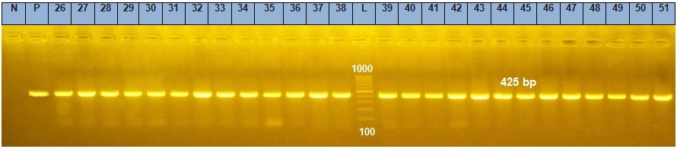

Figure S1: Agarose gel electrophoresis of the PCR analysis of recA gene (425 bp) of the 51 A. baumannii clinical isolates. N, negative control (PCR reaction without recA primers), P, Positive control (PCR reaction with chromosomal DNA of A. baumannii ATCC 17978 as a PCR template).

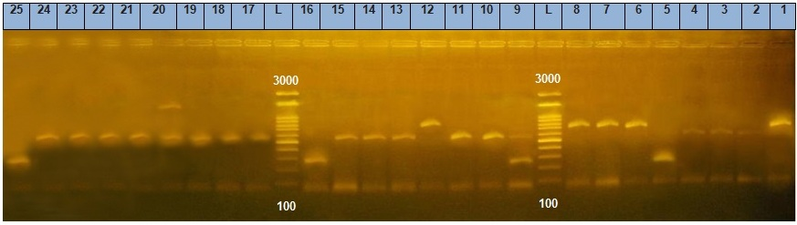

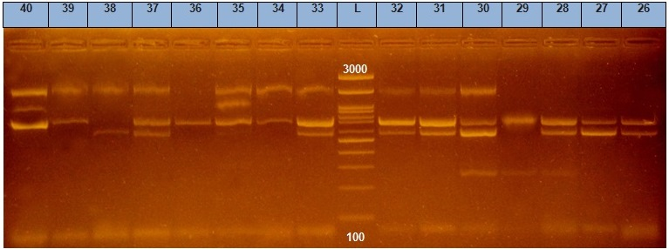

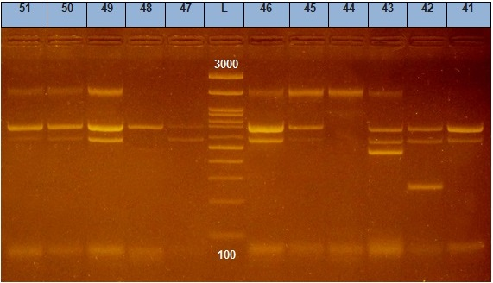
Figure S2: Agarose gel electrophoresis of the ERIC-PCR analysis of the 51 MDR A. baumannii clinical isolates.

Figure S3. FICI values of three tested antibiotic combinations against nine MDR A. baumannii

Figure S4. Total percentage of synergy, additive, and antagonistic effects of three tested antibiotic combinations (CT+MEM, TGC+MEM and TGC+CT) against MDR A. baumannii (n=9)

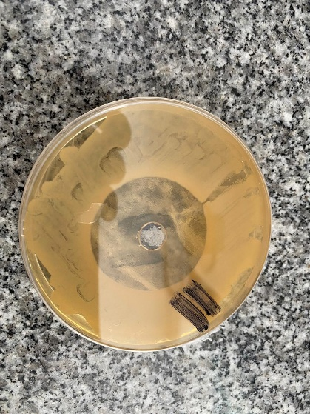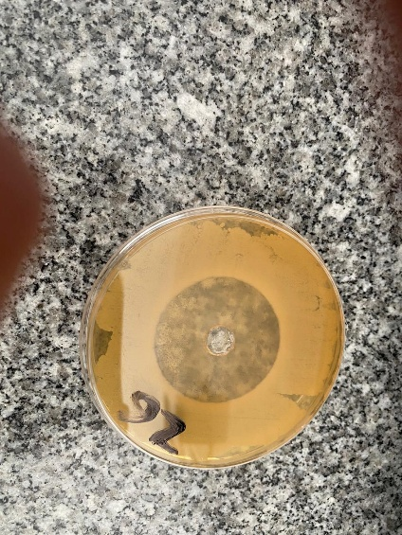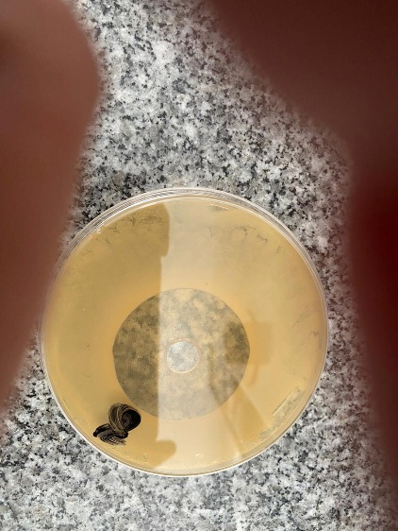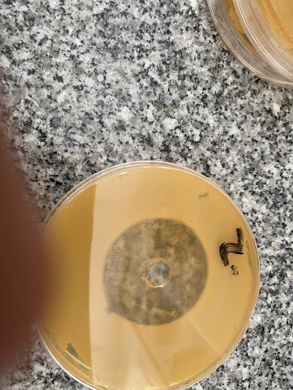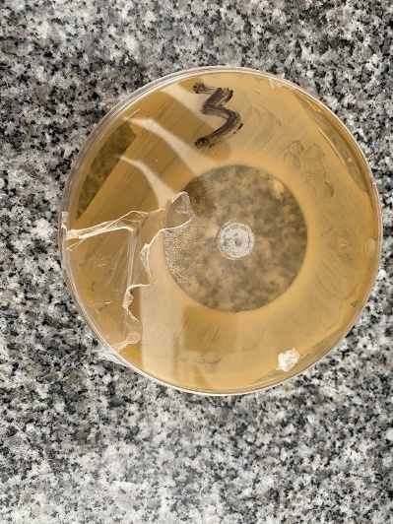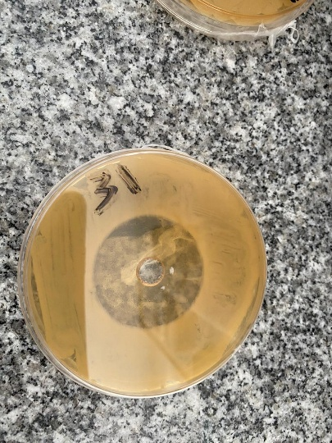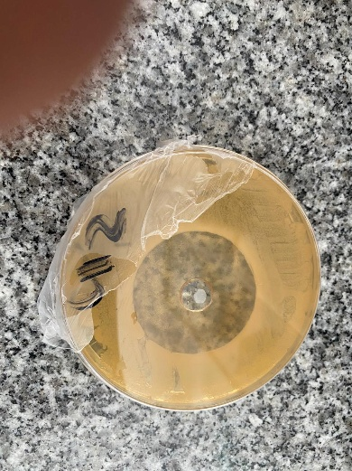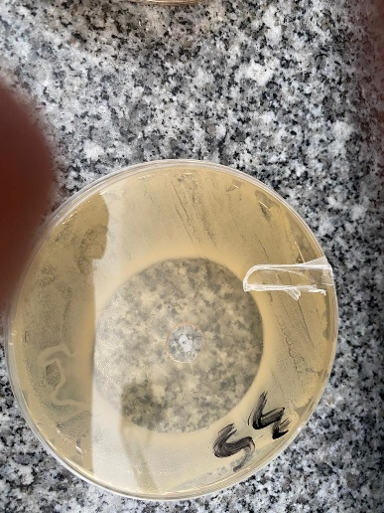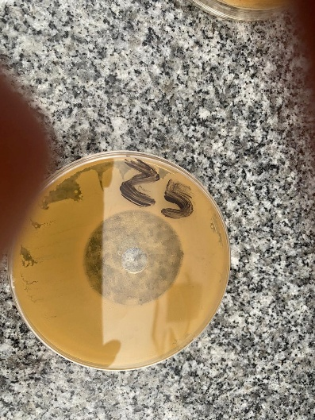
Figure S5. Well-cut Diffusion Technique antimicrobial test.

Table S1: Antibiogram analysis of the 51 of A. baumannii clinical isolates.
Isolate code | Antimicrobial agents
Isolate code | PIP | FEP | CN | CRO | AK | IPM | CIP | SXT | SAM | DO | TPZ | MEM | TGC | CT
A1 | R | R | R | R | R | R | R | R | R | R | R | R | S | S
A2 | R | R | R | R | R | R | R | R | R | R | R | R | S | S
A3 | R | R | R | R | R | R | R | R | R | R | R | R | S | S
A4 | R | R | R | R | R | R | R | R | R | R | R | R | S | S
A5 | R | R | R | R | R | R | R | R | R | R | R | R | S | S
A6 | R | R | R | R | R | R | R | R | R | R | R | R | S | S
A7 | R | R | R | R | R | R | R | S | R | R | R | R | S | S
A8 | R | R | R | R | R | R | R | R | R | R | R | R | S | S
A9 | R | R | R | R | R | R | R | R | R | R | R | R | S | S
A10 | R | R | R | R | R | R | R | R | R | R | R | R | S | S
A11 | R | R | S | R | R | R | R | R | R | R | R | R | S | S
A12 | R | R | R | R | R | R | R | R | R | R | R | R | S | R
A13 | R | R | R | R | R | R | R | R | R | R | R | R | S | S
A14 | R | R | R | R | R | R | R | R | R | R | R | R | S | S
A15 | R | R | R | R | R | R | R | R | R | R | R | R | S | S
A16 | R | R | R | R | R | R | R | R | R | R | R | R | S | S
A17 | R | R | R | R | R | R | R | R | R | R | R | R | S | S
A18 | R | R | R | R | R | R | R | R | R | R | R | R | S | S
A19 | R | R | R | R | R | R | R | R | R | R | R | R | S | S
A20 | R | R | R | R | R | R | R | R | R | R | R | R | S | S
A21 | R | R | R | R | R | R | R | R | R | R | R | R | S | S
A22 | R | R | R | R | R | R | R | R | R | R | R | R | S | S
A23 | R | R | R | R | R | R | R | R | R | R | R | R | S | S
A24 | R | R | R | R | R | R | R | R | R | R | R | R | S | S
A25 | R | R | R | R | R | R | R | R | R | R | R | R | S | S
A26 | R | R | R | R | R | R | R | R | R | R | R | R | R | S
A27 | R | R | R | R | R | R | R | R | R | R | R | R | S | S
A28 | R | R | R | R | R | R | R | R | R | R | R | R | S | S
A29 | R | R | R | R | R | R | R | R | R | R | R | R | R | S
A30 | R | R | R | R | R | R | R | R | R | R | R | R | S | S
A31 | R | R | R | R | R | R | R | R | R | R | R | R | S | S
A32 | R | R | R | R | S | R | R | R | R | R | R | R | S | S
A33 | R | R | R | R | R | R | R | R | R | R | R | R | S | S
A34 | R | R | S | R | R | R | R | R | R | R | R | R | S | S
A35 | R | R | R | R | R | R | R | R | R | R | R | R | S | S
A36 | R | R | R | R | R | R | R | R | R | R | R | R | S | S
A37 | R | R | R | R | R | R | R | R | R | R | R | R | S | S
A38 | R | R | R | R | R | R | R | R | R | R | R | R | S | S
A39 | R | R | R | R | R | R | R | R | R | R | R | R | S | S
A40 | R | R | R | R | R | R | R | R | R | R | R | R | S | S
A41 | R | R | R | R | R | R | R | R | R | R | R | R | S | S
A42 | R | R | R | R | R | R | R | R | R | R | R | R | S | S
A43 | R | R | R | R | R | R | R | R | R | R | R | R | S | S
A44 | R | R | R | R | R | R | R | R | R | R | R | R | S | S
A45 | R | R | R | R | R | R | R | R | R | R | R | R | S | S
A46 | R | R | R | R | R | R | R | R | R | R | R | R | S | S
A47 | R | R | R | R | R | R | R | R | R | R | R | R | S | S
A48 | R | R | R | R | S | R | R | R | S | R | R | R | S | S
A49 | R | R | R | R | S | R | R | R | R | R | R | R | S | R
A50 | R | R | R | R | S | R | R | R | S | R | R | R | S | S
A51 | R | R | R | R | R | R | R | R | R | R | R | R | S | S
R, resistant; S, Senstive. Piperacillin (PIP, 100 μg), piperacillin/tazobactam (TPZ, 10/100 μg), ampicillin-sulbactam (SAM, 10/10 μg), cefepime (FEP, 30 μg), ceftriaxone (CRO, 30 μg), Amikacin (AK, 30), gentamicin (CN, 30 mcg), ciprofloxacin (CIP, 5 mcg), imipenem (IMP, 10 μg), meropenem (MEM, 10 μg), doxycycline (DO, 30 μg), Trimethoprim-sulfamethoxazole (SXT, 1.25/23.7), tigecycline (TGC, 15 μg), colistin (CT).

Table S2. MIC values (µg/ml) of the tested antibiotics either alone or in combinations
Isolate Code | MIC (µg/ml)
Isolate Code | CT | TGC | MEM | CT+MEM | TGC+MEM | CT+TGC
A3 | 2.0 | 2.0 | 64.0 | 0.5 | 1.0 | 8.0
A8 | 1.0 | 0.5 | 64.0 | 0.25 | 0.25 | 4.0
A11 | 1.0 | 2.0 | 32.0 | 0.25 | 0.5 | 4.0
A20 | 2.0 | 0.5 | 64.0 | 0.5 | 0.25 | 4.0
A25 | 1.0 | 0.5 | 64.0 | 0.25 | 0.25 | 4.0
A26 | 1.0 | 3.0 | 64.0 | 0.5 | 1.0 | 4.0
A31 | 1.0 | 0.5 | 64.0 | 0.5 | 0.25 | 4.0
A35 | 2.0 | 2.0 | 64.0 | 0.5 | 0.5 | 8.0
A42 | 2.0 | 2.0 | 64.0 | 0.25 | 0.5 | 8.0
MIC, minimum inhibitory concentration; CT, colistin; MEM, meropenem; TGC, tigecycline

