Supplementary Material
Figure S1: Risk of asthma and COPD in individuals exposed to second-hand smoking in the general population. Logistic regression models adjusted for age, gender and smoking status. Asthma was defined as an affirmative response to one of the following two questions “Has a physician ever told you that you have/have had asthma?” or “Do you take daily or almost daily medication for asthma/bronchitis (including spray/powder)?”. COPD was defined as prebronchodilator FEV1/FVC< 0.7 excl. individuals who reported physician diagnosed asthma or taking daily medication for asthma/bronchitis.

Figure S2: Risk of atopy in individuals exposed to second-hand smoking in the general population. Logistic regression models adjusted for age, gender and smoking status. Atopy was an affirmative response to “Has a physician ever told you that you have/have had asthma?”, “Have you ever had hayfever?”, and/or an affirmative response to the following two questions “Have you had an itchy rash at any time in the last 12 months?” and “Has this itchy rash at any time affected the folds of the elbows, behind the knees, in front of the ankles, under the buttocks, or around the eyes?”.

Figure S3: Risk of light dyspnoea, severe dyspnoea, wheezing, and cough on exertion in individuals exposed to second-hand smoking in the general population stratified according to smoking status. Logistic regression models adjusted for age and sex.

Figure S4: FEV₁% predicted and FVC% predicted in individuals exposed to second-hand smoking in the general population stratified according to smoking status. Values are mean and SD. * P< 0.05, ‡P<0.001 vs individuals not exposed to second-hand smoking.

Figure S5: Risk of asthma and COPD in individuals exposed to second-hand smoking in the general population stratified according to smoking status. Logistic regression models adjusted for age and sex.

Figure S6: Risk of light dyspnoea, severe dyspnoea, wheezing, and cough on exertion in individuals exposed to second-hand smoking in the general population stratified according to sex. Logistic regression models adjusted for age and smoking status.

Figure S7: FEV₁% predicted and FVC% predicted in individuals exposed to second-hand smoking in the general population stratified according to sex. Values are mean and SD. * P< 0.05, † P< 0.01, ‡P<0.001 vs individuals not exposed to second-hand smoking.

Figure S8: Risk of asthma and COPD in individuals exposed to second-hand smoking in the general population stratified according to sex. Logistic regression models adjusted for age and smoking status.

Figure S9: Risk of light dyspnoea, severe dyspnoea, wheezing, and cough on exertion in individuals exposed to second-hand smoking in the general population stratified according to airway obstruction. Logistic regression models adjusted for age, gender and smoking status.

Figure S10: FEV₁% predicted and FVC% predicted in individuals exposed to second-hand smoking in the general population stratified according to airway obstruction. Values are mean and SD. * P< 0.05, † P< 0.01, ‡P<0.001 vs individuals not exposed to second-hand smoking.

Figure S11: Risk of asthma and COPD in individuals exposed to second-hand smoking in the general population stratified according to airway obstruction. Logistic regression models adjusted for age, gender and smoking status.

Figure S12: Risk of asthma and COPD in individuals exposed to second-hand smoking in the general population aged 39 years and below. Logistic regression models adjusted for age, gender and smoking status.

Supplementary figure 1

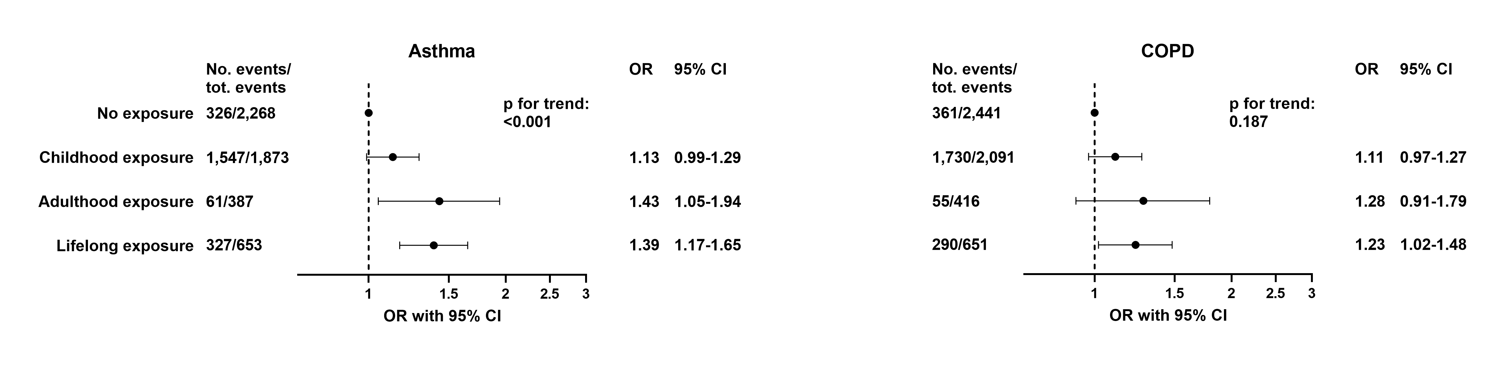

Supplementary figure 2

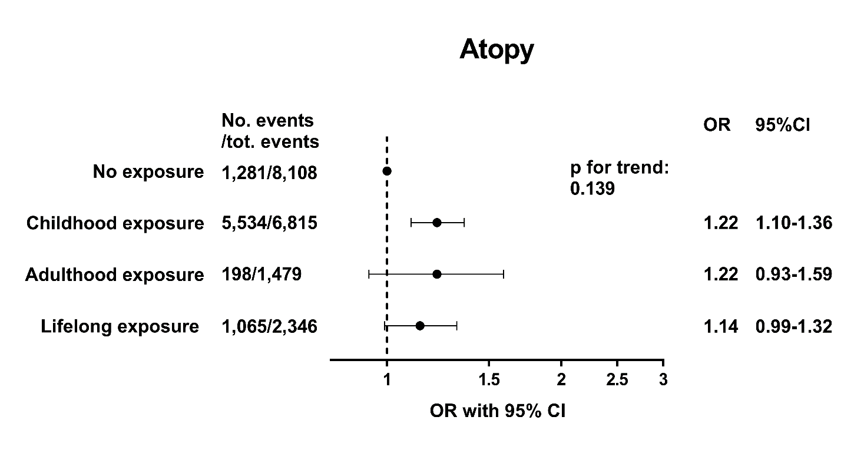

Supplementary figure 3

Supplementary figure 4

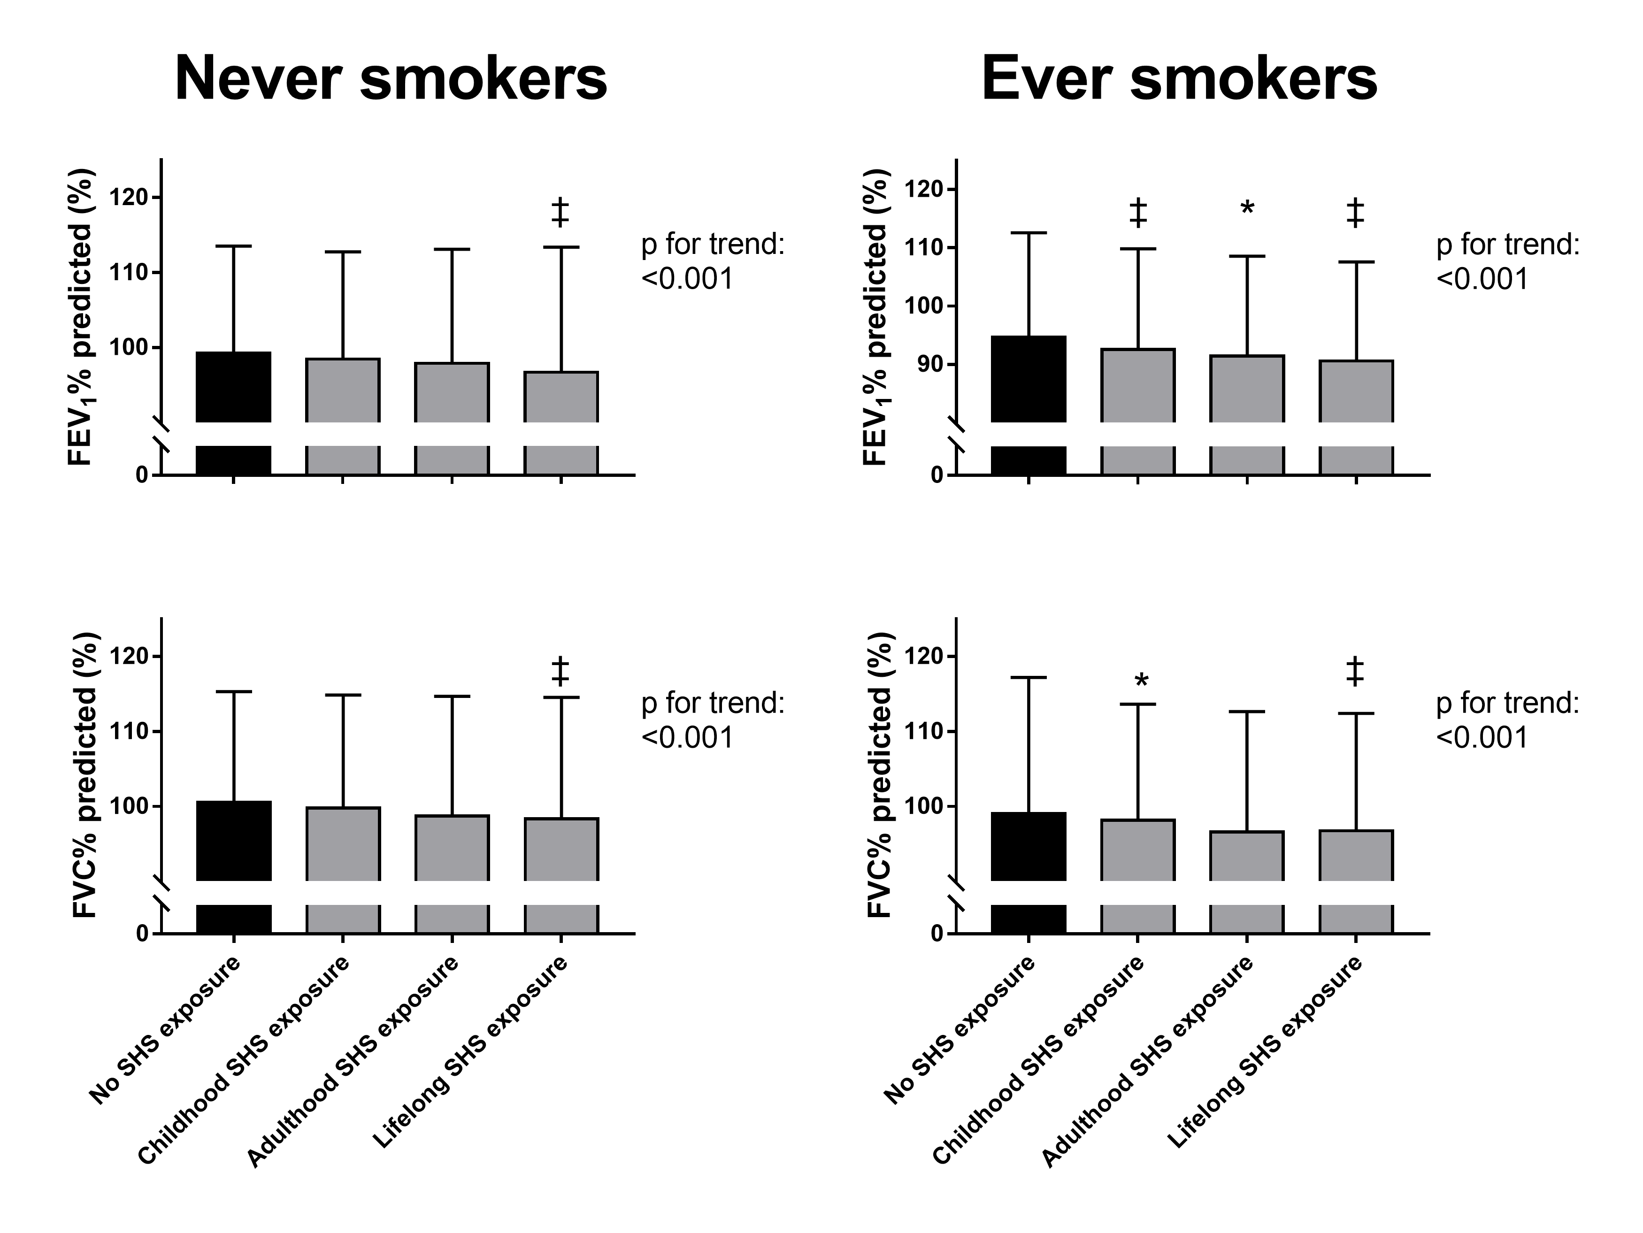

Supplementary figure 5

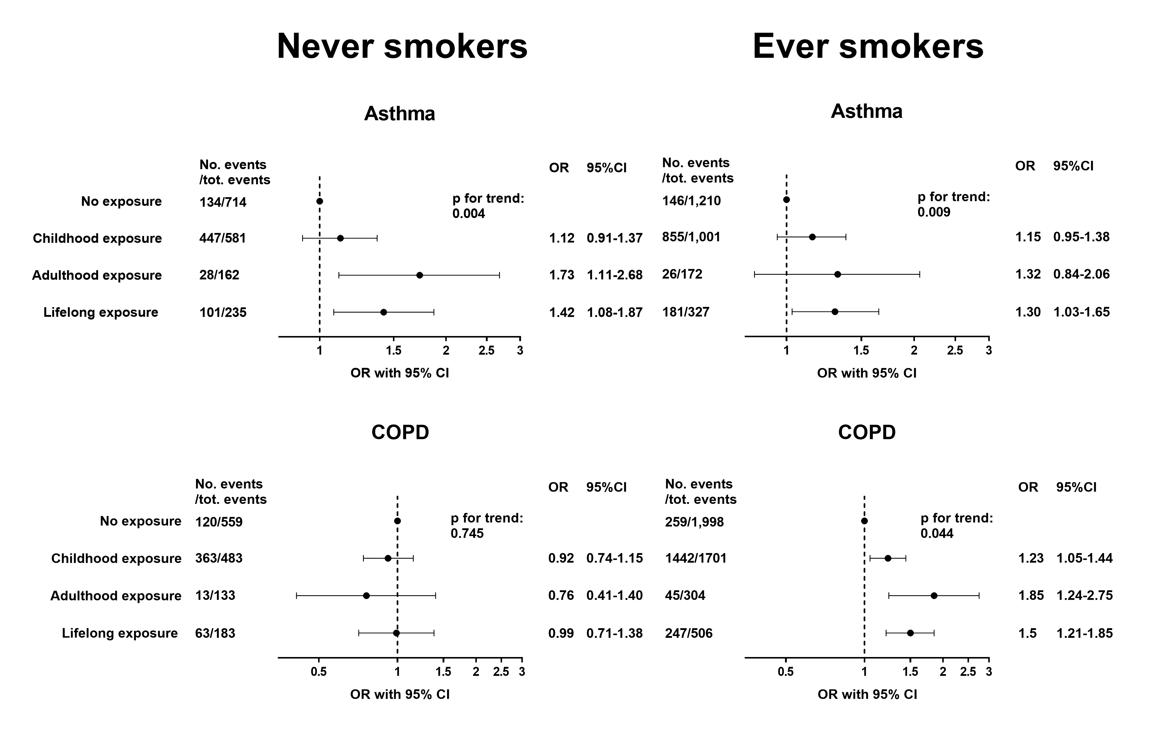
Supplementary figure 6

Supplementary figure 7

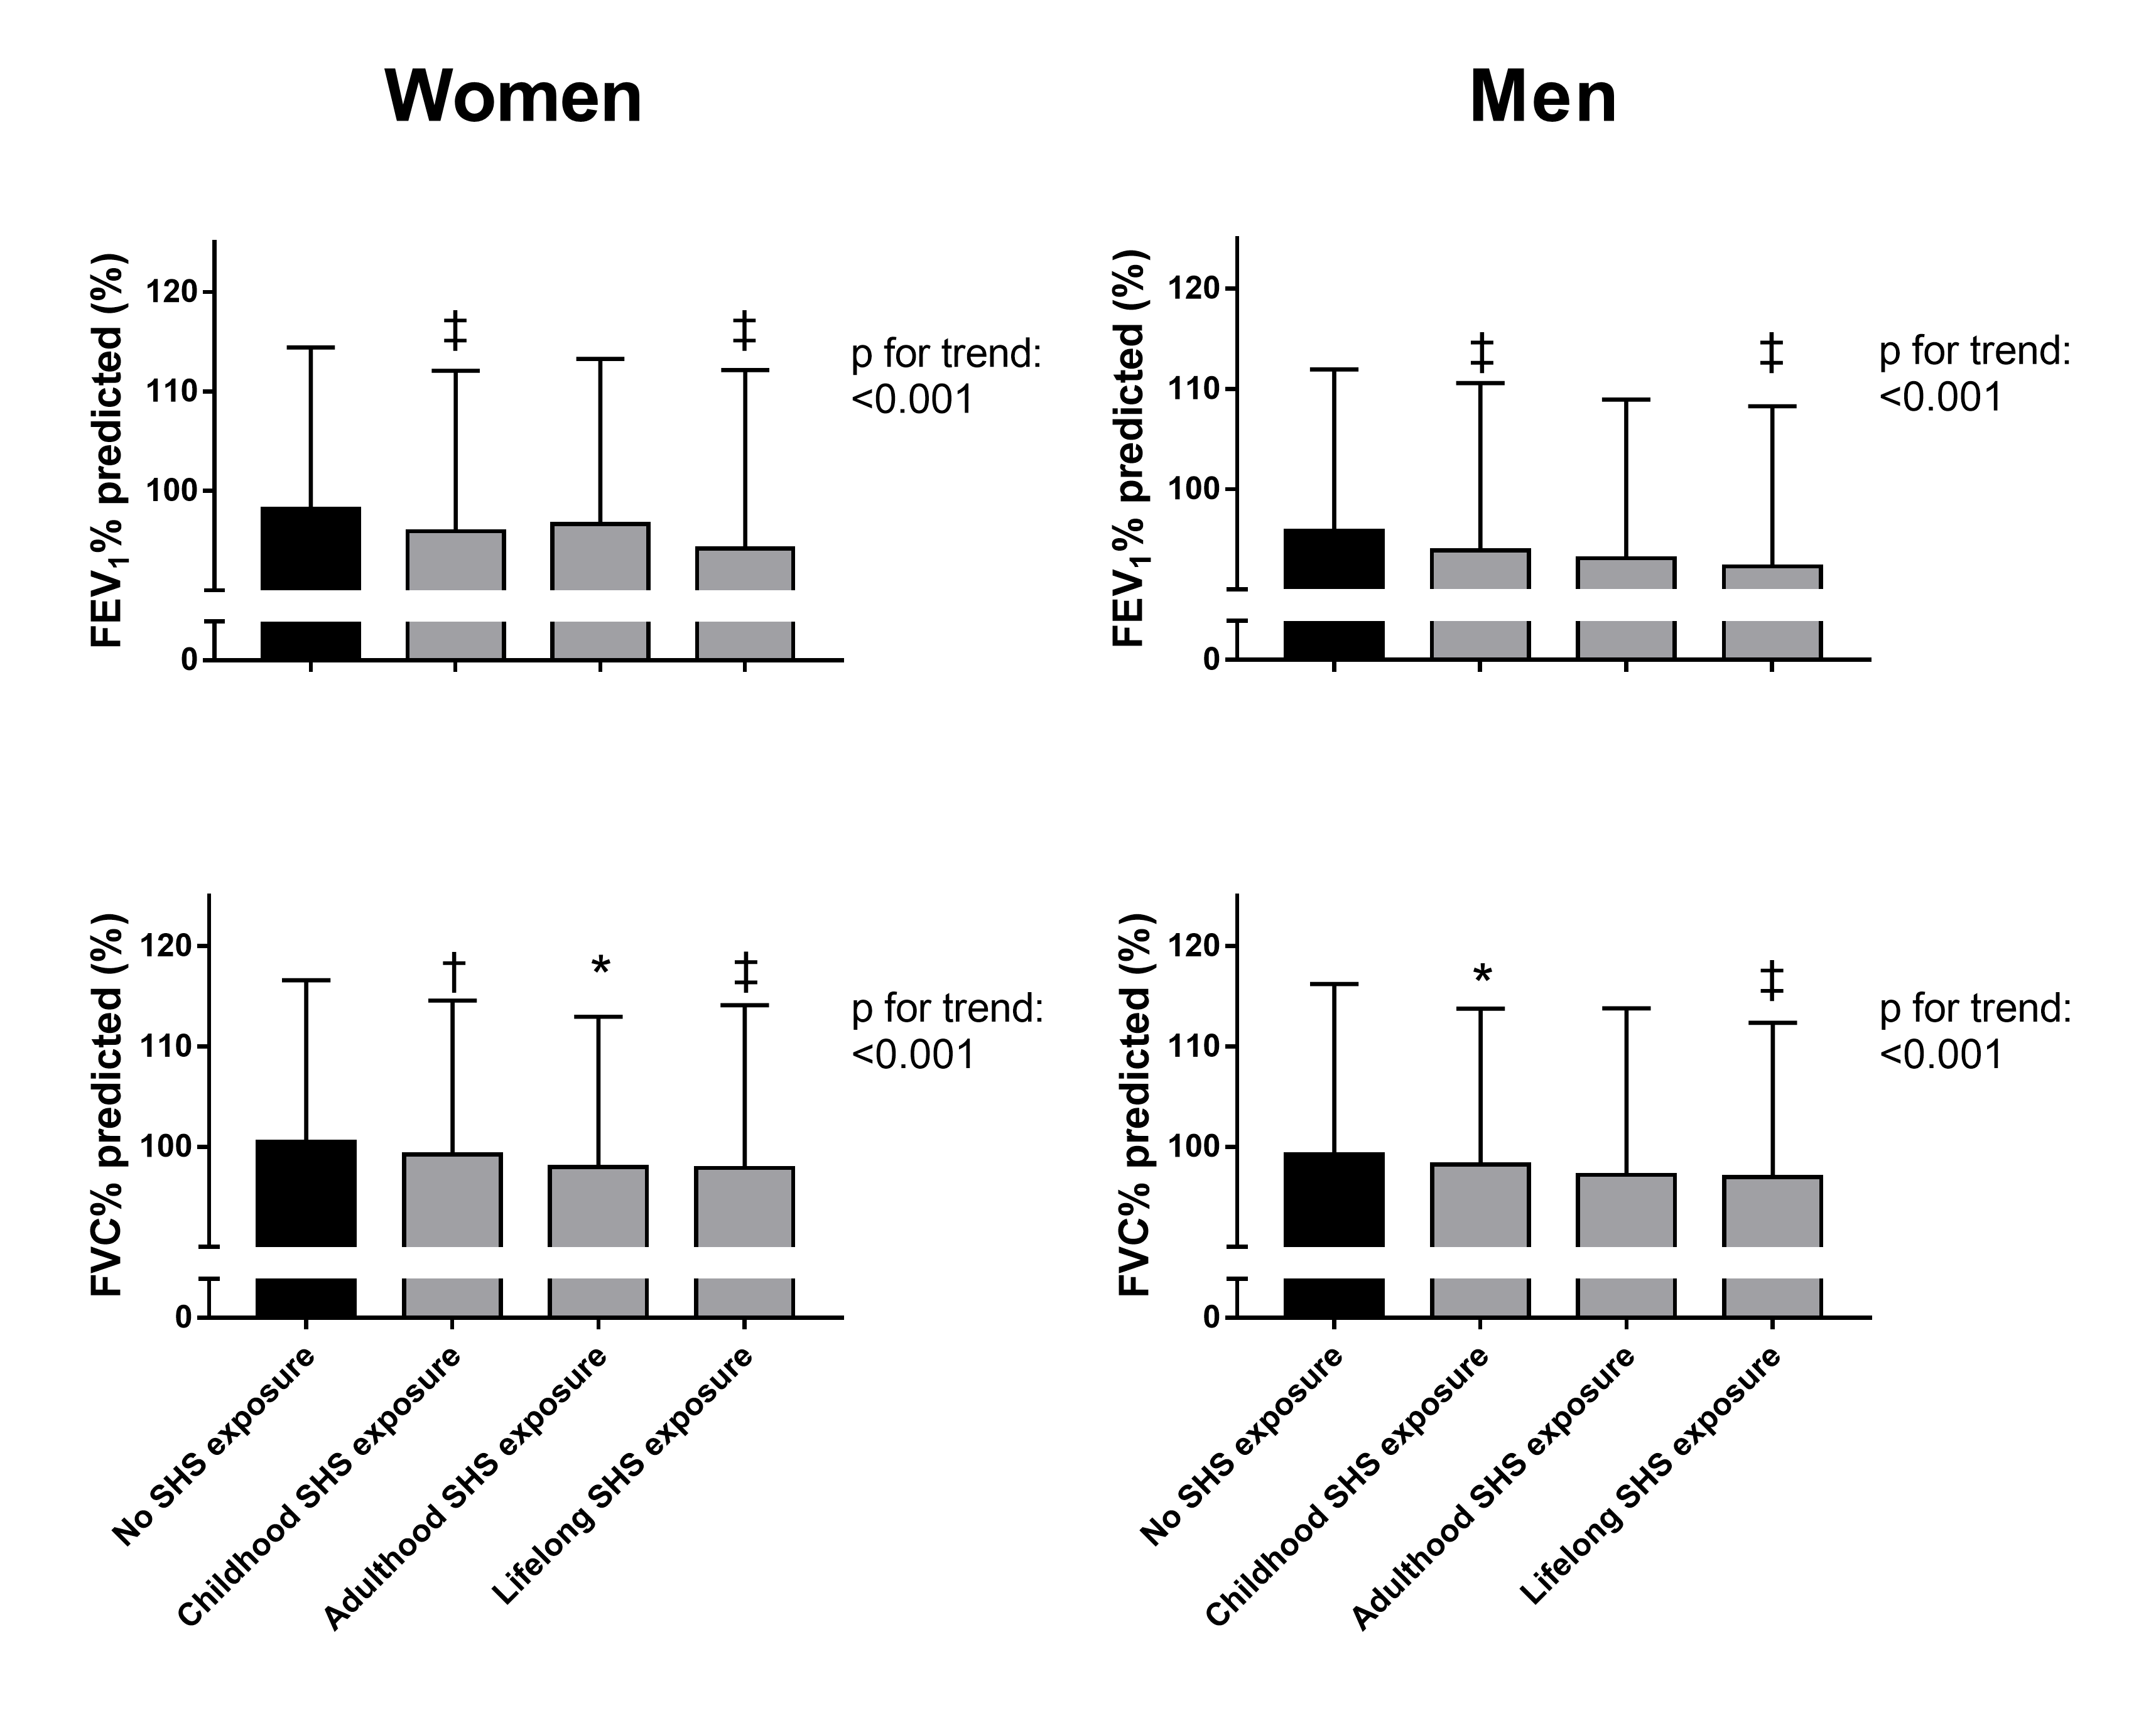

Supplementary figure 8

Supplementary figure 9

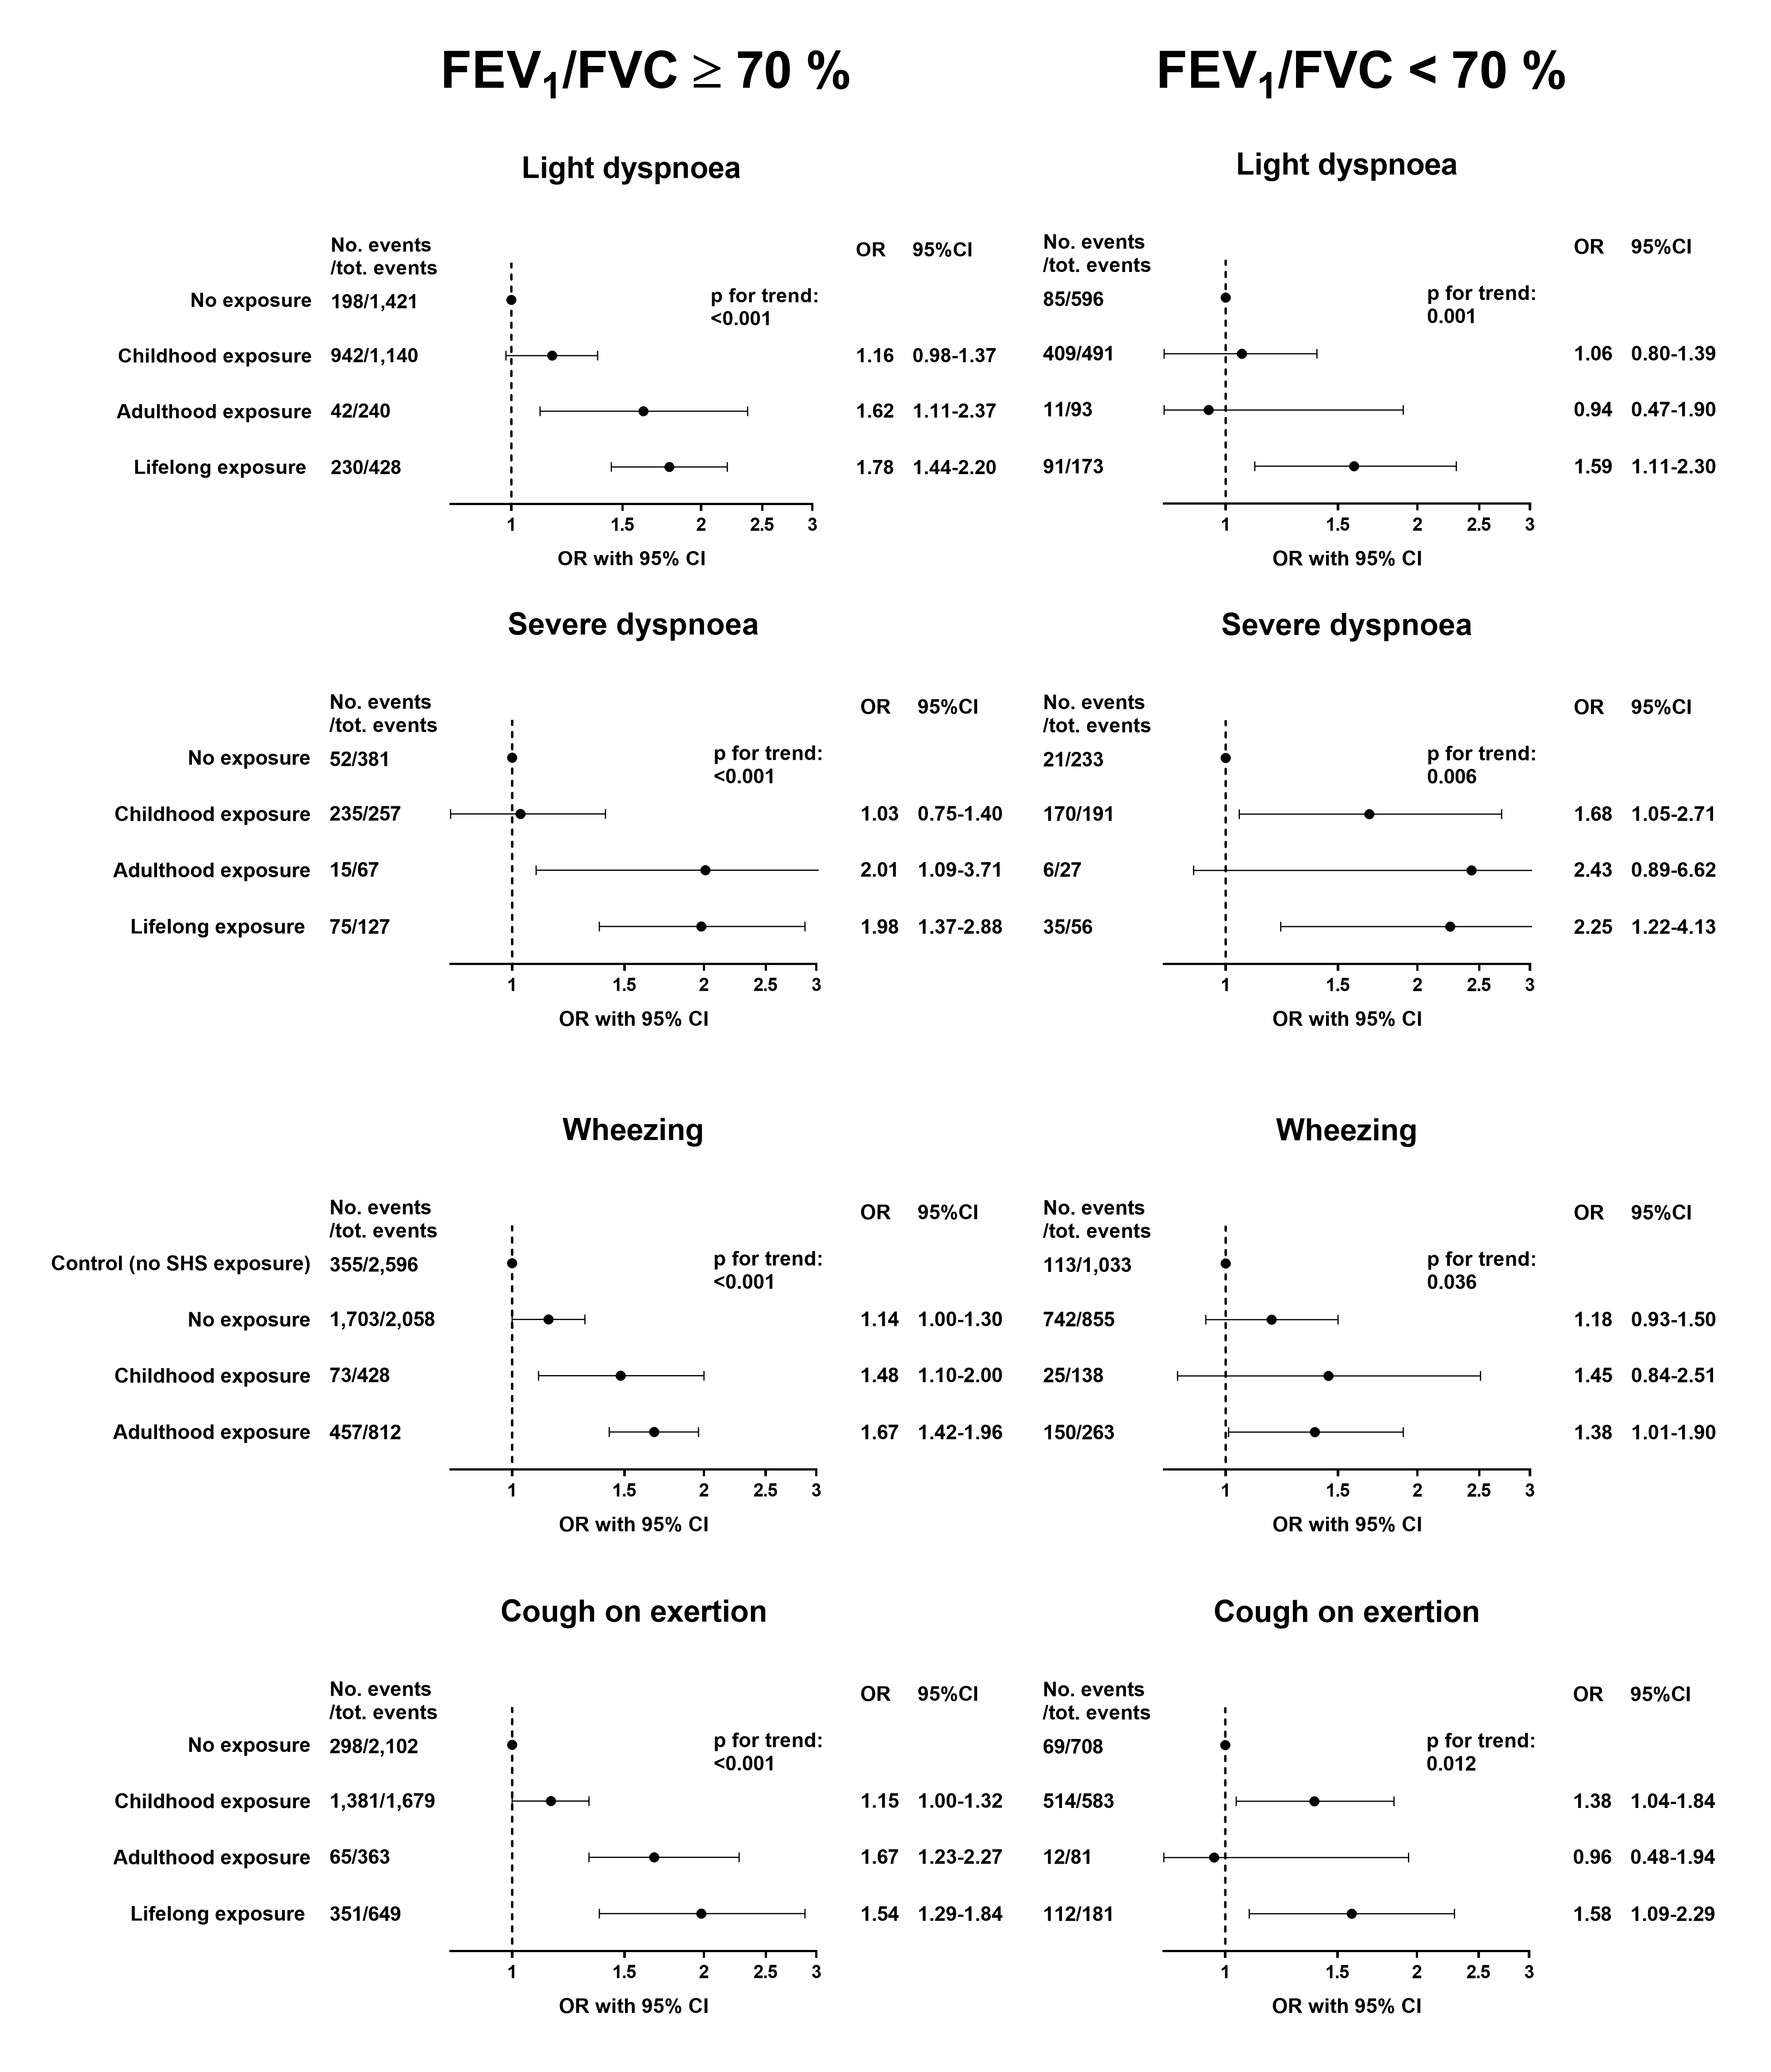

Supplementary figure 10

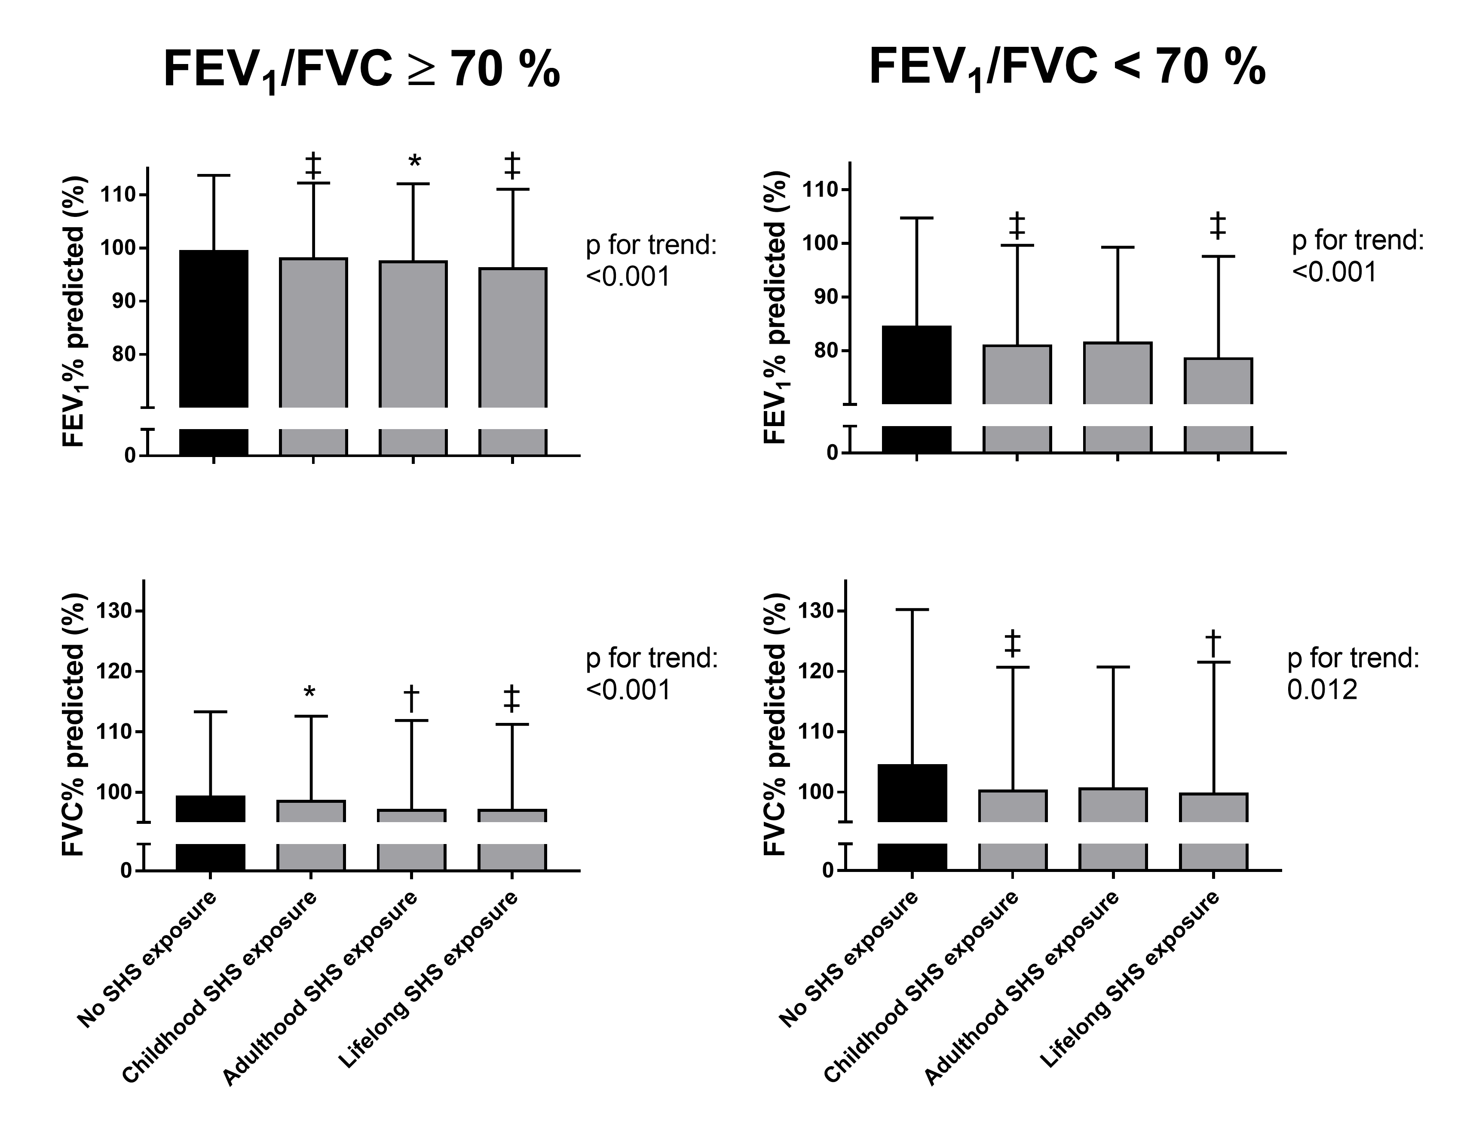
Supplementary figure 11

Supplementary figure 12

