Supplementary table 1. Demographic information according to the lymph node (LN) yield less than 12 versus 12 or more in rectal cancer patients receiving neoadjuvant therapy (N=2260).
Variables |  | LN <12 | LN ≧12 | P-value*
Overall |  | 950 (42.04) | 1310(57.96)
Gender
 | Male | 641 (67.47) | 896 (68.40) | 0.6424
 | Female | 309 (32.53) | 414 (31.60)
Age groups
 | ≦65 | 586 (61.68) | 906 (69.16) | 0.0002
 | >65 | 364 (38.32) | 404 (30.84)
Grade
 | Well/Moderately | 887 (93.37) | 1218 (92.98) | 0.7160
 | Poorly/ Undifferentiated | 63 (6.63) | 92 (7.02)
Clinical T stage
 | T1 | 8 (0.84) | 3 (0.23) | 0.0014
 | T2 | 144 (15.16) | 141 (10.76)
 | T3 | 709 (74.63) | 1016 (77.56)
 | T4 | 89 (9.37) | 150 (11.45)
Clinical N stage
 | N0 | 364 (38.32) | 327 (24.96) | <.0001
 | N1 | 384 (40.42) | 553 (42.21)
 | N2 | 202 (21.26) | 430 (32.82)
Pathologic T stage
 | ypT0 | 158 (16.63) | 135 (10.31) | <.0001
 | ypT1 | 50 (5.26) | 62 (4.73)
 | ypT2 | 252 (26.53) | 288 (21.98)
 | ypT3 | 437 (46.00) | 747 (57.02)
 | ypT4 | 53 (5.58) | 78 (5.95)
Pathologic N stage
 | ypN0 | 662 (69.68) | 812 (61.98) | <.0001
 | ypN1 | 231 (24.32) | 303 (23.13)
 | ypN2 | 57 (6.00) | 195 (14.89)
Charlson comorbidity
 | 0-1 | 826 (86.95) | 1181 (90.15) | 0.0207
 | 2-3 | 95 (10.00) | 108 (8.24)
 | ≧4 | 29 (3.05) | 21 (1.60)
Margin
 | Positive | 31 (3.26) | 56 (4.27) | 0.2172
 | Negative | 919 (96.74) | 1254 (95.73)
Adjuvant chemotherapy
 | No | 675 (71.05) | 946 (72.21) | 0.5432
 | Yes | 275 (28.95) | 364 (27.79)
* P-value was calculated from Pearson’s chi-square.

Supplement Table 2. Adjusted odds ratio of 5-years survival probability according to the lymph node (LN) yield less than 12 versus 12 or more in rectal cancer patients.
 | Survival | Adjusted ORª  (95% C.I.) | P-value
Did not received neoadjuvant therapy, N=2084
LN <12 | 249 (69.17) | -
LN ≧12 | 1313 (76.16) | 1.41(1.06-1.88) | 0.0192
Received neoadjuvant therapy, N=2260
LN <12 | 703 (74.00) | -
LN ≧12 | 1014 (77.40) | 1.33(1.06-1.66) | 0.0124
- Adjusted for the lymph node (LN) yield less than 12 versus 12 or more, gender, age groups, grade, pathologic T/N stage, CCI groups, adjuvant chemotherapy, surgery type, diagnosed year of cancer and margin.

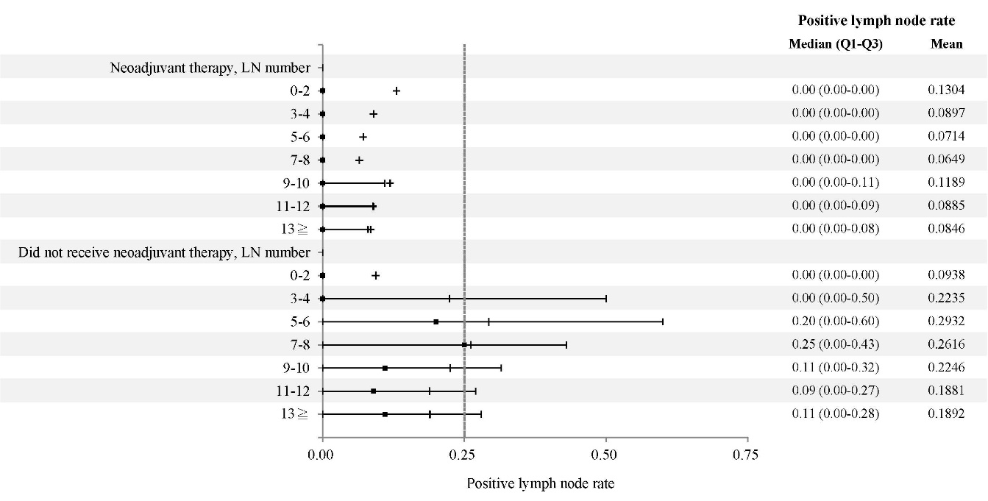
Supplementary Figure 1. The change of positive node rate between different lymph node (LN) number harvests in rectal cancer patients receiving neoadjuvant therapy or not.

