Supplementary material-Computer simulation inspection efficiency
Simulation of the number of female samples (95 cases)
Power by sample size and effect
 | Odds ratio 1.55 | Odds ratio 1.66 | Odds ratio 2.63
N= 50 | 0.242 | 0.280 | 0.755
N= 100 | 0.443 | 0.520 | 0.978
N= 150 | 0.603 | 0.715 | 0.997
N= 200 | 0.722 | 0.836 | 1.000
N= 250 | 0.796 | 0.898 | 1.000
Parameters: Incidence of osteoporosis in female T2DM: 0.158, HOMA-IR (CP) mean: 3.41, standard deviation: 1.11
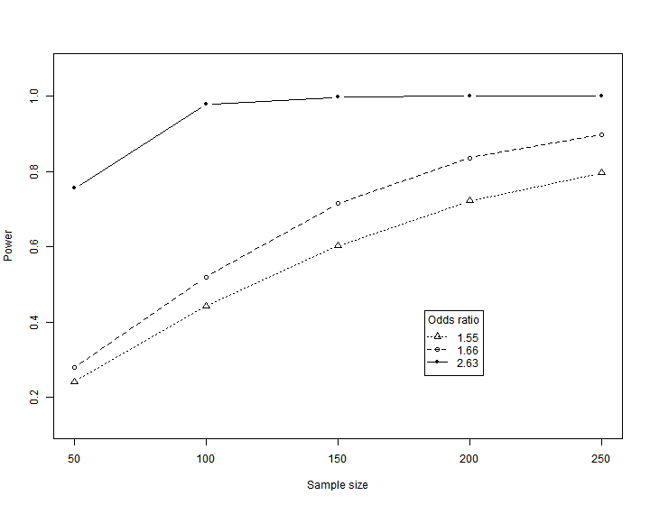
Simulation of the number of male samples (139 cases)
Power by sample size and effect
 | Odds ratio 0.74 | Odds ratio 0.80 | Odds ratio 0.86
N= 100 | 0.295 | 0.186 | 0.111
N= 150 | 0.445 | 0.249 | 0.134
N= 250 | 0.640 | 0.383 | 0.222
N= 400 | 0.843 | 0.580 | 0.328
N= 600 | 0.953 | 0.766 | 0.472
Parameters: Incidence of osteoporosis in male T2DM: 0.137, HOMA-IR (CP) mean: 3.57, standard deviation: 1.43
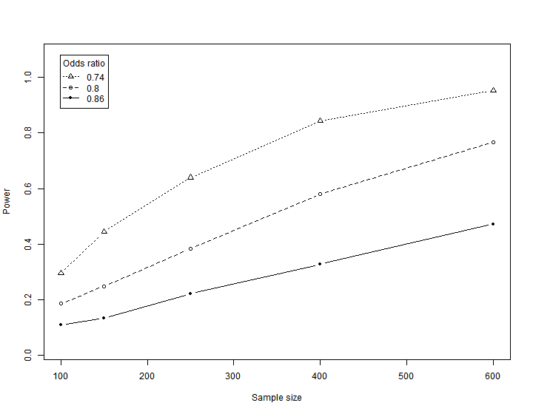

Supplementary Table S1: Comparison of clinical data of T2DM patients with and without BMD data
 | Patients missing BMD data | Patients with available BMD data | P-value
N | 311 | 250
Age | 57.70 ± 13.37 | 57.35 ± 11.02 | 0.735
Gender (male) | 183 (58.8%) | 148 (59.2%) | 0.932
BMI (kg/m²) | 24.4 ± 3.6 | 24.9 ± 3.9 | 0.176
Waist-to-hip ratio | 0.92 ± 0.06 | 0.92 ± 0.06 | 0.327
Disease course (years) | 7.0 (1.0-10.5) | 7.0 (1.0-10.0) | 0.537
Fasting blood-glucose (mmol/L) | 8.50 ± 2.58 | 8.63 ± 2.41 | 0.548
Fasting C-peptide (pmol/L) | 1.69 (1.20-2.33) | 1.72 (1.16-2.39) | 0.808
HOMA-IR (CP) | 3.38 ± 1.15 | 3.49 ± 1.31 | 0.281
HOMA-islet (CP-DM) | 32.78 (20.25-58.73) | 32.62 (19.66-58.65) | 0.653
HbA1c (%) | 9.73 ± 2.87 | 9.84 ± 4.41 | 0.715
Uric acid (μmol/L) | 292.30 ± 91.73 | 303.80 ± 93.55 | 0.154
Total cholesterol (mmol/L) | 4.53 ± 1.16 | 4.62 ± 1.13 | 0.345
Triacylglycerol (mmol/L) | 1.79 (1.25-2.45) | 1.83 (1.28-2.71) | 0.290
High-density lipoprotein (mmol/L) | 1.05 ± 0.25 | 1.03 ± 0.26 | 0.251
Low-density lipoprotein (mmol/L) | 2.38 ± 0.73 | 2.46 ± 0.80 | 0.280
Note: the data are expressed as Mean ± SD / Median (Q1 - Q3) / N (%). BMI, body mass index; HOMA-IR (CP), homeostasis model assessment for insulin resistance based on C-peptide; HOMA-islet (CP-DM), homeostasis model assessment islet beta-cell function based on C-peptide; HbA1c, hemoglobin A1c.

