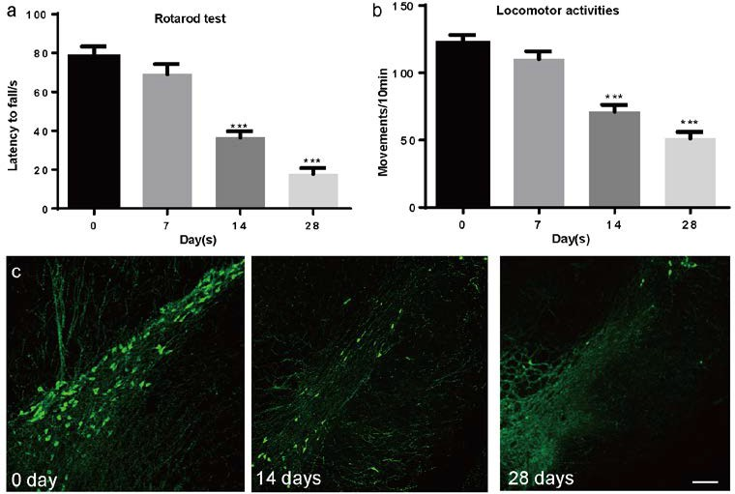

Supplementary Figure 1. Motor deficits and pathological changes in rotenone model of PD. (a-b) Rats showed motor symptoms after 2 weeks of rotenone treatments, including(a) reduced rotarod fall latency and (b) locomotor activities in the open field test. (c)Progressive decrease in tyrosine hydroxylase expression in the substantia nigra pars compacta. n = 6, *: P<0.05, **: P<0.01, ***: P<0.001, one-way ANOVA with Tukey’s test.

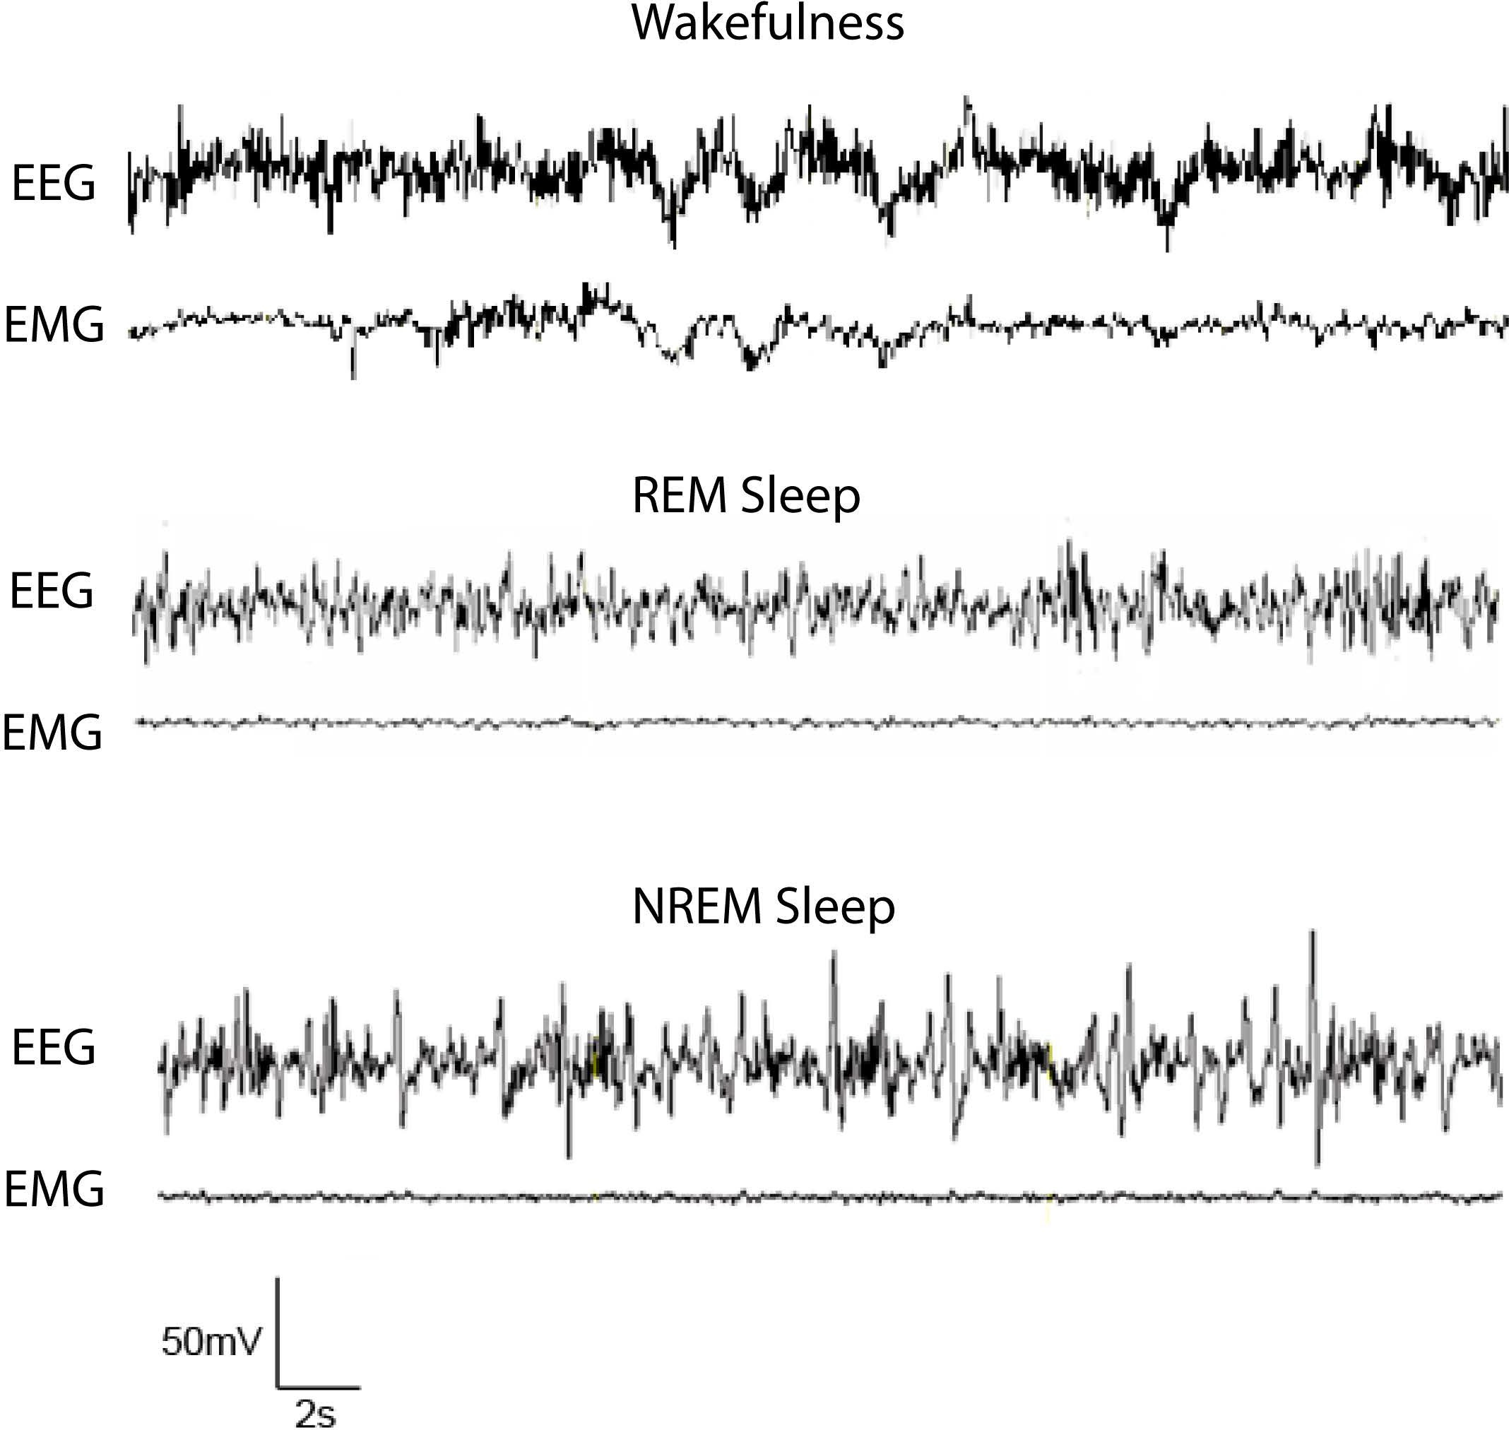
Supplementary Figure 2. Typical EEG and EMG traces of vigilance states. Rat vigilance states were identified as wakefulness, REM sleep and NREM sleep in each 10s recording segment. Wakefulness segments were typically associated with low-amplitude EEG and active EMG. REM sleep segments have relatively low amplitude EEG and low EMG activities. NREM sleep typically exhibits high-amplitude or spindle rhythm in EEG with low EMG activities.

