OB_ELISA
Tests of Normality
 | Group | Kolmogorov-Smirnovª |  |  | Shapiro-Wilk
 | Group | Statistic | df | Sig. | Statistic | df | Sig.
OB_ELISA | OB | .178 | 8 | .200* | .937 | 8 | .577
OB_ELISA | OVX | .182 | 8 | .200* | .939 | 8 | .600
OB_ELISA | Sham | .232 | 8 | .200* | .836 | 8 | .068
*. This is a lower bound of the true significance.
a. Lilliefors Significance Correction

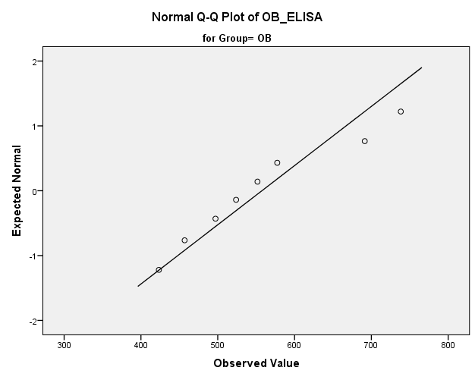

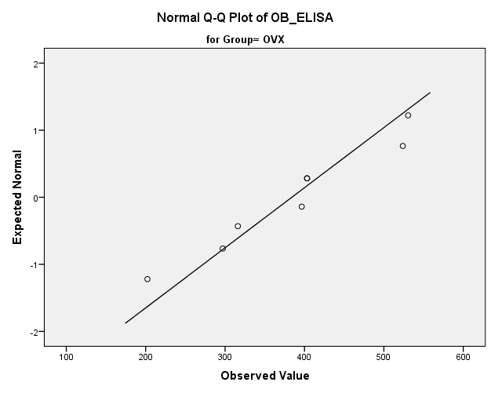

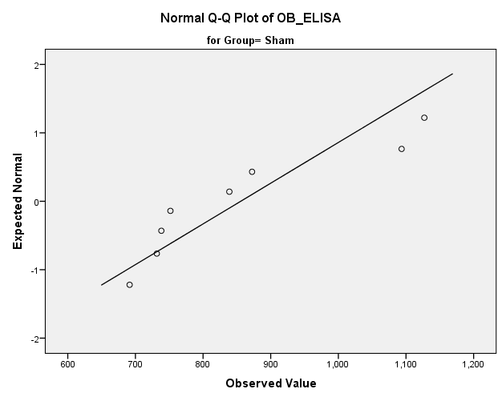

OB-section

Tests of Normality
 | Group | Kolmogorov-Smirnovª |  |  | Shapiro-Wilk
 | Group | Statistic | df | Sig. | Statistic | df | Sig.
OB_section | OB | .258 | 8 | .126 | .871 | 8 | .153
OB_section | OVX | .232 | 8 | .200* | .935 | 8 | .566
OB_section | Sham | .252 | 8 | .145 | .901 | 8 | .294
*. This is a lower bound of the true significance.
a. Lilliefors Significance Correction

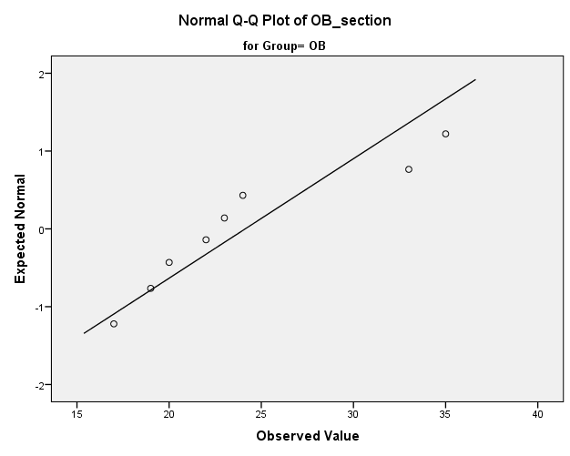

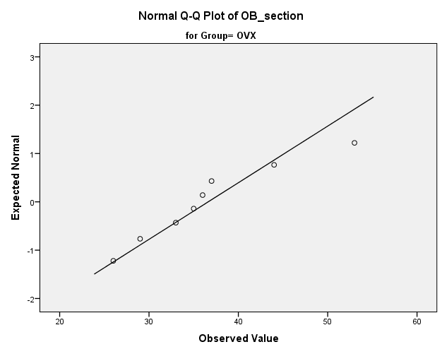

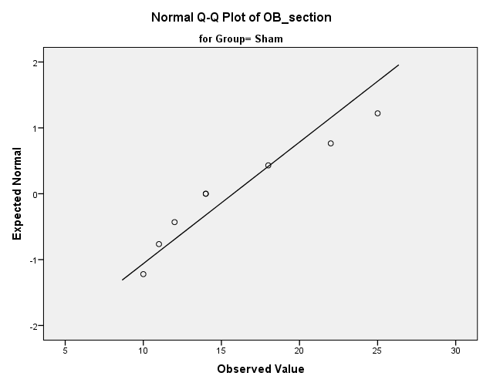

OB-uCT

Tests of Normality
 | Group | Kolmogorov-Smirnovª |  |  | Shapiro-Wilk
 | Group | Statistic | df | Sig. | Statistic | df | Sig.
OB_uCT | OB | .284 | 8 | .057 | .782 | 8 | .019
OB_uCT | OVX | .205 | 8 | .200* | .898 | 8 | .278
OB_uCT | Sham | .255 | 8 | .134 | .860 | 8 | .121
*. This is a lower bound of the true significance.
a. Lilliefors Significance Correction

