Supporting Information for
(2Z)-3-hydroxy-3-(4-R-phenyl)-prop-2-enedithioic acids as new antituberculosis compounds.

Gustavo Pretelín-Castillo¹, Mayra Silva Miranda², Clara Espitia³, Rosa María Chávez-Santos¹, Abel Suárez-Castro⁴, Luis Chacón-García⁴, Rodrigo Aguayo-Ortiz⁵, and Roberto Martínez^{1,}*
¹ Instituto de Química, Universidad Nacional Autónoma de México, Circuito Exterior, Ciudad Universitaria, 04510, Cd. México, México
² Catedrática CONACYT adscrita al Instituto de Investigaciones Biomédicas, Universidad Nacional Autónoma de México, Ciudad Universitaria, 04510, Cd. México, México
³ Instituto de Investigaciones Biomédicas Departamento de Inmunología, Universidad Nacional Autónoma de México, Ciudad Universitaria, 04510, Cd. México, México
⁴ Instituto de Investigaciones Químico-Biológicas, Universidad Michoacana de San Nicolás de Hidalgo, Edificio B-1, Ciudad Universitaria, 58030, Morelia Michoacán, México
⁵ Departamento de Farmacia, Facultad de Química, Universidad Nacional Autónoma de México, Circuito Exterior, Ciudad Universitaria, 04510, Cd. México, México.

✉ Roberto Martínez
robmar@unam.mx

Spectral Data

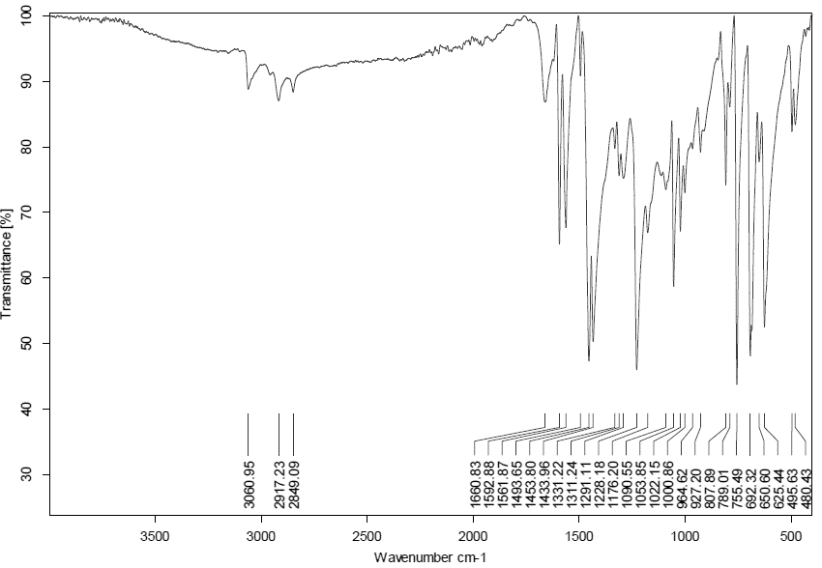

Figure 1. IR (ATR) spectra of (2Z)-3-hydroxy-3-phenylprop-2-enedithioic acid (11a)
Figure 2. ¹H NMR (300 MHz, CDCl₃) of (2Z)-3-hydroxy-3-phenylprop-2-enedithioic acid (11a)
Figure 3. ¹³C NMR (75 MHz, CDCl₃) of (2Z)-3-hydroxy-3-phenylprop-2-enedithioic acid (11a)
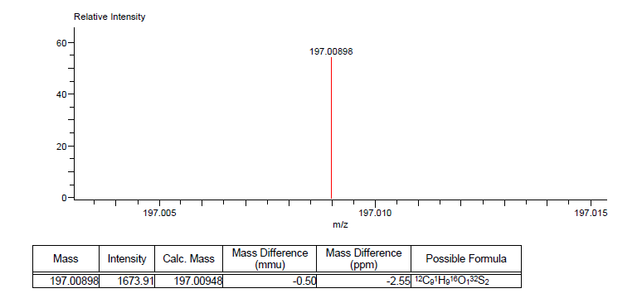
Figure 4. High Resolution Mass Spectra of (2Z)-3-hydroxy-3-phenylprop-2-enedithioic acid (11a)

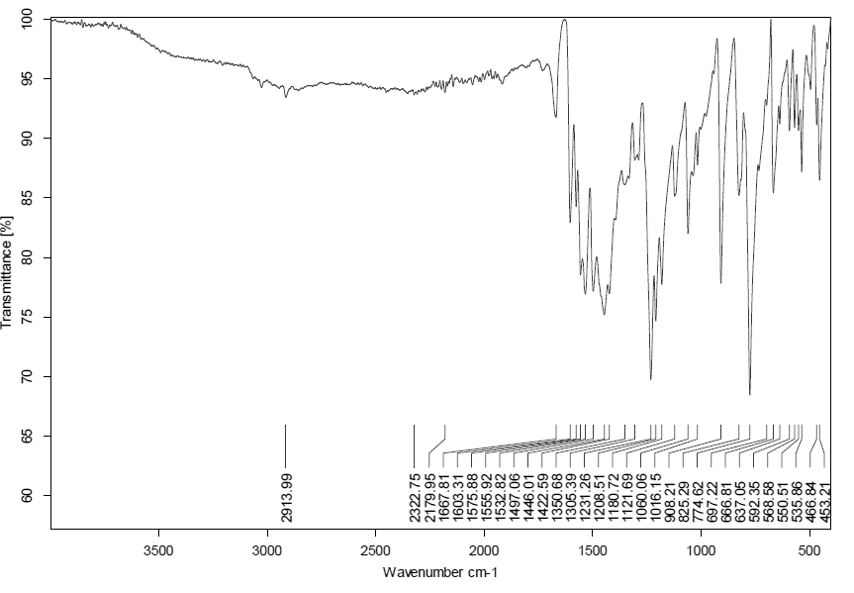
Figure 5. IR (ATR) spectra of (Z)-3-hydroxy-3-(p-methylphenyl)-prop-2-enedithioic acid (11b)

Figure 6. ¹H NMR (300 MHz, CDCl₃) of (Z)-3-hydroxy-3-(p-methylphenyl)-prop-2-enedithioic acid (11b)
Figure 7. ¹³C NMR (75 MHz, CDCl₃) of (Z)-3-hydroxy-3-(p-methylphenyl)-prop-2-enedithioic acid (11b)
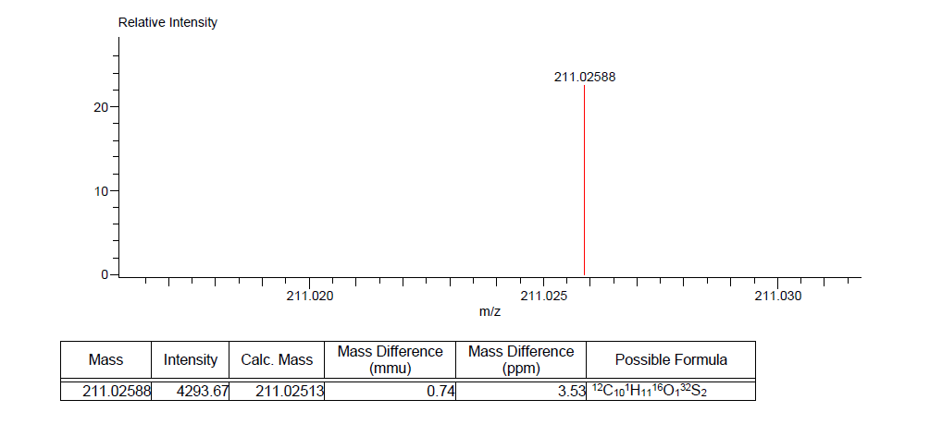
Figure 8. High Resolution Mass Spectra of (Z)-3-hydroxy-3-(p-methylphenyl)-prop-2-enedithioic acid (11b)

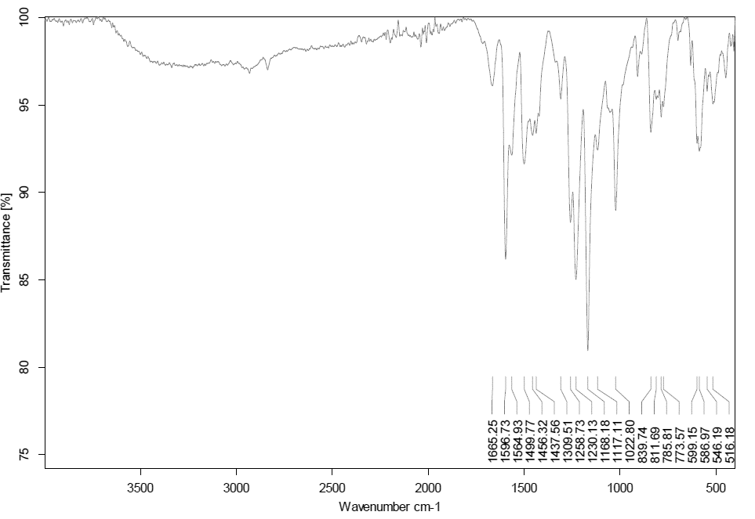
Figure 9. IR (ATR) spectra of (2Z)-3-hydroxy-3-(4-methoxyphenyl)-prop-2-enedithioic acid (11c)

Figure 10. ¹H NMR (300 MHz, CDCl₃) of (2Z)-3-hydroxy-3-(4-methoxyphenyl)-prop-2-enedithioic acid (11c)
Figure 11. ¹³C NMR (75 MHz, CDCl₃) of (2Z)-3-hydroxy-3-(4-methoxyphenyl)-prop-2-enedithioic acid (11c)

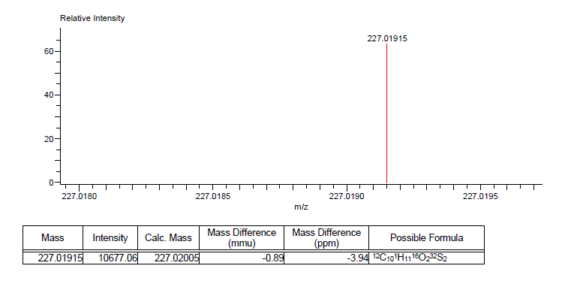
Figure 12. High Resolution Mass Spectra of (2Z)-3-hydroxy-3-(4-methoxyphenyl)-prop-2-enedithioic acid (11c)

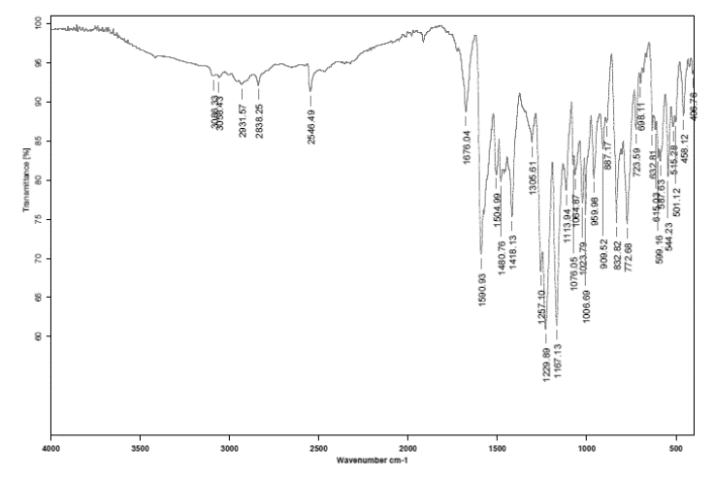
Figure 13. IR (ATR) spectra of (2Z)-3-hydroxy-3-(4-hydroxyphenyl)-prop-2-enedithioic acid (11d)

Figure 14. ¹H NMR (300 MHz, CDCl₃) of (2Z)-3-hydroxy-3-(4-hydroxyphenyl)-prop-2-enedithioic acid (11d)
Figure 15. ¹³C NMR (75 MHz, CDCl₃) of (2Z)-3-hydroxy-3-(4-hydroxyphenyl)-prop-2-enedithioic acid (11d)

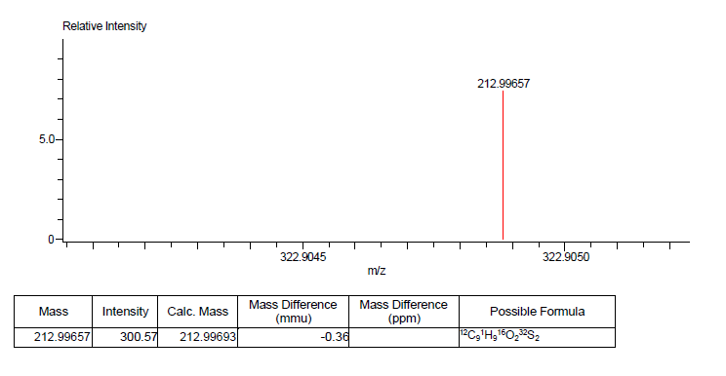
Figure 16. High Resolution Mass Spectra of (2Z)-3-hydroxy-3-(4-hydroxyphenyl)-prop-2-enedithioic acid (11d)
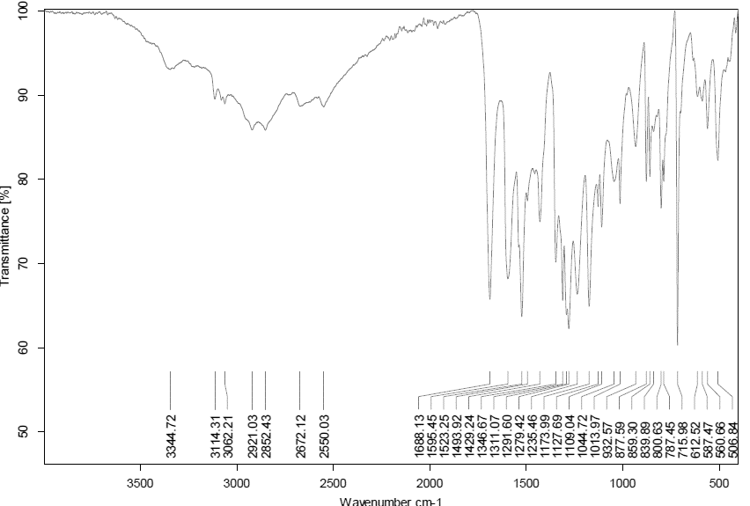
Figure 17. IR (ATR) spectra of (2Z)-3-hydroxy-3-(4-nitrophenyl)-prop-2-enedithioic acid (11e)

Figure 18. ¹H NMR (300 MHz, CDCl₃) of (2Z)-3-hydroxy-3-(4-nitrophenyl)-prop-2-enedithioic acid (11e)

Figure 19. ¹³C NMR (75 MHz, CDCl₃) of (2Z)-3-hydroxy-3-(4-nitrophenyl)-prop-2-enedithioic acid (11e)

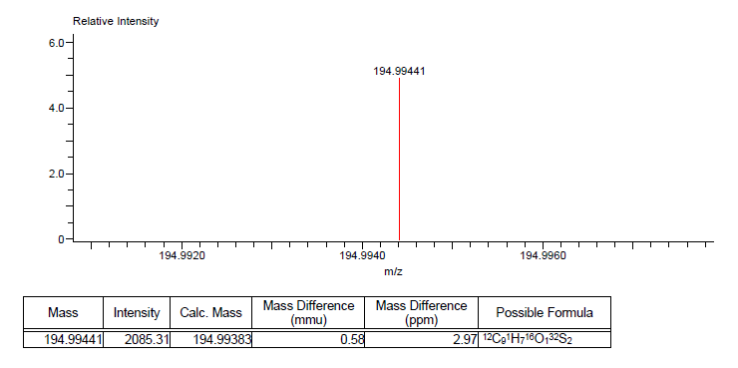
Figure 20. High Resolution Mass Spectra of (2Z)-3-hydroxy-3-(4-nitrophenyl)-prop-2-enedithioic acid (11e)

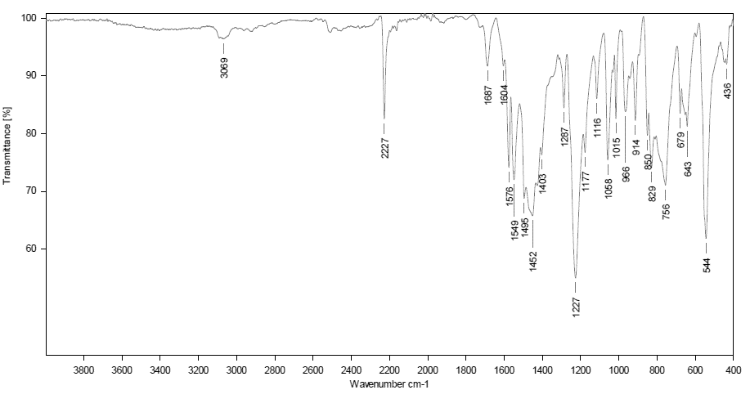
Figure 21. IR (ATR) spectra of (2Z)-3-(4-cyanophenyl)-3-hydroxyprop-2-enedithioic acid (11f)

Figure 22. ¹H NMR (300 MHz, CDCl₃) of (2Z)-3-(4-cyanophenyl)-3-hydroxyprop-2-enedithioic acid (11f)

Figure 23. ¹³C NMR (75 MHz, CDCl₃) of (2Z)-3-(4-cyanophenyl)-3-hydroxyprop-2-enedithioic acid (11f)

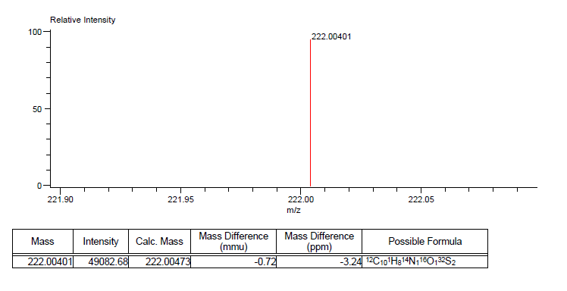
Figure 24. High Resolution Mass Spectra of (2Z)-3-(4-cyanophenyl)-3-hydroxyprop-2-enedithioic acid (11f)

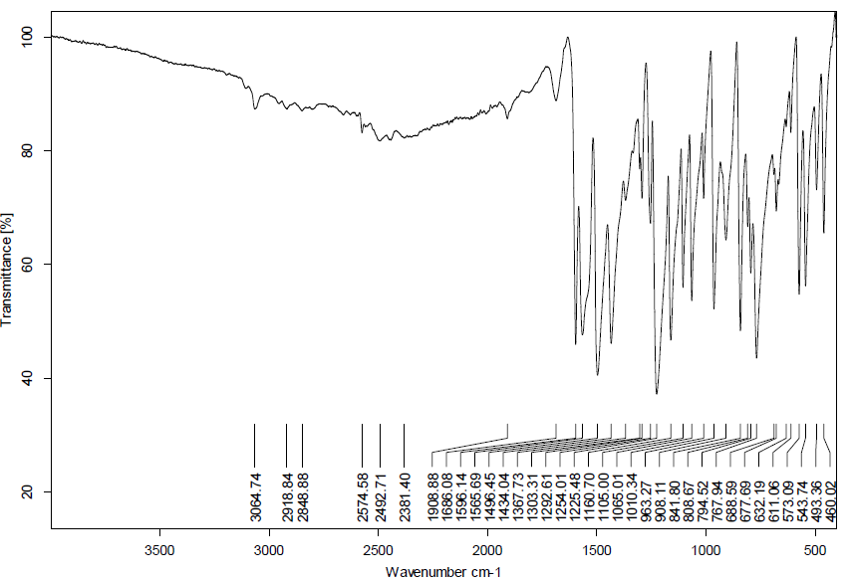
Figure 25. IR (ATR) spectra of (2Z)-3-(4-fluorophenyl)-3-hydroxyprop-2-enedithioic acid (11g)

Figure 26. ¹H NMR (300 MHz, CDCl₃) of (2Z)-3-(4-fluorophenyl)-3-hydroxyprop-2-enedithioic acid (11g)
Figure 27. ¹³C NMR (75 MHz, CDCl₃) of (2Z)-3-(4-fluorophenyl)-3-hydroxyprop-2-enedithioic acid (11g)

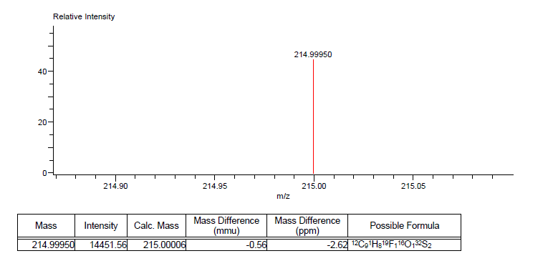
Figure 28. High Resolution Mass Spectra of (2Z)-3-(4-fluorophenyl)-3-hydroxyprop-2-enedithioic acid (11g)

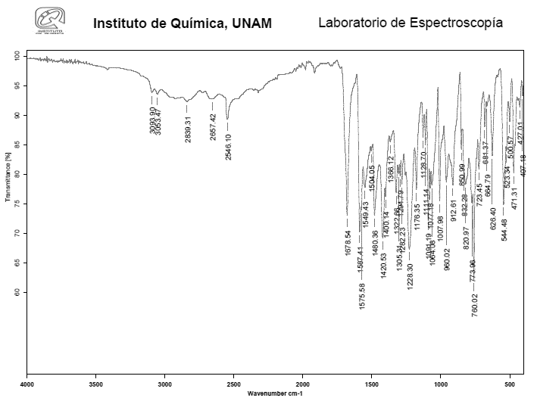
Figure 29. IR (ATR) spectra of (2Z)-3-(4-chlorophenyl)-3-hydroxyprop-2-enedithioic acid (11h)
Figure 30. ¹H NMR (300 MHz, CDCl₃) of (2Z)-3-(4-chlorophenyl)-3-hydroxyprop-2-enedithioic acid (11h)
Figure 31. ¹³C NMR (75 MHz, CDCl₃) of (2Z)-3-(4-chlorophenyl)-3-hydroxyprop-2-enedithioic acid (11h)

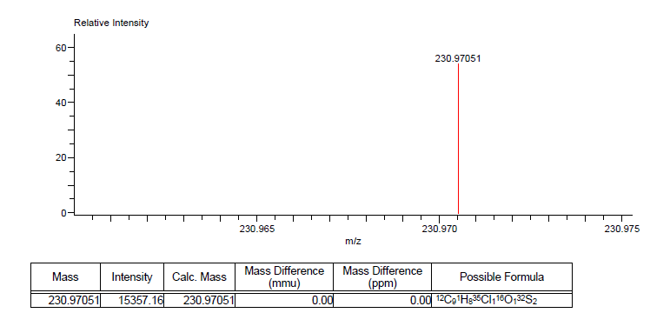
Figure 32. High Resolution Mass Spectra of (2Z)-3-(4-chlorophenyl)-3-hydroxyprop-2-enedithioic acid (11h)

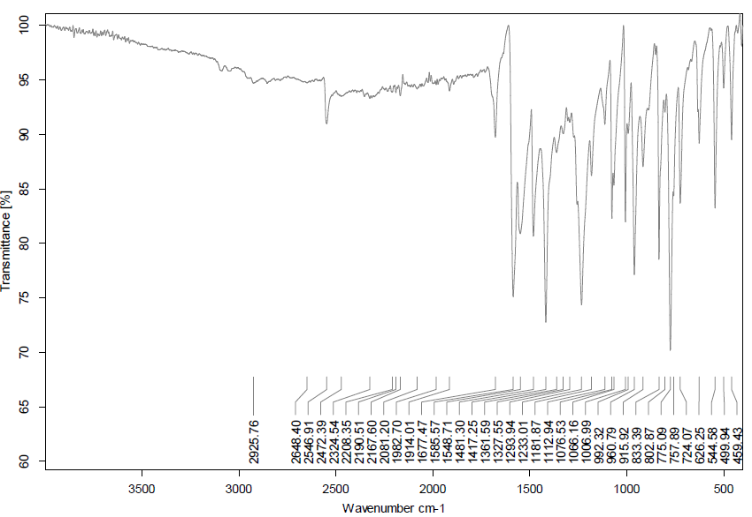
Figure 33. IR (ATR) spectra of (2Z)-3-(4-bromophenyl)-3-hydroxyprop-2-enedithioic acid (11i)

Figure 34. ¹H NMR (300 MHz, CDCl₃) of (2Z)-3-(4-bromophenyl)-3-hydroxyprop-2-enedithioic acid (11i)

Figure 35. ¹³C NMR (75 MHz, CDCl₃) of (2Z)-3-(4-bromophenyl)-3-hydroxyprop-2-enedithioic acid (11i)

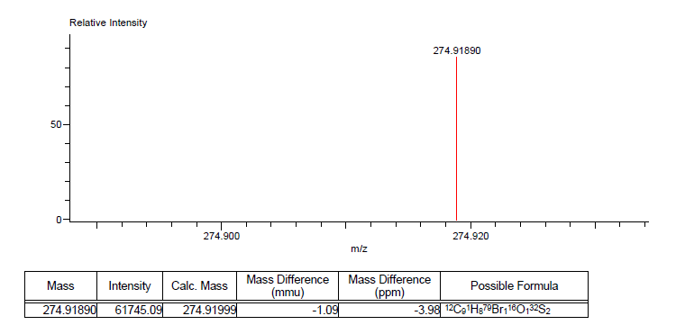
Figure 36. High Resolution Mass Spectra of (2Z)-3-(4-bromophenyl)-3-hydroxyprop-2-enedithioic acid (11i)

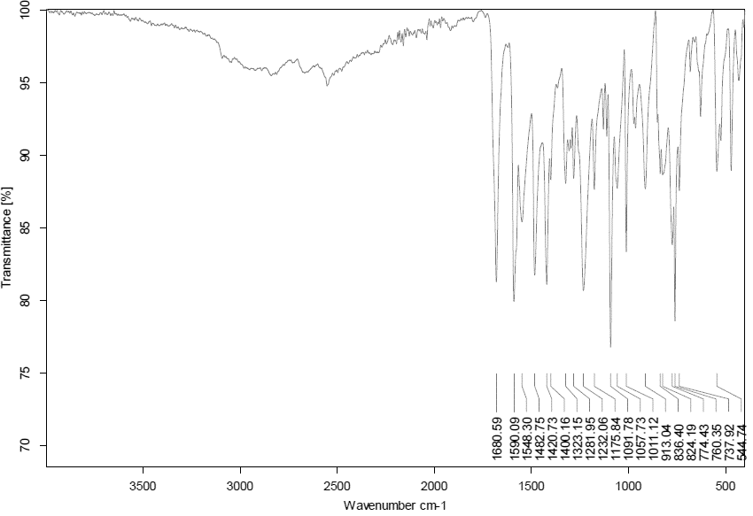
Figure 37. IR (ATR) spectra of (2Z)-3-(4-iodophenyl)-3-hydroxyprop-2-enedithioic acid (11j)

Figure 38. ¹H NMR (300 MHz, CDCl₃) of (2Z)-3-(4-iodophenyl)-3-hydroxyprop-2-enedithioic acid (11j)

Figure 39. ¹³C NMR (75 MHz, CDCl₃) of (2Z)-3-(4-iodophenyl)-3-hydroxyprop-2-enedithioic acid (11j)

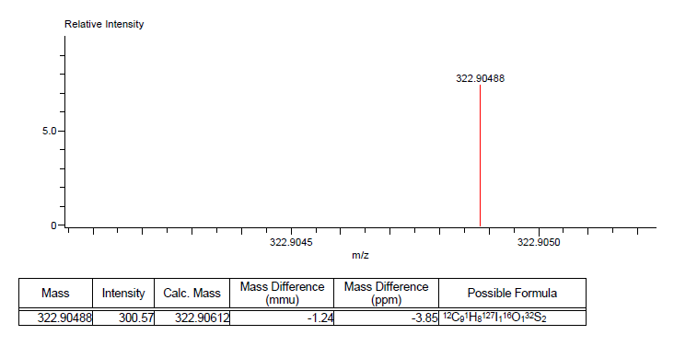
Figure 40. High Resolution Mass Spectra of (2Z)-3-(4-iodophenyl)-3-hydroxyprop-2-enedithioic acid (11j)

