Does the efficacy of high intensity ventilation in stable COPD depend on the ventilator model? A bench-to-bedside study.

Online - only supplement.

e-figure 1. Pressure time product at 300 and 500 msec. True values and percentage of “ideal values”.

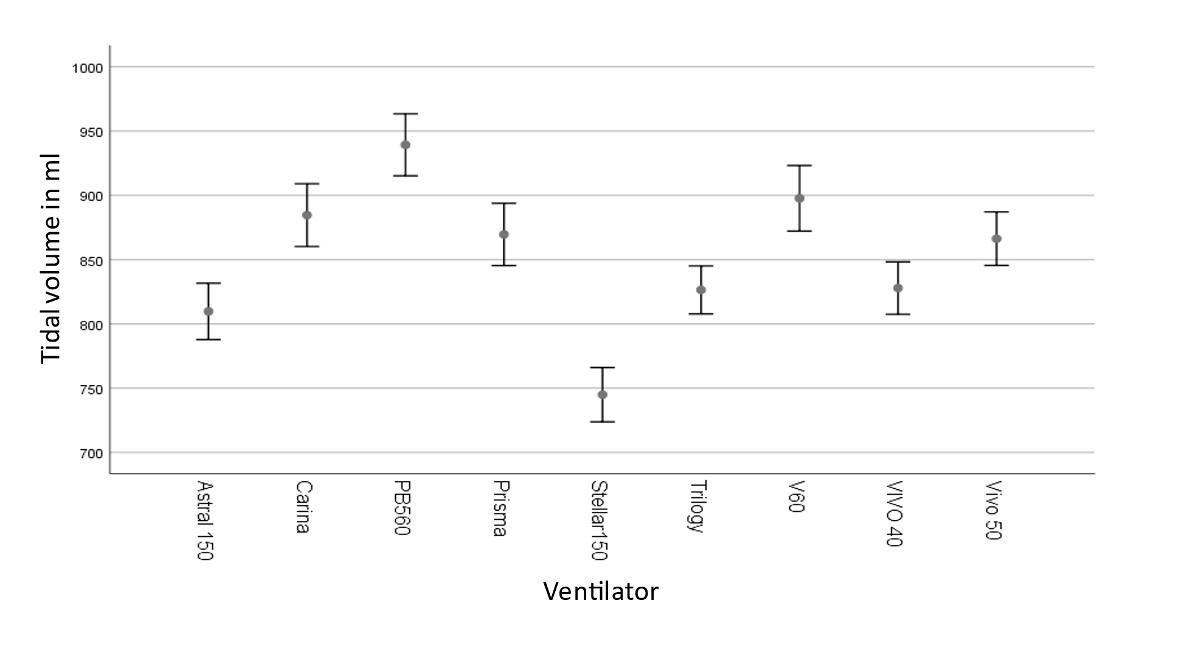

E-Figure 2. Mean tidal volume in ml for all conditions, bench test (p <0.01 ANOVA)

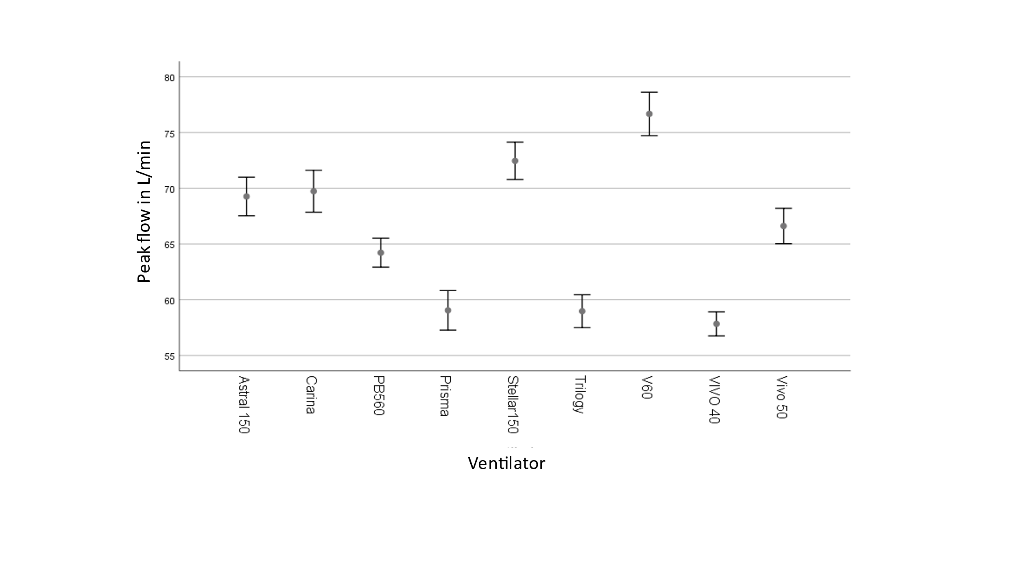

E-Figure 3. Maximum inspiratory flow in L / min for all conditions, bench test (p <0.01, ANOVA).

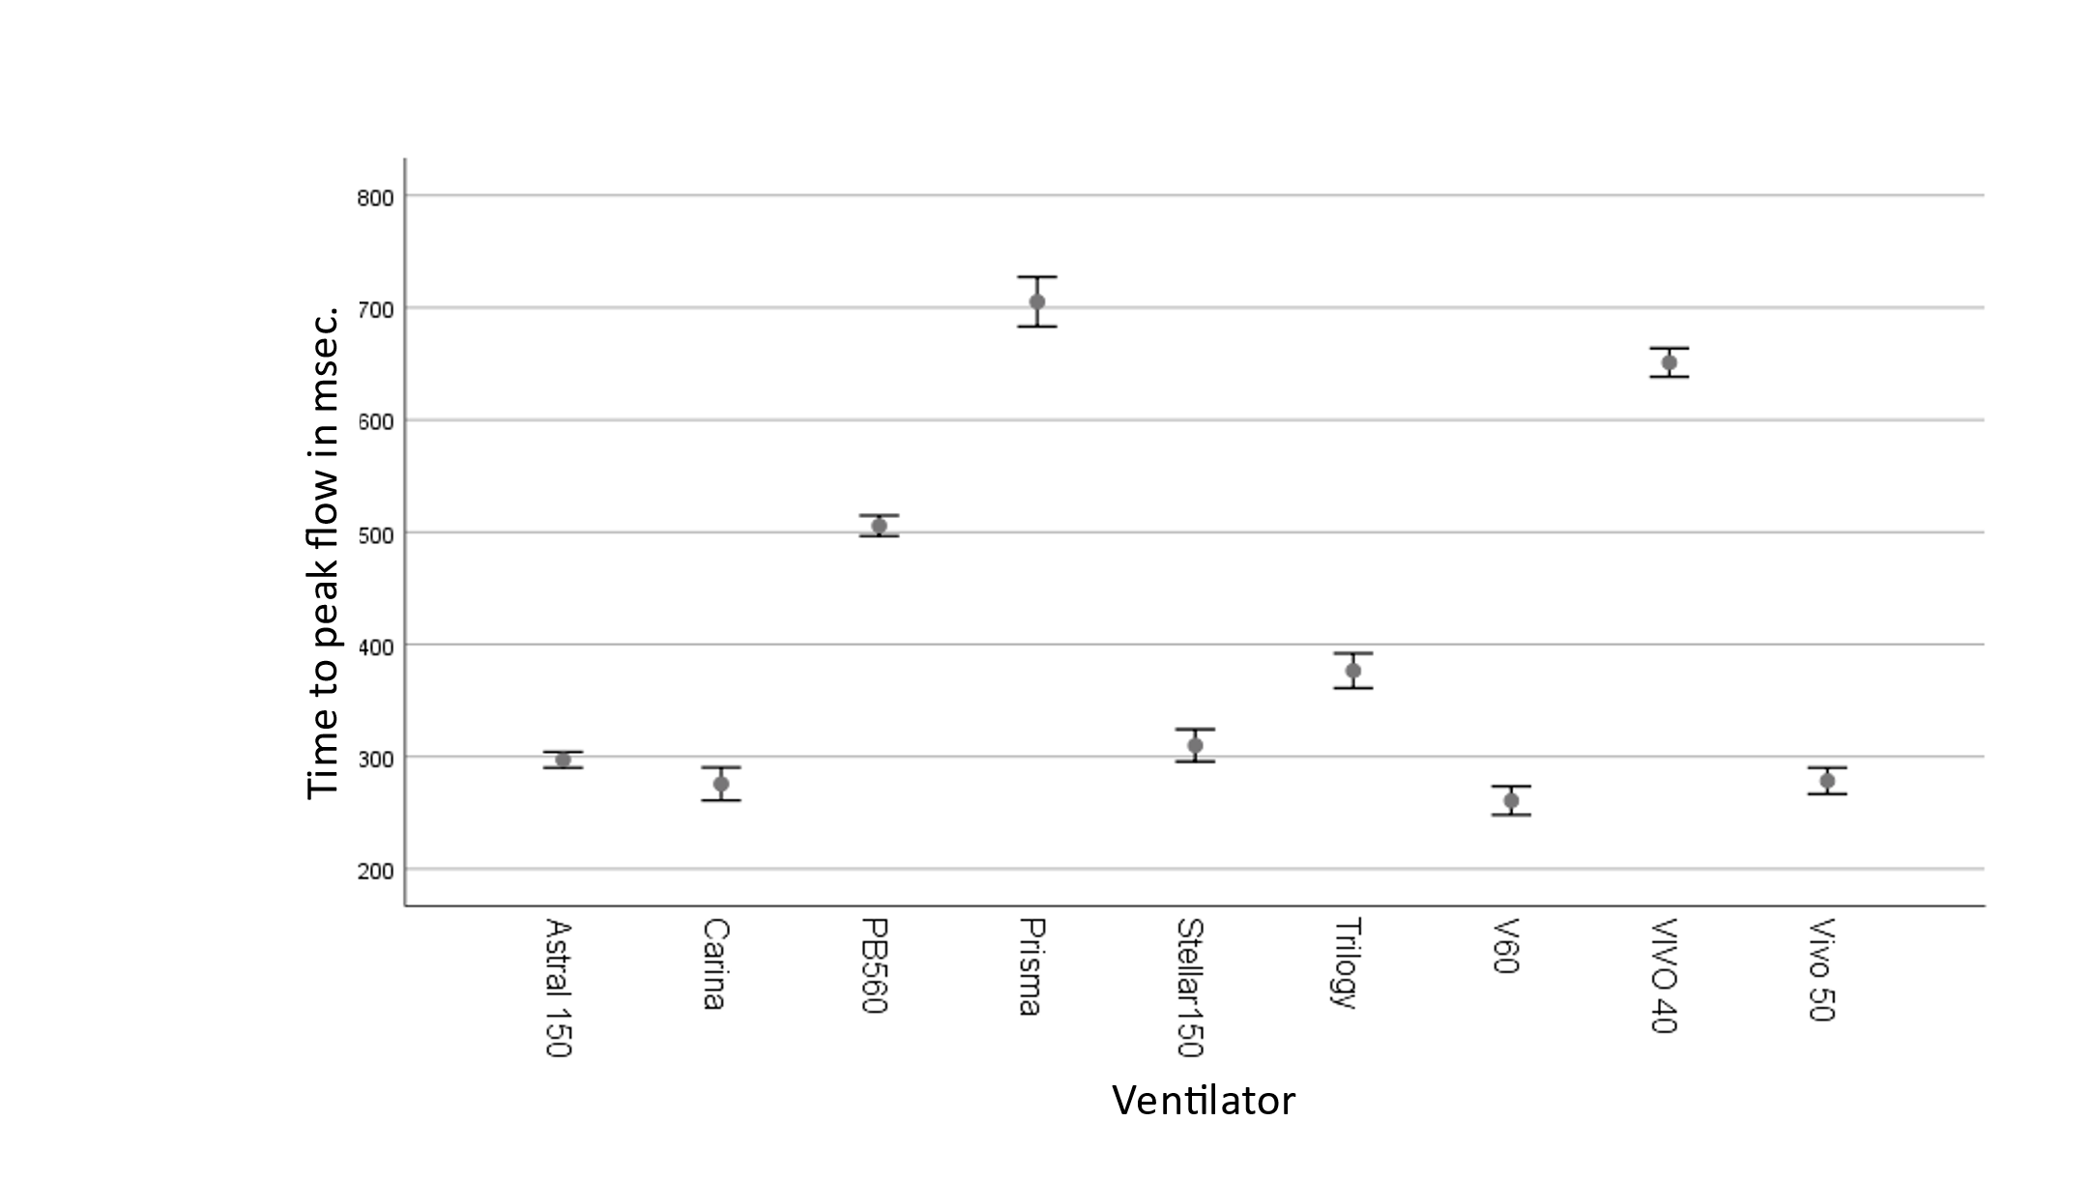

E-Figure 4 Time to maximum inspiratory flow in msec for all conditions, bench test (p <0.01, ANOVA)

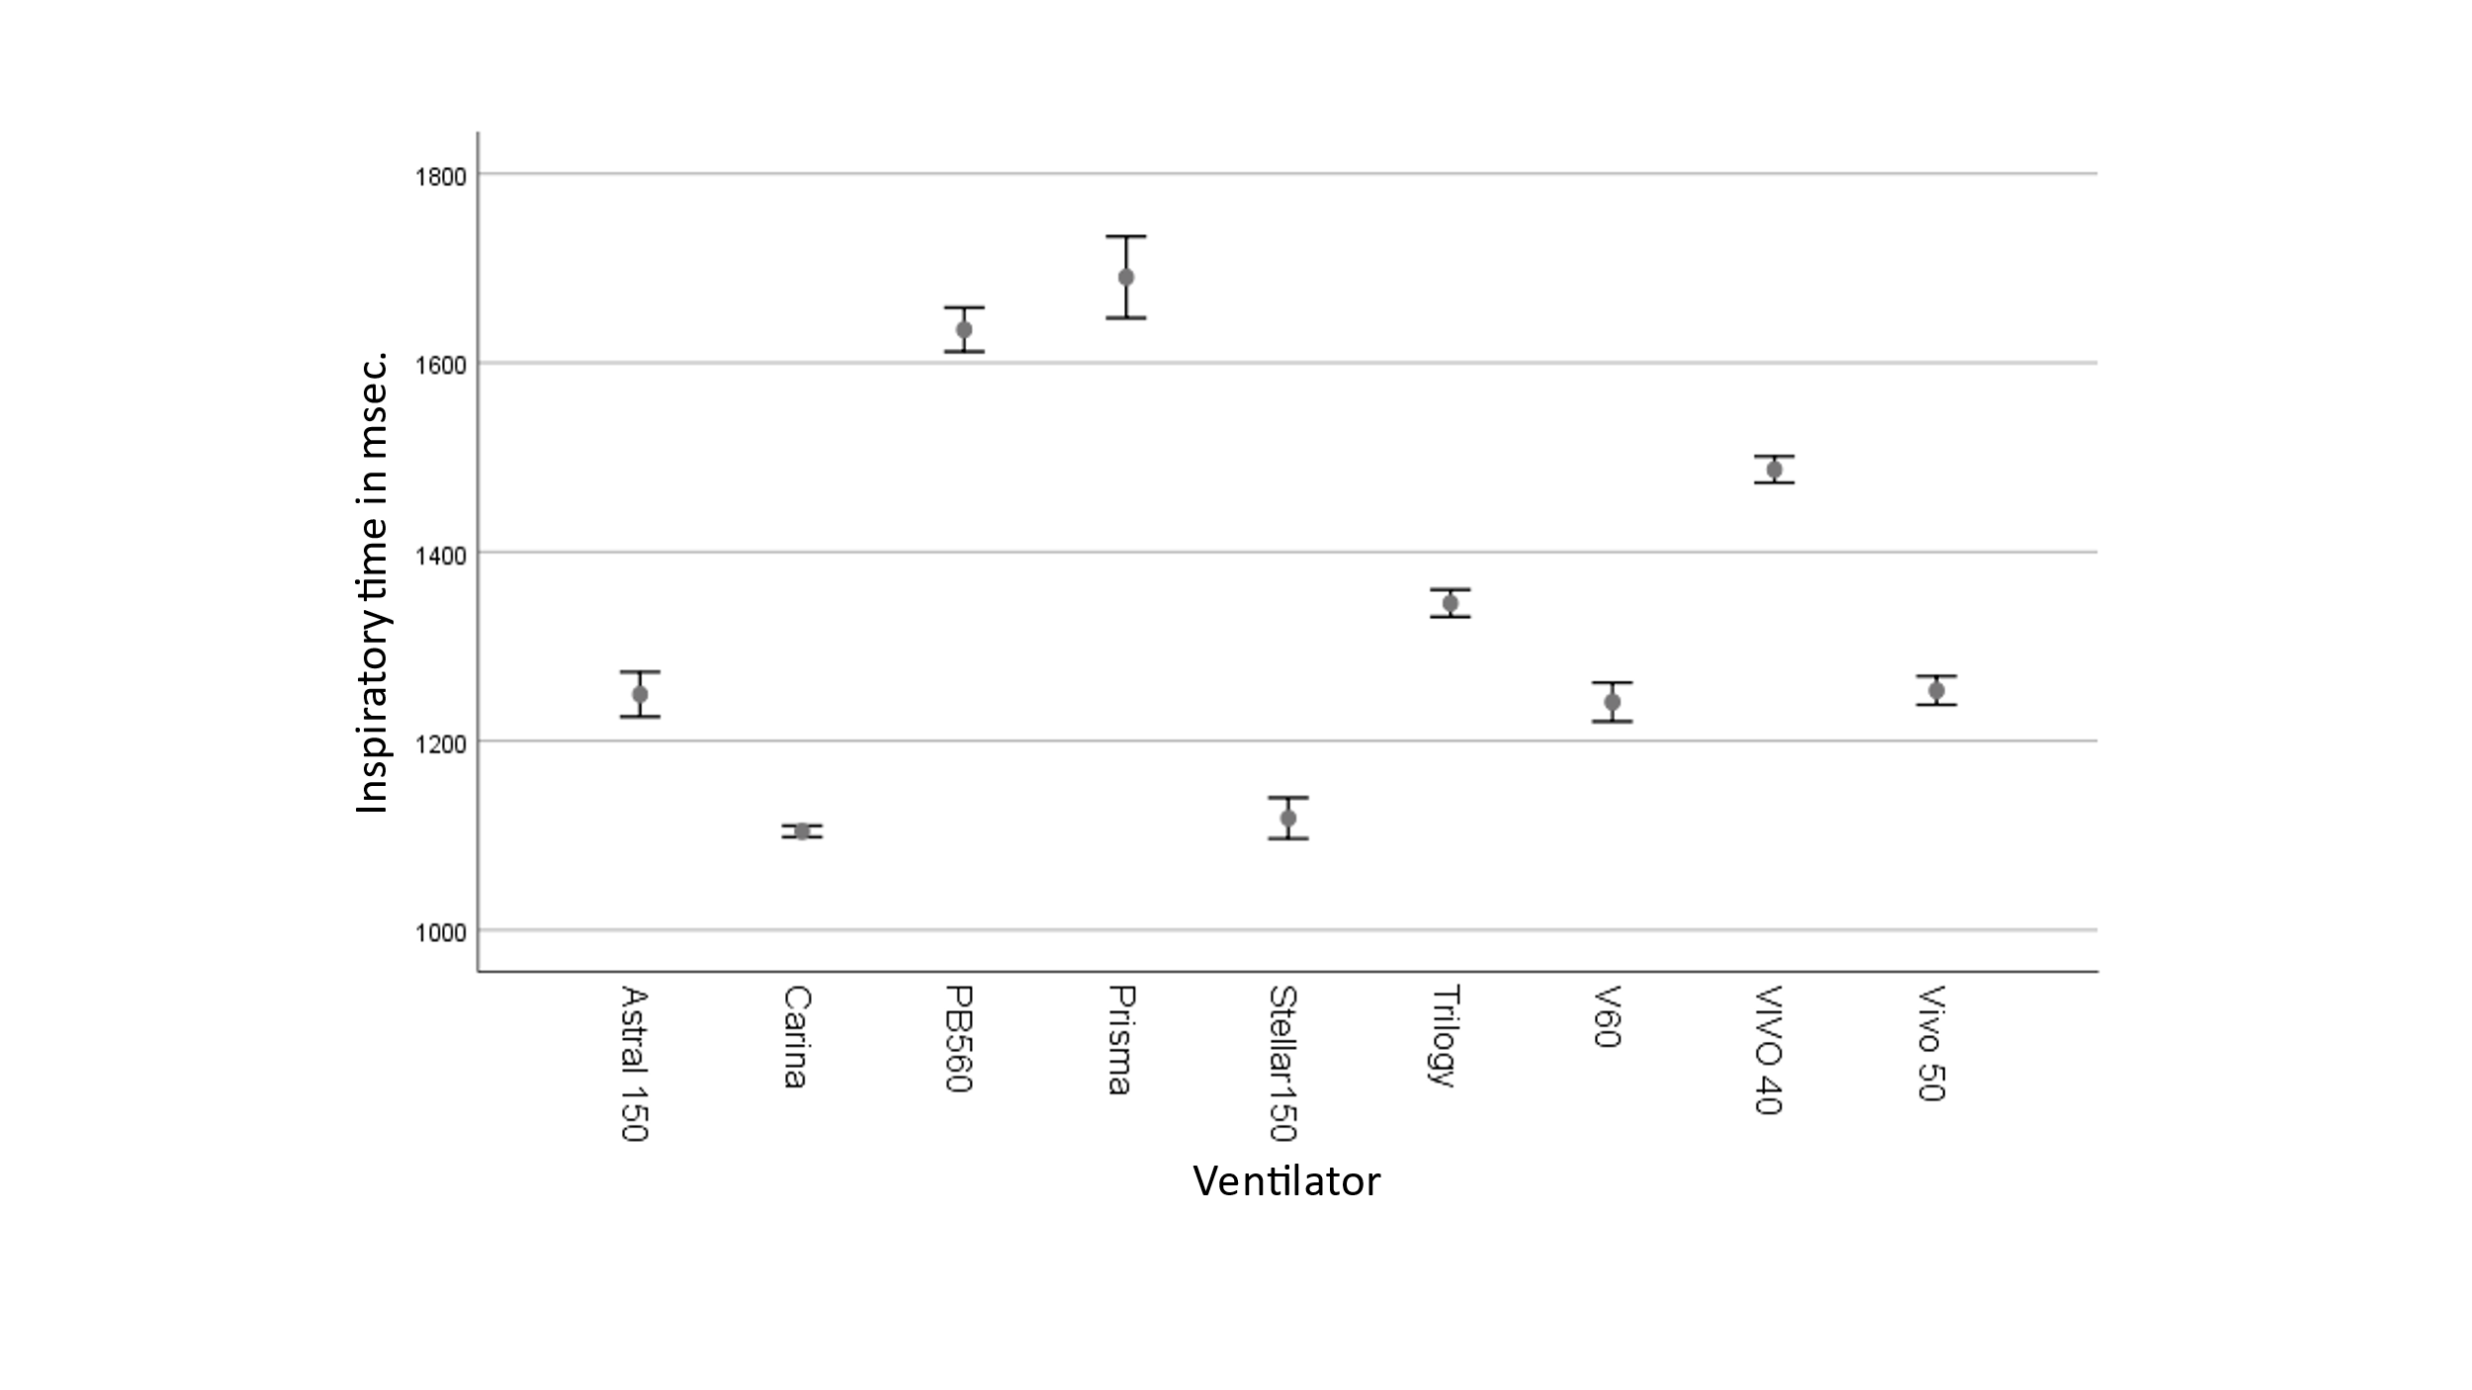
E-Figure 5. Inspiratory time in msec for all conditions, bench test (p <0.01, ANOVA)

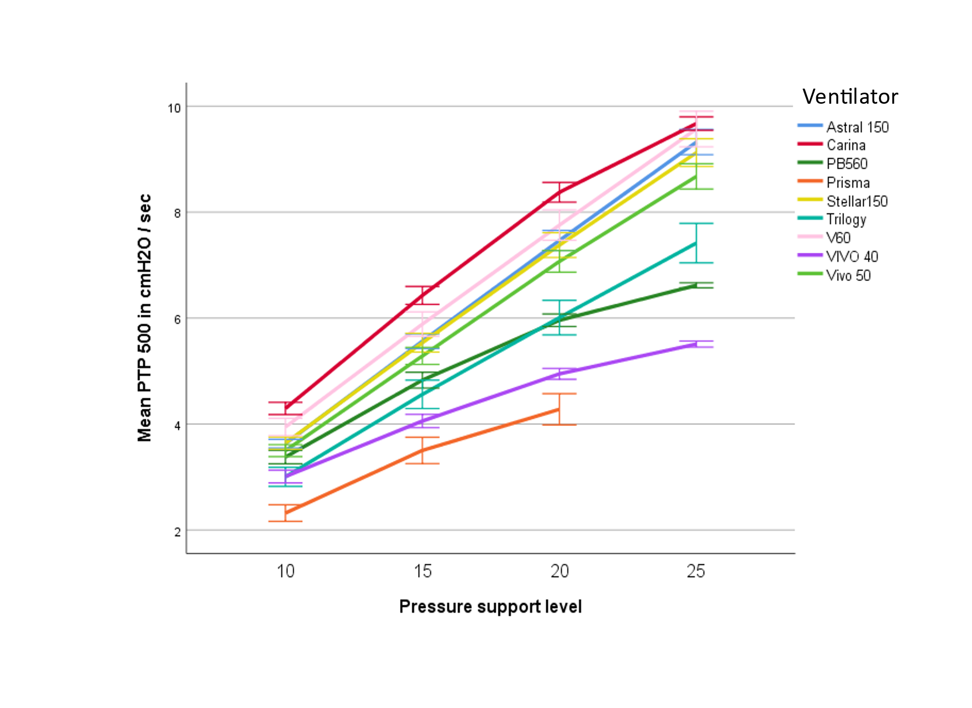
E-Figure 6. Absolute mean value of PTP 500 and PS level (p <0.01 between ventilator models, general linear model for repeated measures)

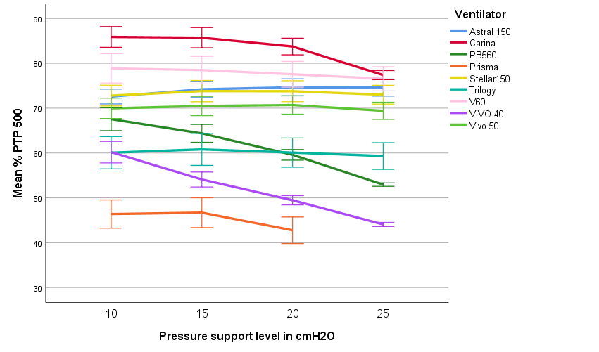
E-Figure 7. Percentage for each ventilator and ideal PTP 500 (p <0.01 between ventilator models, general linear model for repeated measures)

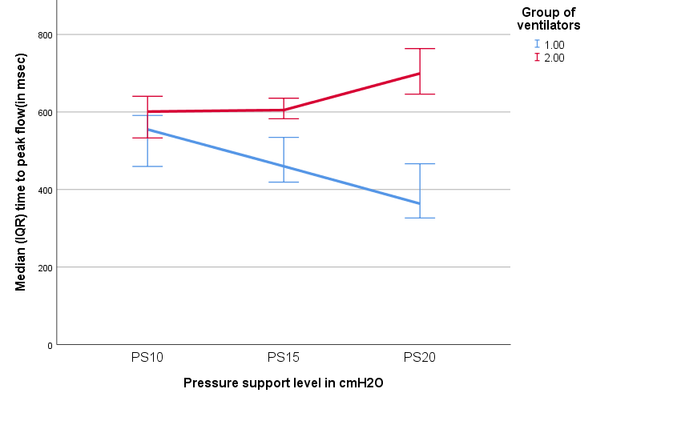

E-Figure 8. Time to peak flow for both groups of ventilators (p <0.01 between groups, Mann-Whitney U test).

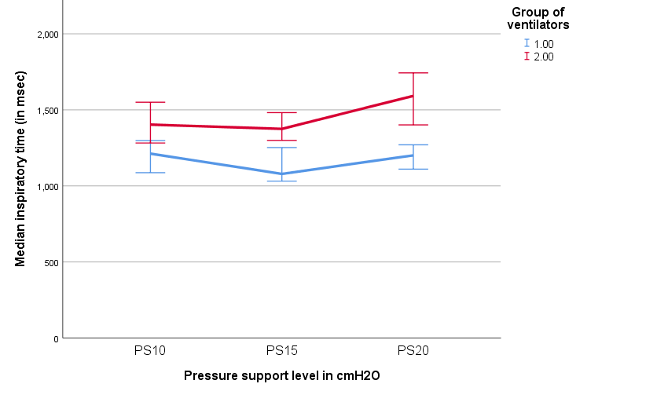

E-Figure 9. Inspiratory time for both groups of ventilators (p <0.01 between groups, Mann-Whitney U test).

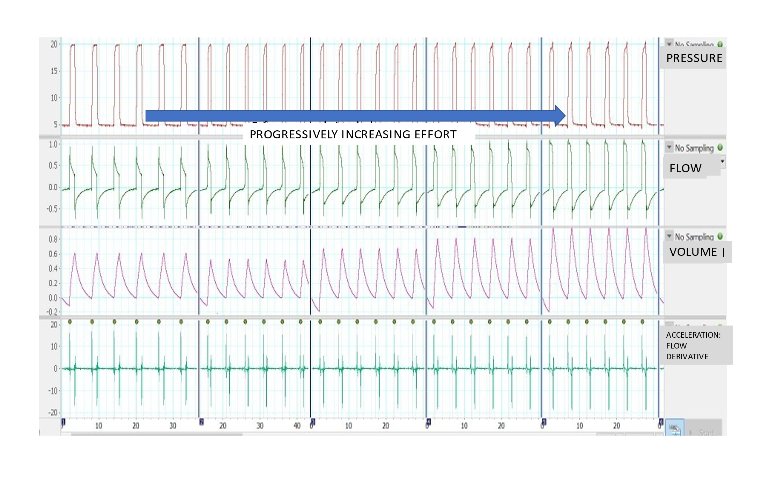
E-Figure 10 Semiological changes in some variables recorded in the bench test. Note that as the effort increases (the vertical lines represent progressively increasing efforts) there are changes in peak flow, volume, but not in the positive peak of acceleration (channel 4).

E-Figure 11. Example of different respiratory muscle unloading assessed by parasternal EMG. On the left of the figure, ventilator of group 1. On the right, ventilator of group 2.

