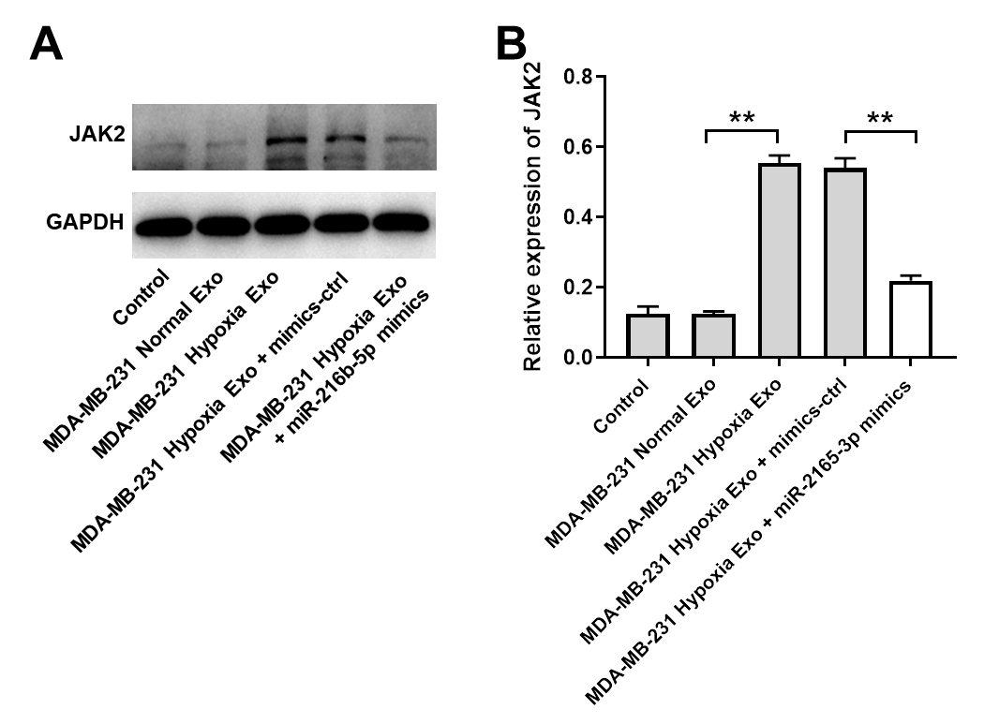
Supplementary Figure 1 Exosomes derived from hypoxic breast cancer cells upregulates JAK2 expression in HUVECs. (A, B) HUVECs were treated with indicated exosomes, exosomes + si-SNHG1-3, exosomes + mimics-ctrl or exosomes + miR-216b-5p mimics. Western blot analysis of JAK2 expression in HUVECs. **P<0.01; n = 3.

