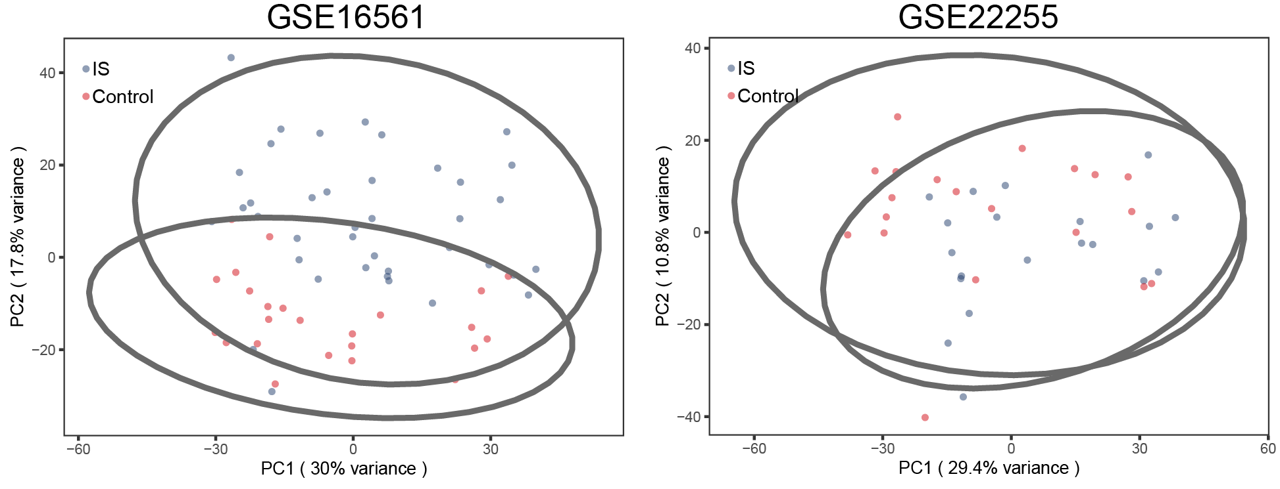
Supplementary Figure S1. Principal component analysis of ischemic stroke (IS) samples and control samples in the GSE16561 and GSE22255 datasets. PC, principal component.

