Supplementary file

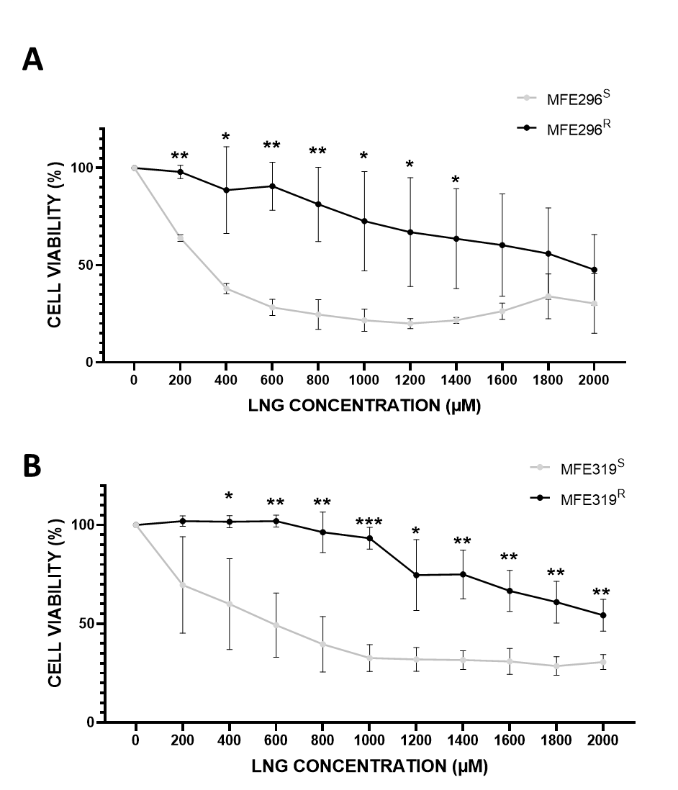
Supplementary Figure 1: Resistant cell lines have increased cell viability in comparison to the control cell lines when exposed to increasing doses of LNG.
CCK8 assay showing the difference in cell viability of A) MFE296^{S} (grey) and MFE296^{R} (black) and B) MFE319^{S} (grey) and MFE319^{R} (black) cell lines respectively after increasing LNG doses. Both resistant cell lines (MFE296^{R} and MFE319^{R}) have increased cell viability in comparison to the control cell lines (MFE296^{S} and MFE319^{S}) when exposed to increasing doses of LNG. Results are expressed as mean ± SD, experiments performed in triplicate (n=3). Individual groups were analysed using T-test. α = 0.05 is used as the minimum requirement to recognise statistical significance. Significance is shown via (*). * P <0.05, **P < 0.01, *** P < 0.001.
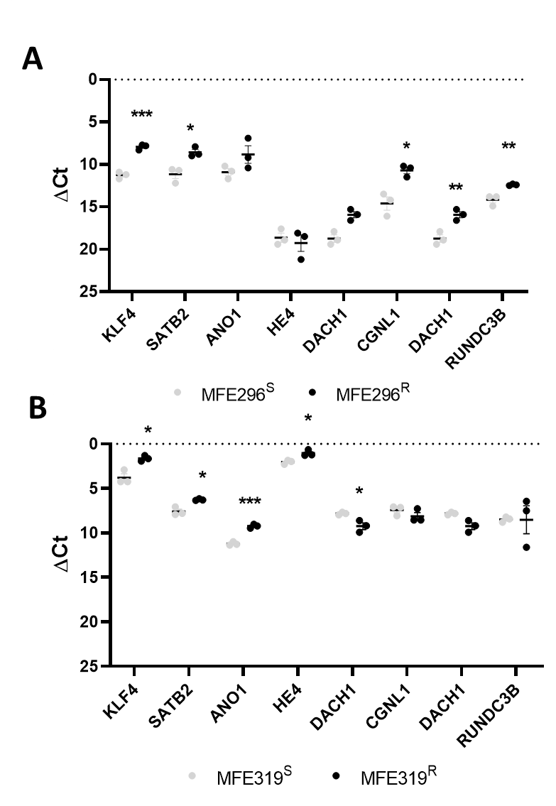
Supplementary Figure 2: LNG resistant cells express different levels of mRNA to controls in immortalised cell lines.
RT-qPCR was performed in triplicate and C_{t} values were normalised to three different housekeeping genes (SDHA, HSPCB, and RPL13A). A) ΔCt mRNA expression of key genes in the MFE296^{S} (grey) and MFE296^{R} (black) cell lines. B) t ΔCt mRNA expression of key genes in the MFE319^{S} (grey) and MFE319^{R} (black) cell lines. Results are expressed as mean ± SEM, experiments were performed in triplicate (n=3). Individual groups were analysed using T-test. * P <0.05, **P < 0.01, ***P < 0.001.
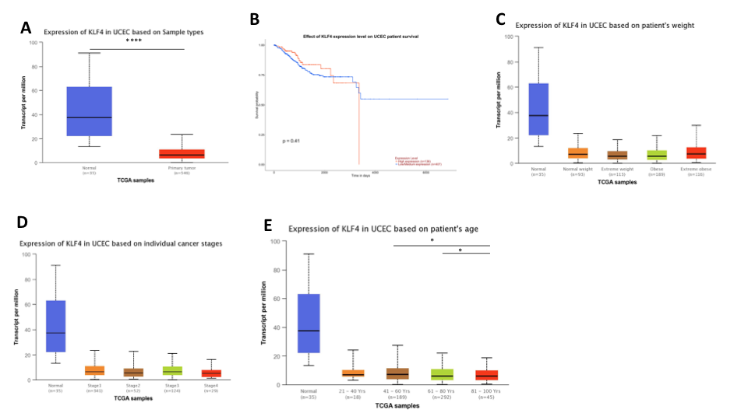
Supplementary Figure 3: Analysis of TCGA mRNA expression data of KLF4 in endometrial cancer using UALCAN to investigate any relationships with clinical parameters. Box and whisker plots generated by UALCAN show KLF4 mRNA expression is significantly decreased in EC primary tumours compared to healthy controls. There is no significant relationship between KLF4 and overall survival, weight or cancer stage. KLF4 mRNA expression is however significantly higher in patients between 40-60 compared to patients between 60-100 years old. * P <0.05, **P < 0.01, ***P < 0.001.
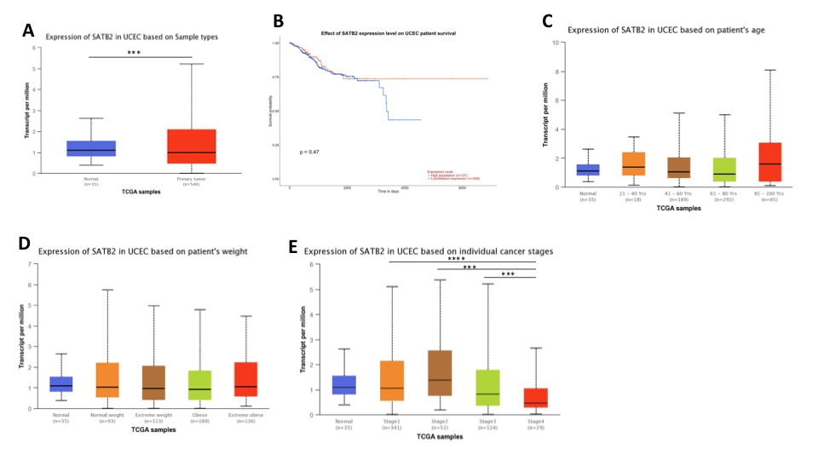
Supplementary Figure 4: Analysis of TCGA mRNA expression data of SATB2 in endometrial cancer using UALCAN to investigate any relationships with clinical parameters. Box and whisker plots generated by UALCAN show SATB2 mRNA expression is significantly increased in EC primary tumours compared to healthy controls. There is no significant relationship between SATB2 and overall survival, weight or age. Expression of SATB2 is significantly higher in stage 1, 2 and 3 cancers in comparison to stage 4 cancers. * P <0.05, **P < 0.01, ***P < 0.001.
Supplementary Table 1: List of primers
GENE | PRIMER | PRODUCT LENGTH | GC% | Tm
CACNA2D3 | F: TGATGTGGTGTGGACCGAAG  R: GCCCTTCGATCTGGTTTCGT | 139 | F: 55.00  R: 55.00 | F: 59.97  R: 60.39
HOTAIR | F: CCAGCCCTAGCCTTTGGAAG  R: GCTGCCAGTTAGAAAAGCGG | 109 | F: 60.00  R: 55.00 | F: 60.39  R: 59.83
SATB2 | F: GGAGAACGACAGCGAGGAA  R: CCGATGTATTGCTTTGCCTAGT | 139 | F: 57.86  R: 45.45 | F: 59.41  R: 58.79
HE4 | F: GTTCGGCTTCACCCTAGTCTC  R: CAGGAACCCTCCTTATCATTGGG | 183 | F: 57.14  R: 60.44 | F: 60.14  R: 60.44
DKK1 | F: ACAACTACCAGCCGTACCC  R: TGCAGGCGAGACAGATTTGC | 111 | F: 57.89  R: 55.00 | F: 59.02  R: 61.30
KLF₄ | F: ACCCCACCTTCTTCACCC  R: TAAGGTTTCTCACCTGTGTGG | 200 | F: 61.11  R: 47.62 | F: 58.41  R: 57.51
ANO1 | F: GAGCCAAAGACATCGGAATCTG  R: TGAAGGAGATCACACGAAGGCAT | 89 | F: 50.00  R: 47.83 | F: 59.39  R: 61.95
SOX17 | F: AGTGACGACCAGAGCCAGAC  R: CCTTAGCCCACACCATGAAA | 214 | F: 60.00  R: 50.00 | F: 61.53  R: 57.79
CGNL1 | F: GGCTGAGGAGGAAATCGACA  R: ACTCGGCAGCTTCTTCAGTCTTA | 142 | F: 55.00  R: 47.83 | F: 59.46  R: 61.62
DACH1 | F: TGCCGCATTCTGTCCCT  R: GAGTCTGCTCCATGTTGGTTATT | 184 | F: 58.82  R: 43.48 | F: 58.48  R: 58.73
RUNDC3B | F: TGGATGGCAGTTTTCCTGCT  R: ACCACTGCTTCCCAAAGTCC | 113 | F: 50.00  R: 55.00 | F: 59.89  R: 60.18
SH3YL1 | F: CCGCAGGTACGCCCTC  R: AGGTATAGGGTTATTCATGCTGCCC | 123 | F: 75.00  R: 48.00 | F: 59.46  R: 62.26
CRISPLD1 | F: GATATAGGCCCCCGACGTTT  R: CCCACCAGTTTCCCCTGTGT | 148 | F: 55.00  R: 60.00 | F: 59.32  R: 62.01
PRB | F: GGTCTACCCGCCCTATCTCA  R: TAGTTGTGCTGCCCTTCCAT | 195 | F: 60.00  R: 50.00 | F: 60.18  R: 59.30
ER | F: TGGGAATGATGAAAGGTGGGAT  R: GGTTGGCAGCTCTCATGTCT | 129 | F: 45.45  R: 55.00 | F: 59.41  60.04
FOXO1 | F: CTGAGGGTTAGTGAGCAGGTTAC  R: CTGCCAAGTCTGACGAAAGG | 161 | F: 52.17  R:55.00 | F:60.37  R: 58.85
RPL13A | F: CCTGGAGGAGAAGAGGAAAGAGA  R: TTGAGGACCTCTGTGTATTTGTCAA | 126 | F: 52.17  R: 40.00 | F: 60.57  R: 60.16
SDHA | F: TGGGAACAAGAGGGCATCTG  R: CCACCACTGCATCAAATTCATG | 86 | F: 55.00  R: 45.45 | F: 59.67  R: 58.48
HSPCB | F: TCTGGGTATCGGAAAGCAAGCC  R: GTGCACTTCCTCAGGCATCTTG | 80 | F: 54.55  R: 54.55 | F: 62.64  R: 61.77
Supplementary Table 2: (ΔCt) ±SD for non-significant MFE296 data
 | MFE296^{S} (ΔCt) | MFE296^{R}(ΔCt)
HOTAIR | N/A | N/A
CRISPLD1 | 17.2 ± 4.4 | 15.1 ± 2.5
SOX17 | 17.5 ± 3.8 | 15.7 ± 3.3
ANO1 | 10.9 ± 0.6 | 8.8 ± 1.8
HE4 | 18.6 ± 0.9 | 19.2 ± 1.7
ER | 14.4 ± 5.2 | 15.2 ± 0.1
PR | 12.8 ± 12.4 | 11.7 ± 2.3
SH3YL1 | 17.3 ± 3.2 | 15.7 ± 2.0
FOXO1 | 7 ± 21.1 | 4.1 ± 1.0
DKK1 | 17.5 ± 1.4 | 18.1 ± 0.4
CACNA2D3 | 11.2 ± 12.7 | 13.1 ± 2.2
MSX1 | 7.7 ± 4.6 | 7.2 ± 3.5
MDR1 | 14.7 ± 4.1 | 14.9 ± 3.4

Supplementary Table 3: (ΔCt) ±SD for non-significant MFE319 data
 | MFE319^{S} (ΔCt) | MFE319^{R}(ΔCt)
HOTAIR | N/A | N/A
CRISPLD1 | 15.2 ± 0.8 | 11.30 ± 2.2
SOX17 | 14.8 ± 1.1 | 16.6 ± 1.3
ER | 10.8 ± 0.3 | 10.8 ± 0.9
PR | 11.5 ± 1.25 | 11.2 ± 0.8
SH3YL1 | 14.3 ± 2.0 | 11.5 ± 1.4
CGNL1 | 7.4 ± 0.6 | 8.1 ± 0.7
FOXO1 | 7 ± 21.1 | 3.7 ± 0.7
RUNDC3B | 8.5 ± 0.3 | 8.5 ± 2.7
DKK1 | 11.3 ± 1.4 | 14.1 ± 0.6
CACNA2D3 | 9.2 ± 3.3 | 11.6 ± 3.9
MSX1 | 5.8 ± 1.9 | 6.6 ± 6.2
MDR1 | 13.5 ± 2.0 | 9.8 ± 0.6
Supplementary Table 4: (ΔCt) ±SD for non-significant Primary cell line data
 | LNG^{S} (ΔCt) | LNG^{R}(ΔCt)
SATB2 | 8.1 ± 1.6 | 6.9 ± 2.6
SOX17 | 12.7 ±2.9 | 15.1 ± 3.7
ANO1 | 8.9 ± 1.7 | 14.9 ± 4.5
HE4 | 8.8 ± 5.0 | 13.6 ± 4.3
PR | 7.6 ± 1.8 | 7.0 ± 1.6
MSX1 | 6.4 ± 1.2 | 4.8 ± 1.6
MDR1 | 9.0 ± 3.8 | 11.8 ± 1.1

