Supplementary materials

Table S1. Basic information of scales and descriptive items

Item | Item content | Mean  (SD) | Median (IQR) | Prevalence ª | Predictability
ISI1 | Severity of sleep onset | 0.68 (0.83) | 0 (0-1) | 48.8% | 67.1%
ISI2 | Sleep maintenance | 0.52 (0.77) | 0 (0-1) | 38.4% | 70.0%
ISI3 | Early morning wakening problems | 0.51 (0.76) | 0 (0-1) | 38.6% | 51.5%
ISI4 | Sleep dissatisfaction | 1.28 (1.02) | 1 (1-2) | 75.2% | 61.6%
ISI5 | Noticeability of sleep problems by others | 0.55 (0.78) | 0 (0-1) | 40.8% | 67.4%
ISI6 | Distress caused by the sleep difficulties | 0.42 (0.70) | 0 (0-1) | 32.8% | 66.6%
ISI7 | Interference with daytime functioning | 0.46 (0.74) | 0 (0-1) | 34.7% | 73.6%
Note:
ª The prevalence indicates the rate of the presence of each symptom with a score more than 0.
IQR: interquartile range; ISI1: Severity of sleep onset; ISI2: Sleep maintenance; ISI3: Early morning wakening problems; ISI4: Sleep dissatisfaction; ISI5: Noticeability of sleep problems by others; ISI6: Distress caused by the sleep difficulties; ISI7: Interference with daytime functioning; SD: standard deviation.

Table S2. Weighted adjacency matrix

 | ISI1 | ISI2 | ISI3 | ISI4 | ISI5 | ISI6 | ISI7
ISI1 | 0.000 | 0.385 | 0.000 | 0.236 | 0.000 | 0.105 | 0.152
ISI2 | 0.385 | 0.000 | 0.374 | 0.125 | 0.070 | 0.041 | 0.146
ISI3 | 0.000 | 0.374 | 0.000 | 0.112 | 0.032 | 0.106 | 0.000
ISI4 | 0.236 | 0.125 | 0.112 | 0.000 | 0.111 | 0.000 | 0.267
ISI5 | 0.000 | 0.070 | 0.032 | 0.111 | 0.000 | 0.343 | 0.323
ISI6 | 0.105 | 0.041 | 0.106 | 0.000 | 0.343 | 0.000 | 0.343
ISI7 | 0.152 | 0.146 | 0.000 | 0.267 | 0.323 | 0.343 | 0.000
ISI1: Severity of sleep onset; ISI2: Sleep maintenance; ISI3: Early morning wakening problems; ISI4: Sleep dissatisfaction; ISI5: Noticeability of sleep problems by others; ISI6: Distress caused by the sleep difficulties; ISI7: Interference with daytime functioning

Figure S1. Stability of centrality index (i.e. strength) by case dropping subset bootstrap.
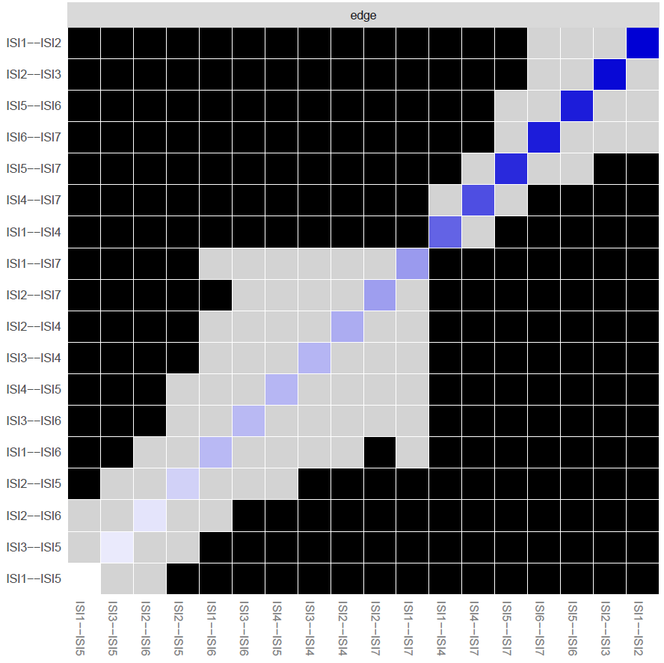
Figure S2. Estimation of edge weight difference by bootstrapped difference test.
Bootstrapped difference tests between edge weights in the network. Gray boxes indicate edges that do not significantly differ from one-another. Black boxes represent edges with significant difference from one another (α = 0.05). Blue boxes in the edge-weight plot indicate positive correlations.
ISI1: Severity of sleep onset; ISI2: Sleep maintenance; ISI3: Early morning wakening problems; ISI4: Sleep dissatisfaction; ISI5: Noticeability of sleep problems by others; ISI6: Distress caused by the sleep difficulties; ISI7: Interference with daytime functioning
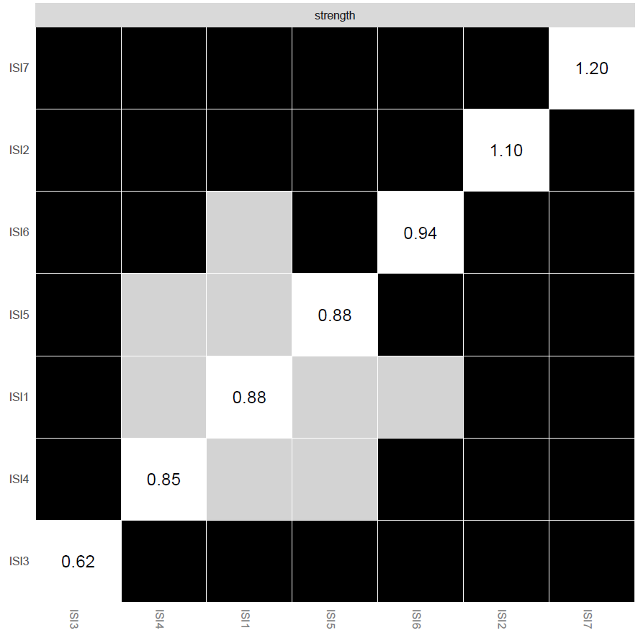
Figure S3. Estimation of node strength difference by bootstrapped difference test. Bootstrapped difference tests between node strength of insomnia symptoms. Gray boxes indicate nodes that do not significantly differ from one-another. Black boxes represent nodes that differ significantly from one another (α = 0.05). White boxes show the values of node strength.
ISI1: Severity of sleep onset; ISI2: Sleep maintenance; ISI3: Early morning wakening problems; ISI4: Sleep dissatisfaction; ISI5: Noticeability of sleep problems by others; ISI6: Distress caused by the sleep difficulties; ISI7: Interference with daytime functioning

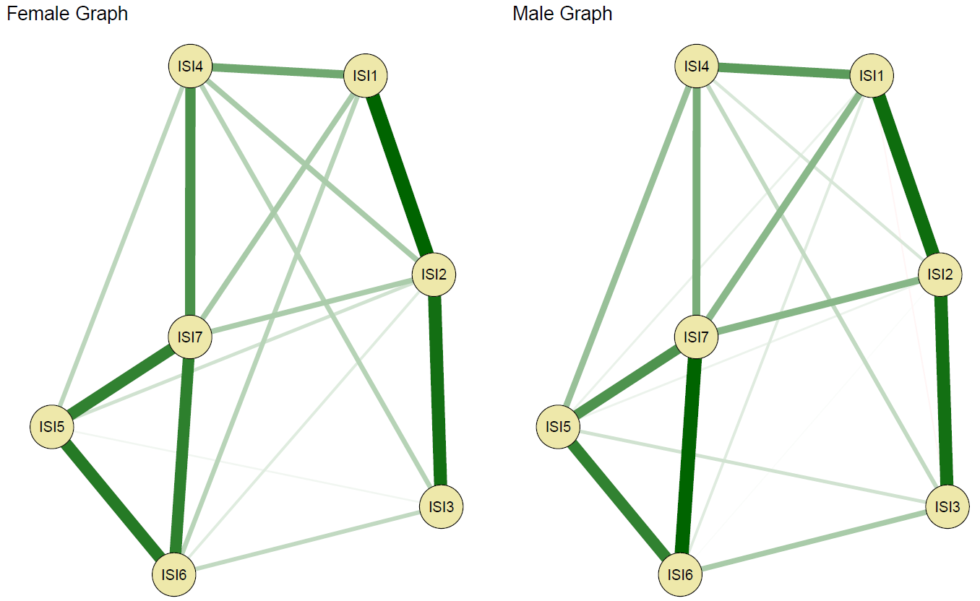
Figure S4. Comparison of network structure between females and males (N _{Male}=1,635; N _{Female}=8,881)
ISI1: Severity of sleep onset; ISI2: Sleep maintenance; ISI3: Early morning wakening problems; ISI4: Sleep dissatisfaction; ISI5: Noticeability of sleep problems by others; ISI6: Distress caused by the sleep difficulties; ISI7: Interference with daytime functioning

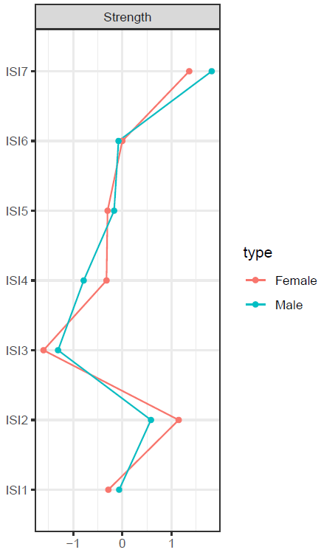
Figure S5. Comparison of network centrality (node strength) between females and males
ISI1: Severity of sleep onset; ISI2: Sleep maintenance; ISI3: Early morning wakening problems; ISI4: Sleep dissatisfaction; ISI5: Noticeability of sleep problems by others; ISI6: Distress caused by the sleep difficulties; ISI7: Interference with daytime functioning
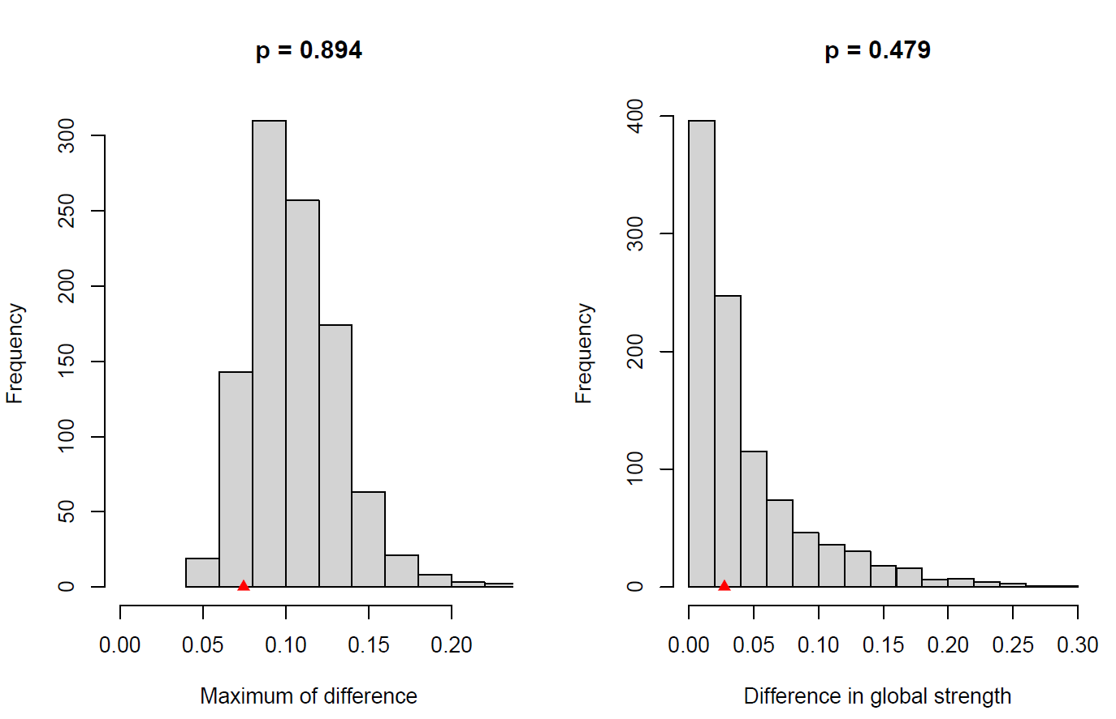
Figure S6. Comparison of network properties between females and males

