Supplementary Figure 1
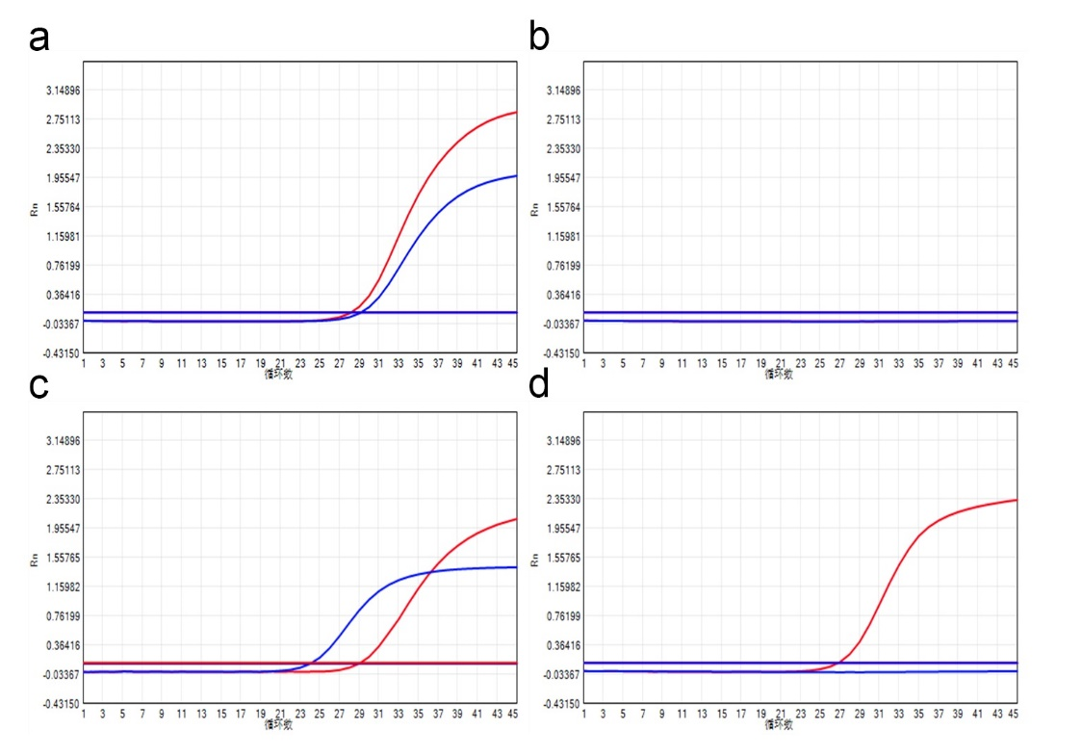
B
A
D
C
Cycle number
Cycle number
Cycle number
Cycle number

Supplementary Figure 1. Representative amplification curves of multiplex real time PCR in this study. (A) positive control of P. jirovecii: Ct ≤ 40 at channel FAM and CY5 (internal control); (B) negative control of P. jirovecii: no Ct or Ct > 40 at channel FAM and CY5 (internal control); (C) positive sample of P. jirovecii; (D) negative sample of P. jirovecii. Blue: P. jirovecii in FAM channel; red: internal control in CY5 channel.

